MILESTONE 1
Gossip Training over AXL
Four-node decentralized parallel SGD on CIFAR-10 / ResNet-32
4  symmetric workers | 91.58%  D-PSGD mean accuracy | 0.08 pp  mean gap to FedAvg

Bottom line
D-PSGD finished within 0.08 percentage points of centralized FedAvg across three seeds. All training and peer exchange ran over real AXL connections, with no central training coordinator.

This report covers what we built, what we measured, and where the release evidence lives.

Executive summary
- Four workers trained locally, exchanged model bundles over AXL, and averaged weights with peers.
- We ran three ResNet-32/CIFAR-10 jobs with seeds 17, 29, and 41. Each job completed 400 training rounds plus two consensus-only rounds; all 12 workers exited successfully after committing round 401.
- D-PSGD reached 91.58% mean final accuracy. FedAvg reached 91.50%, a difference of 0.08 percentage points.
- We measured all-pairs AXL RTT and 1/4/8/12 MiB transfers, including retries, checksums, and full-checkpoint exchange.
- The public release includes the report, per-seed charts, final safetensors checkpoints, and provenance. Per-node logs, sealed manifests, and raw AXL evidence are retained in a private reviewer archive and require separate access.

1. Implementation and protocol
Dromeus forms fixed membership with control messages transported over AXL. AXL provides encrypted byte routing.

Round lifecycle
- Dromeus forms a fixed four-node group through the AXL bootstrap route.
- Each worker runs 40 local SGD steps on its own IID CIFAR-10 partition.
- Every worker independently derives the same seeded pseudorandom pair schedule from the sealed manifest. Each bundle carries its round and tensor metadata.
- Before applying a bundle, the worker checks the round, metadata, tensor schema, finite values, and checksum.
- The worker mixes the accepted weights as local ← 0.5 × local + 0.5 × peer, commits the result, and records a CountSketch consensus estimate.

Reliability primitives
Primitive | Implementation evidence
Chunk acknowledgments | Transfers acknowledge each chunk, so both sides know what arrived.
Retries and deduplication | Retries are bounded at three, and duplicate chunks are ignored.
Integrity checks | Checksums are checked before transport artifacts or model bundles are applied.
Application flow control | Bounded queues limit in-flight data.
Peer/update validation | Workers check the round, metadata, artifact, tensor schema, dtype, shape, and finite values.
Durability | Committed round state and final checkpoints are retained. Intermediate snapshots are not part of the submission.

2. Acceptance criteria mapping
Acceptance criterion | Result | Evidence location
Working D-PSGD gossip training over AXL on four nodes | PASS | Per-seed manifest hashes; reviewer worker logs; all 12 workers exit 0
CIFAR-10 final accuracy within a few points of centralized FedAvg | PASS | Accuracy table below; 0.08 pp mean difference
Chart showing consensus distance falling toward zero | PASS | Per-seed consensus figures; final-distance records
Tagged release with public benchmark | PASS | Published GitHub Release v0.1.0 with benchmark assets
Per-node logs and run manifest provided | PASS | Per-node logs present in benchmarks/results/dromeus-m1-20260731/official/logs
Transport latency baselines from the start | PASS | All-pairs AXL baseline table and raw run prefix

The v0.1.0 tag and benchmark assets are now public.

3. Training benchmark
We trained ResNet-32 on CIFAR-10 with four IID partitions, 400 training rounds, two consensus-only rounds, 40 local SGD steps per training round, batch size 128, learning rate 0.1 (multiplied by 0.1 at local steps 8,000 and 12,000), momentum 0.9, and weight decay 0.0001. Each seed used four workers.
Seed | D-PSGD | FedAvg | D-PSGD − FedAvg | Final consensus
17 | 91.69% | 91.71% | -0.02 pp | 0.00
29 | 91.44% | 91.55% | -0.11 pp | 0.0024
41 | 91.60% | 91.23% | +0.37 pp | 0.00
Mean | 91.58% | 91.50% | +0.08 pp | see charts

Result interpretation
Across the three seeds, D-PSGD is effectively tied with FedAvg. Its mean is 0.08 percentage points higher, and the largest per-seed difference is 0.37 percentage points.

Configuration and provenance
Item | Value
Model / dataset | ResNet-32 / CIFAR-10; 50,000 samples; 4 × 12,500 IID partitions
Training | 400 training rounds + 2 consensus-only rounds; 40 local steps/round; batch 128; SGD; LR 0.1, ×0.1 at local steps 8,000 and 12,000; momentum 0.9; weight decay 0.0001
Protocol | D-PSGD; safetensors-v1; protocol version 1; 4,096-entry consensus sketch
Framework | PyTorch 2.13.0+cpu
Workers | Four symmetric workers per seed; 12 worker runs total across seeds 17, 29, 41

4. Accuracy and loss curves
These plots show accuracy and loss for each seed. The curves summarize the four workers; report.json also keeps the min, mean, and max values.
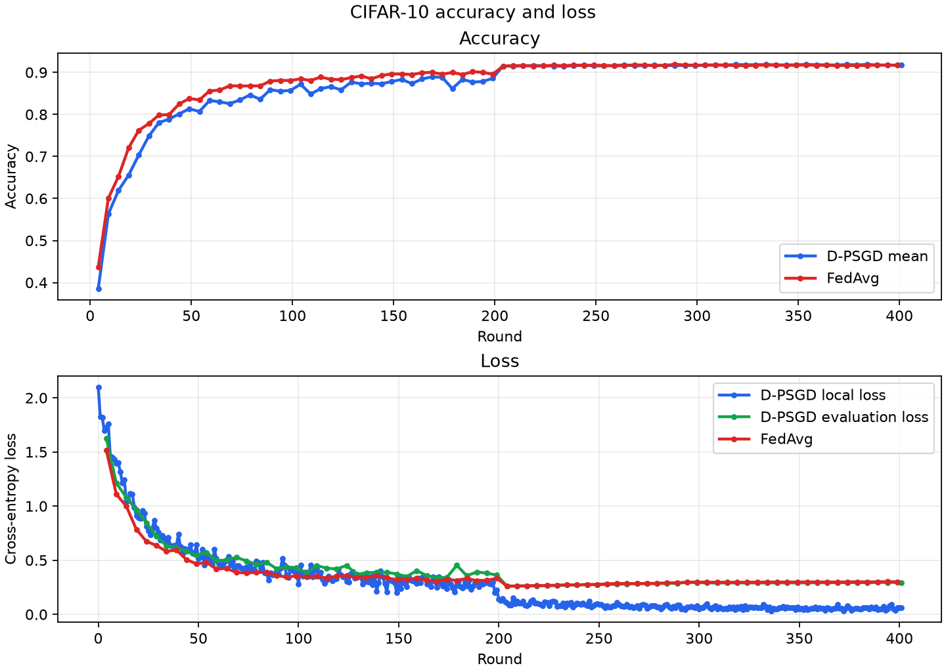
Seed 17: D-PSGD/FedAvg accuracy and loss across four workers.

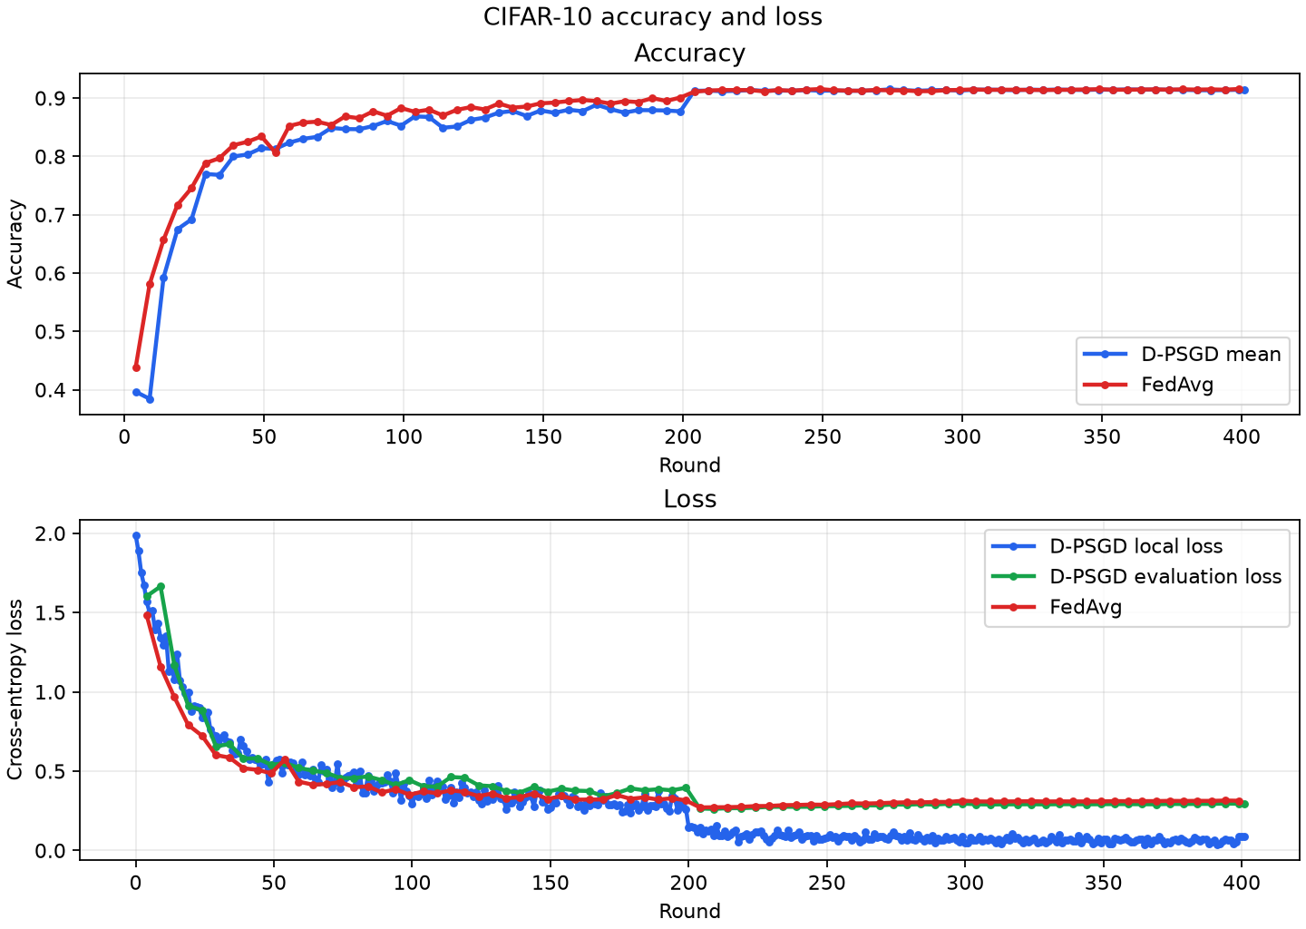
Seed 29: D-PSGD/FedAvg accuracy and loss across four workers.
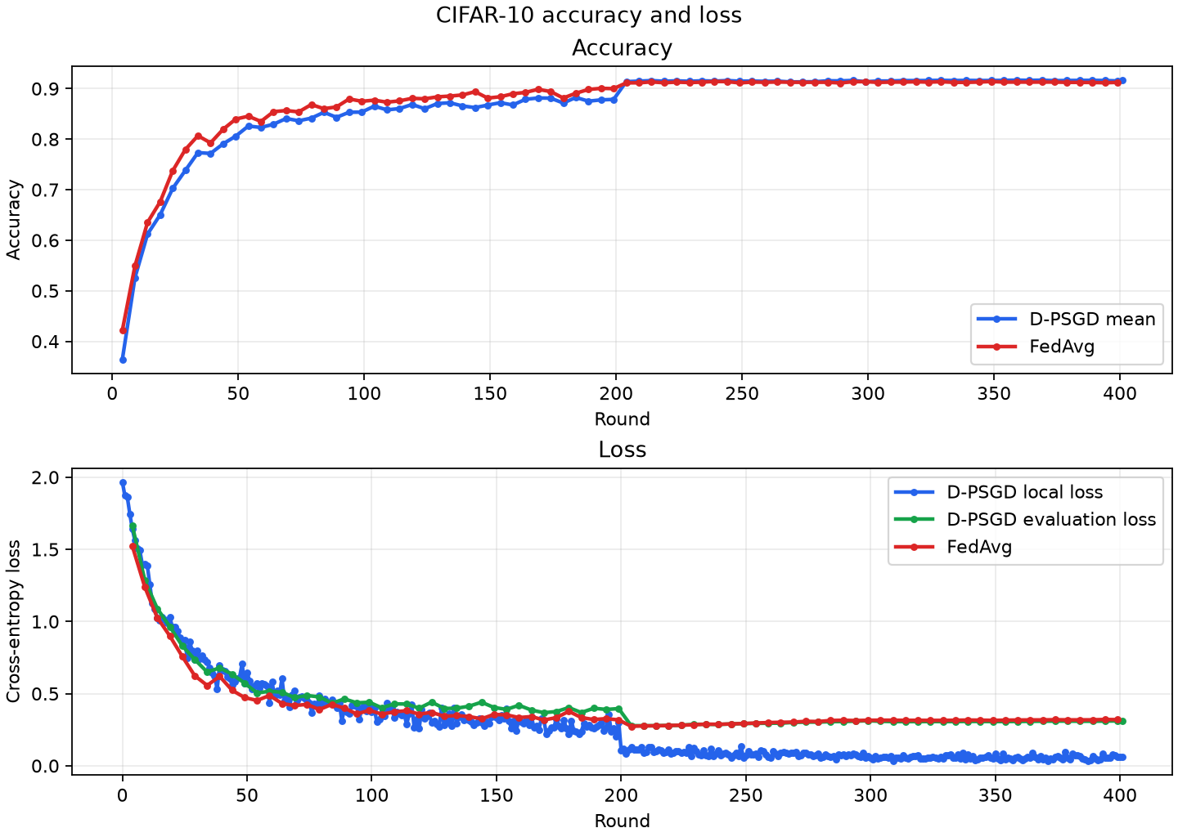
Seed 41: D-PSGD/FedAvg accuracy and loss across four workers.

5. Consensus evidence
We tracked approximate consensus distance with a 4,096-entry CountSketch. Seeds 17 and 41 end at zero; seed 29 ends at 0.002431. All workers committed round 401, but the archived diagnostics lack a complete four-node CountSketch set for that round, so the charts and final statistic use the last complete observation at round 400.
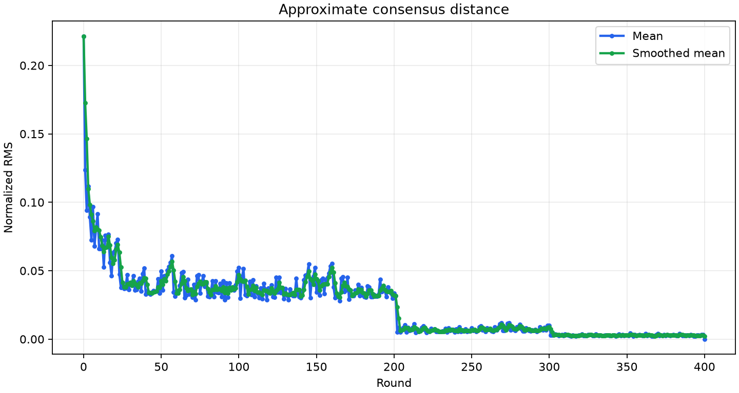
Seed 17: approximate consensus distance across the D-PSGD run; final value 0.000000.
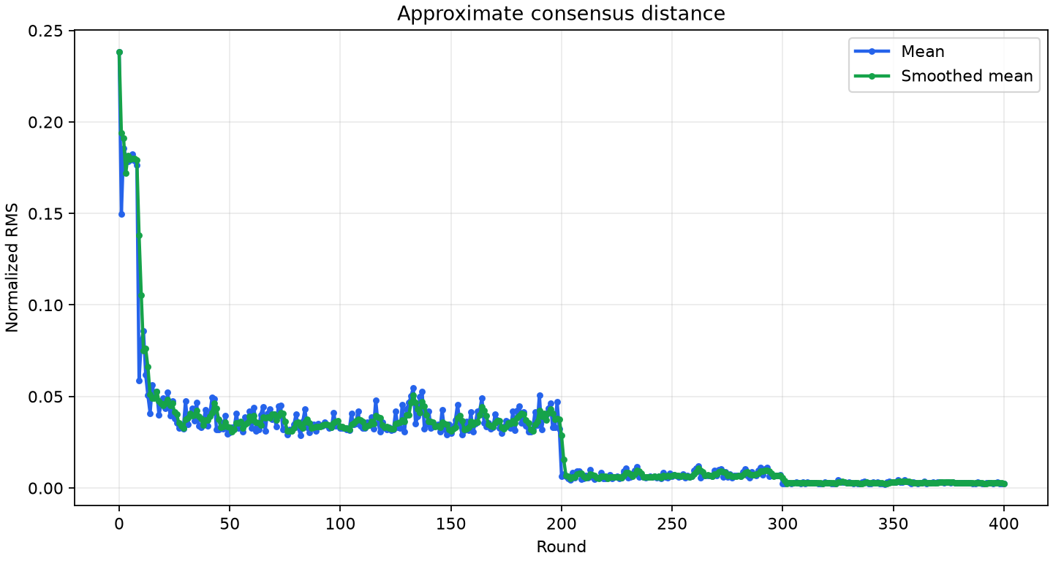
Seed 29: approximate consensus distance across the D-PSGD run; final value 0.002431.

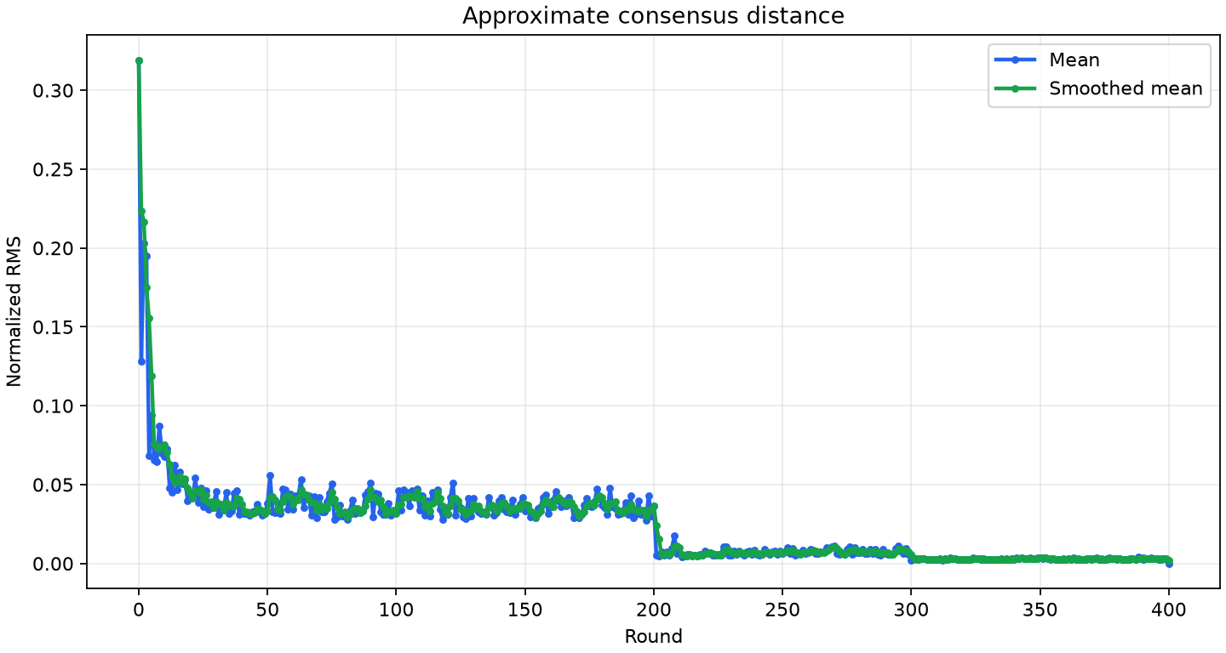
Seed 41: approximate consensus distance across the D-PSGD run; final value 0.000000.

6. AXL transport and reliable-transfer baselines
We used four c7i.xlarge workers across us-east-1 and us-east-2. The benchmark covered all 12 directed paths concurrently, with five samples per payload and 60 control RTT samples. Dromeus transferred payloads through its reliable-transfer layer over AXL; the ResNet-32 checkpoint was 1,879,464 bytes.
Payload | Mean goodput | p50 latency | p95 latency | p99 latency
Raw control RTT | n/a | 0.385 s | 0.568 s | 0.671 s
1 MiB | 2.31 MiB/s | 0.454 s | 1.455 s | 10.530 s
Full checkpoint | 7.61 MiB/s | 0.226 s | 0.862 s | 3.836 s
4 MiB | 7.48 MiB/s | 0.493 s | 2.040 s | 11.714 s
8 MiB | 10.41 MiB/s | 0.636 s | 4.408 s | 15.552 s
12 MiB | 15.28 MiB/s | 0.649 s | 10.934 s | 15.418 s

Reliability measure | Observed result
Total transfer samples | 300
Checksum failures | 0
Retried samples | 3 (1.0%); each retried once
Checkpoint-transfer retries | 0

These results measure end-to-end Dromeus reliable transfer over AXL, not bare AXL socket throughput. The p99 value pools 60 samples per payload (five per directed path), so it is a tail indicator near the slowest observed transfers, not an SLA.

7. Evidence and reproduction

Included in the public release
Artifact | Location / contents
Submission report | official/submission-report/report.json and report.md
Charts | Per-seed consensus, accuracy/loss, goodput, and timing PNGs
Final checkpoints | 12 final .safetensors files; four per seed;
Run provenance | Manifest hashes, environment records, tensor schema, and report hashes; sealed manifests and worker logs are in the private reviewer archive
Release marker | GitHub Release v0.1.0

Quick review
- Review the three-seed accuracy table and consensus figures.
- Inspect the AXL baseline and reliability tables.
- Open the Dromeus v0.1.0 release and download the benchmark package.

