MILESTONE 1
Gossip Training over AXL
Four-node decentralized parallel SGD on CIFAR-10 / ResNet-32
Field | Value
To | Gensyn team
From | Dromeus
Date | 31 July 2026
Status | PASS. Benchmark and evidence package complete
Release | v0.1.0 published with benchmark assets

4  symmetric workers | 91.58%  D-PSGD mean accuracy | 0.08 pp  mean gap to FedAvg

Bottom line
D-PSGD finished within 0.08 percentage points of centralized FedAvg across three seeds. All training and peer exchange ran over real AXL connections, with no central training coordinator.

This report covers what we built, what we measured, and where the release evidence lives.

Executive summary
- Four workers trained locally, exchanged model bundles over AXL, and averaged weights with peers.
- We ran three 400-round ResNet-32/CIFAR-10 jobs with seeds 17, 29, and 41. All 12 workers exited successfully after round 401.
- D-PSGD reached 91.58% mean final accuracy. FedAvg reached 91.50%, a difference of 0.08 percentage points.
- We measured all-pairs AXL RTT and 1/4/8/12 MiB transfers, including retries, checksums, and full-checkpoint exchange.
- The release includes per-seed charts, manifests, report JSON/Markdown, final safetensors checkpoints, and provenance. Full run archives remain private in S3.

1. Implementation and protocol
AXL handles group formation and byte transport. The workers train and average their models themselves. The bootstrap service does not aggregate updates or run the training rounds.

Round lifecycle
- The workers form a fixed four-node group through the AXL bootstrap path.
- Each worker runs 40 local SGD steps on its own IID CIFAR-10 partition.
- A deterministic peer schedule selects pairwise exchanges. Each bundle carries its round and tensor metadata.
- Before applying a bundle, the worker checks the round, metadata, tensor schema, finite values, and checksum.
- The worker mixes the accepted weights as local ← 0.5 × local + 0.5 × peer, commits the result, and records a CountSketch consensus estimate.

Reliability primitives
Primitive | Implementation evidence
Chunk acknowledgments | Transfers acknowledge each chunk, so both sides know what arrived.
Retries and deduplication | Retries are bounded at three, and duplicate chunks are ignored.
Integrity checks | Checksums are checked before transport artifacts or model bundles are applied.
Application flow control | Bounded queues limit in-flight data.
Peer/update validation | Workers check the round, metadata, artifact, tensor schema, dtype, shape, and finite values.
Durability | Committed round state and final checkpoints are retained. Intermediate snapshots are not part of the submission.

Checkpoint scope
We submit final checkpoints rather than every intermediate state. Historical checkpoints can help with forensic replay, but they are not needed for M1 review. The submitted evidence is the final safetensors files, logs, manifests, and provenance.

2. Acceptance criteria mapping
Acceptance criterion | Result | Evidence location
Working D-PSGD gossip training over AXL on four nodes | PASS | Per-seed run manifests; worker logs; all 12 workers exit 0
CIFAR-10 final accuracy within a few points of centralized FedAvg | PASS | Accuracy table below; 0.08 pp mean difference
Chart showing consensus distance falling toward zero | PASS | Per-seed consensus figures; final-distance records
Tagged release with public benchmark | PASS | Published GitHub Release v0.1.0 with benchmark assets
Per-node logs and run manifest provided | PASS | Submission report bundle plus private raw S3 evidence
Transport latency baselines from the start | PASS | All-pairs AXL baseline table and raw run prefix

The v0.1.0 tag and benchmark assets are now public.

3. Training benchmark
We trained ResNet-32 on CIFAR-10 with four IID partitions, 400 rounds, 40 local SGD steps per round, batch size 128, learning rate 0.1, momentum 0.9, and weight decay 0.0001. Each seed used four workers.
Seed | D-PSGD | FedAvg | D-PSGD − FedAvg | Final consensus
17 | 91.69% | 91.71% | -0.02 pp | 0.000000
29 | 91.44% | 91.55% | -0.11 pp | 0.002431
41 | 91.60% | 91.23% | +0.37 pp | 0.000000
Mean | 91.58% | 91.50% | +0.08 pp | see charts

Result interpretation
Across the three seeds, D-PSGD is effectively tied with FedAvg. Its mean is 0.08 percentage points higher, and the largest per-seed difference is 0.37 percentage points.

Configuration and provenance
Item | Value
Model / dataset | ResNet-32 / CIFAR-10; 50,000 samples; 4 × 12,500 IID partitions
Training | 400 rounds; 40 local steps; batch 128; SGD; LR 0.1; momentum 0.9; weight decay 0.0001
Protocol | D-PSGD; safetensors-v1; protocol version 1; 4,096-entry consensus sketch
Framework | PyTorch 2.13.0+cpu
Workers | Four symmetric workers per seed; 12 worker runs total across seeds 17, 29, 41

4. Accuracy and loss curves
These plots show accuracy and loss for each seed. The curves summarize the four workers; report.json also keeps the min, mean, and max values.
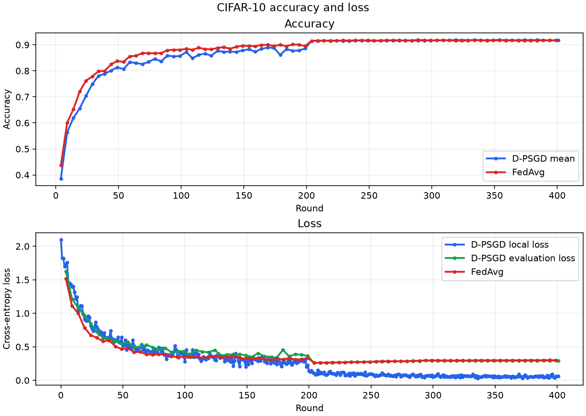
Seed 17: D-PSGD/FedAvg accuracy and loss across four workers.

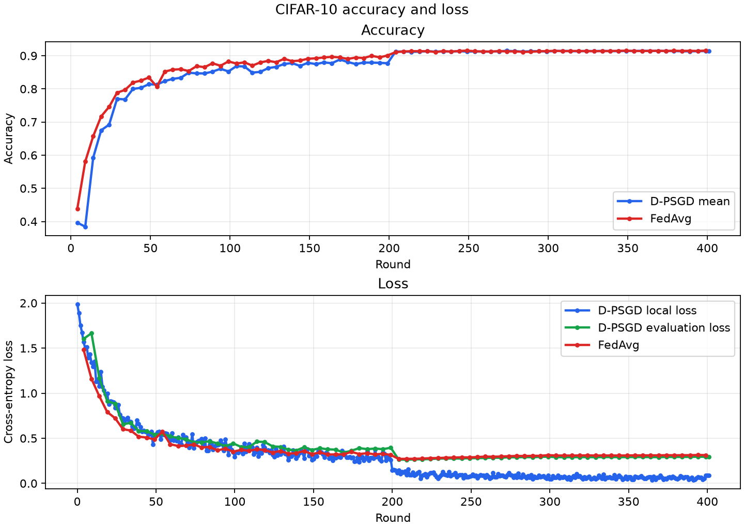
Seed 29: D-PSGD/FedAvg accuracy and loss across four workers.

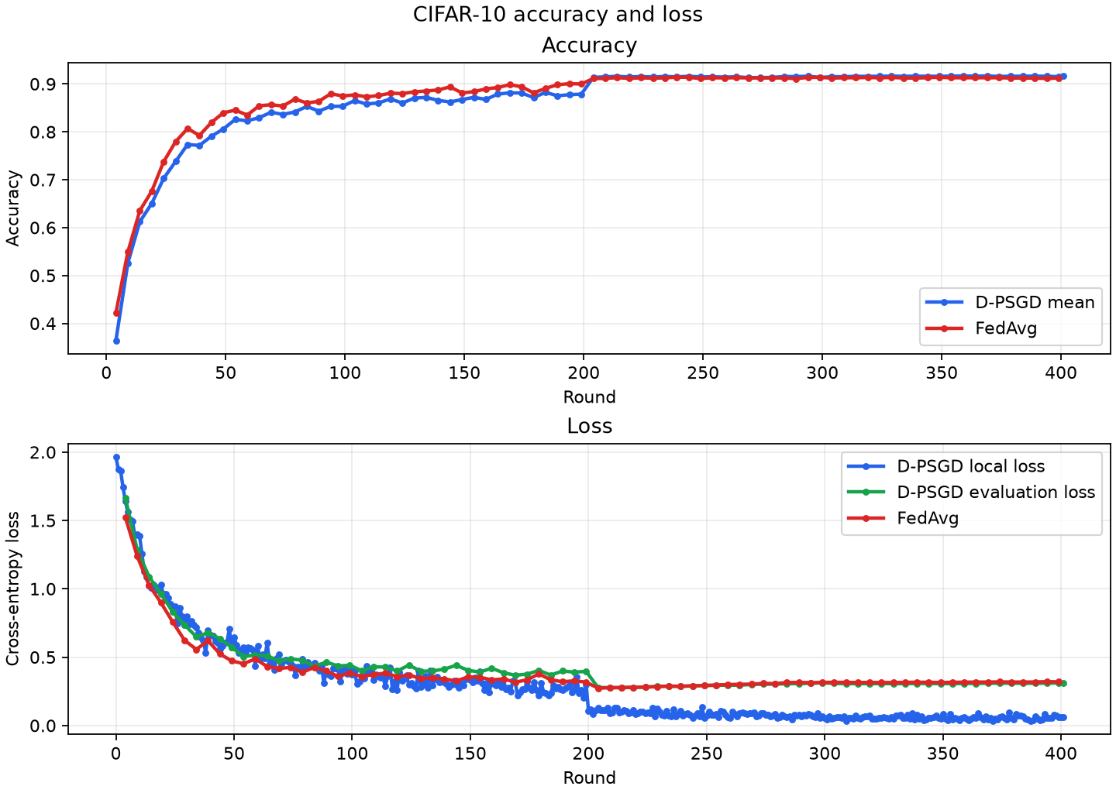
Seed 41: D-PSGD/FedAvg accuracy and loss across four workers.
Node-level reporting decision
We did not add four separate node curves because the retained bundle has aggregate min/mean/max traces, not four complete time series. After the final consensus exchange, all four nodes have the same final accuracy within each seed: 91.69% for seed 17, 91.44% for seed 29, and 91.60% for seed 41. Raw worker logs remain available if a node-by-node view is needed.

5. Consensus evidence
We tracked consensus distance during training and the final exchange. Seeds 17 and 41 finish at zero; seed 29 finishes at 0.002431. For a partial final diagnostic log, we use the last complete all-node reading.
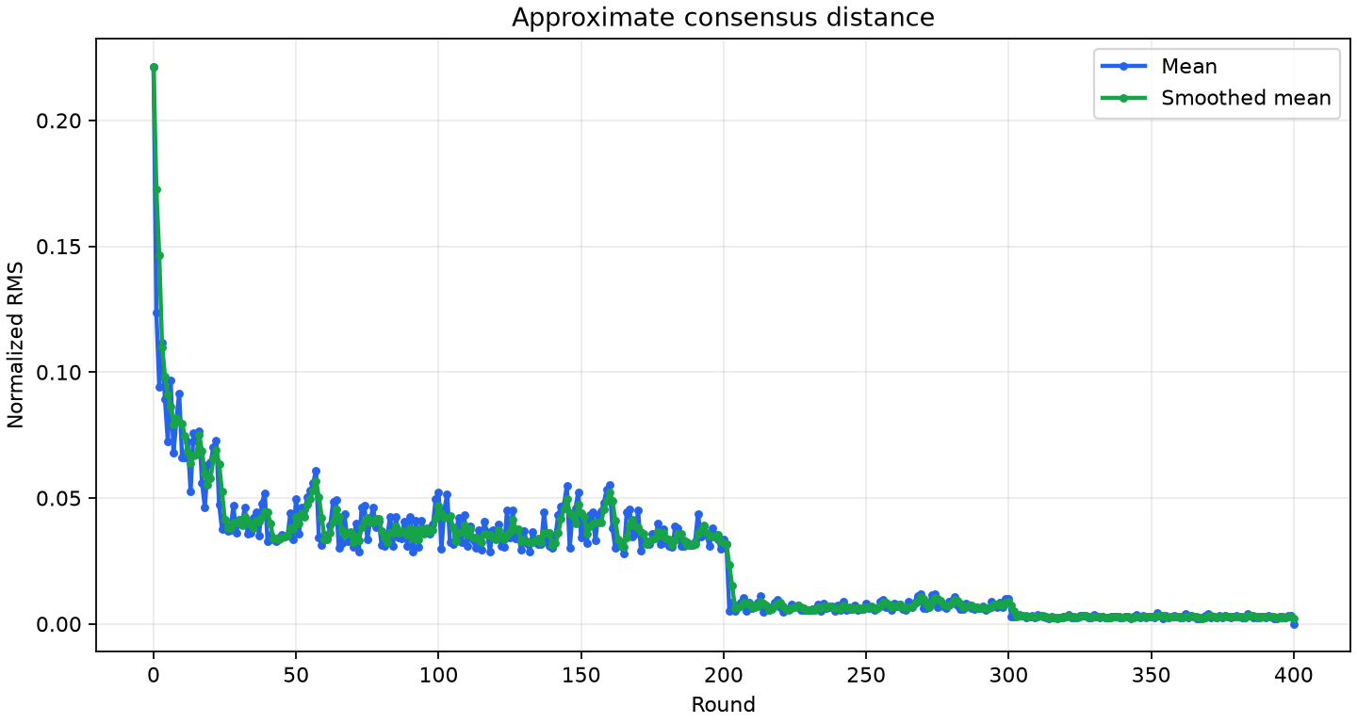
Seed 17: approximate consensus distance across the D-PSGD run; final value 0.000000.

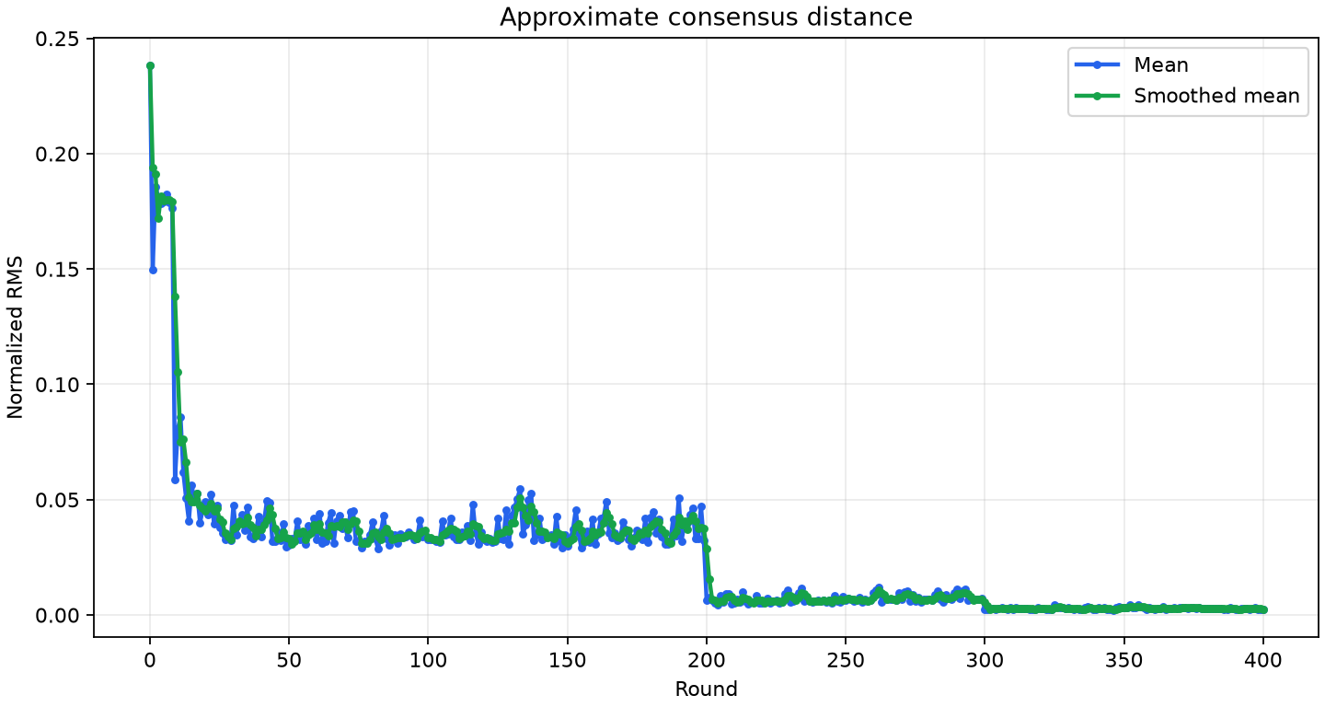
Seed 29: approximate consensus distance across the D-PSGD run; final value 0.002431.

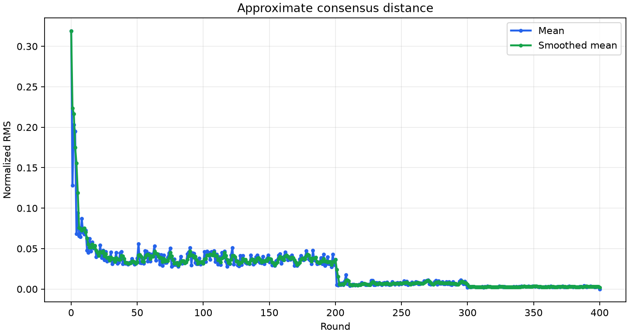
Seed 41: approximate consensus distance across the D-PSGD run; final value 0.000000.

6. Raw AXL transport baselines
We used four c7i.xlarge workers across us-east-1 and us-east-2. The run covered 12 directed paths in parallel, with five samples per payload and 60 control RTT samples. The ResNet-32 checkpoint was 1,879,464 bytes.
Payload | Mean goodput | p50 latency | p95 latency | p99 latency
Raw control RTT | n/a | 0.385 s | 0.568 s | 0.671 s
1 MiB | 2.31 MiB/s | 0.454 s | 1.455 s | 10.530 s
Full checkpoint | 7.61 MiB/s | 0.226 s | 0.862 s | 3.836 s
4 MiB | 7.48 MiB/s | 0.493 s | 2.040 s | 11.714 s
8 MiB | 10.41 MiB/s | 0.636 s | 4.408 s | 15.552 s
12 MiB | 15.28 MiB/s | 0.649 s | 10.934 s | 15.418 s

Reliability measure | Observed result
Total transfer samples | 300
Checksum failures | 0
Retried samples | 3 (1.0%); each retried once
Checkpoint-transfer retries | 0
AXL binary SHA-256 | 8ddebe8c…0256385
Raw evidence prefix | s3://dromeus-m1-benchmark-150911080841/quality/axl-baseline-20260730T131931Z-samples5/

Together, these numbers show the normal transfer times and the long-tail behavior that the raw AXL reliability layer must handle.

7. Evidence and reproduction

Included in the release
Artifact | Location / contents
Submission report | official/submission-report/report.json and report.md
Charts | Per-seed consensus, accuracy/loss, goodput, and timing PNGs
Final checkpoints | 12 final .safetensors files; four per seed; approximately 3.76 MB each
Run provenance | Per-seed manifests, environment records, tensor schema, and report hashes
Release marker | GitHub Release v0.1.0 at tag commit 8dd1c702...

Build details
Anchor | Value
Dromeus benchmark commit | 86be4ad812f071ed95409a67b7c56b95f8fbedf0
Frozen container image | sha256:1015f58ea64621b98319aa0dd61598d9028d5d71cc9c1eb9df7b23c36da1f89b
AXL commit | 628e28ace077f26dfe8d0259009b357216a9d8d4
Model definition hash | 83a4ed0acf0ff01fd04a6d013021d6e230601d1d33f9c07ff4adee4dc949cb14
Dataset version | huggingface-0b2714987fa478483af9968de7c934580d0bb9a2
Preprocessing hash | fab263925c870b8df3cd8f82e3258262e4f8db4943db449988058a60eaf04bf0

Publication note
The benchmark and public release are complete. The release contains the selected report and final checkpoints. Full historical checkpoint archives remain private and are not needed for acceptance review.

Quick review
- Check the four-node D-PSGD setup and confirm there is no central training aggregator.
- Review the three-seed accuracy table and consensus figures.
- Inspect the AXL baseline and reliability tables.
- Open the v0.1.0 release assets.

Appendix: per-seed run identifiers
Seed | Run ID | Manifest hash
17 | dpsgd-resnet32-400-20260730-seed17 | c8f5f7592b4d78fdeda8507f997386b0d373f6d0e47e21c433c56316a656466d
29 | dpsgd-resnet32-400-20260730-seed29 | ec9b27e700242c8af87125ca792321ed47a0095efd8e09deb531d54e06f3f70d
41 | dpsgd-resnet32-400-20260730-seed41 | f0de1016a77380493bedb2844fd53483b6274b0b2dc393bd4e409deeb37ec19b

Source note: values are rounded for presentation. report.json is the machine-readable source of record.

