Module – 11

Lecture-2

Instruction Set of Intel 8085 microprocessor

Data Transfer Group:

This group of instructions transfers data to and from registers and memory. Condition flags are not affected by any instruction in this group.

Move Register : MOV 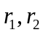 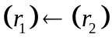

The content of register is moved to register .

These are single byte instructions and the format is

0 1 D D D S S S

D D D : Represents the destination register
S S S : Represents the source register.

The bit pattern designating one of the registers A, B, C, D, E, H, L.

D D D or S S S Register name

1 1 1 A
0 0 0 B
0 0 1 C
0 1 0 D
0 1 1 E
1 0 0 H
1 0 1 L

For example :
0 1 1 1 1 0 0 0

This machine instruction indicates

MOV A, B

i.e. the contents of register B will be moved to accumulator A.

The op-code of this machine instruction in hexadecimal is

7 8
and this is a single byte instruction

MOV r, M (Move from memory)

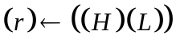
The content of the memory location, whose address is in registers H and L, is moved to register r.

0 1 D D D 1 1 0

It is observed that there is no register available for the encoding 1 1 0 . So, in source field S S S, the contents 1 1 0 indicates a memory access.

Example:

Assume that the contents of H is 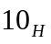 and L is 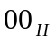. Then the instruction
0 1 1 1 1 1 1 0

Moves the contents of memory location 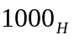 to accumulator. The op-code of this machine instruction in hexadecimal is 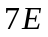

MVI r, data (Move immediate)

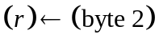
It is a 2-byte instruction, the content of the byte 2 of the instruction is moved to register r.
0 0 D D D 1 1 0
data

Example
0 0 0 0 0 1 1 0
0 0 1 1 0 0 1 1

The data 0 0 1 1 0 0 1 1 i.e 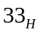 will be moved to register B.
The machine instruction in hexadecimal is

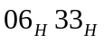
MVI M, data (Move to memory immediate)
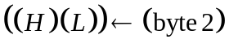

The content of byte 2 of the instruction is moved to the memory location whose address is in register H and L .

0 0 1 1 0 1 1 0
data

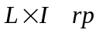 , data 16 (Load register pair immediate)

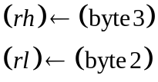

Byte 3 of the instruction is moved in to the higher order register 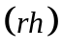of the register pair 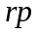. Byte 2 of the instruction is moved into the low-order register 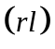of the register pair .
0 0 R P 0 0 0 1
low-order data

high-order data

The bit pattern in RP designating one of the register pairs B, D, H & SP :

RP Register-Pair
0 0 B-C
0 1 D-E
1 0 H-L
1 1 SP

For example:
0 0 1 0 0 0 0 1
0 0 0 0 0 0 0 0

0 0 0 1 0 0 0 0

This instruction loads the register pair H-L by .
The machine instruction in hexadecimal format is
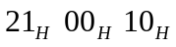

LDA addr (Load accumulator direct)
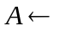((byte 3) (byte 2))

The contents of the memory location, whose address is specified in byte 2 and byte 3 of the instruction, is moved to register A. It is a three byte instruction.

0 0 11 1 0 1 0
low-order Adress

high-order Address

The instruction 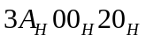 moves the contents of memory location 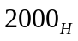 to accumulator.

STA addr (store accumulator direct)

((byte-3) (byte-2)) 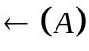

The content of the accumulator is moved to the memory location whose address is specified in byte 2 and byte 3 of the instruction.
0 0 11 0 0 1 0
low-order Adress

high-order Address

The instruction 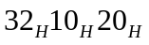 moves the contents of accumulator into memory location 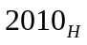

LHLD addr (Load H and L direct)

(L) ((byte 3)(byte 2)
(H) ((byte 3)(byte 2) +1)

The contents of the memory location, whose address is specified in byte 2 and byte 3 of the instruction, is moved to register L. The content of the next memory location is moved to register H.
0 0 1 01 0 1 0
low-order Adress

high-order Address

SHLD addr (store H and L direct)

((byte 3) (byte 2))(L)
((byte 3) (byte 2) +1)(H)

The content of register L is moved to the memory location whose address is specified in byte 2 and byte 3. The content of register H is moved to the next memory location.

0 0 1 0 0 0 1 0
low-order Adress

high-order Address

For example:
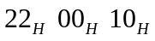
This instruction moves the content of register L to the memory location and moves the content of register H to the memory location 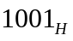

LDA ((rp))

The content of memory location, whose address is in the register pair rp, is moved to accumulator.

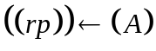
The content of register A is moved to the memory location whose address is in the register pair
0 0 R P 0 0 1 0

XCHG (Exchange H and L with D and E)

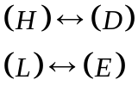
The contents of register H and L are exchanged with the contents of register D and E.
1 1 1 0 1 0 1 1

Arithmetic Group:

This group of instructions performs arithmetic operations on data in registers and memory.

Most of the instructions in this group affect the flag bits according to the standard rules.

All subtraction operations are performed via 2’s complement arithmetic and set the carry flag to one to indicates a borrow and clear it to indicate no borrow.

ADD r (Add Register)
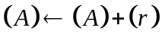
The content of register r is added to the content of the accumulator. The result is placed in the accumulator.

1 0 0 0 0 S S S

e.g.

1 0 0 0 0 0 0 1 indicates the operation 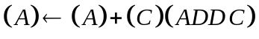 because the binary coding for register C is 001. The op-code for ADD C in hexadecimal is 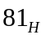.

The content of accumulator is added to the content of register C, and the result is stored in accumulator.

Depending on the result of the operation, the flags bits are set or reset.

If the result of the operation is zero, then the Z flag is set to 1. Generally it will follow the standard rule to set the flags.

The other operation in arithmetic group is listed below.

Now you are in a position to interprets the meaning of each instruction.

Addition group

Operation | Operation  Performed | OP code | Flags affected
ADD r  (Add register) |  | 1 0 0 0 0 S S S | Z, S, P, CY, AC
ADD M  (Add memory) | 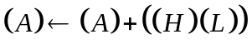 | 1 0 0 0 0 1 1 0 | Z, S, P, CY, AC
ADI data  (Add Immediate) | 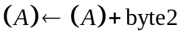 | 1 1 0 0 0 1 1 0  (data) | Z, S, P, CY, AC
ADC r  (Add register with carry | 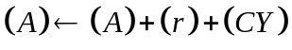 | 1 0 0 0 1 S S S | Z, S, P, CY, AC
AMC M  (Add memory with carry | 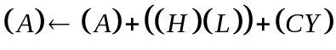 | 1 0 0 0 1 1 1 0 | Z, S, P, CY, AC
ACI data  (Add Immediate with carry) | 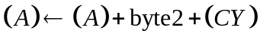 | 1 1 0 0 1 1 1 0  (data) | Z, S, P, CY, AC

Subtraction group

Operation | Operation  Performed | OP code | Flags affected
SUB r  (Subtract Register) | 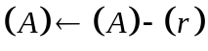 | 1 0 0 10 S S S | Z, S, P, CY, AC
SUB M  (Subtract Memory) | 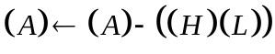 | 1 0 0 1 0 1 1 0 | Z, S, P, CY, AC
SUI data  (Subtract Immediate) | 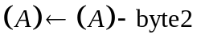 | 1 1 0 1 0 1 1 0  (data) | Z, S, P, CY, AC
SBB r  (Subtract Register with borrow) | 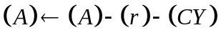 | 1 0 0 1 0 S S S | Z, S, P, CY, AC
SBB M  (Subtract Memory with borrow) | 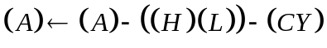 | 1 0 0 1 1 1 1 0 | Z, S, P, CY, AC
SBI data  (Subtract immediate with borrow) | 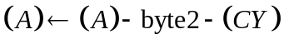 | 1 1 0 1 1 1 1 0  (data) | Z, S, P, CY, AC

Increment/Decrement group

Operation | Operation  Performed | OP code | Flags affected
INR r  (Increment register) | 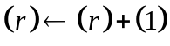 | 0 0 D D D 1 0 0 | Z, S, P, AC
INR M  (Increment memory) | 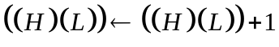 | 0 0 1 1 0 1 0 0 | Z, S, P, AC
DCR r  (Decrement register) | 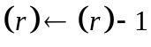 | 0 0 D D D 1 0 1 | Z, S, P, AC
DCR M  (Decrement memory) | 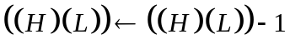 | 0 0 1 1 0 1 0 1 | Z, S, P, AC
INX rp  (Increment register pair) | 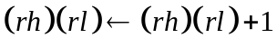 | 0 0 R P 0 0 1 1 | None
DCX rp  (Decrement register pair) | 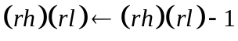 | 0 0 R P 1 0 1 1 | None
DAD rp  (Add register pair to H & L) | 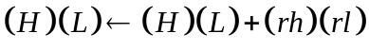 | 0 0 R P 1 0 0 1 | CY
DAA  (Decimal Adjust Accumulator) | The eight bit number in the accumulator is adjusted to form two four-bit Binary-coded decimal digits. | 0 0 1 0 0 1 1 1 | Z,S,P,AC,C

Logical group:

This group of instructions perform logical (Boolean) operations on data in registers and memory and on condition flags.

All instructions in this group affect the Zero, Sign, Parity, Auxiliary carry and carry flags according to the standard rules.

Operation | Operation  Performed | Op-code
ANA r  (AND Register) | 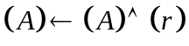 | 1 0 1 0 0 S S S
ANA M  (AND memory) | 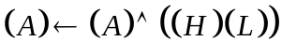 | 1 0 1 0 0 1 1 D
ANI data  (AND immediate) | 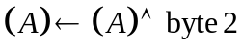 | 1 1 1 0 0 1 1 0  (data)
XRA r  (Exclusive OR Register) | 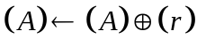 | 1 0 1 0 1 S S S
XRA M  (Exclusive OR memory) | 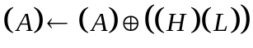 | 1 0 1 0 1 1 1 0
XRI data  (Exclusive OR immediate) | 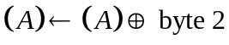 | 1 1 1 0 1 1 1 0  (data)
ORA r  (OR Register) | 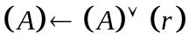 | 1 0 1 1 0 S S S
ORA M  (OR memory) | 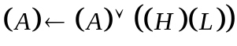 | 1 0 1 1 0 1 1 0
ORI data  (OR immediate) | 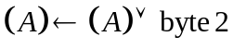 | 1 1 1 1 0 1 1 0
CMP r  (Compare register) | 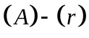  the accumulator remains unchanged.  Z flag is set to 0 if 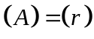  CY flag is set to 1 if 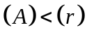 | 1 0 1 1 1 S S S
CMP M  (Compare memory) | 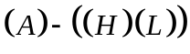 | 1 0 1 1 1 1 1 0
CPI data  (Compare immediate) | 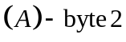 | 1 1 1 1 1 1 1 0  data
RLC  (Rotate left) | 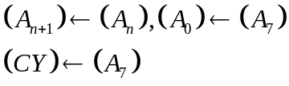 | 0 0 0 0 0 1 1 1
RRC  (Rotate right) | 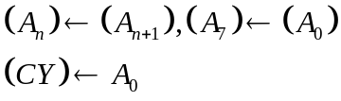 | 0 0 0 0 1 1 1 1
RAL  (Rotate left through carry) | 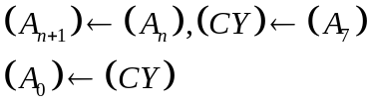 | 0 0 0 1 0 1 1 1
RAR  (Rotate right through carry) | 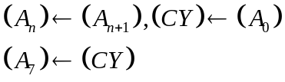 | 0 0 0 1 1 1 1 1
CMA  (Complement accumulator) | 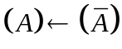 | 0 0 1 0 1 1 1 1
CMC  (complement carry) | 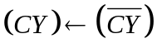 | 0 0 1 1 1 1 1 1
STC  (Set carry) | 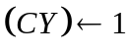 | 0 0 1 1 0 1 1 1

Branch group :

This group of instructions alter normal sequential flow of the program.

Condition flags are not affected by any instruction in this group.

There are two types of branch instructions- unconditional and conditional.

Unconditional transfers simply load the program counter with the new address of the instruction from where the execution starts again.

Conditional transfer examine the status of one of the four processor flags to determine if the specified branch is to be executed.

The conditions that may be specified are as follows:

Condition | C C C
NZ- not zero (Z = 0) | 0 0 0
Z- zero (Z =1 ) | 0 0 1
NC- no carry (CY = 0) | 0 1 0
C- carry (CY = 1) | 0 1 1
PO- Parity odd (P = 0) | 1 0 0
PE – parity even (P = 1) | 1 0 1
P= plus ( S = 0) | 1 1 0
M – Minus ( S = 1) | 1 1 1

JMP addr (Jump)
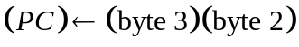
Control is transferred to the instruction whose address is specified in byte 3 and byte 2 of the current instruction.
1 1 0 0 0 0 1 1
Low-order address

High-order address

J condition addr (Conditional jump)

If (C C C) then
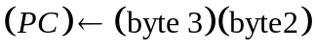

If the specified condition is true, control is transferred to the instruction whose address is specified in byte 3 and byte 2 of the current instruction, otherwise control continuous sequentially.
1 1 C C C 0 1 0 1
Low-order address

High-order address

Example:

1 1 0 0 1 0 1 1, this op-code indicates JZ, ie. Jump on zero. It will check the zero flag bit, and if the Z flag is 1, control will jump to specified address.

In hex, this op-code is 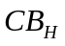

Therefore, 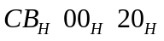, for this instruction,
It will check the Z flag, if Z flag is set to 1, then program counter will be loaded with , otherwise control sequentially.

CALL addr (Call)

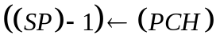
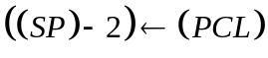
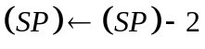
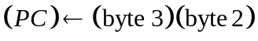
1 1 0 0 1 1 0 1
Low-order address

High-order address

C condition addr (condition call)
If 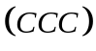,
1 1 C C C 1 0 0
Low-order address

High-order address

RET (Return)

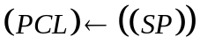
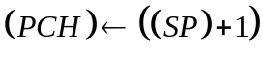
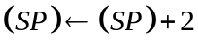
1 1 0 0 1 0 0 1

R condition (conditional Return)

If ,
1 1 C C C 0 0 0

RST n (Restart)

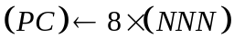

Control is transferred to the instruction whose address is eight times the content of NNN.

1 1 N N N 1 1 1

PCHL (Jump H and L indirect – move H and L tp PC )

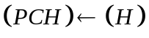
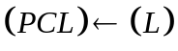
1 1 1 0 1 0 0 1

Stack, 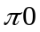 and machine control group

This group of instructions performs , manipulates the stack, and alters internal control flags.

PUSH rp (Push)

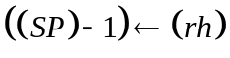
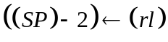
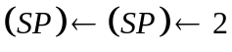
1 1 R P 0 1 0 1

PUSH PSW (Push processor status word)

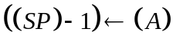
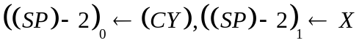
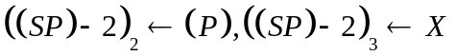
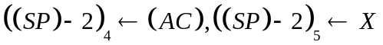
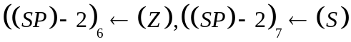
1 1 1 1 0 1 0 1

FLAG WORD
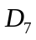
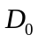
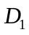
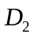
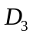
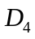
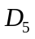
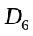
S Z X AC X P X CY

POP rp (Pop)

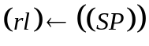
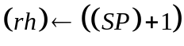

1 1 R P 0 0 0 1

POP PSW (Pop processor status word)

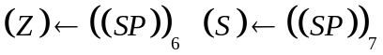
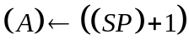

XTHL ( Exchange stack top with H and L)
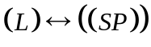
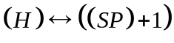
1 1 1 0 0 0 1 1

SPHL Move HL to SP

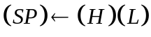

1 1 1 1 1 0 0 1

IN port (Input)

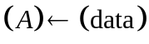
The data placed on the eight bit bi-directional data bus by the specified port is moved to register A.
1 1 0 1 1 0 1 1
port

OUT port (output)

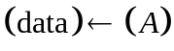
The content of register A is placed on the eight bit bi-directional data bus for transmission to the specified port.
1 1 0 1 0 0 1 1
port

EI (Enable Interrupt)

The interrupt system is enabled following the execution of the next instruction. Interrupts are not recognised during the EI instruction.

1 1 1 1 1 0 1 1

DI (Disable interrupt)

The interrupt system is disabled immediately following the execution of th DI instruction. Interrupts are not recognized during the DI instruction.
1 1 1 1 0 0 1 1

HLT (Halt)

The processor is stopped.

0 1 1 1 0 1 1 0

NOP (No operation)

No operation is performed. The registers and flags are unaffected.
0 0 0 0 0 0 0 0

RIM (Read Interrupt Masks)

The RIM instruction loads data into the accumulator relating to interrupts and serial input.
0 0 1 0 0 0 0 0

Accumulator content after RIM

SID 17.5 16.5 15.5 IE M7.5 M6.5 M5.5

Serial
Input
data
Interrupts
pending
Interrupt
Enable flags
Interrupt masks

SIM (Set interrupt masks)

The execution of SIM instruction uses the content of the accumulator to perform the following functions

- Program the interrupt masks for the RST 7.5, 6.5 and 5.5 hardware interrupts
- Reset the edge-triggered RST 7.5 input latch
- Load the SOD output latch.

0 0 1 1 0 0 0 0

