Machines Lab
Experiment 2

Open Circuit and Short circuit Test on Single Phase Transformer

Group D5: Kumar Ashutosh(16D070043)
Anhad Bhati(16D070045)
Devesh Kumar(16D070044)

Aim: To obtain the transformer circuit parameters from the no load thest and short circuit test and plot efficiency and regulation at various loads.
Equivalent circuit of a transformer:-
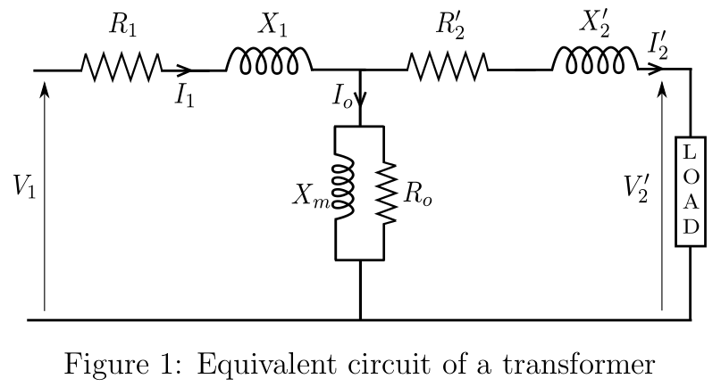
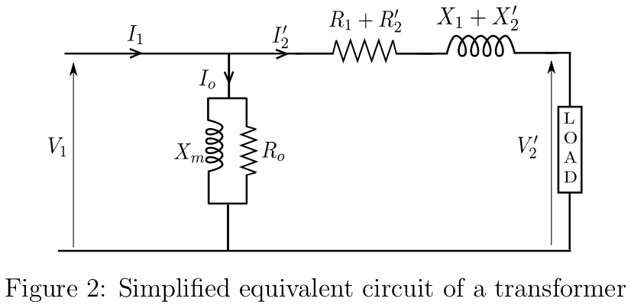
1. No load/Open circuit test:-

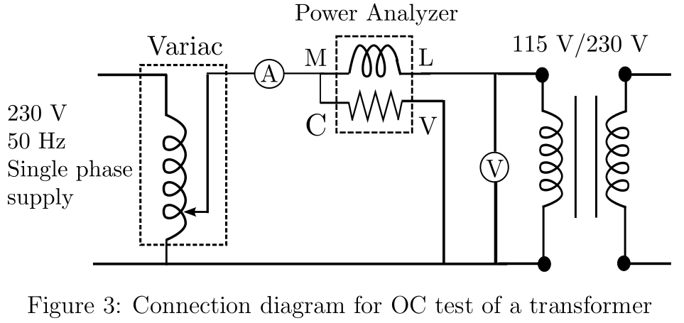
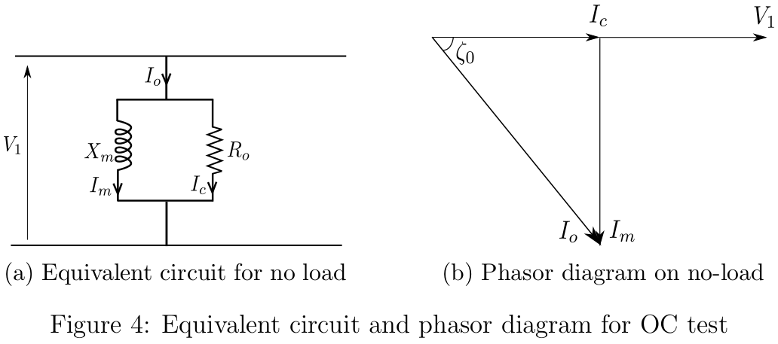
2. Short circuit test:-
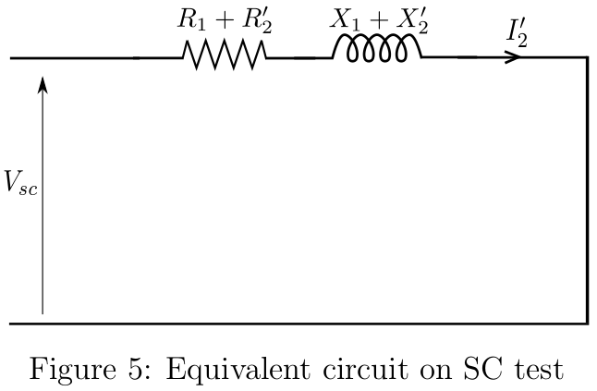

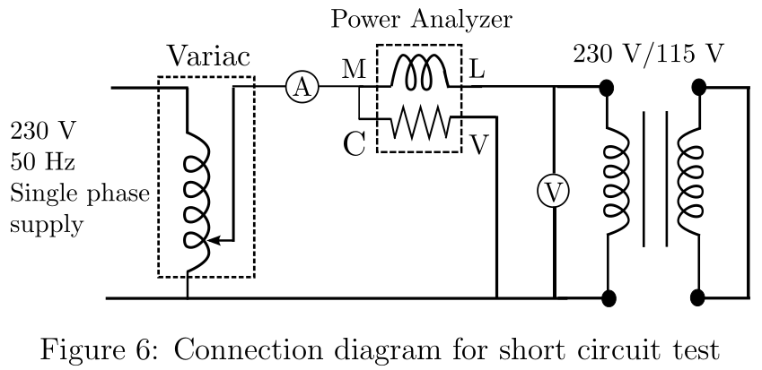
Observations:-

1. No load test:-

Input at LV side(V) | Measured current(mA) | Power (W)
22.25 | 32.84 | 0.57
43.2 | 58.54 | 2.210
63.94 | 83.49 | 4.372
78.2 | 107.42 | 6.228
91.28 | 138.47 | 8.404
108.51 | 210.1 | 11.73
112.25 | 240.7 | 12.68
115.05 | 264.3 | 13.22

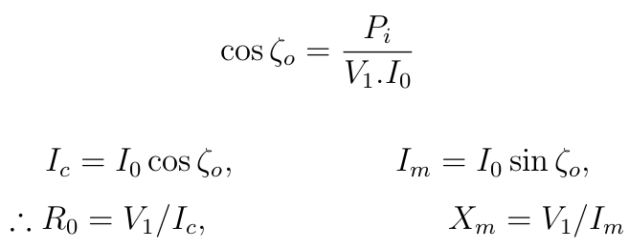

From the observations, P.F = 0.435
ς₀ = 64.23º
R₀ = 1.001kΩ
X_{m} = 483.37Ω

2. Short Circuit Test:-

Input at HV(V) | Current(A) | Power(W)
4.78 | 3.4 | 15.4
8.76 | 6.45 | 52.7
12.168 | 9.081 | 103.75

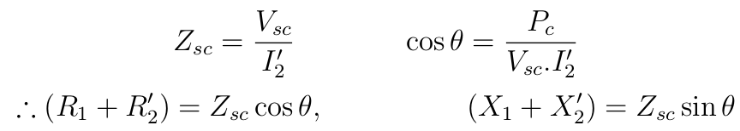
From the observations,

Z_{SC} =
θ =
R₁+R₂’ =
X₁+X₂’ =
Calculation:-
1.Regulaion:-
2.Efficiency:-
Graphs:-

Conclusion:-

1. We operate the transformer at the knee point. Therefore the core goes into saturation. But the flux, which is determined by the (sinusoidal) voltage alone, should be sinusoidal. Therefore, to compensate for the saturation, the current starts to peak and a distorted waveform is observed.

2. At lower values of loads, the core losses(hysteresis+eddy current) loss are comparable to the output. Therefore the efficiency as we increase the load, increases. But after a certain point, the copper losses due to the winding resistance increases, and therefore the efficiency starts to go down. Thus, the plot of efficiency verus load starts to increase, reaches a maxima and the decreases.

3. Voltage regulation increases with increasing power factor, since as the power factor increases, lesser current is drawn from the source and therefor the voltage drop across the series parameters will decrease. Thus the voltage regulation will be higher.

Demo experiment description:-
In the demo experiment shown in the lab, we first observed the current waveform in the transformer, which is observed to peaking, since we operate the device at the knee point, due to which the core gets saturated, and therefore to maintain a sinusoidal flux in the core which is determined by the voltage alone, the current starts to peak.
Then we observed a transformer whose secondary side has been connected with a constant current source. This can be seen as a superposition of an AC and DC current. The flux does not change due to the DC part, and is not reflected in the primary side. The AC part, however, has an effect on the primary and a peaking current is observed.

Questions:-

1.Which winding ( LV or HV) should be kept open while conducting OC test? Justify your answer.
Ans:
The HV winding is kept open during the no load test for measurement purposes, since if the LV is kept open and the rated voltage applied on the HV side, very less current will be drawn and will be difficult to measure.

2.Assume that the given transformer has the following name plate ratings:
40 kVA, 440 V/11 kV, 50 Hz.
What do these numbers imply?
Ans:
40 kVA is the volt-ampere rating, i.e the maximum power that can be transformed. 440V is the rated voltage of the LV side while !!kV is the rated voltage of the HV side. 50Hz is the frequency at which the transformer operates.

3. Comment on the nature of the current waveform drawn from the source during OC test for (i)
50%, (ii) 100% and (iii) 110% of the rated voltage.
Ans:
At 50% of the rated voltage, the knee point is not crosses, and thus the current observed should be sinusoidal.
At 100% the core may saturate and therefore the current waveform will be sinusoidal in some regions, while peaky in the others.
At 110%, the knee point has been crossed, and thus to maintain a sinusoidal flux, the current starts peaking, and a non sinusoidal waveform is observed.

4.Can the regulation be negative? What does it signify?
Ans:
Yes, the voltage regulation can be negative. It signifies that a leading load(R-C) is being used.

5. Assume that you have been given a transformer manufactured in the US ( The supply voltage
and frequency are 110 V and 60 Hz respectively). What voltage will you apply if this transformer
is to be used in this country? Justify your answer.
Ans:
Since we assume most of the loads to be lagging in nature, the impedance increases with increasing frequency. Thus at lower frequency, a higher current will be drawn, which causes the core to go into the non linear region, and the efficiency would decrease. Thus a voltage less than the rated voltage should be applied.

6. What is the reason for high no load current at lower-than-rated voltage for the no load test on
high frequency transformer which was demonstrated to you by the TAs ?
Ans:
The inductive reactance increases with frequency, which causes a higher voltage drop across the windings, and thus a higher load current for a lower-than-rated voltage is observed.

7. Assume that you have been given two transformers of identical VA, and voltage ratings. But one
of them is a 10 kHz transformer and another is a 100 Hz transformer. Just by inspection, how
would you identify which one is the high frequency transformer? Justify your answer.
Ans:
The flux and the emf are related as e = 4.44fΦN. Thus, given identical VA ratings, The one with a higher frequency will have lesser number of turns in the windings.

8. What is an ‘impedance matching’ transformer? Name one instrument of everyday use, in which
this transformer being used.
Ans:
We can use transformes for matching the impedances ot circuits. This is used to maximise the power output or to minimize signal reflection from the load.

