**EE 780: Mid-Semester Examination**

Date: 24th February 2020 Total Marks: 25

---------------------------------------------------------------------------------------------------------------------------------------

**Make convenient assumptions (if required) and state them**

**Free space Permeability** =***μ0***- 1.2566 X 10-6 Wb.A-1m-1.

**Naper to dB conversion**🡺 1 Naper= 8.685889 dB

**Free space Permittivity**= **ε0-** 8.85418 X 10-12 m-3 kg-1 s4 A2

Please write appropriate units for the answers. **Improper units may attract deduction of 0.5 marks**.

------------------------------------------------------------------------------------------------------------------------------------------

Q.1 (**5 Marks**)

(a) ‘Radiated Emission (RE)’ measurement was performed on a unit (DUT) with an antenna located at 3 m from DUT. The antenna factor is 6 dB. The voltage strength of the signal at antenna terminals was observed to be 1mV. Compute the ‘Effective Radiated Power (ERP)’ of the DUT.

(1 Mark)

(b) In an electronic panel, a pair of supply lines are being routed to a module positioned at (3,4).

**Electronic Panel**

Module

Route-2

X axis (cm)

Y axis (cm)

1 2 3 4

0 1 2 3

Route-1

See Figure. There are two options, Route 1 (along the edge, one turn)

Route2 (Direct).

Considering the common mode conduction noise on these supply lines and in order to have minimum *E* field generated by the common mode signal at 3 meter, which option should be preferred?

Calculate the relative magnitudes of the *E* fields and justify your answer. (2 Marks)

(c) The viewing window of a domestic microwave oven (operating at 2.45 GHz) has a metallic sheet with circular perforations (holes) of diameter 1.22mm. If the electric field inside the microwave oven is 600Vm-1, find the electric field strength near the outer surface of the viewing window.

(1 Mark)

(d) Earth connection to an electrical instrument rack is provided using copper strip with cross section 20mm X 3 mm. This strip runs 20m from the rack to the earth-pit. Find the inductance offered by this part of the strip. (1 Mark)

Q2 **(6 marks)**

A 50 Ω microstrip line is fabricated by making line on one side and the ground plane on the other side of the substrate. The surface resistivity of the material is 2 X 10 3 Ω/□. Width of the microstrip line is 0.5mm and the loss tangent (tan δ) of the dielectric material is 0.2.

1. Compute the conduction loss coefficient (αc) (1 Mark)
2. Compute the dielectric loss coefficient (αd) at 2 GHz. (assume q=0.8) (1 Mark)
3. At what frequency will these two losses be equal? (1 Mark)
4. What is the maximum length of the transmission line where the power is halved at 1 GHz.? (1 Mark)
5. Can this line be considered as a low pass filter? At what rate the signal amplitude fall? It is linear in log scale? In other words, Can it be express in classical terms as ‘X’ dB per decade)

(2 Mark)

Q3 Quasi-peak (Q-P) detector is a lossy t detector. (**5 marks**)

1. Why is it preferred over classical peak detector (where the instantaneous peak value is captured) for considering CE/ RE readings during the EMC tests? (Hint: These tests measure the ‘nuisance potential’ of the DUT.) (1 mark)
2. The calibration of Q-P detector, required to measure the same value as the RMS for sinusoidal input. With this condition, calculate the discharge depth of the peak voltage.

(Make suitable assumptions; e.g. linear discharge) (1 marks)

(c) Calculate the discharge rate. This means that compute the discharge constant in terms of time period or frequency of the signal) (2mark)

(d) If the same detector (with the discharge time constant at *f*calibration)is used for 0.9 *f*calibration to 1.1 *f*calibration. What calibration factors are used for 0.9 *f*calibration and 1.10.9 *f*calibration ? Make convenient/ linear assumptions. (1 mark)

Q4 (9 **marks**)

Open core current transformer is used for current measurement

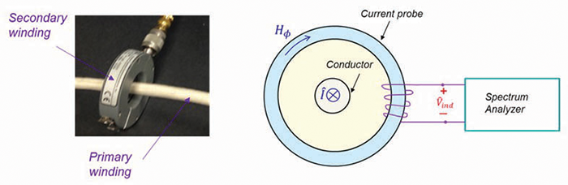

I

Imeasured

1. For 50 Hz current measurement, derive the relation between ‘I /Imeasured’ In terms of relevant parameters and constants, namely, A,r, μ, N. (2 mark)
2. Now, this arrangement is used to impart current on the input lines of the DUT (CS106). It required to impart sinusoidal the signal of 10A over the frequency band o 1 MHz to 30 MHz Describe the experimental set up and the values of parameters.

(1mark)

1. Now, the same arrangement is used to impart 30nS, 5A current pulse on the input lines of the DUT (CS115). What is the minimum band width of the transformer?

(1 mark)

1. Agilent power supply (model 6643-A) provides a 24 V/3.5A (it can supply 0 to 3.5 AMP in CV mode) supply with source resistance of 0.4 Ω. The SMPS in the DUT generates CE noise of 110 dBμA @ 100 kHz.. For the DUT compliance to CE, this component is expected to be below 84 dBμA. This means the suppression of at least 26 dB is required. Design an inductor (differential filter/choke) to offer required suppression. You may plan a good margin and design for 40 dB suppression. Graphical data of commercially available cores is given.
2. Calculate Inductance

(ii) Calculate power handling and select a core

(iii) Estimate reduction in ‘μ’ from the B-H curve

(iv) Calculate number of turns.

(v) How many number of turns will it require if the inductor did not use any core?

(5 marks)



**(6H20)**

**Power handling capacity of the material**

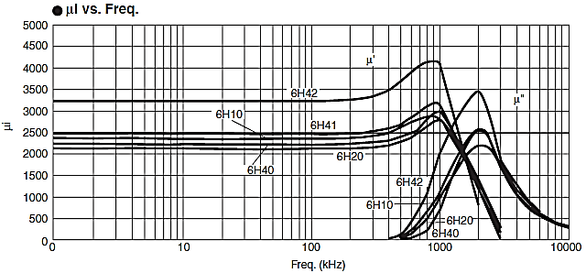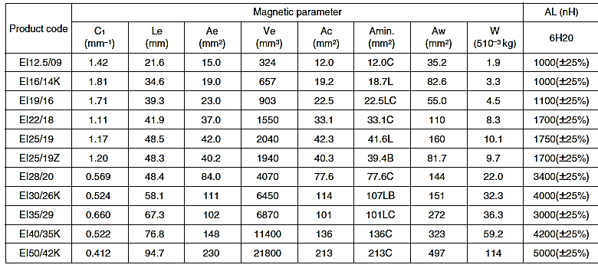

**Data of the available cores**

**Initial Permeability**

**Mid-Sem Exam EE 780-2019-1**

**Answers (and guidelines for the evaluation)**

**Q1 (a)** (Eq. 2.32, Lecture notes part-1)

ERP (dBW) = VdBμv + 20 log R + AF(dB) – 135

Also, 1 mV= 60 dBμV,

Therefore,

ERP (dBW) = 60 + 9.542 + 6 -135

= -59.4576 dBW = 1.133 μW≈ 1mW (1 Mark)

(Correct formula but for calculation mistake, deduct 0.5 marks)

(b) Both the routing options would lead to produce same electric field.

No preferred route with *Ec* considerations. (1 Mark)

**Justification:**

The relation between common mode current and *E* field produced

*Ec*α *I f d.* We are concerned with the proportionality of the length so we assume

*Ec* = k *d* (Length), where k is constant of proportionality.

For Route1: *Ec1* = Field due to vertical section + Field due to horizontal section

= 4 k +3k

Route2: *Ec1* = Field due to slant line

= 5k = 4 k +3k

Hence both the fields are identical. (1 Mark)

(Any equivalent treatment to show the fields are equal, may be given credit)

(c) Shield effectiveness due to the perforated sheets is given by (4.10 lecture notes-2) 

Substituting, wavelength at 2.45 GHz is (3 X 108)/(2.45 X 109= 0.1224m



Field on the outside= 60/50.16= 1.196 Vm-1. (1 mark)

(d) The inductance of the strip is given by the following expression. (5.6), lecture notes)





= 0.002 X 2000 (7.46114 +0.5+0.000257)= 31.845588 μH. (1 mark)

Q2. (a) (Fig 1.6 – Lecture notes) (1 mark)

 = 0.69dB.m-1.

🡺  Naper.m-1

=1.3097 dBm-1. (1 mark)

(c) The conducting loss remains constant.

The dielectric loss is directly proportional to frequency.

🡺 Therefore, both the losses will equal when αd is reduced by a factor of (0.08/ 0.150796≈0.53051). Considering that it is proportional to frequency,

We get that value at 1 GHz X 0.53051= 530.512MHz (1 mark)

(d) Total loss αc+ αd= 0.69 + 1.3097=1.9997dB @ 1GHz, 1 meter.

Both the losses linearly increae with distance, so 3 dB loss is observed at ≈1.5 m

(e) Yes it can be considered as a low pass filter. (1 mark)

However the attenuation increases exponentially as the frequency. The fall in amplitude is described as ‘dB/m’ as seen in earlier examples.

However, for a given length, conduction length is constant and the dielectric loss is proportional to frequency. So if the frequency is increased by 10, the loss increases @ 10 napers/ decade OR ‘86.85 dB per decade’. (1 mark)

Q3. (a) The main motive of the EMC detectors is to estimate “Nuisance Potential” of the emissions from the DUT. In this context, it is assumed that high peak value at low repetition rate has comparable nascence-value lower peaks at higher repetition rate. This can be weighed using a ‘. lossy detector’. It can be seen that lossy detector discharges to lesser value if the periodicity of the peaks is low.

The exact ‘trade-off’ of this comparison is achieved by the calibration criterion.

This criterion, required that the QP value to equal the RMS value for a sinusoidal signal input. (1 mark)

(b) Following diagram shows the Q-P discharge curve for sinusoidal waveform. (Blue-dotted line)

This lines discharges to level ‘l’ so that the average is peak value is ‘0.707 times the peak’.

Assuming linear discharge curve, we see that the lowest point is 0.414 times the peak. (1 mark)

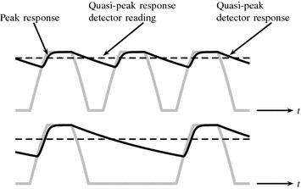

This will be reached in 0.88 of the (Q=P diode time constant, as (≈ e-0.88). (1mark)

Therefore, the time constant works out to be ≈‘0.928 X T’. Where T is the period of the sinusoidal waveform (=1/*fcalibrtion )*  (1 mark)

1. If the frequency is 0.9 times, the discharge value will be lower by (1/0.9 times, linear approximation so calibration) so factor will be Multiply by (1/ 0.9)

(0.5 Marks)

Similarly, If the frequency is 1.1 times, the discharge value will be higher by (1/1.1 times, linear approximation) so calibration factor will be Multiply by (1/1.1) (0.5 mark)

Q4. (a) We compute the flux density in the core

 and Induced voltage (1 Mark)

The time derivation of sinusoid signal is a sinusoid, multiplied by ω. (assuming impedance=50Ω)

 🡺  (1 Mark)

Flux equating attempt using transformer model will lead to ratio of N (simply) (0.5 Marks)

1. By reciprocity, it is possible to induce the current in the core winding/ measurement port.

(The assumption is that the core supports frequencies up to 30 MHz. (1 Mark)

1. For imparting 30nS pulse, approximately (1/ 30 X10-9) Hz bandwidth is required.

🡺 33.333 MHz. (1 Mark)

(d) The suppression by 40 dB would require the inductor impedance 99 times the source impedance. (can be easily seen that the suppression = Rsource/ Rind + Rsource. 🡺 3.96 ohms

Now putting *jωl*= 3.96Ω. 🡺 6.3 μH (1 Mark)

Power handling is= 0.5 *LI2X2f*🡺 {(6.3 X 10-6 X 12.25)/ 2} X 2 X 105= 7.7175 Watts.

We select flux density of 200 mT. One could select any flux density (Generally select higher than central value of the flux range) It is 450kWm-3 Sop for our requirement, 🡺

From the power handling capacity of the core material, we get the core volume of 17.15 cm3

= (17,150 mm3)

We select **EI 50/42K w**ith volume of 21800 mm3  ………….(1 mark)

Ae= 230mm2 and length is 94.7 mm.

From the B-H curve, it appears that the slope at 200 mT is approximately 4 times lesser than the initial value (μi) 2100 (for 6H20). Considering this de-rating, we take a rounded up figure of 500. So for our equation, μr= 500. (1 mark)

This is important to de-rate, as that the 100 kHz noise will appear with current ( and hence Flux) bias.

The inductor value= (6.3 x 10-6= N2X1.257 X 10-6 X 500 X 230 X 10-6)/ 0.0947

N2= 4.09 🡺 2 turns !

(1 mark)

If no core was used, (μr) the value of N2 will be 4.09 X 500= 2045🡺 N= 45.22≈45. (1 mark)

----------- X----

**Some comments**

The actual value of the inductor value will depend on, μr

As an example, for full current of 3.5 A, the Magnetic field strength/ intensity (H) is = (3.5 X 2)/ 0.0947=

73 Am-1. Which actually occurs at 350-400 mT and the μr falls additionally by a factor around 4.5.

(Main fact is that the core does not saturate!!)

This will make the value of inductance lower and hence suppression lower by 13 dB. Here the margin comes for help.

Lower load currents are safe anyway!