**EE 875: Quiz-1**

**11th Feb 2020 Max marks: 10**

**Make convenient assumptions (if required) and state them**

**Free space Permeability** =***μ0***- 1.2566 X 10-6 Wb.A-1m-1.

**Free space Permittivity**= **ε0-** 8.85418 X 10-12 m-3 kg-1 s4 A2

**Q** 1 Four options provided for each question. Select one (or more) correct/ nearest answer(s) **Explanations justifying your answers MUST be given to earn credit/ marks**

1. Electrostatic Static Discharge (ESD) test involves discharging high voltage (± 2 to 15 kV) through 150pf/ 330Ω network on equipment under test (EUT) using a pointed probe. This test is categorized as.
2. Conducted Emission (CE) (b) Conducted Susceptibility (CS)

(c) Radiated Emission (RE) (d) Radiated Susceptibility (RS) … (1 mark)

1. Sound intensity of 80 dB correspond to the “Sound Pressure Level (SPL )” of
2. 0.2 N.m-2 (b) 500 μPa (c)2000 N. m-2 (d)500mPa … (1 mark)
3. An antenna with parabolic reflector of effective area (*Ae*)= 1m2, and operating at 1 GHz has antenna factor (@1 GHz) of X dBm-1; X= ?
4. 9.739 (b) 2.746 (c) 4.386 (d) 8.773 … (1 mark)
5. The antenna mentioned in (iii) has operating bandwidth 0.5 GHz to 3 GHz. Its gain at 2 GHz is 558.5 (27.4dB), and the antenna factor at 2 GHz is Y m-1; Y= ..?
6. 9.739 (b) 2.746 (c) 4.386 (d) 8.773 … (1 mark)

(v) Differential mode signal current of 1mA is flowing through parallel wires of length 10cm places separated by 5mm. At a distance of 3m, this signal produces electric field of 2.19μV.m-1. What is the frequency of the signal?

(a)3.33MHz (b) 10 MHz (c)33.3 MHz (d)100MHz (1 mark)

Q2. Write one or two line answers/ comments for the following questions.

(i) Radiated Susceptibility (RS) tests that require high field, are done in TEM cells or parallel place chambers because it has advantage over EM field generation using antennas. Comment on this statement in the context of (a) Far-distance EM field generation. (b) High strength field generation.

(2 marks)

(ii) The concept diagram of non- mechanical pump is given in following figure.

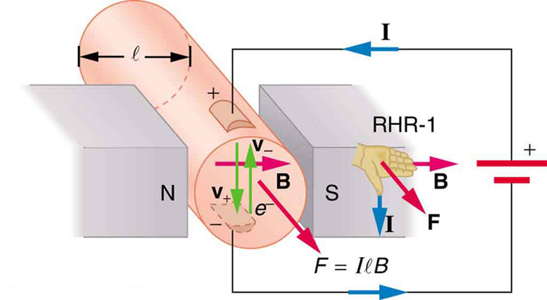

(a) If the diameter of the pipe (magnetic field interaction length) ‘**l** ‘ is 0.1m, The magnetic flux density (B) is 1 mTesla, and the current is 3.14 A. Find the force on the fluid. (0.5 Marks)

(b) If the magnet is replaced with Helmholtz coil, give the design parameters of that coil. (This means give the values of radius, the distance between coils, current and number of turns) (2 Marks)

)

Fluid

(c) From which source does the energy to pump the fluid come? Helmholtz coil circuit or electric circuit? (0.5 Marks)

**Answer and Instruction for correction**

**Q1:**

1. (b) The ESD test imparts charge on metal surface of the DUT. This results in Current on that surface. This action is imparting “conducted disturbance”. Hence is ‘Conducted susceptibility test. (In fact it is CS-118-X in MIL-STD 461 G) Correct Choice (0.5), Explanation (0.5)
2. (a) The expression for SPL 

SPL of 80 dB would require the ratio, SPL (Pa)/20 μPa= 104. (0.5 Marks)

Hence SPL = **0.2 Pa** OR 0.**2 Nm-2**. Correct Choice (0.5 marks)

1. (d) The , in this case, AF= 2.7459. (0.5 Marks)

Since, this is a ratio of signal strengths,

AF (dB) = 20 log (2.7459) = 8.779. Correct Choice (0.5 marks)

1. (b) The first statement tells that the antenna functions at 2 GHz.

The AF does depend only on the effective area, so the antenna factor is same as (iii) Same credit If a student calculates G and λ to reach the same conclusion (0.5 Marks) hence, AF = 2.746. Correct Choice (0.5 marks)

1. (c) The electric field due to differential mode current is 

With given value  (0.5 Marks)

Solving, we get *f=* 31.62 MHz. Correct Choice (0.5 marks)

Q2 (i) At far distance (or when EM waves travel far distance) the E wave **fronts are parallel**.

OR it is a **plane wave**. This is achieved in TEM cell as it is **waveguide structure**.

(0.5 Marks)

The EMC test set-ups have short distance between the antenna and the DUT.

The field imparted using antenna (s) has spherical wave-front. (0.5 marks)

(Any equivalent argument)

1. (a) *F=I* X *l* X *B*= 3.14 X0 1 X 10-3=3.14 X 10-4 *N*. (with the direction shown in the diagram)

(If any student writes about correct direction he may be given advantage elsewhere in the answer-sheet, if required!) (0.5 marks)

(b) Helmholtz coil design:

The distance between the coil**= 0.1 m**  (0.5 marks)

The radius of the coil is = 0.1 m (should be equal to the distance between the coils), to get B=1 mT

(0.5 marks)

Substituting these values in we have *I* x *N*=111.18 Ampere-turns; 🡺

Keeping the current same as electrin circuit, (3.14A), N=35.4 ≈ 35 turns! any combination is OK,

(e.g 1A& 111.18 ≈111. Turns, 10A& 11.118 ≈11 Turns) (0.5x2=1 mark)

(c) The energy is supplied by **electrical circuit**. As the movement is perpendicular to B, No work is done by the magnetic field!! (0.5 marks)