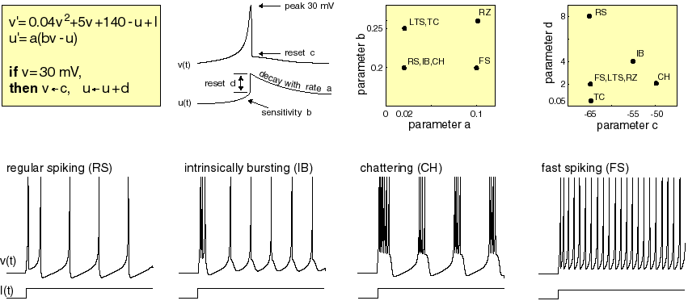

See the code in the same folder. Essentially, we use the Izhikevich parameters to show the dynamics. The dynamics in (u,v) space presents an intuitive picture.

Chattering neurons time dynamics is also shown as evolution in (u,v) space;
Regular spiking neurons time dynamics vs. trajectory in the (u,v) space.

Question:
1. Can you intuitively describe the (u,v) dynamics corresponding to the v(t) dynamics? How does it relate to inter-spike-interval (ISI) time?
2. Based on this behavior, can we design the parameters for the various other neuronal dynamics. The RZ is probably th2e most tricky on first guess.

