**Employee Attrition Prediction**

What is employee attrition?

* According to the definition, employee attrition is the loss of employees through a natural process, such as retirement, resignation, elimination of a position, personal health, or other similar reasons.

What is the cost of employee attrition?

* Between costs associated with separation, loss of productivity, recruitment, interviewing, training, and onboarding, the loss of a single employee is estimated to cost businesses 50% of that individual’s annual salary

Why Do We Learn This?

* Average cost of losing an employee is a staggering 33% of their annual salary
* 21.5% of employees that don’t feel recognized when they do great work have interviewed for a job in the last three months
* Employees are 23% more likely to stay if their manager clearly explains their roles and responsibilities
* Employees who say there’s a low level of respect between colleagues are 26% more likely to quit their jobs
* Employees who are committed and engaged at work perform 20% better and are 87% less likely to leave their current company

**AI PROJECT CYCLE**

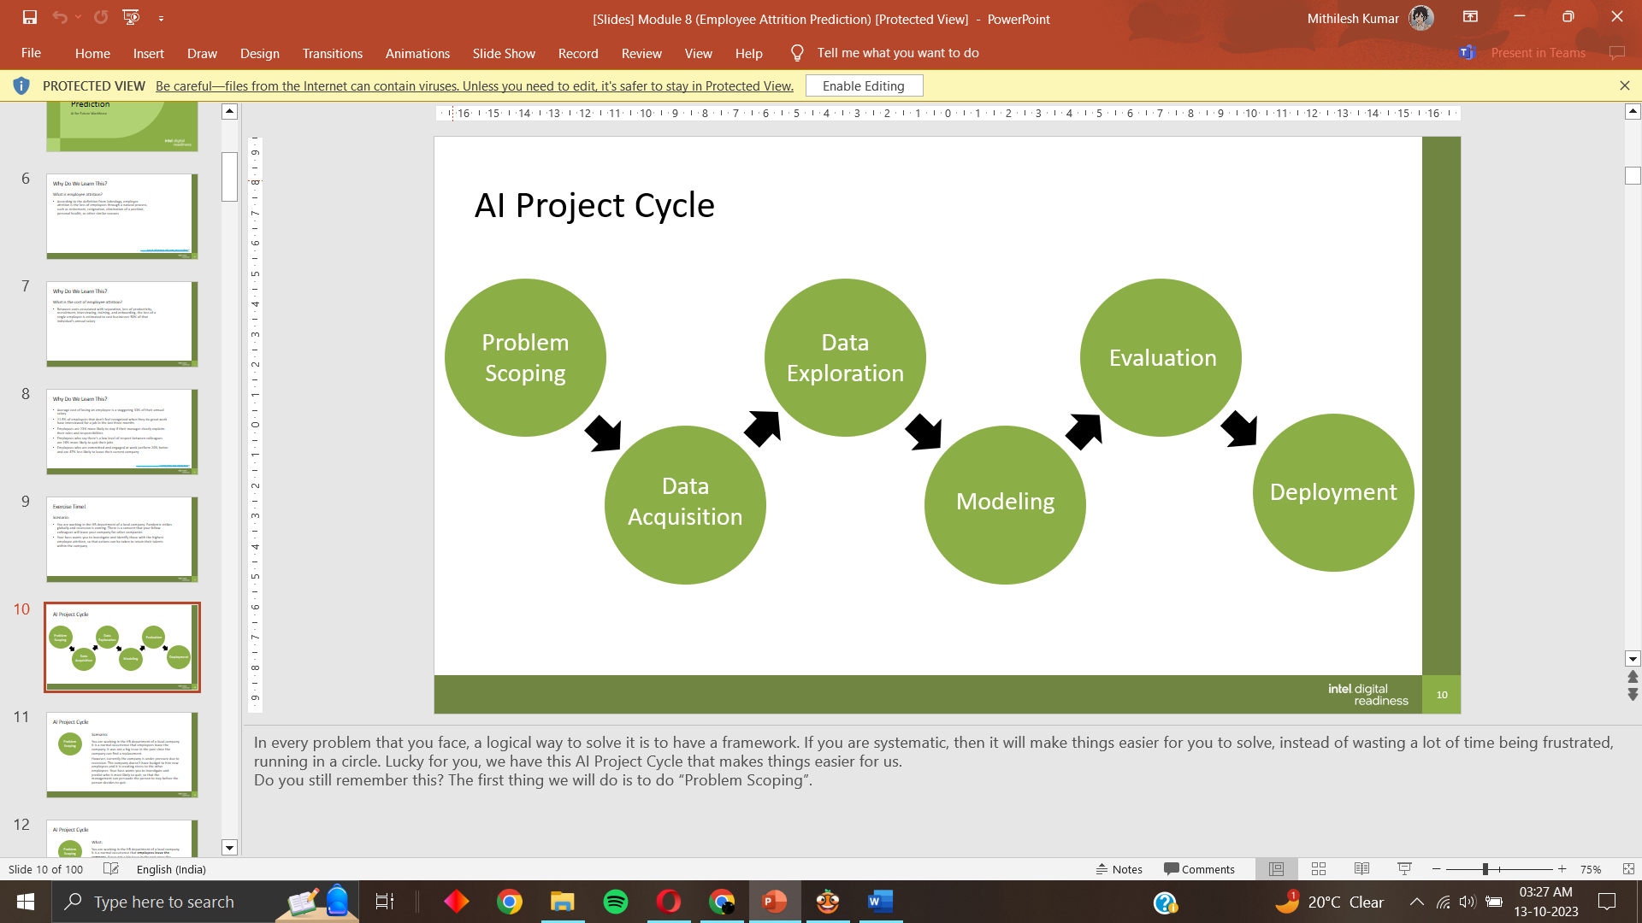

**Steps involved throughout data mining in Orange**

