WHOLESALE MANAGEMENT SYSTEM

Submitted by

**Bajaj Devesh Kamal(15BCE0553)**

Prepared For

**DATABASE MANAGEMENT SYSTEMS (CSE2004)**

**PROJECT COMPONENT**

Submitted To

**Faculty name**

**Janani T**

**School of Computer Science and Engineering**



Table of Contents

1. Introduction 3

2. User Requirements. 3

3. Project Scope 3

4. Preliminary design 3

5. ER Diagram 4

6. Table and Constrain 5

7. Frontend 5

9. Work break down 5

8. Review Evaluation 5

# Introduction

1. Wholesale suppliers need to be able to handle multiple orders in varying configurations. They have to keep track of a lot of information, like wave-based distribution, vendor management, and catalogues. Making mistakes costs you customers, and the challenge is clear. You need a good software system that is able to be customized to your unique parameters and adapt as your business continues to grow Maintain the details of stock like their id, name, quantity
2. Maintain the details of buyers from which manager has to buy stock like buyer id, name, address, stock id to be boughtdetails of customers i.e. name

# User Requirements

* Maintain the details of stock like their id, name, quantity
* Maintain the details of buyers from which manager has to buy stock like buyer id, name, address, stock id to be bought
* details of customers i.e. name, address, id
* defaulters list of customers who has not paid their pending amount
* list of payment paid or pending
* stock that is to be buy if quantity goes less than a particular amount.
* Profit calculation for a month.
* Quantity cannot be sold to a customer if required amount is not present in stock and date of delivery should be maintained up to which stock can be provided.

# Project SCOPE

**Wholesalers** buy goods directly from the manufacturers in bulk and sell them in large quantities to retailers, distributors, smaller sellers and even consumers. **Wholesale** buying has various **advantages** and disadvantages. Lower costs. ... This saves traders time because they are buying **wholesale** from a single location

* defaulters list of customers who has not paid their pending amount
* list of payment paid or pending
* stock that is to be buy if quantity goes less than a particular amount.
* Profit calculation for a month.

Quantity cannot be sold to a customer if required amount is not present in stock and date of delivery should be maintained up to which stock can be provided

# Project Resource Requirements

## Software Resurce Requirements

* Windows 8.1
* Python 3.4
* MySQL 5.7l
* mysql-connector-python-2.1.3-py3.4-winx64.msiNetBeans (IDE)
* PyQt5-5.4.1-gpl-Py3.4-Qt5.4.1-x64 (Qt designer for frontend)

# ER Diagram

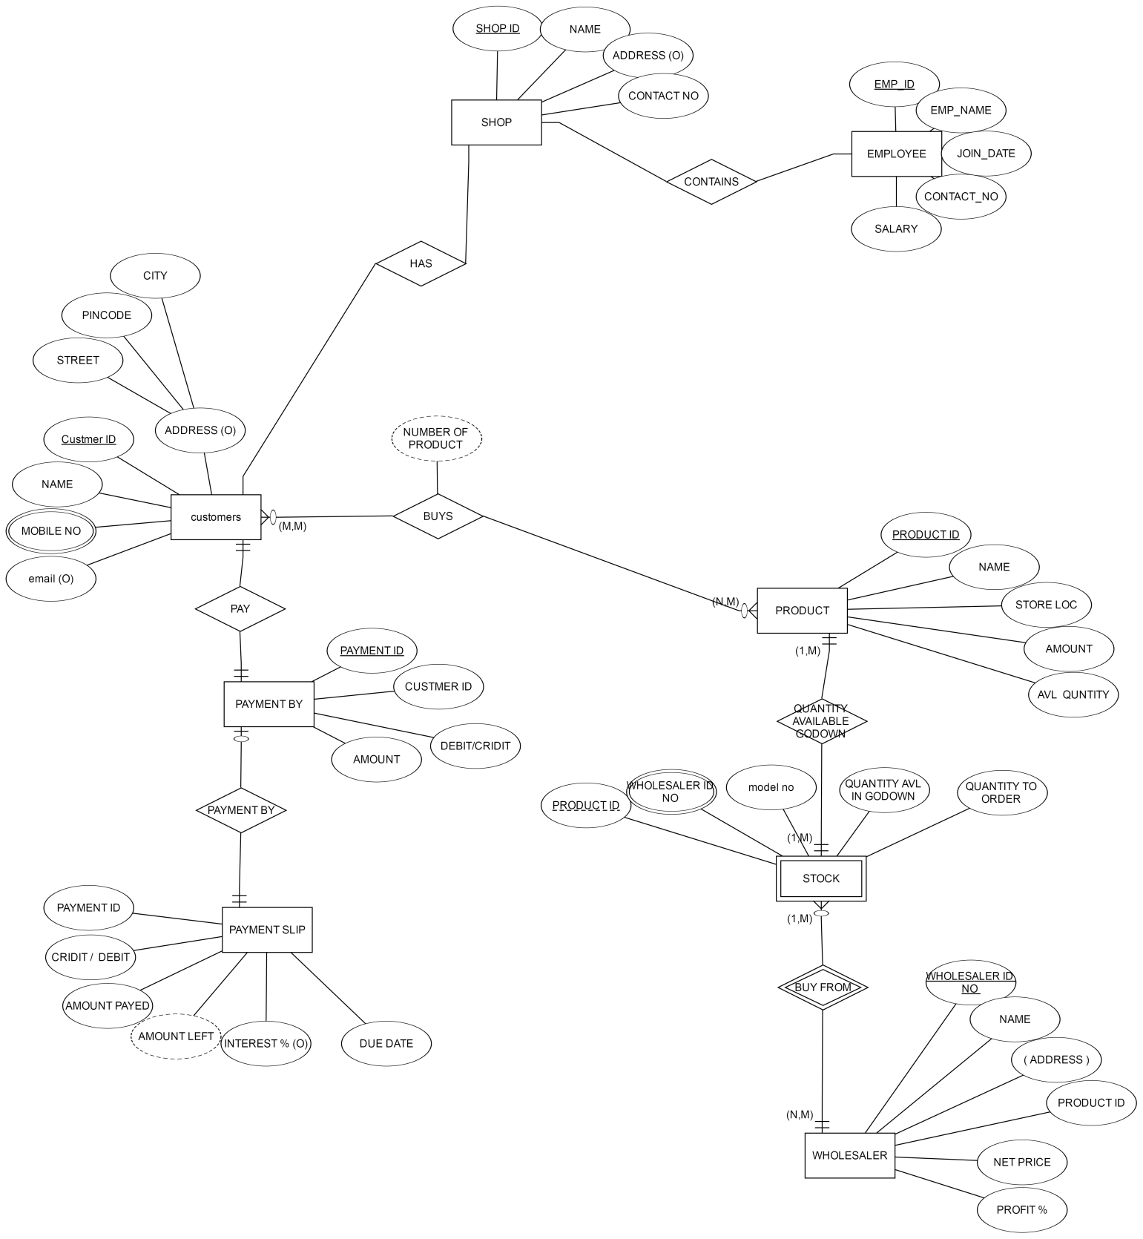

**Schema**

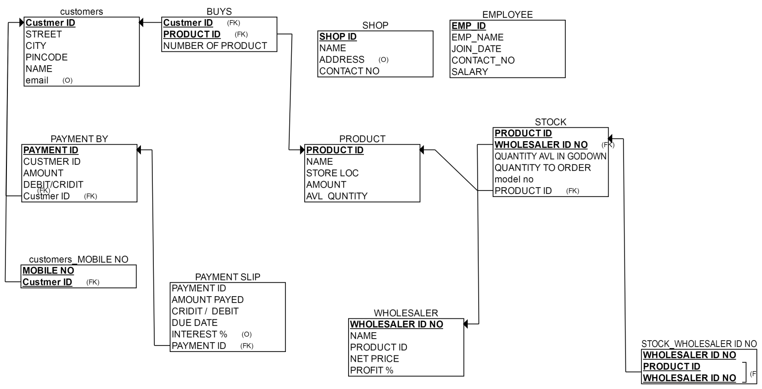

# Tables and Constraints

+---------------------------------------+

| Tables_in_wholesale_management_system |

+---------------------------------------+

| buys |

| customer |

| customer_adress |

| employee |

| payment |

| payment_slip |

| product |

| stock |

| wholesaler |

+---------------------------------------+

9 rows in set (0.03 sec)

mysql> desc buys;

+------------+---------+------+-----+---------+-------+

| Field | Type | Null | Key | Default | Extra |

+------------+---------+------+-----+---------+-------+

| no_product | int(11) | YES | | NULL | |

+------------+---------+------+-----+---------+-------+

1 row in set (0.69 sec)

mysql> desc customer;

+------------+--------------+------+-----+---------+-------+

| Field | Type | Null | Key | Default | Extra |

+------------+--------------+------+-----+---------+-------+

| custmer_id | int(11) | NO | PRI | NULL | |

| Name | varchar(255) | NO | | NULL | |

| email |varchar(255) | YES | | NULL | |

| mobile_no | int(10) | YES | | NULL | |

+------------+--------------+------+-----+---------+-------+

4 rows in set (0.03 sec)

mysql> desc customer_adress;

+------------+--------------+------+-----+---------+-------+

| Field | Type | Null |Key | Default | Extra |

+------------+--------------+------+-----+---------+-------+

| custmer_id | int(11) | YES | MUL | NULL | |

| street | varchar(255) | YES | | NULL | |

| city | varchar(255) | YES | | NULL | |

| pincode | int(6) | YES | | NULL | |

+------------+--------------+------+-----+---------+-------+

4 rows in set (0.04 sec)

mysql> desc employee;

+-------------+--------------+------+-----+---------+-------+

| Field | Type | Null | Key | Default | Extra |

+-------------+--------------+------+-----+---------+-------+

| employee_id | int(11) | NO | PRI | NULL | |

| Name | varchar(255) | NO | | NULL | |

| join_date | date | YES | | NULL | |

| mobile_no | int(10) | YES | | NULL | |

| salary | int(10) | YES | | NULL | |

+-------------+--------------+------+-----+---------+-------+

5 rows in set (0.06 sec)

mysql> desc payment;

+-------------+------------+------+-----+---------+-------+

| Field | Type | Null | Key | Default | Extra |

+-------------+------------+------+-----+---------+-------+

| custmeer_id | int(11) | YES | MUL | NULL | |

| payment_id | int(11) | NO | PRI | NULL | |

| amount | int(11) | YES | | NULL | |

| method | varchar | YES | | NULL | |

+-------------+------------+------+-----+---------+-------+

4 rows in set (0.03 sec)

mysql> desc payment_slip;

+--------------+---------+------+-----+---------+-------+

| Field | Type | Null | Key | Default | Extra |

+--------------+---------+------+-----+---------+-------+

| payment_id | int(11) | YES | MUL | NULL | |

| amount_payed | int(11) | NO | | NULL | |

| due_date | date | YES | | NULL | |

| intrest | int(3) | YES | | NULL | |

+--------------+---------+------+-----+---------+-------+

4 rows in set (0.24 sec)

mysql> desc product;

+--------------+--------------+------+-----+---------+-------+

| Field | Type | Null | Key | Default | Extra |

+--------------+--------------+------+-----+---------+-------+

| product_id | int(11) | NO | PRI | NULL | |

| Name | varchar(255) | NO | | NULL | |

| store_loc | int(10) | YES | | NULL | |

| avl_quantity | int(10) | YES | | NULL | |

+--------------+--------------+------+-----+---------+-------+

4 rows in set (0.00 sec)

mysql> desc stock;

+---------------------+---------+------+-----+---------+-------+

| Field | Type | Null | Key | Default | Extra |

+---------------------+---------+------+-----+---------+-------+

| avl_quantity_godown | int(10) | YES | | NULL | |

| quantity_to_order | int(10) | YES | | NULL | |

| model_no | int(10) | YES | | NULL | |

| product_id | int(11) | YES | | NULL | |

+---------------------+---------+------+-----+---------+-------+

4 rows in set (0.04 sec)

mysql> desc wholesaler;

+---------------+--------------+------+-----+---------+-------+

| Field | Type | Null | Key | Default | Extra |

+---------------+--------------+------+-----+---------+-------+

| wholesaler_id | int(11) | NO | PRI | NULL | |

| Name | varchar(255) | NO | | NULL | |

| product_id | int(11) | YES | | NULL | |

| netprice | int(10) | YES | | NULL | |

| profit | int(3) | YES | | NULL | |

+---------------+--------------+------+-----+---------+-------+

5 rows in set (0.00 sec)

**FRONTEND**

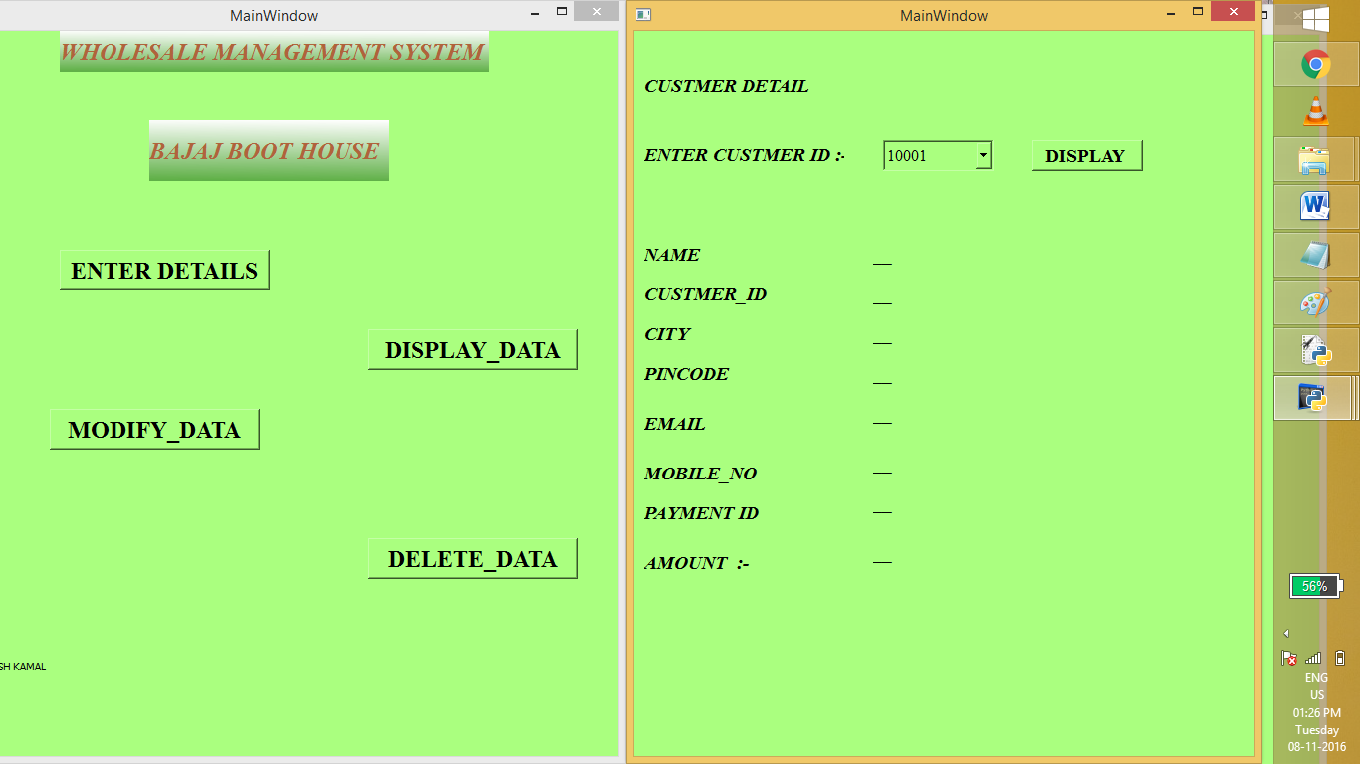

# TEAM DETAILS

|  |  |  |  |
| --- | --- | --- | --- |
| **Team Number** | **Name** | **Registration Number** | **Phone Number** |
| T3 | BAJAJ DEVESH KAMAL | 15BCE0553 | 9790545548 |

# Work break down

|  |  |  |
| --- | --- | --- |
| **Team Member Registration Number** | **Name** | **Work Assigned** |
| 15BCE0553 | BAJAJ DEVESH KAMAL | TOTAL WORK |

# REVIEW EVALUATION

|  |  |  |
| --- | --- | --- |
| COMPONENT | MARKS | MEMBER 1 |
| USER REQ. AND SCOPE | 5 |  |
| PRELIMINARY DESIGN | 5 |  |
| ER DIAGRAM | 5 |  |
| PRESENTATION | 5 |  |
| TOTAL | 20 MARKS |  |