MCP Inspector
https://modelcontextprotocol.io/docs/2026-07-28/tools/inspector#remote-http-server

Interactive developer tooling for testing and debugging MCP servers, in the browser, on the command line, and in the terminal
npx @modelcontextprotocol/inspector

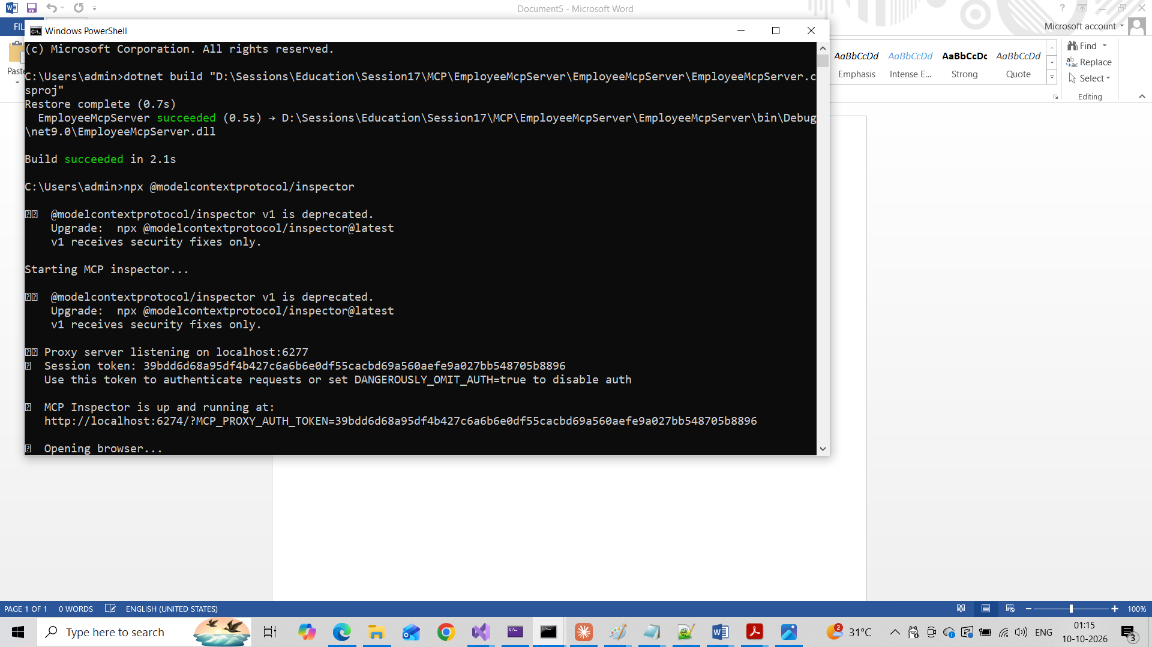

C:\Users\admin>npx @modelcontextprotocol/inspector

⚠️ @modelcontextprotocol/inspector v1 is deprecated.
Upgrade: npx @modelcontextprotocol/inspector@latest
v1 receives security fixes only.

Starting MCP inspector...

⚠️ @modelcontextprotocol/inspector v1 is deprecated.
Upgrade: npx @modelcontextprotocol/inspector@latest
v1 receives security fixes only.

⚙️ Proxy server listening on localhost:6277
🔑 Session token: 39bdd6d68a95df4b427c6a6b6e0df55cacbd69a560aefe9a027bb548705b8896
Use this token to authenticate requests or set DANGEROUSLY_OMIT_AUTH=true to disable auth

🚀 MCP Inspector is up and running at:
http://localhost:6274/?MCP_PROXY_AUTH_TOKEN=39bdd6d68a95df4b427c6a6b6e0df55cacbd69a560aefe9a027bb548705b8896

🌐 Opening browser...
New STDIO connection request
Query parameters: {"command":"C:\\Program Files\\dotnet\\dotnet.exe","args":"run --project D:\\\\Sessions\\\\Education\\\\Session17\\\\MCP\\\\EmployeeMcpServer\\\\EmployeeMcpServer\\\\EmployeeMcpServer.csproj","env":"{\"APPDATA\":\"C:\\\\Users\\\\admin\\\\AppData\\\\Roaming\",\"HOMEDRIVE\":\"C:\",\"HOMEPATH\":\"\\\\Users\\\\admin\",\"LOCALAPPDATA\":\"C:\\\\Users\\\\admin\\\\AppData\\\\Local\",\"PATH\":\"C:\\\\Users\\\\admin\\\\AppData\\\\Local\\\\npm-cache\\\\_npx\\\\5a9d879542beca3a\\\\node_modules\\\\.bin;C:\\\\Users\\\\admin\\\\node_modules\\\\.bin;C:\\\\Users\\\\node_modules\\\\.bin;C:\\\\node_modules\\\\.bin;C:\\\\Program Files\\\\nodejs\\\\node_modules\\\\npm\\\\node_modules\\\\@npmcli\\\\run-script\\\\lib\\\\node-gyp-bin;C:\\\\Windows\\\\system32;C:\\\\Windows;C:\\\\Windows\\\\System32\\\\Wbem;C:\\\\Windows\\\\System32\\\\WindowsPowerShell\\\\v1.0\\\\;C:\\\\Windows\\\\System32\\\\OpenSSH\\\\;C:\\\\Program Files\\\\Microsoft SQL Server\\\\150\\\\Tools\\\\Binn\\\\;C:\\\\Program Files\\\\Microsoft SQL Server\\\\Client SDK\\\\ODBC\\\\170\\\\Tools\\\\Binn\\\\;C:\\\\Program Files\\\\dotnet\\\\;C:\\\\Program Files\\\\nodejs\\\\;C:\\\\Program Files\\\\Git\\\\cmd;C:\\\\Program Files\\\\WSL\\\\;C:\\\\Program Files\\\\Docker\\\\Docker\\\\resources\\\\bin;C:\\\\Users\\\\admin\\\\AppData\\\\Local\\\\Programs\\\\Python\\\\Python313\\\\Scripts\\\\;C:\\\\Users\\\\admin\\\\AppData\\\\Local\\\\Programs\\\\Python\\\\Python313\\\\;C:\\\\Users\\\\admin\\\\AppData\\\\Local\\\\Microsoft\\\\WindowsApps;C:\\\\Users\\\\admin\\\\.dotnet\\\\tools;C:\\\\Users\\\\admin\\\\AppData\\\\Roaming\\\\npm;C:\\\\Users\\\\admin\\\\AppData\\\\Local\\\\Programs\\\\Microsoft VS Code\\\\bin;C:\\\\Users\\\\admin\\\\.lmstudio\\\\bin;C:\\\\Users\\\\admin\\\\AppData\\\\Local\\\\Programs\\\\Ollama;C:\\\\Users\\\\admin\\\\AppData\\\\Local\\\\Python\\\\bin;C:\\\\Users\\\\admin\\\\AppData\\\\Local\\\\Programs\\\\cursor\\\\resources\\\\app\\\\bin;C:\\\\Users\\\\admin\\\\AppData\\\\Local\\\\Programs\\\\Antigravity\\\\bin\",\"PROCESSOR_ARCHITECTURE\":\"AMD64\",\"SYSTEMDRIVE\":\"C:\",\"SYSTEMROOT\":\"C:\\\\Windows\",\"TEMP\":\"C:\\\\Users\\\\admin\\\\AppData\\\\Local\\\\Temp\",\"USERNAME\":\"admin\",\"USERPROFILE\":\"C:\\\\Users\\\\admin\",\"PROGRAMFILES\":\"C:\\\\Program Files\"}","transportType":"stdio"}
STDIO transport: command=C:\Program Files\dotnet\dotnet.exe, args=run,--project,D:\Sessions\Education\Session17\MCP\EmployeeMcpServer\EmployeeMcpServer\EmployeeMcpServer.csproj
Created client transport
Created server transport
Received POST message for sessionId 3f6c083c-1f2e-4077-81ef-6ea088b79e1b
Received POST message for sessionId 3f6c083c-1f2e-4077-81ef-6ea088b79e1b
Received POST message for sessionId 3f6c083c-1f2e-4077-81ef-6ea088b79e1b
Received POST message for sessionId 3f6c083c-1f2e-4077-81ef-6ea088b79e1b
Received POST message for sessionId 3f6c083c-1f2e-4077-81ef-6ea088b79e1b
file:///C:/Users/admin/AppData/Local/npm-cache/_npx/5a9d879542beca3a/node_modules/@modelcontextprotocol/sdk/dist/esm/server/sse.js:152
throw new Error('Not connected');
^

Error: Not connected
at SSEServerTransport.send (file:///C:/Users/admin/AppData/Local/npm-cache/_npx/5a9d879542beca3a/node_modules/@modelcontextprotocol/sdk/dist/esm/server/sse.js:152:19)
at PassThrough.<anonymous> (file:///C:/Users/admin/AppData/Local/npm-cache/_npx/5a9d879542beca3a/node_modules/@modelcontextprotocol/inspector/server/build/index.js:578:33)
at PassThrough.emit (node:events:518:28)
at addChunk (node:internal/streams/readable:561:12)
at readableAddChunkPushByteMode (node:internal/streams/readable:512:3)
at Readable.push (node:internal/streams/readable:392:5)
at node:internal/streams/transform:178:12
at PassThrough._transform (node:internal/streams/passthrough:46:3)
at Transform._write (node:internal/streams/transform:171:8)
at writeOrBuffer (node:internal/streams/writable:572:12)

Node.js v22.17.1

⚠️ @modelcontextprotocol/inspector v1 is deprecated.
Upgrade: npx @modelcontextprotocol/inspector@latest
v1 receives security fixes only.

Starting MCP inspector...

⚠️ @modelcontextprotocol/inspector v1 is deprecated.
Upgrade: npx @modelcontextprotocol/inspector@latest
v1 receives security fixes only.

⚙️ Proxy server listening on localhost:6277
🔑 Session token: e888b014536daa125556609e9b465733e8041c92e9d63695fdb48d1a589cb33e
Use this token to authenticate requests or set DANGEROUSLY_OMIT_AUTH=true to disable auth

🚀 MCP Inspector is up and running at:
http://localhost:6274/?MCP_PROXY_AUTH_TOKEN=e888b014536daa125556609e9b465733e8041c92e9d63695fdb48d1a589cb33e

🌐 Opening browser...
New STDIO connection request
Query parameters: {"command":"C:\\Program Files\\dotnet\\dotnet.exe","args":"run --project D:\\\\Sessions\\\\Education\\\\Session17\\\\MCP\\\\EmployeeMcpServer\\\\EmployeeMcpServer\\\\EmployeeMcpServer.csproj","env":"{\"APPDATA\":\"C:\\\\Users\\\\admin\\\\AppData\\\\Roaming\",\"HOMEDRIVE\":\"C:\",\"HOMEPATH\":\"\\\\Users\\\\admin\",\"LOCALAPPDATA\":\"C:\\\\Users\\\\admin\\\\AppData\\\\Local\",\"PATH\":\"C:\\\\Users\\\\admin\\\\AppData\\\\Local\\\\npm-cache\\\\_npx\\\\5a9d879542beca3a\\\\node_modules\\\\.bin;C:\\\\Users\\\\admin\\\\node_modules\\\\.bin;C:\\\\Users\\\\node_modules\\\\.bin;C:\\\\node_modules\\\\.bin;C:\\\\Program Files\\\\nodejs\\\\node_modules\\\\npm\\\\node_modules\\\\@npmcli\\\\run-script\\\\lib\\\\node-gyp-bin;C:\\\\Windows\\\\system32;C:\\\\Windows;C:\\\\Windows\\\\System32\\\\Wbem;C:\\\\Windows\\\\System32\\\\WindowsPowerShell\\\\v1.0\\\\;C:\\\\Windows\\\\System32\\\\OpenSSH\\\\;C:\\\\Program Files\\\\Microsoft SQL Server\\\\150\\\\Tools\\\\Binn\\\\;C:\\\\Program Files\\\\Microsoft SQL Server\\\\Client SDK\\\\ODBC\\\\170\\\\Tools\\\\Binn\\\\;C:\\\\Program Files\\\\dotnet\\\\;C:\\\\Program Files\\\\nodejs\\\\;C:\\\\Program Files\\\\Git\\\\cmd;C:\\\\Program Files\\\\WSL\\\\;C:\\\\Program Files\\\\Docker\\\\Docker\\\\resources\\\\bin;C:\\\\Users\\\\admin\\\\AppData\\\\Local\\\\Programs\\\\Python\\\\Python313\\\\Scripts\\\\;C:\\\\Users\\\\admin\\\\AppData\\\\Local\\\\Programs\\\\Python\\\\Python313\\\\;C:\\\\Users\\\\admin\\\\AppData\\\\Local\\\\Microsoft\\\\WindowsApps;C:\\\\Users\\\\admin\\\\.dotnet\\\\tools;C:\\\\Users\\\\admin\\\\AppData\\\\Roaming\\\\npm;C:\\\\Users\\\\admin\\\\AppData\\\\Local\\\\Programs\\\\Microsoft VS Code\\\\bin;C:\\\\Users\\\\admin\\\\.lmstudio\\\\bin;C:\\\\Users\\\\admin\\\\AppData\\\\Local\\\\Programs\\\\Ollama;C:\\\\Users\\\\admin\\\\AppData\\\\Local\\\\Python\\\\bin;C:\\\\Users\\\\admin\\\\AppData\\\\Local\\\\Programs\\\\cursor\\\\resources\\\\app\\\\bin;C:\\\\Users\\\\admin\\\\AppData\\\\Local\\\\Programs\\\\Antigravity\\\\bin\",\"PROCESSOR_ARCHITECTURE\":\"AMD64\",\"SYSTEMDRIVE\":\"C:\",\"SYSTEMROOT\":\"C:\\\\Windows\",\"TEMP\":\"C:\\\\Users\\\\admin\\\\AppData\\\\Local\\\\Temp\",\"USERNAME\":\"admin\",\"USERPROFILE\":\"C:\\\\Users\\\\admin\",\"PROGRAMFILES\":\"C:\\\\Program Files\"}","transportType":"stdio"}
STDIO transport: command=C:\Program Files\dotnet\dotnet.exe, args=run,--project,D:\Sessions\Education\Session17\MCP\EmployeeMcpServer\EmployeeMcpServer\EmployeeMcpServer.csproj
Created client transport
Created server transport
Received POST message for sessionId 6d114cc6-b12e-4da5-9b05-474fed559ca7
Received POST message for sessionId 6d114cc6-b12e-4da5-9b05-474fed559ca7
Received POST message for sessionId 6d114cc6-b12e-4da5-9b05-474fed559ca7
Received POST message for sessionId 6d114cc6-b12e-4da5-9b05-474fed559ca7

Claude

MCP inspector

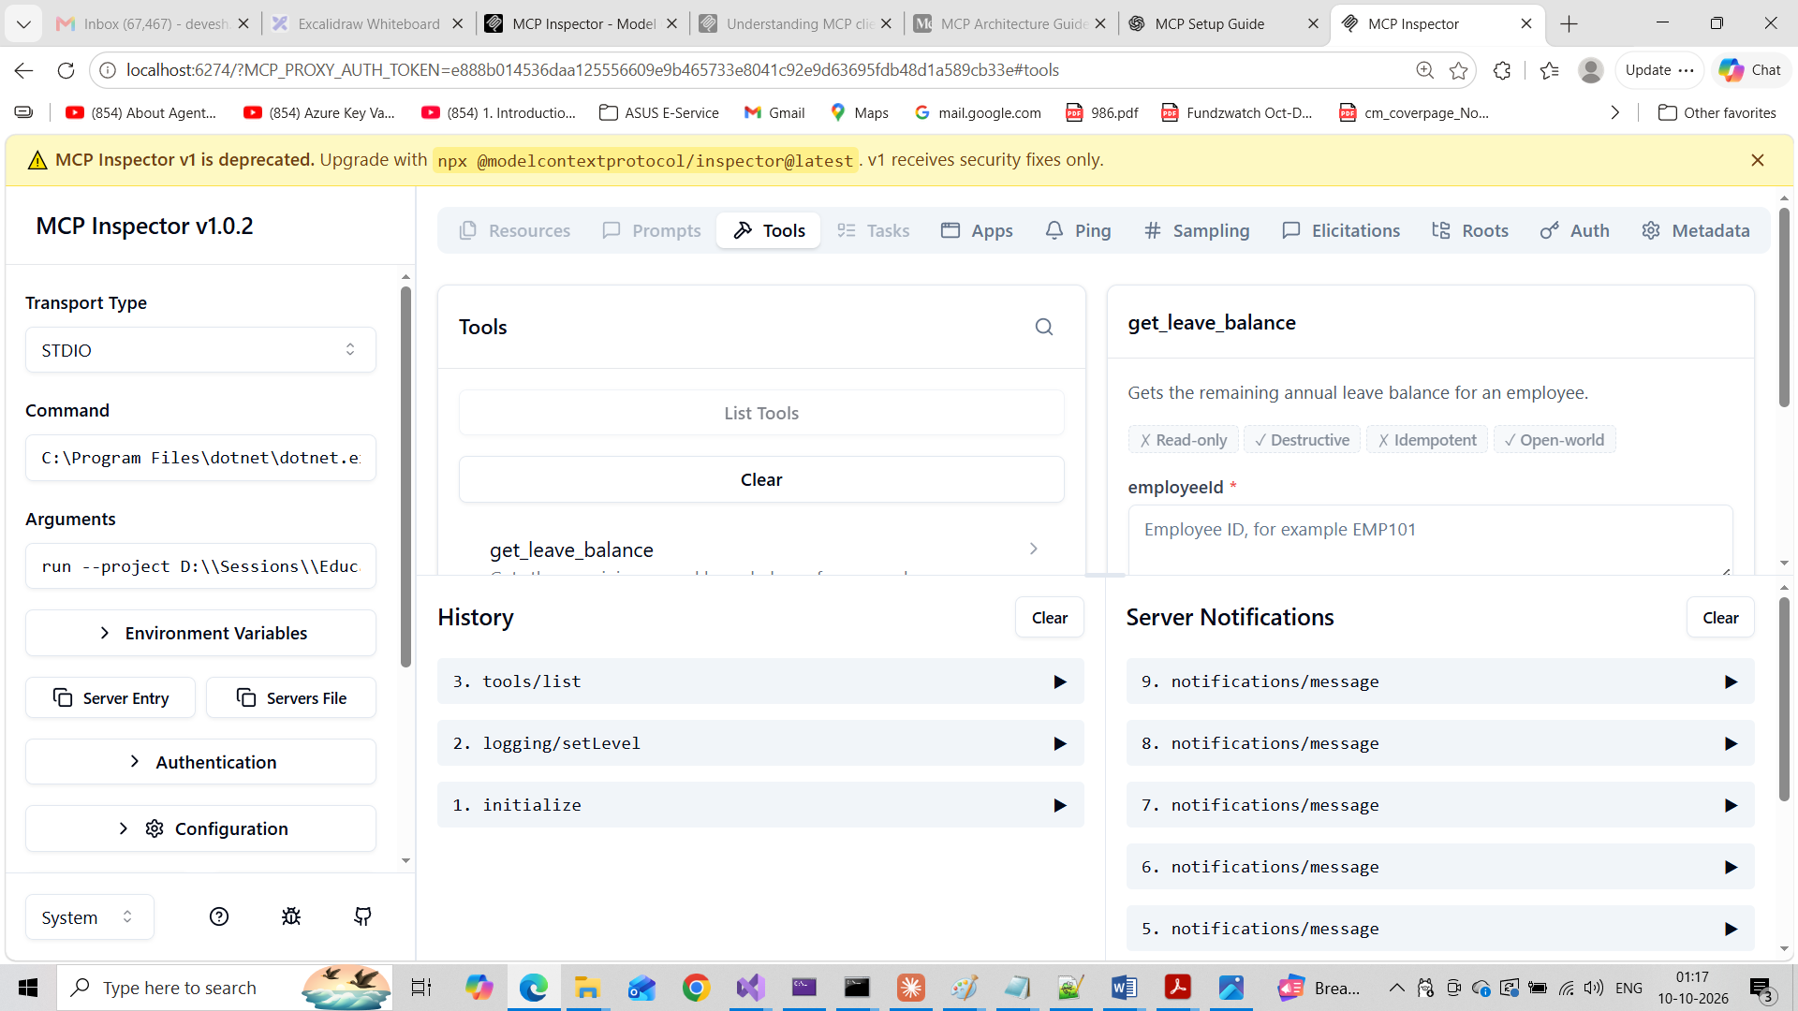
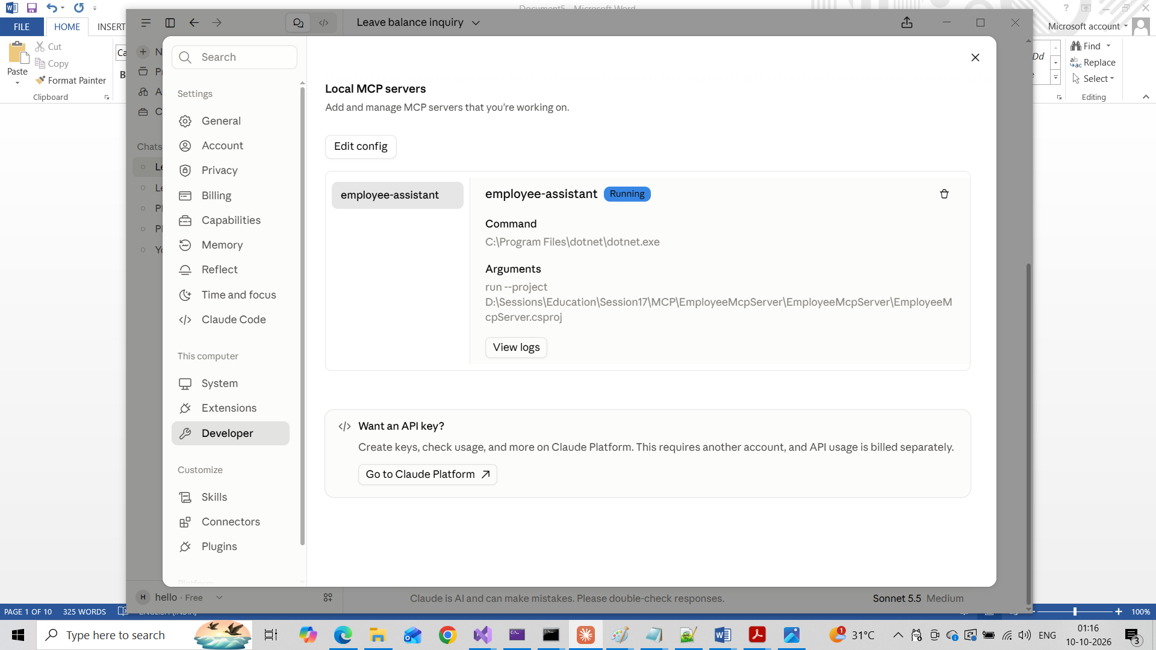

Claude config

"mcpServers": {
"employee-assistant": {
"command": "C:\\Program Files\\dotnet\\dotnet.exe",
"args": [
"run",
"--project",
"D:\\Sessions\\Education\\Session17\\MCP\\EmployeeMcpServer\\EmployeeMcpServer\\EmployeeMcpServer.csproj"
]
}
},

Config path

C:\Users\admin\AppData\Local\Packages\Claude_pzs8sxrjxfjjc\LocalCache\Roaming\Claude

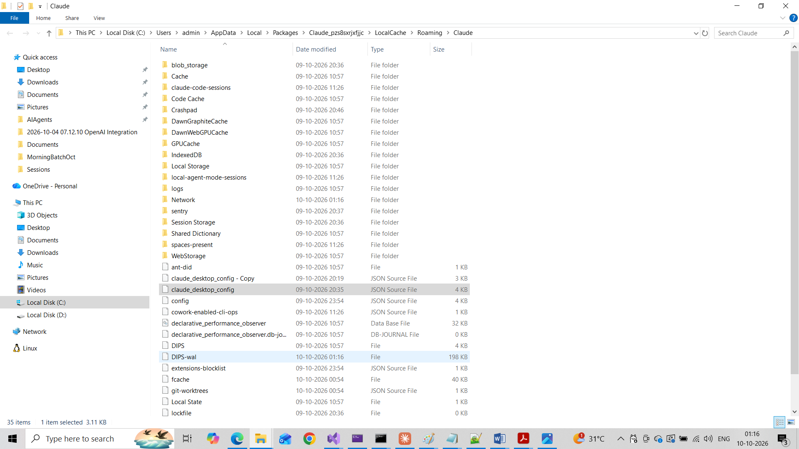

MCP Inspector

Command=C:\Program Files\dotnet\dotnet.exe

Argument
run --project D:\\Sessions\\Education\\Session17\\MCP\\EmployeeMcpServer\\EmployeeMcpServer\\EmployeeMcpServer.csproj

