

DEVESH PANT December 3, 2022 RIMA PANT   
38 HIGHLAND ST   
ROCKY HILL, CT 06067-3152

**Please Review**

Account(s): ***-**3624

Dear DEVESH PANT:

On 11/02/2022, we sent you a letter to let you know that recent trading activity in your above referenced account had resulted in a significant decrease in overall account equity. We also suggested that you review your account activity, including option trading, to make sure that it still met your investment objective, financial circumstances, and risk tolerance.

Our records reflect that over the last month, your account has had similar activity and that 635 trades were executed and your overall equity value has decreased by $28731.42.

As we previously communicated, because Fidelity does not provide investment guidance on the purchase of individual equity securities, options, or non-investment-grade bonds, it is your role to consider the risks and costs associated with your investment decisions and strategies.

We are sending you this letter to help ensure that you understand and consider the nature and consequences of your trading activity. We urge you to review your account statements and trade confirmations to determine whether this activity is still consistent with your investment objectives, financial circumstances, and risk tolerance.

If you wish to continue your current investment activity and strategy, please immediately sign the enclosed Customer Acknowledgement and send back to us.

You can easily upload the signed document by following these steps:

1. Visit **Fidelity.com** and Log in   
2. Click Customer Service   
3. Select Contact us   
4. Click Email a secure message   
5. Upload the requested document and make sure to reference the file number show below in the subject line

Fidelity Investments and pyramid design logo are registered service marks of FMR LLC. Fidelity Brokerage Services LLC, Member NYSE, SIPC, 900 Salem Street, Smithfield, RI 02917©2022 FMR LLC. All rights reserved

|  |  |  |
| --- | --- | --- |
| 877806.1.0 | W760317-03DEC22 | Page 1 of 3 |

S



Alternatively, you can send the document back to us via U.S. Mail by using one of the following addresses:

**Regular mail:**  **Overnight Mail:**

Fidelity Investments Fidelity Investments PO Box 770001 100 Crosby Parkway Cincinnati, OH 45277-0002 Covington, KY 41015

**If we do not receive your signed acknowledgement form within thirty (30) days, we will restrict the trading in your account and allow closing transactions only. This account restriction will be removed once you return the acknowledgement form**. Fidelity will not be responsible for continuing to monitor your account or for notifying you of further losses. If you would like more information regarding Fidelity’s educational tools and investment offerings, please visit Fidelity.com. Additionally, if you trade options and would like more information regarding the risks of options trading, a copy of the OCC’s “Characteristics and Risks of Standardized Options” is also available on Fidelity.com, or you may call a Fidelity representative at (800) 343-3548 to assist you.

Thank you for choosing Fidelity Investments to help with your financial needs.

Sincerely,   
Fidelity Investments

Our File Number: W760317-03DEC22   
Enclosure: Return Envelope, Customer Acknowledgement

*Options trading entails significant risk and is not appropriate for all investors. Certain complex options strategies carry additional risk.*

Fidelity Investments and pyramid design logo are registered service marks of FMR LLC. Fidelity Brokerage Services LLC, Member NYSE, SIPC, 900 Salem Street, Smithfield, RI 02917©2022 FMR LLC. All rights reserved

|  |  |  |
| --- | --- | --- |
| 877806.1.0 | W760317-03DEC22 | Page 2 of 3 |



DEVESH PANT   
RIMA PANT   
38 HIGHLAND ST   
ROCKY HILL, CT 06067-3152

Date: 12/02/2022

**Customer Acknowledgement**

Account(s): ***-**3624

To Fidelity Brokerage Services LLC:

I have reviewed all of the activity in my account number ***-**3624, including commissions and changes in equity. I understand and accept the risks associated with the trading and the overall investment strategy that I am pursuing and I have determined that the activity in my account is consistent with my investment objectives, financial circumstances, and risk tolerance.

I further acknowledge that I am responsible for all trading and activity in my account(s) and I understand that Fidelity will not be responsible for monitoring my account or notifying me of further losses.

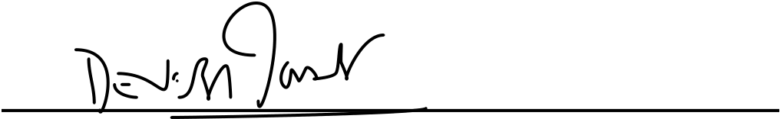 

Account Owner /Trustee / Custodian Joint Account / Owner / Trustee

 

Date

Please note: For Joint and Trust accounts, each owner/trustee must sign.

Our File Number: W760317-03DEC22

Fidelity Investments and pyramid design logo are registered service marks of FMR LLC. Fidelity Brokerage Services LLC, Member NYSE, SIPC, 900 Salem Street, Smithfield, RI 02917©2022 FMR LLC. All rights reserved

|  |  |  |
| --- | --- | --- |
| 877806.1.0 | W760317-03DEC22 | Page 3 of 3 |