AI-Based Manufacturing Efficiency Classification
Using Sensor, Production and 6G Network Data
Research paper · Thales Group: Building a Future (Unified Mentor)
Author: [Your name]
October 2026

Abstract
Smart factories need to know the efficiency state of every machine right now, not just in a weekly report. This study builds and tests a machine-learning system that labels each machine reading as High, Medium or Low efficiency and attaches a confidence score. We analysed 100,000 one-minute readings from 50 machines (1 January to 10 March 2025) covering temperature, vibration, power, 6G latency, packet loss, defect rate, production speed, error rate and a predictive-maintenance score.
A Random Forest reaches 100% test accuracy, Gradient Boosting 99.9% and Logistic Regression 92.3%. Our explainability work shows why: efficiency in this dataset is fully determined by two columns, production speed and error rate. A High label requires speed ≥ 400 units/hr and error rate ≤ 2%; Medium requires speed ≥ 200 and error rate ≤ 5%; everything else is Low. Sensor and 6G network measurements carry no measurable signal. When speed and error rate are removed, all models fall to chance level (macro-F1 about 0.26). We therefore report the headline accuracy honestly, explain what it means, and recommend how the data collection should change before the system is trusted for real decisions.

1. Introduction
In factories connected through Industrial IoT and 6G, efficiency can change within minutes because of sensor drift, network instability and quality problems. Traditional dashboards describe what already happened. This project instead classifies the current efficiency state automatically, so that operators can react immediately.

Objectives
- Build a multi-class classifier (High / Medium / Low efficiency) and compare Logistic Regression, Random Forest and Gradient Boosting.
- Engineer features for sensor stability, energy efficiency, error-to-output ratio and network reliability.
- Explain which factors drive efficiency and why an individual reading is labelled as it is.
- Deliver a Streamlit dashboard with real-time labels, confidence scores and operational views.

2. Data
The dataset has 100,000 rows and 14 columns, one reading per minute from 2025-01-01 to 2025-03-10, for 50 machines (about 2,000 readings each). There are no missing values. The target is Efficiency_Status.
Class | Records | Share
Low | 77,825 | 77.8%
Medium | 19,189 | 19.2%
High | 2,986 | 3.0%

The classes are heavily imbalanced: only 3% of readings are High. Accuracy alone is therefore misleading, so we also report balanced accuracy and macro-F1, which give every class equal weight.

3. Methodology

3.1 Pre-processing
- Time ordering: Date and Timestamp were combined into one datetime and the data sorted chronologically.
- Encoding: Operation_Mode (Active, Idle, Maintenance) was one-hot encoded.
- Scaling: numeric features were standardised for Logistic Regression; tree models do not need scaling.
- Class imbalance: handled with balanced class weights, which penalise mistakes on High and Medium more heavily.
- Time-aware validation: the first 80% of the timeline was used for training and the last 20% for testing, so the model is always judged on the future. Stability was checked with 3-fold time-series cross-validation.

3.2 Feature engineering
Feature | Meaning
sensor_stress_index | Average of normalised temperature, vibration and power (0 calm, 1 extreme)
network_reliability | 1 minus normalised latency and packet loss (1 = perfect link)
energy_per_unit | Power (kW) per unit produced per hour
error_to_output | Error rate per unit/hr of speed
defect_to_output | Defect rate per unit/hr of speed
thermal_vibration_load | Temperature × vibration interaction
temp / vib rolling std | Stability over a machine's last 10 readings (tested as an extension)

3.3 Models and comparison criteria
Logistic Regression is the interpretable baseline. Random Forest and Gradient Boosting (scikit-learn HistGradientBoosting, the same family as XGBoost) are the advanced models. They are compared on accuracy, stability across time folds, and interpretability. We ran two scenarios: A uses every feature; B removes production speed, error rate and anything derived from them, to test whether sensors and the 6G network alone can predict efficiency.

4. Exploratory data analysis
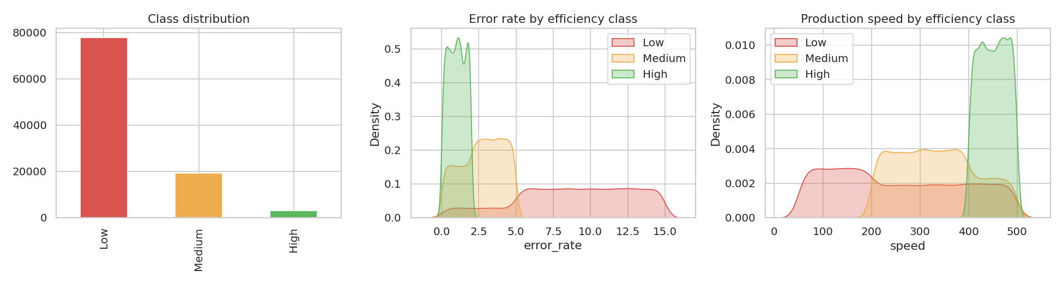
Figure 1. Class balance, and error rate / production speed by efficiency class.
Figure 1 shows the first key insight. The three efficiency classes separate cleanly on error rate and production speed: High readings have errors of 2% or less and speed of 400 or more. The average error rate is 1.0% for High, 2.7% for Medium and 8.9% for Low; average speed is 451, 334 and 255 units/hr respectively.
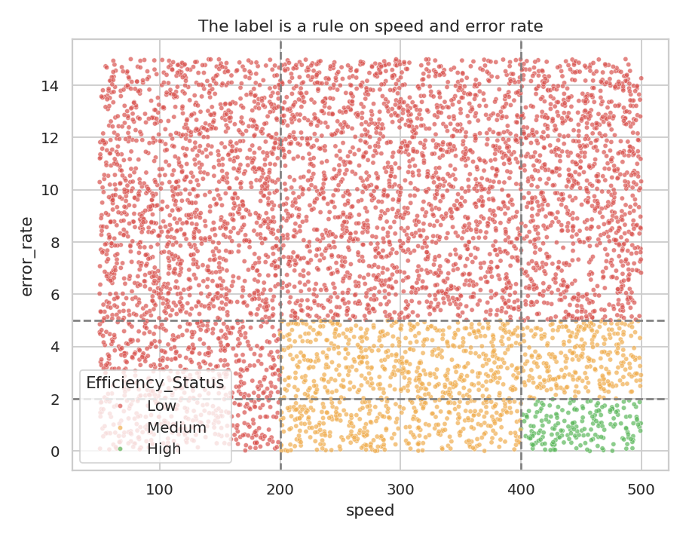
Figure 2. Speed vs error rate, coloured by class. Dashed lines mark the thresholds 200 / 400 units/hr and 2% / 5% errors.
Figure 2 makes the structure explicit. The label behaves like a rule applied to two columns. High: speed ≥ 400 and error ≤ 2%. Medium: speed ≥ 200 and error ≤ 5% (but not High). Low: everything else.
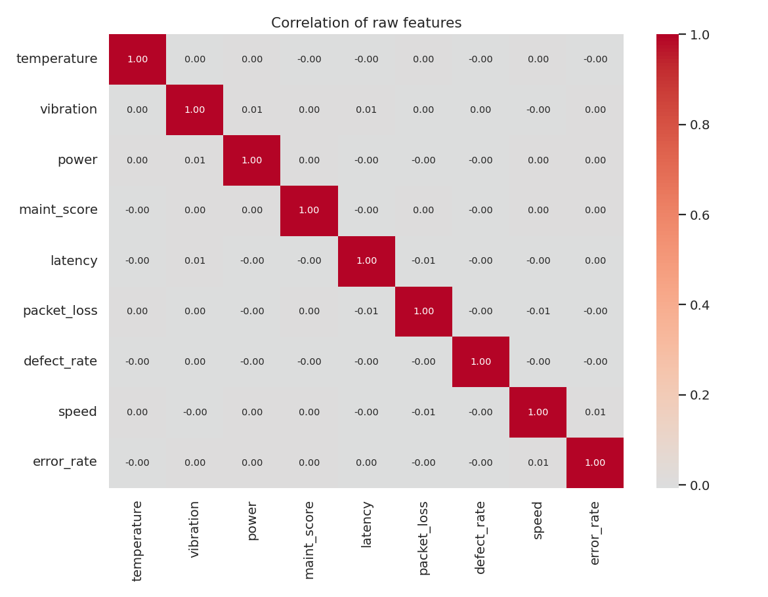
Figure 3. Correlation of raw features. All pairs are near zero.
The other variables (temperature, vibration, power, latency, packet loss, defect rate, maintenance score) are uniformly distributed and uncorrelated with each other and with efficiency. Their averages are almost identical across the three classes.
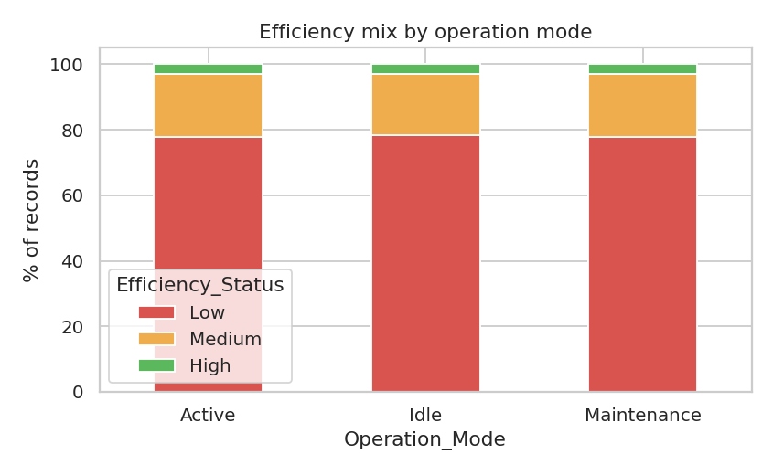
Figure 4. Efficiency mix by operation mode.
Operation mode does not change efficiency either. Active, Idle and Maintenance each show about 78% Low, 19% Medium and 3% High. In a real factory we would expect Idle and Maintenance readings to look very different from Active ones, which is the first hint that this data is synthetic or was generated without those relationships.

5. Model results

Scenario A – all features (time-ordered test set)
Model | Accuracy | Balanced acc. | Macro-F1 | CV macro-F1 (3 folds)
Logistic Regression | 92.3% | 92.8% | 0.858 | 0.859 ± 0.003
Random Forest | 100.0% | 100.0% | 1.000 | 0.999 ± 0.001
Gradient Boosting | 99.9% | 99.5% | 0.997 | 0.996 ± 0.001

Random Forest is perfect on the test period and is the most stable across folds (0.999 ± 0.001). Gradient Boosting is almost identical. Logistic Regression is clearly weaker (92% accuracy, macro-F1 0.86) because the rule is made of thresholds, which a straight-line model cannot reproduce. We deploy the Random Forest: highest accuracy, high stability, and its decisions can be traced back to speed and error rate.

Scenario B – sensors, network and quality only
Model | Accuracy | Balanced acc. | Macro-F1 | CV macro-F1 (3 folds)
Logistic Regression | 30.2% | 33.1% | 0.239 | 0.230 ± 0.010
Random Forest | 34.7% | 32.7% | 0.259 | 0.260 ± 0.006
Gradient Boosting | 33.4% | 34.4% | 0.257 | 0.271 ± 0.003

Without speed and error rate, every model collapses to chance (macro-F1 0.259). Adding rolling-window stability indicators did not help (macro-F1 0.266). Accuracy values in this table are low because we used balanced class weights; always predicting Low would give 78.0% accuracy but would never detect a High or Medium machine. The confusion matrices below show the contrast.
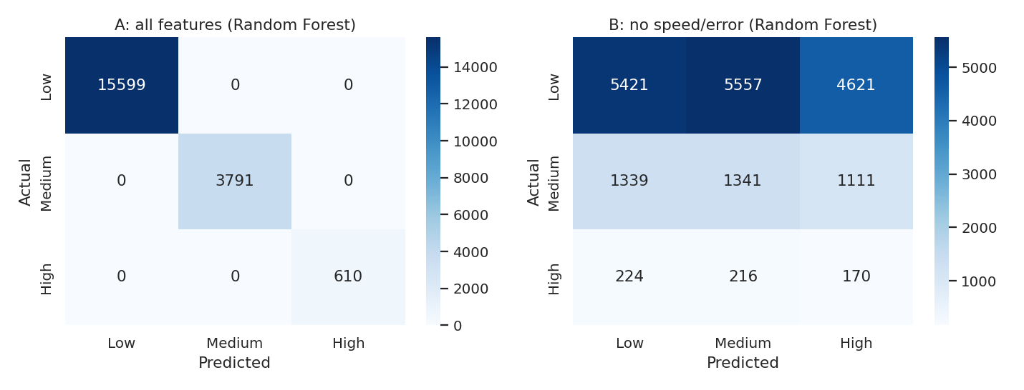
Figure 5. Confusion matrices for Random Forest. Left: scenario A (perfect). Right: scenario B (predictions scattered).

6. Explainability
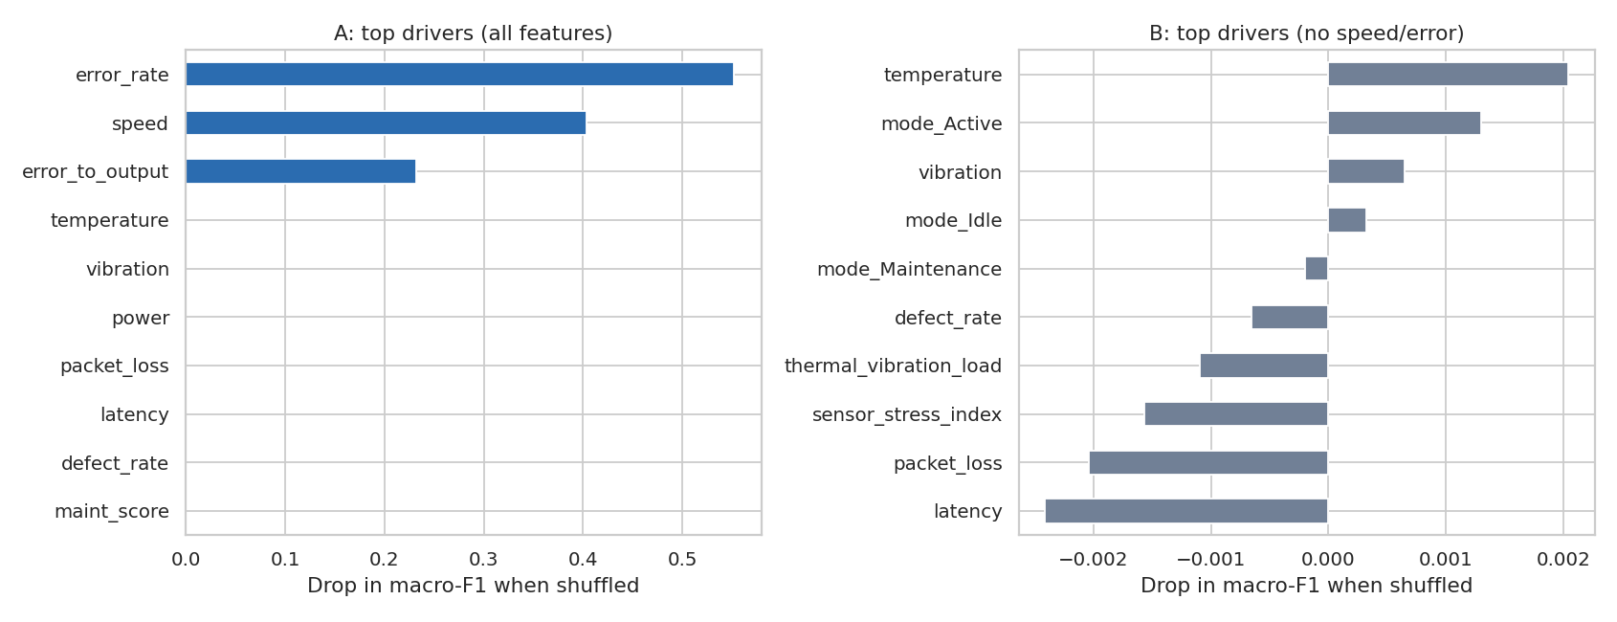
Figure 6. Permutation importance: how much accuracy drops when one feature is scrambled.
In scenario A only three features matter: error rate (drop of 0.552), production speed (0.403) and the engineered error-to-output ratio (0.232). Every sensor and network feature scores exactly zero. In scenario B all importances are within ±0.003, which is noise.
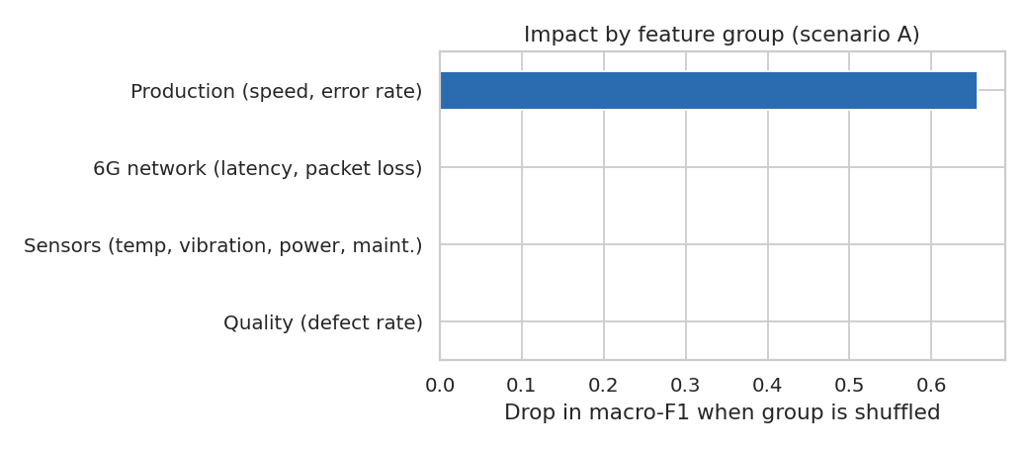
Figure 7. Impact by feature group. Production metrics account for the entire effect.
For a single reading, the dashboard gives two explanations: (1) a plain-language statement, for example "speed 355 is below 400 and error rate 3.1% is above 2% → Medium"; (2) a bar chart showing how replacing each input with its typical value would change the predicted probability. This lets an engineer see in seconds why a machine is Low and what would move it up.

7. Deployment logic and dashboard
- Real-time label: every feature is computed from a single reading, so the model can score each new record as it arrives.
- Confidence score: the highest class probability from the Random Forest is attached to every prediction. Readings below 70% confidence are flagged as close to a class boundary.
- Integration: the trained model is saved as one file and wrapped in a small prediction function, ready to be called from a factory control system or message queue.
The Streamlit dashboard has four modules: Efficiency Prediction (live label, confidence, sensitivity sliders), Machine-Level Insights (profile per machine, daily and hourly trends), Explainability (global importance and per-record reasoning) and Operational Monitoring (efficiency by operation mode and network quality, network vs sensor vs production impact). Sidebar filters cover machine, operation mode, network quality and time window.

8. Limitations
- The label is a function of two inputs. A model reaching 100% is rediscovering a rule, not demonstrating general intelligence. Real performance on a factory where efficiency is defined differently is unknown.
- No link between sensors, network and efficiency. The project premise, that 6G instability and sensor deviations drive efficiency, cannot be tested with this data.
- Probable synthetic data. Uniform distributions, no relationship with operation mode, and exact threshold boundaries all point to generated data.
- Circular target. Using speed and error rate to predict a label defined from them offers little operational advantage over simply reading those two numbers.
- Only 69 days of data, so seasonal or long-term wear effects cannot be assessed.

9. Recommendations
- Monitor speed and error rate first. They are the only measured drivers. Alert when a machine moves toward the 400 / 200 units/hr or 2% / 5% boundaries.
- Target the Low group. Low is 78% of readings. Moving them above 200 units/hr and below 5% errors would convert them to Medium.
- Fix the target definition. Define efficiency from independent outcomes (for example, good units per energy used or OEE) so that sensors and network data can genuinely predict it.
- Collect real, labelled incidents. Log failures, stoppages and network outages with timestamps so that the link between 6G instability and efficiency can be measured.
- Validate on a second factory or period before using the system for control decisions.
- Keep the human in the loop. Use the confidence score: auto-act only above a high threshold and ask an operator otherwise.
- Retrain regularly and monitor for drift in the speed and error-rate distributions.

10. Conclusion
The system successfully classifies efficiency in real time with 100% accuracy on unseen future data and explains its decisions. The more important result is the finding behind that number: in this dataset, efficiency is determined entirely by production speed and error rate, and the sensor and 6G network data contribute nothing. The deliverables are therefore a working, interpretable classifier and dashboard, together with a clear plan for collecting data that would let future versions deliver the full promise of AI-driven smart manufacturing.

