MySQL ROW_NUMBER() Function

The ROW_NUMBER() function in MySQL is used to returns the **sequential number** for each row within its partition. It is a kind of window function. The row number starts from 1 to the number of rows present in the partition.

It is to be noted that MySQL does not support the ROW_NUMBER() function before version 8.0, but they provide a **session variable** that allows us to emulate this function.

**Syntax**

The following are the basic syntax to use ROW_NUMBER() in [MySQL](https://www.javatpoint.com/mysql-tutorial):

1. ROW_NUMBER() OVER (<partition_definition> <order_definition>)

**Let us demonstrate it using an example**.

First, we are going to create a table named "**Person**" using the below statement:

1. **CREATE** **TABLE** Person (
2. **Name** **varchar**(45) NOT NULL,
3. Product **varchar**(45) **DEFAULT** NULL,
4. Country **varchar**(25) **DEFAULT** NULL,
5. Year **int** NOT NULL
6. );

Next, it is required to add values to this table. Execute the below statement:

1. **INSERT** **INTO** Person(**Name**, Product, Country, Year)
2. **VALUES** ('Stephen', 'Computer', 'USA', 2015),
3. ('Joseph', 'Laptop', 'India', 2016),
4. ('John', 'TV', 'USA', 2016),
5. ('Donald', 'Laptop', 'England', 2015),
6. ('Joseph', 'Mobile', 'India', 2015),
7. ('Peter', 'Mouse', 'England', 2016);

Next, execute the SELECT statement to display the records:

1. mysql> **SELECT** * **FROM** Person;

We will get the output, as shown below:

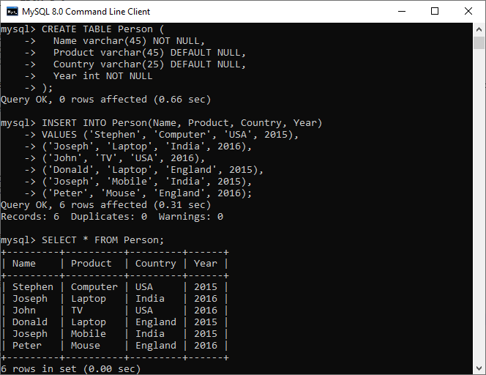

Now, we can use the ROW_NUMBER() function to assign a sequence number for each record using the below statement:

1. **SELECT** *,
2. ROW_NUMBER() OVER(PARTITION **BY** Year) **AS** row_num
3. **FROM** Person;

It will give the following output:

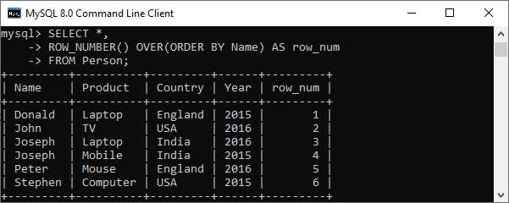

Again, we can use the ROW_NUMBER() function to assign a sequence number for each record within a partition using the below statement:

1. **SELECT** *,
2. ROW_NUMBER() OVER(PARTITION **BY** Year) **AS** row_num
3. **FROM** Person;

It will give the output as below where two partitions found based on the year (2015 and 2016).

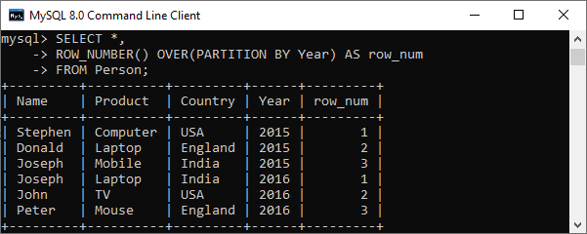

MySQL ROW_NUMBER() Using Session Variable

We can emulate the ROW_NUMBER() function to add a row number in increasing order using the session variable.

Execute the below statement that add the row number for each row, which starts from 1:

1. **SET** @row_number = 0;
3. **SELECT** **Name**, Product, Year, Country,
4. (@row_number:=@row_number + 1) **AS** row_num
5. **FROM** Person **ORDER** **BY** Country;

In this statement, we have first specify the session variable **@row_number** indicated by @prfix and set its value 0. Then, we have selected the data from the table Person and increases the value for variable @row_number by one to each row.

After the successful execution of the queries, we will get the output as below:

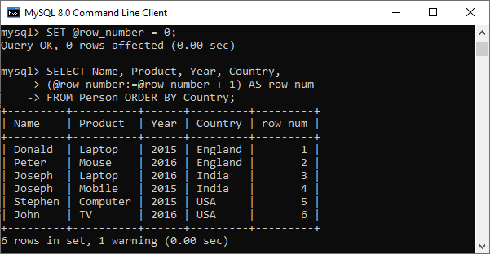

Again, we are going to use a session variable as a table and cross join it with source table using the following statement:

1. **SELECT** (@row_number:=@row_number + 1) **AS** row_num, **Name**, Country, Year
2. **FROM** Person, (**SELECT** @row_number:=0) **AS** **temp** **ORDER** **BY** Year;

We will get the output as below:

