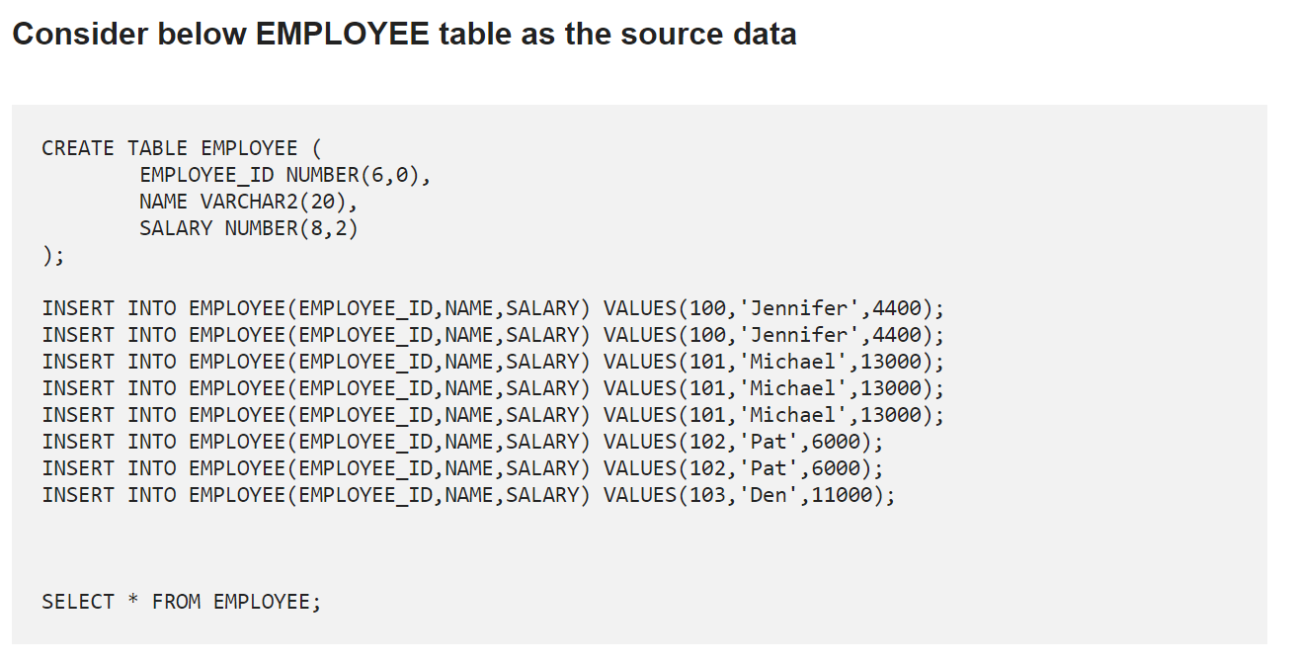

1. **How to select UNIQUE records from a table using a SQL Query?**

select distinct EMPLOYEE_ID,NAME,SALARY from employee

select EMPLOYEE_ID,NAME,SALARY from employee group by EMPLOYEE_ID

1. **How to delete DUPLICATE records from a table using a SQL Query?**

select * from employee

select *,count(*) from employee group by emp_id,name,salary having count(*)>1

delete from employee where emp_id not in (select min(emp_id) from employee group by name,salary).

1. **How to read TOP 5 records from a table using a SQL query?**

Consider below table DEPARTMENTS as the source data.

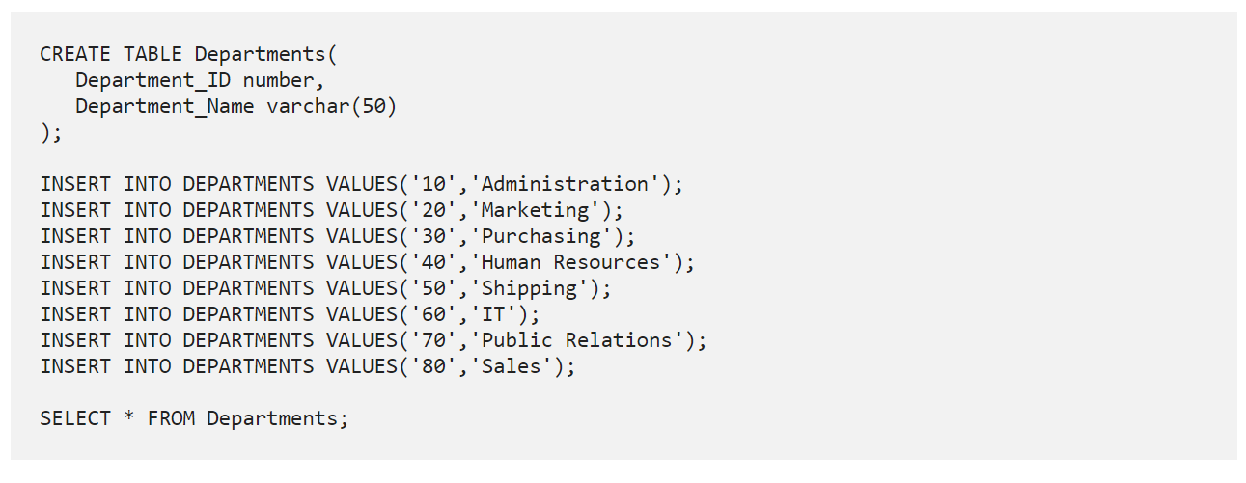

select * from departments order by Department_ID asc limit 5

select * from departments limit 5

1. **How to read LAST 5 records from a table using a SQL query?**

select * from departments order by Department_ID desc limit 5

## here last 5 records in ascending order

(select * from departments order by Department_ID desc limit 5) order by Department_ID

1. **How to find the employee with second MAX Salary using a SQL query?**

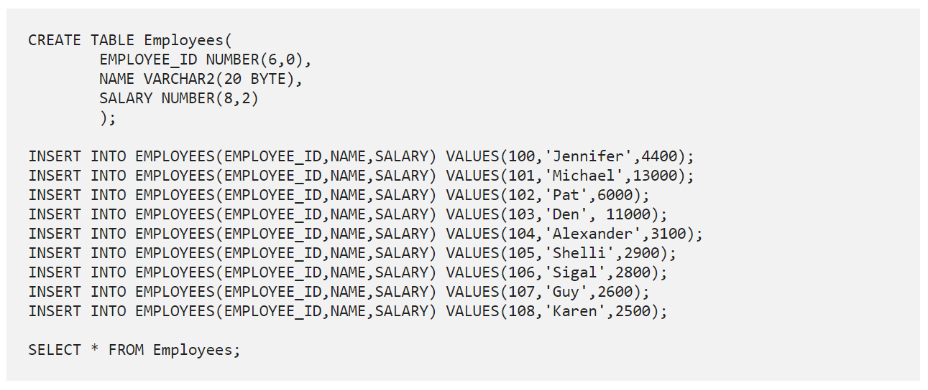select max(salary) as second_max_salary from employee where salary not in (select max(salary) from employee).

## If we need all the columns too

with

temp as(

select max(salary) as salary from employee where salary not in

(select max(salary) as salary from employee)

)

select a.* from employee a join temp b on a.salary = b.salary

1. **How to find the employee with third MAX Salary using a SQL query without using Analytic Functions?**

Consider the same EMPLOYEES table as source discussed in previous question

SELECT name, salary FROM Employee e1

WHERE 3-1 =

(SELECT COUNT(DISTINCT salary) FROM Employee e2 WHERE e2.salary > e1.salary)

## with functions

Select Salary from employees order by Salary DESC limit 2,1;

1. **Assume you have the below tables on sessions that users have, and a users table. Write a query to get the active user count of daily cohorts.**

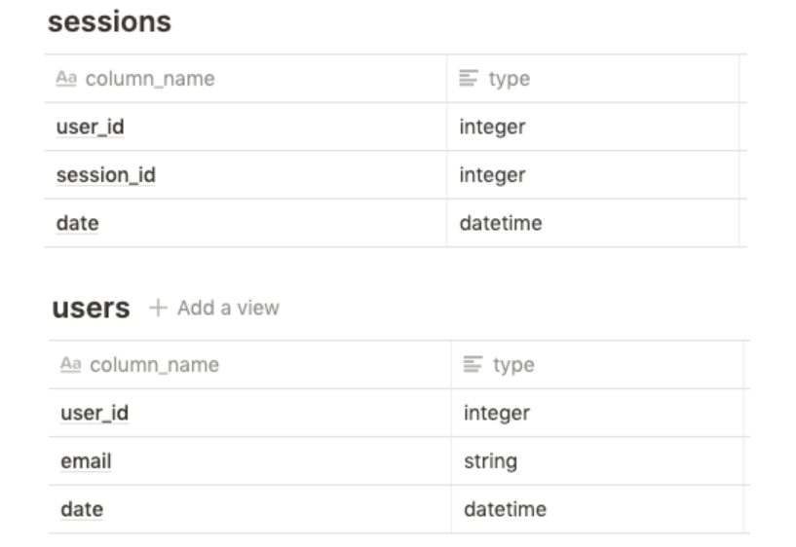

By definition, daily cohorts are active users from a particular day. First, we can use a subquery to get the sessions of new users by day using an inner join with users. This is to filter for only active users by a particular join date for the cohort. Then we can get a distinct count to return the active user count:

with new_users_by_date as(

select s.* from sessions s join users u on s.user_id = u.user_id s.date = u.date)

select date,count(distinct user_id) as active_user_count from new_users_by_date group by date order by asc

1. **Assume you are given the below table on transactions from users for purchases. Write a query to get the list of customers where their earliest purchase was at least $50.**

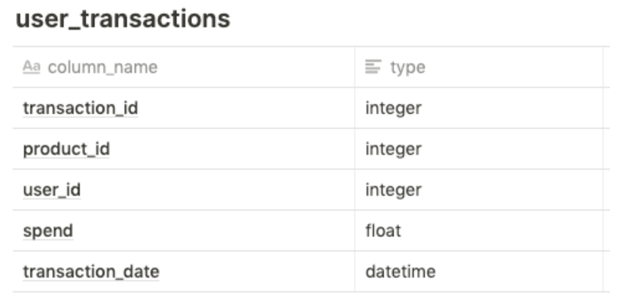

we can also use the RANK() window function to get the ordering of purchase by customer, and then use that subquery to filter on customers where the first purchase (rank one) is at least 50 dollars. Note that this requires the subquery to include spend as well.

with purchase_rank as

( select user_id,spend,rank() over ( partition by user_id order by transaction_date asc)

as rank_ from user_transactions)

select user_id,spend from purchase_rank where rank =1 and spend>=50

1. **Assume you are given the below table on transactions from users. Write a query to get the number of users and total products bought per latest transaction date where each user is bucketed into their latest transaction date.**



First, we need to get the latest transaction date for each user, along with the number of products they have purchased. This can be done in a subquery where we GROUP BY user_id and take a COUNT(DISTINCT product_id) to get the number of products they have purchased, and a MAX(transaction_date) to get the latest transaction date (while casting to a date). Then, using this subquery, we can simply do an aggregation by the transaction date column in the previous subquery, while doing a COUNT() on the number of users, and a SUM() on the number of products:

with latest_transaction as(

select user_id, count(distinct product_id) as product_num,

max(transaction_date::Date) as transactions from user_transaction

group by user_id)

select user_transaction, count(user_id) as num_users,

sum(num_products) as total_products from latest_transaction group by 1

1. **Assume you are given the below tables on users and their time spent on sending and opening Snaps. Write a query to get the breakdown for each age breakdown of the percentage of time spent on sending versus opening snaps.**

### activities Table:

| **Column Name** | **Type** |
| --- | --- |
| activity_id | integer |
| user_id | integer |
| activity_type | string ('send', 'open', 'chat') |
| time_spent | float |
| activity_date | Datetime |

### age_breakdown Table:

| **Column Name** | **Type** |
| --- | --- |
| user_id | integer |
| age_bucket | string ('21-25', '26-30', '31-25') |

We can get the breakdown of total time spent on each activity by each user by filtering out for the activity_type and taking the sum of time spent. In doing this, we want to do an outer join with the age bucket to get the total time by age bucket for both activity types. This results in the below two subqueries. Then, we can use these two subqueries to sum them by joining on the appropriate age bucket and take the proportion for send time and the proportion for open time per age bucket :

## send activity_type total time spent on each activity by each user

with send_timespent as(

select age_breakdown.age_bucket, sum(activities.time_spent) from age_breakdown

left join on age_breakdown.user_id = activities.user_id

where activity_type = 'send'

group by 1)

## open activity_type total time spent on each activity by each user

open open_timespent as(

select age_breakdown.age_bucket, sum(activities.time_spent) from age_breakdown

left join on age_breakdown.user_id = activities.user_id

where activity_type = 'open'

group by 1)

## finally for percentage of time spent on sending versus opening snaps.

select a.age_bucket,

s.send_timespent /(s.send_timespent + o.open_timespent) as pct_send,

o.open_timespent / (s.send_timespent + o.open_timespent) as pct_open,

from age_breakdown a

left join send_timespent s on a.age_bucket = s.age_bucket

left join open_timespent o on a.age_bucket = o.age_bucket

group by 1

1. **Assume you are given the below table on reviews from users. Define a top-rated place as a business whose reviews only consist of 4 or 5 stars. Write a query to get the number and percentage of businesses that are top-rated places.**

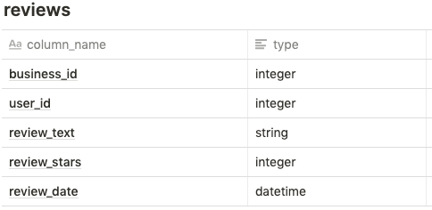

First, we need to get the places where the reviews are all 4 or 5 stars. We can do this using a HAVING clause, instead of a WHERE clause since the reviews need to all be 4 stars or above. For the HAVING condition, we can use a CASE statement that filters for 4 or 5 stars and then take a SUM over them. This can then be compared with the total row count of the particular business_id reviews to ensure that the count of top reviews matches with the total review count. With the relevant businesses, we can then do an outer join with the original table on business_id to get a COUNT of distinct business_id matches, and then the percentage by comparing the COUNT from the top places with the overall COUNT of business_id :-

with top_places as( select business_id from reviews group by 1 having

sum(

case

when review_stars >=4 then 1 else 0 end) = count(*)

)

select count(distinct t.business_id) as top_places,

count(distinct t.business_id/count(r.business_id) as top_places_pct

from reviews r

left join top_places t

on r.business_id = t.business_id)

**12.**

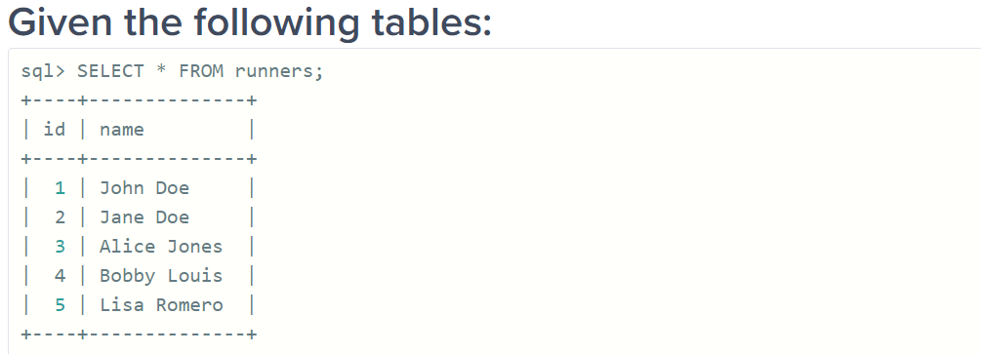

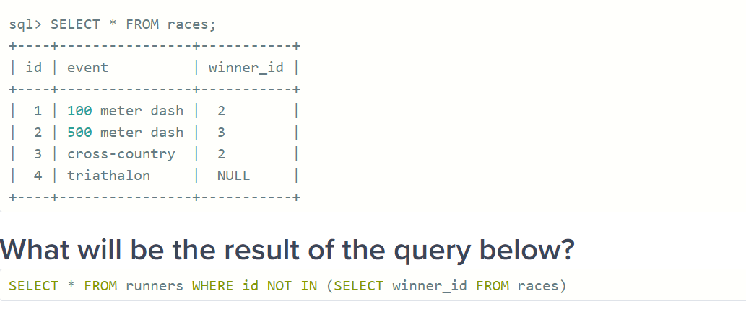

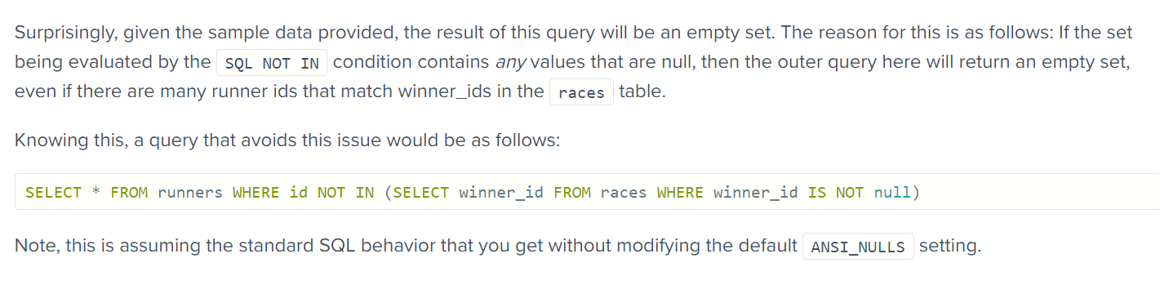

**13.** 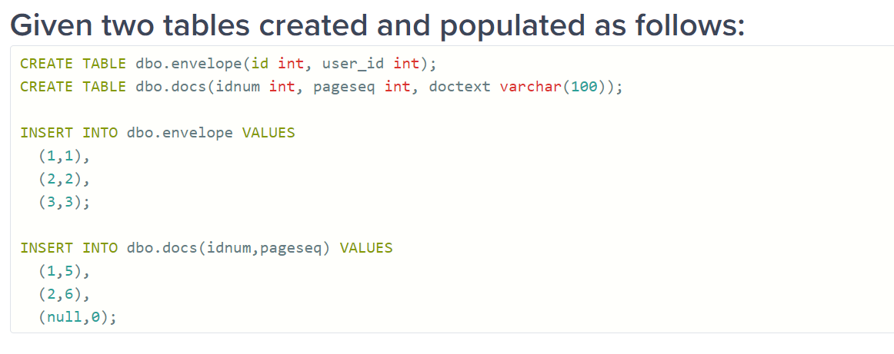

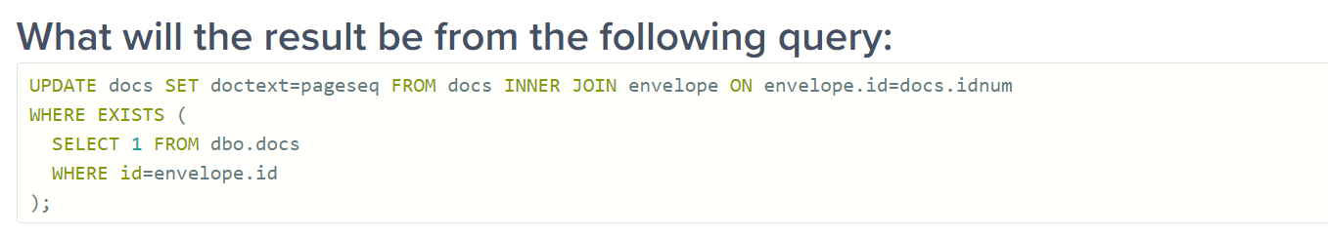

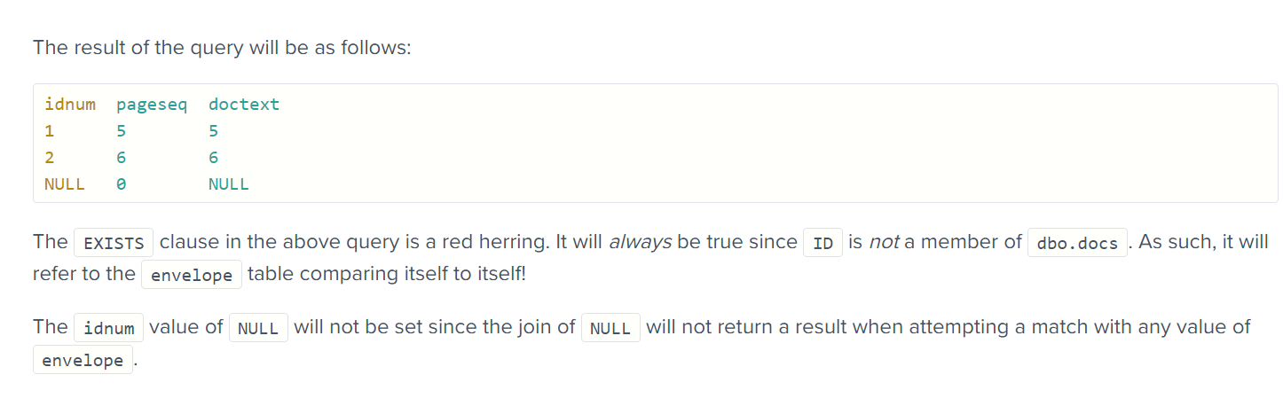

**14.**

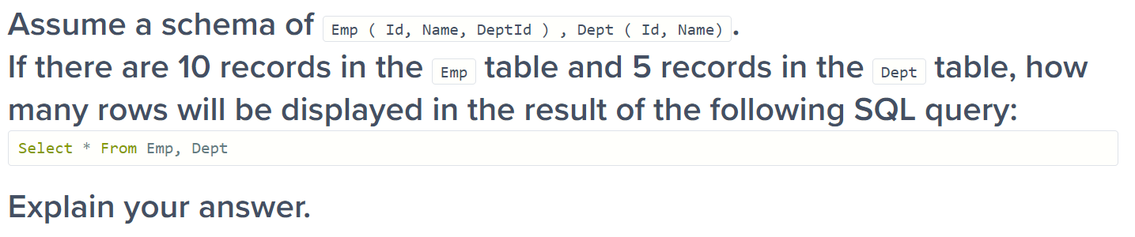

The query will result in 50 rows as a “cartesian product” or “cross join”, which is the default whenever the ‘where’ clause is omitted.

**15.**

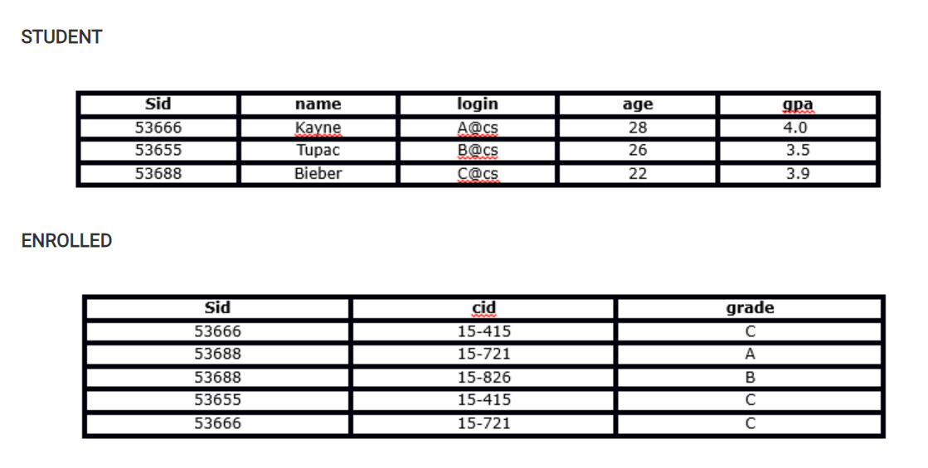

Which of the following is the correct outcome of the SQL query below?

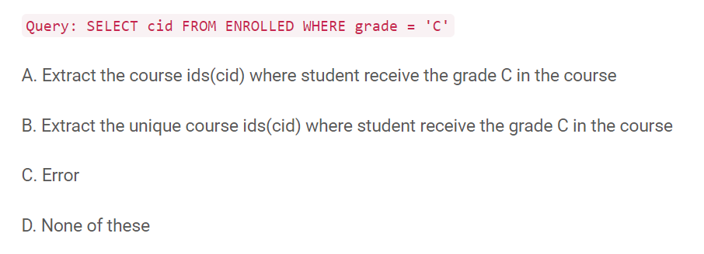

Solution: A

The query will extract the course ids where student receive the grade “C” in the course.

**16.** **What is the correct outcome of the SQL query below?**

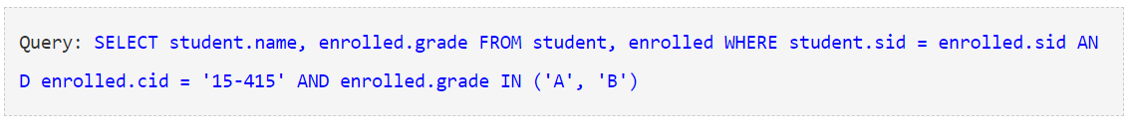

Nothing will be there in output as the above query first joined the ENROLLED and STUDENT tables then it will evaluate the where condition and then it will return the name, grade of the students, those took 15-415 and got a grade ‘A’ or ‘B’ in the course

**17.** Which of the following query will find all the unique students who have taken more than one course?

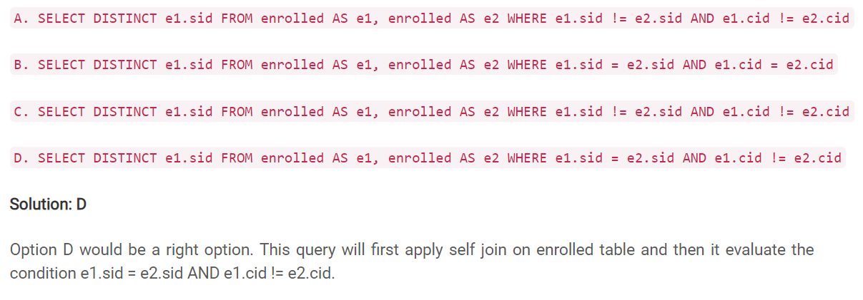

**18**. What are the tuples additionally deleted to preserve reference integrity when the rows (2,4) are deleted from the below table. Suppose you are using ‘ON DELETE CASCADE’.

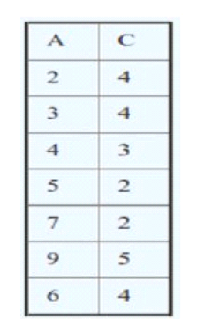

When (2,4) is deleted. Since C is a foreign key referring A with delete on cascade, all entries with value 2 in C must be deleted. So (5, 2) and (7, 2) are deleted. As a result of this 5 and 7 are deleted from A which causes (9, 5) to be deleted.

**19.** Suppose you have a table “Loan_Records”.

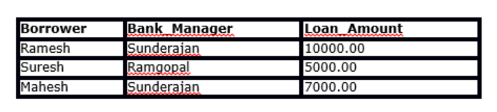

SELECT Count(*)  FROM  ( (SELECT Borrower, Bank_Manager FROM   Loan_Records) AS S NATURAL JOIN (SELECT Bank_Manager, Loan_Amount FROM   Loan_Records) AS T );

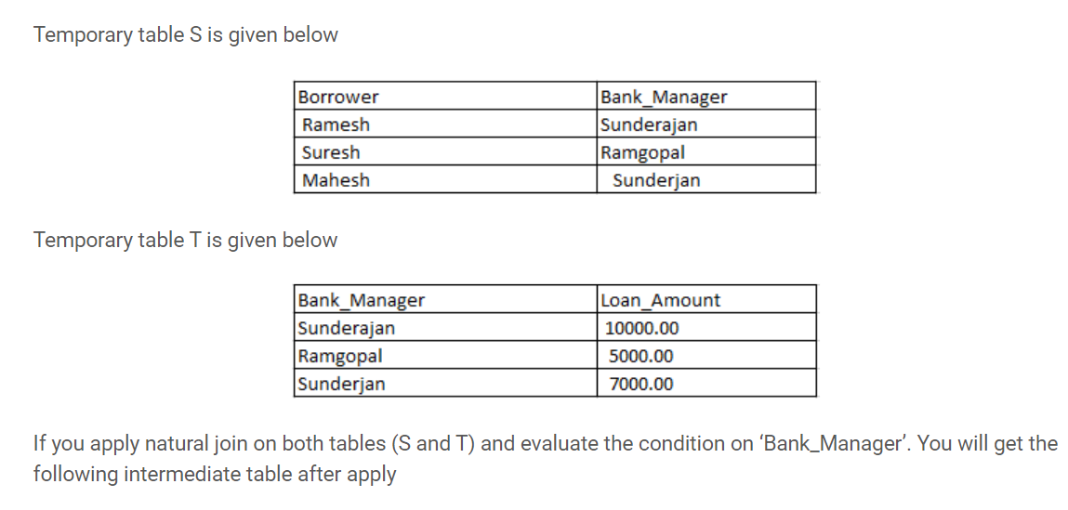

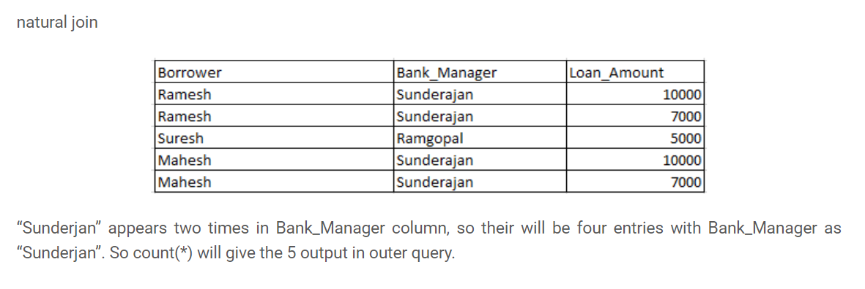

**20.What will be the output of the below query?**

Query: SELECT Company, AVG(Salary) FROM AV1 HAVING AVG(Salary) > 1200 GROUP BY Company WHERE Salary > 1000 ;

**There won’t be any output and error will be there.**

**The order should always be like**

**Where**

**Group by**

**Having**

**21. SQL Query to find the second highest salary of Employee**

**select max(salary) as Second_max_salary from employees where salary not in (select max(salary) from employees)**

**22. SQL Query to find Max Salary from each department.**

**select department_id,max(salary) from employees group by department_id**

**These questions become more interesting if the Interviewer will ask you to print the department name instead of the department id**

**## when we have the department_name in the same table that as of the employee**

**select job_id,max(salary) from employees group by job_id**

**## when we have the department name in another table we need to join the Employee table with Department using the foreign key DeptID, make sure you do**[**LEFT or RIGHT OUTER JOIN**](https://javarevisited.blogspot.com/2013/05/difference-between-left-and-right-outer-join-sql-mysql.html)**to include departments without any employee as well.**

**Select Deptname,max(salary) from employee e left join department d on e. DeptID = d. DeptID group by Deptname.**

**23.** Write SQL Query to display the current date?

SQL has built-in function called GetDate() which returns the current timestamp.

**Select GetDate()**

|  |  |
| --- | --- |
| **Works in:** | SQL Server (starting with 2008), Azure SQL Database, Azure SQL Data Warehouse, Parallel Data Warehouse |

**## In mysql we have another query:-**

**SELECT CURDATE()**

**24.** Write an SQL Query to print the name of the distinct employee who joined between 13-JAN-01 to 03-JAN-06.

select distinct FIRST_NAME,employee_id from employees where HIRE_DATE between ‘13-JAN-01’ and ‘03-JAN-06’.

**25.** Write an SQL Query to find an employee whose salary is equal to or greater than 10000.

select FIRST_NAME from employees where salary >= 10000

**26.** Write SQL Query to find duplicate rows in a employees? and then write SQL query to delete them?

select FIRST_NAME,count(*) as count from employees group by EMPLOYEE_ID having count(EMPLOYEE_ID) >1

**select FIRST_NAME,LAST_NAME,count(*) as count from employees group by LAST_NAME having count(LAST_NAME) >1**

**#### For deletion of records**

**delete from employees where EMPLOYEE_ID not in (select max(EMPLOYEE_ID) from employees group by EMPLOYEE_ID)**

**27. How do you find all employees who are also managers?**

**select e.FIRST_NAME as Employee_Name, m.FIRST_NAME as Manager_name from employees e, employees m where e.MANAGER_ID = m.EMPLOYEE_ID**

One follow-up is to modify this query to include employees which don't have a manager

**select e.FIRST_NAME,e.LAST_NAME from employees e where e.MANAGER_ID is null.**

**28.** The Trips table holds all taxi trips. Each trip has a unique Id, while Client_Id and Driver_Id are both foreign keys to the Users_Id at the Users table. Status is an ENUM type of (‘completed’, ‘cancelled_by_driver’, ‘cancelled_by_client’).

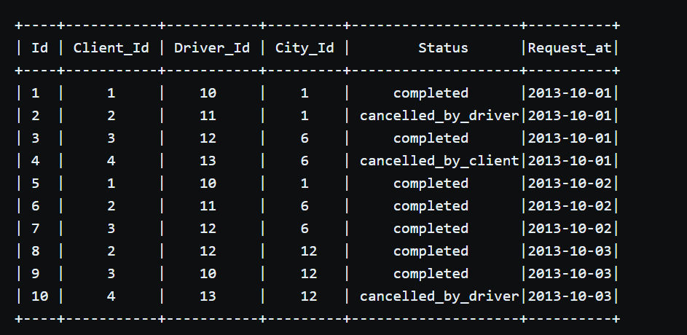

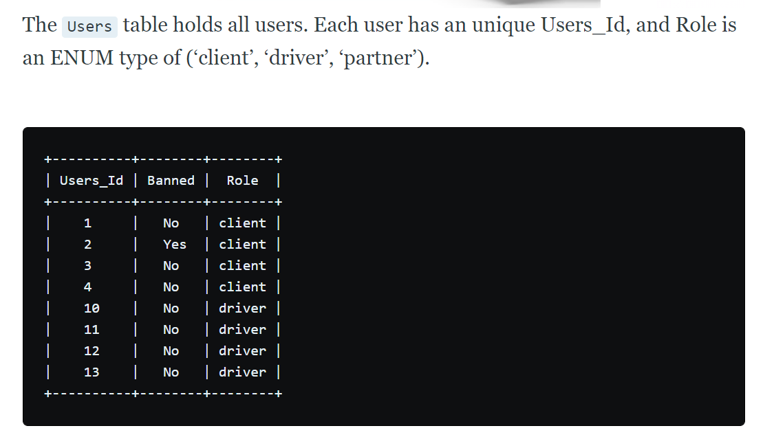

Write a SQL query to find the cancellation rate of requests made by unbanned users between Oct 1, 2013 and Oct 3, 2013. For the above tables, your SQL query should return the following rows with the cancellation rate being rounded to two decimal places.

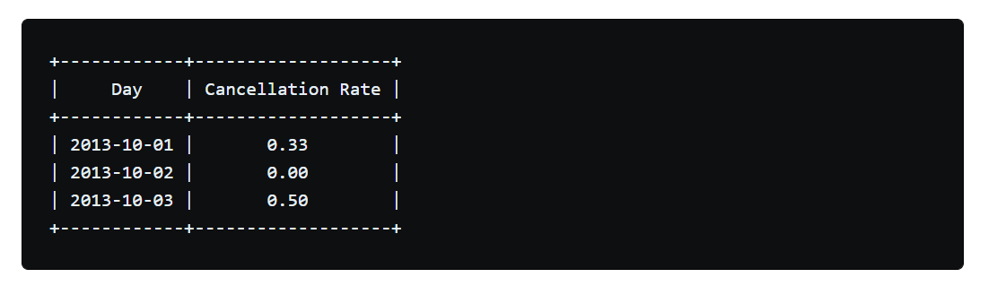

select

result.request_at as "Day",

round(sum(case when result.status = 'completed' then 0 else 1 end)/count(*),2 as "Cancellation Rate"

(select driver_id,status,request_at from trips left join users on trips.client_id = users.users_id where users.banned = 'NO')

result

left join users on result.users_id = result.driver_id ## two foreign keys are present so we need to join the both with users_id

where

users.Banned = 'NO' and result.request_at between '2013-10-01' and '2013-10-03'

group by result.request_at

**29. Write a SQL query to find all duplicate emails in a table named Person.**

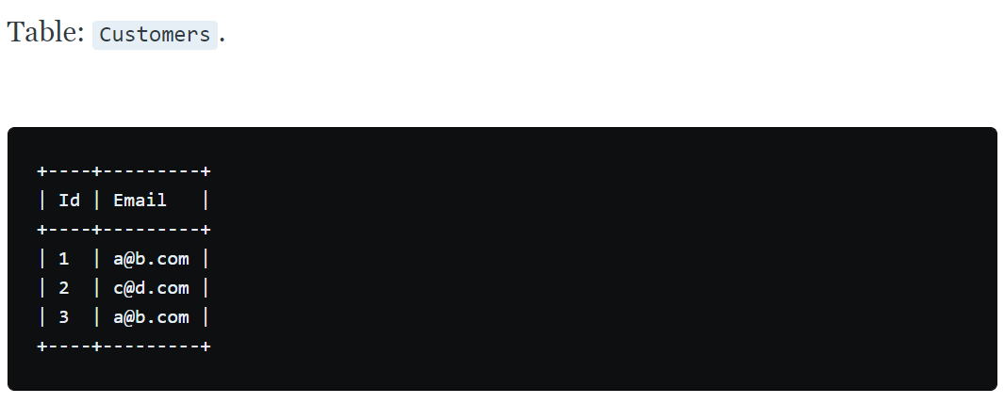

**For example, your query should return the following for the above table:**



**Solution:**

Since all email are in lowercase we can simply groupby email and print those that have a count >1.

If not in lowercase use the lower() string function.

Select lower(Email) as email from customers group by Email having count(Email)>1.

**30**. Given a Weather table, write a SQL query to find all dates' Ids with higher temperature compared to its previous (yesterday's) dates.

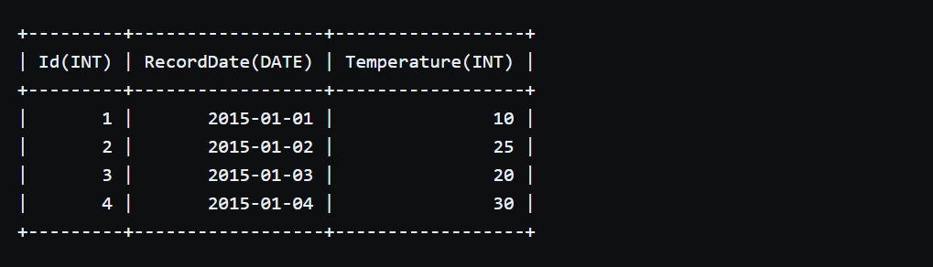

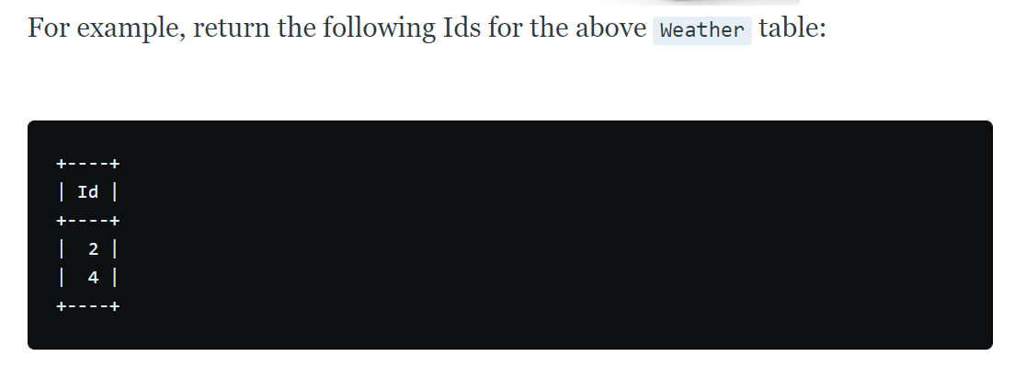

select w1.id from weather w1 inner join weather w2 on datediff(w1.recorddate,w w2.recorddate) =1

where w1.temperature > w2.temperature

**31.** The Employee table holds all employees including their managers. Every employee has an Id, and there is also a column for the manager Id.

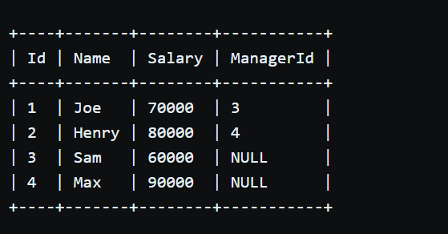

Given the Employee table, write a SQL query that finds out employees who earn more than their managers. For the above table, Joe is the only employee who earns more than his manager.

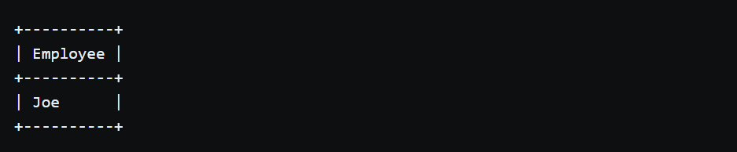

**select e1.FIRST_NAME from employees e1 inner join employees e2**

**on e1.MANAGER_ID = e2.EMPLOYEE_ID where e1.salary > e2.salary**

**32.** The Employee table holds all employees. Every employee has an Id, a salary, and there is also a column for the department Id.

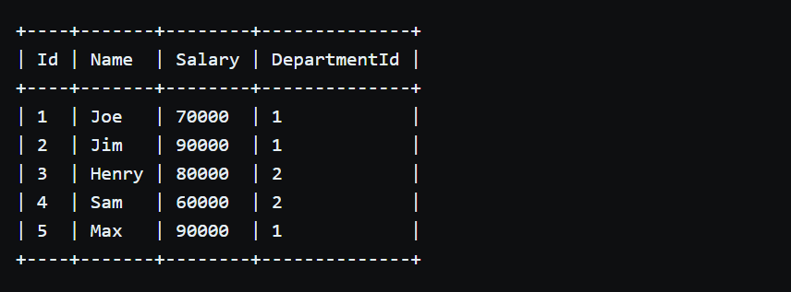

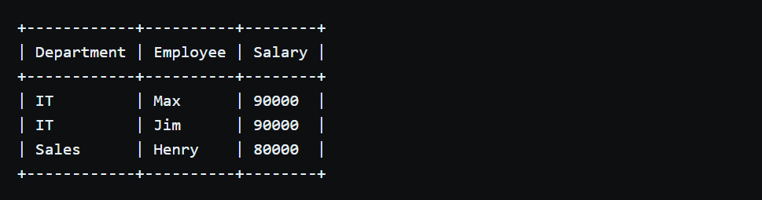

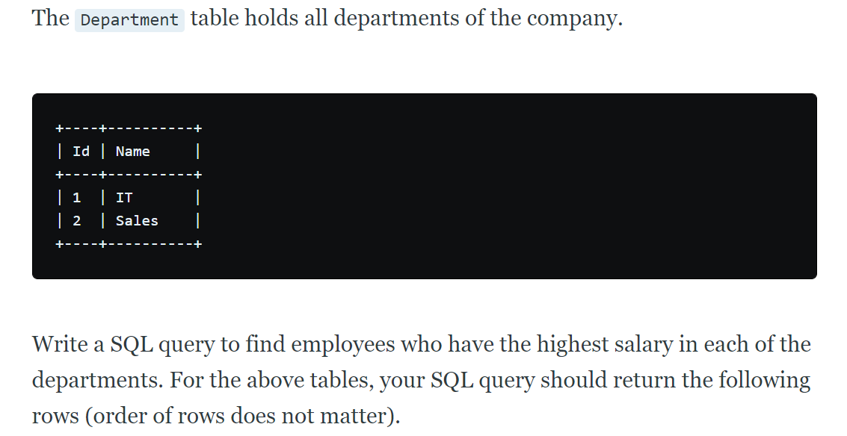

**Select Department.Id as ‘ID’, employee.name as ‘Name’**

**From**

**Employee inner join department on employee. DepartmentId = Department.Id**

**Where**

**(employee .salary, employee.DepartmentId)**

**in**

**(Select max(salary), DepartmentId from employee group by DepartmentId)**

**33.** X city opened a new cinema, many people would like to go to this cinema. The cinema also gives out a poster indicating the movies’ ratings and descriptions.

Please write a SQL query to output movies with an odd numbered ID and a description that is not 'boring'. Order the result by rating.

For example, table cinema:

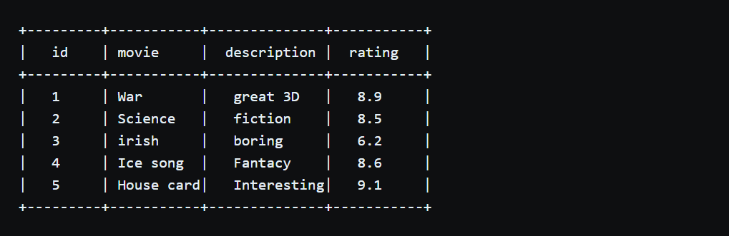

Select * from cinema

Where id%2=1 and description != ‘boring’

Order by rating desc

**34.** 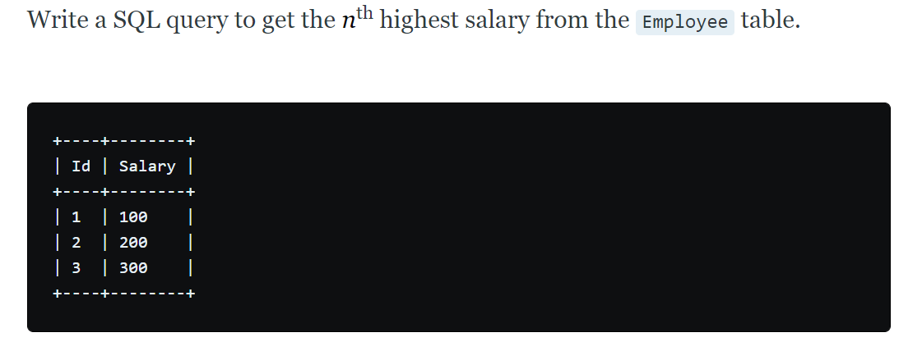

For example, given the above Employee table, the nth highest salary where n = 2 is 200. If there is no nth highest salary, then the query should return null.

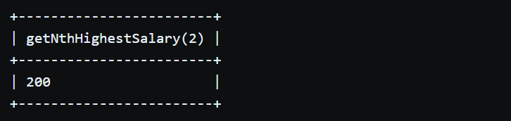

Create function getNthighestsalary (N int) returns int

BEGIN

return(

select e1.salary from employee e1 left join employee e2 on e1.salary <= e2.salary

group by e1.salary

having count(distinct e2.salary) = N

);

END

**35.** From the following table of user IDs, actions, and dates, write a query to return the publication and cancellation rate for each user.

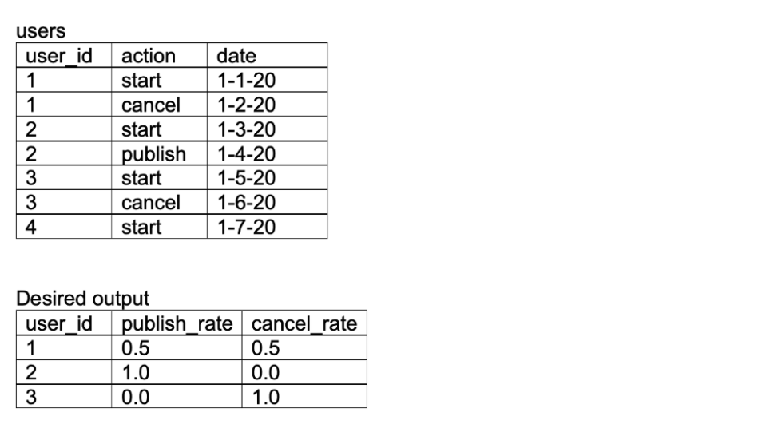

with users (user_id,action,date)

as(values

(‘1’,’start’,cast(‘1-1-20’ as date)),

(‘1’,’cancel’,cast(‘1-2-20’ as date)),

(‘2’,’start’,cast(‘1-3-20’ as date)),

(‘2’,’publish’,cast(‘1-4-20’ as date)),

(‘3’,’start’,cast(‘1-5-20’ as date)),

(‘3’,’cancel’,cast(‘1-6-20’ as date)),

(‘4’,’start’,cast(‘1-7-20’ as date))),

## now we will retrieve the sum of the start,cancel and publish

T1 as (

Select user_id,

Sum(case when action = ‘start’ then 1 else 0 end) as starts,

Sum(case when action = ‘cancel’ then 1 else 0 end) as cancels,

Sum(case when action = ‘publish’ then 1 else 0 end) as publishes

From users

Group by 1

Order by 1)

## calculate the publication, cancelation rate of the each user by dividing the number by starts and casting as float by multiplying by 1

Select user_id, 1.0*publishes/starts as publish_rate,

1.0*cancels/starts as cancel_rate from t1

**36.** From the following table of transactions between two users, write a query to return the change in net worth for each user, ordered by decreasing net change.

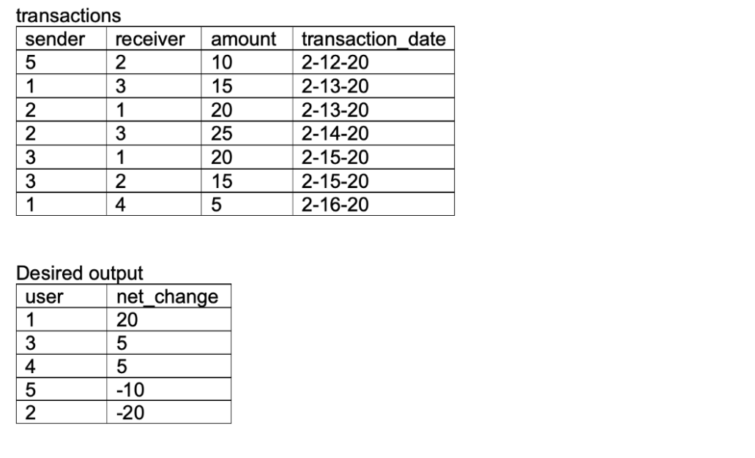

With transactions (sender,receiver,amount,transaction_date)

As values (

(‘5’,’2’,’10’,cast(‘2-12-20’ as date)),

(‘1’,’3’,’15’,cast(‘2-13-20’ as date)),

(‘2’,’1’,’20’,cast(‘2-14-20’ as date)),

(‘2’,’3’,’25’,cast(‘2-15-20’ as date)),

(‘3’,’1’,’20’,cast(‘2-16-20’ as date)),

(‘3’,’2’,’15’,cast(‘2-17-20’ as date)),

(‘1’,’4’,’5’,cast(‘2-18-20’ as date)),

## Total sum of debited debited amount from sender and credited amount for receiver

Debit as(

Select sender, sum(amount) as debited from transactions group by sender)

Credit as(

Select receiver, sum(amount) as credited from transactions group by receiver)

## we will need to full outer join on debit and credit on user id taking the net change as difference between credit and debit, coercing the nulls to 0 with

Coalesce() function

Select coalesce(sender,receiver) as user,

Coalesce(credited,0) – coalesce(debited,0) as net_change from debits d full join credits c on d.sender = c.receiver order by 2 desc

**37.**

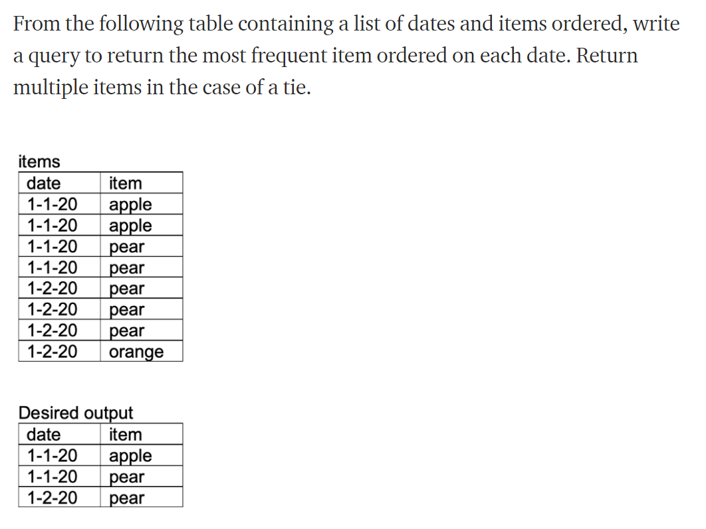

With items(date,item) as values(

(cast(‘01-01-20’ as date),’apple’),

(cast(‘01-01-20’ as date),’apple’),

(cast(‘01-01-20’ as date),’pear’),

(cast(‘01-01-20’ as date),’pear’),

(cast(‘01-02-20’ as date),’pear’),

(cast(‘01-02-20’ as date),’pear’),

(cast(‘01-02-20’ as date),’pear’),

(cast(‘01-02-20’ as date),’orange’))

## add an item count column to existing table, grouping by date and item columns

T1 as(

Select date,item,count(items) as item_counts from items group by 1,2 order by 1)

## add a rank column in descending order, partitioning by date

T2 as(

Select *,rank() over (partition by date order by item_counts desc) as date_rank from T1

## Return all date,items where rank =1

Select date,item from T2 where date_rank = 1

**38.**

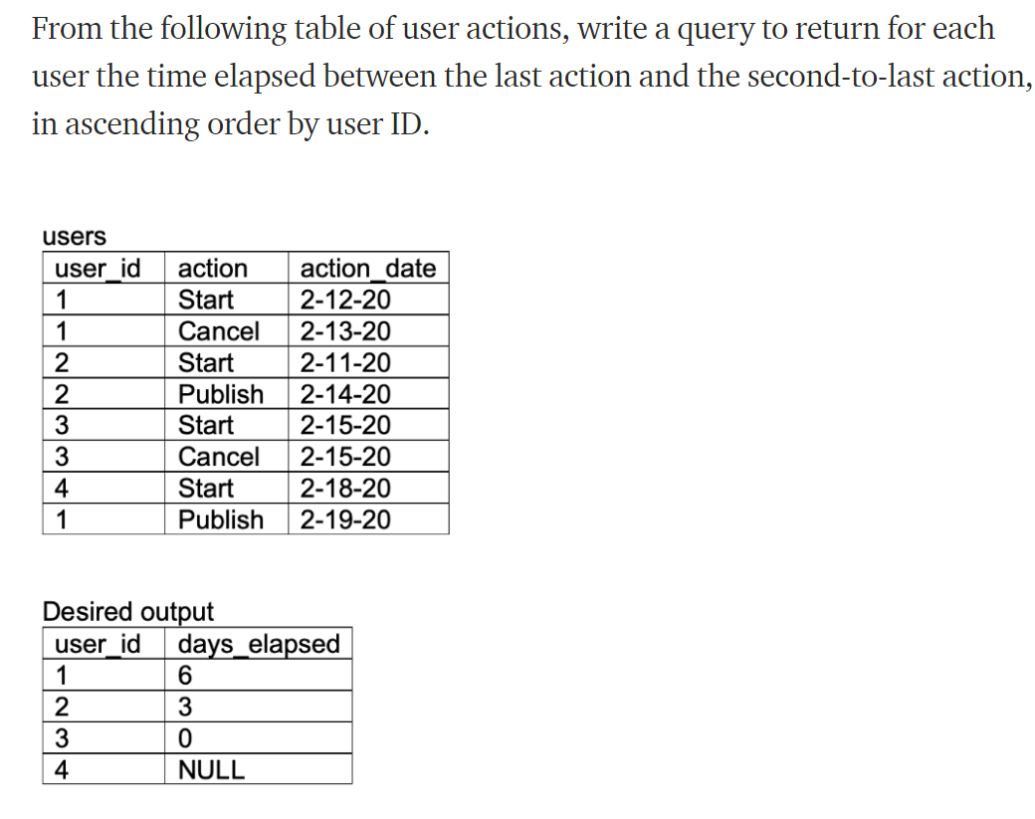

With users (user_id,action,action_date) as values(

(‘1’,’start’,caste(’02-12-20’ as date)),

(‘1’,’cancel’,caste(’02-13-20’ as date)),

(‘2’,’start’,caste(’02-11-20’ as date)),

(‘2’,’publish’,caste(’02-14-20’ as date)),

(‘3’,’start’,caste(’02-15-20’ as date)),

(‘3’,’cancel’,caste(’02-15-20’ as date)),

(‘4’,’start’,caste(’02-18-20’ as date)),

(‘1’,’publish’,caste(’02-19-20’ as date))

## now we will create a date_rank column and partition by user_id using the row_number() window function

T1 as (

Select *, row_number() over () (partition by user_id order by action_date desc) as date_rank from users ),

## filter on date rank column to pull latest and next latest actions from this table.

Latest as ( select * from T1 where date_rank = 1),

Second_latest as ( select * from T2 where date_rank =2),

## left join these tables (everyone will have a latest action, not everyone will have a second latest action) so subtracting the latest with the second_latest to get time elapsed

Select l1.user_id, l1.action_date – l2.action_date as days_elapsed from latest l1 left join second_latest l2 on l1.user_id = l2.user_id order by 1

**39.**

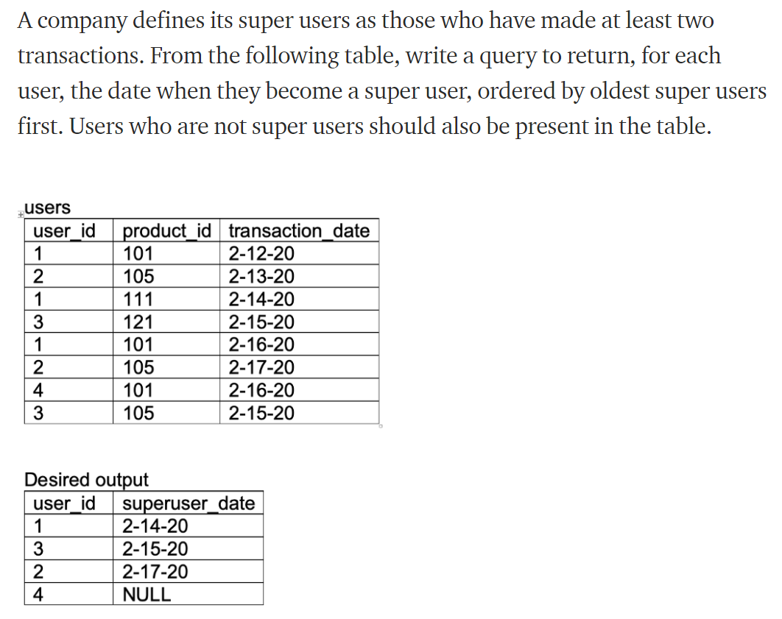

With users( user_id,product_id,transaction_date) as values(

(‘1’,’101’, cast(‘2-12-20’ as date)),

(‘2’,’105’, cast(‘2-13-20’ as date)),

(‘1’,’111’, cast(‘2-14-20’ as date)),

(‘3’,’121’, cast(‘2-15-20’ as date)),

(‘1’,’101’, cast(‘2-16-20’ as date)),

(‘2’,’105’, cast(‘2-17-20’ as date)),

(‘4’,’101’, cast(‘2-16-20’ as date)),

(‘3’,’105’, cast(‘2-15-20’ as date))

## create a transaction number column using row number () function, partitioning by user id

T1 as (

Select *, row number() over() (partition by user_id order by transaction_date asc) as transaction_number) from users),

## filter resulting table on transaction_number =2

T2 as( select user_id,transaction_date from transaction_number where transaction_number =2),

## select distinct user_id from users

T3 as( select distinct(user_id) from users)

## left join super_users onto full user table order by date

Select t3.user_id, t2.transaction_date as superuser_date from t3 left join t2 on t3.user_id = t2.user_id order by 2

**40.** From the following user activity table, write a query to return the fraction of users who are retained (show some activity) a given number of days after joining. By convention, users are considered active on their join day (day 0).

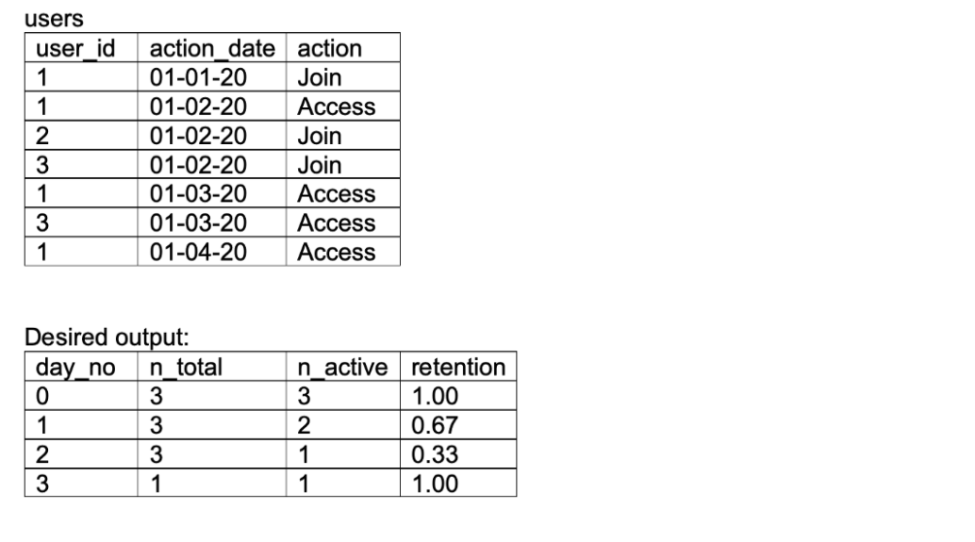

With users (user_id,action_date,action) as values (

(‘1’,cast(’01-01-20’ as date),’Join’),

(‘1’,cast(’01-02-20’ as date),’Access’),

(‘2’,cast(’01-02-20’ as date),’Join’),

(‘3’,cast(’01-02-20’ as date),’Join’),

(‘1’,cast(’01-03-20’ as date), ’Access’),

(‘3’,cast(’01-03-20’ as date), ’Access’),

(‘1’,cast(’01-04-20’ as date), ’Access’)),

## we will get the join dates for each user

Join_dates as (

Select user_id, action_date as join_date from users where action = “Join”),

## create vector containing all dates in the date range

date_vector as(

Select cast ( generate_series (min (action_date)), (max (action_date)), ‘1 day’ :: interval) as date) as dates from users),

## cross join to get all possible user date combinations

all_user_dates as (

select distinct user_id, d.dates from users cross join date_vector d),

## left join users table on all_users_date combinations on matching the user_id and date (null on days where users didn’t engage) , join onto this users sign up date, exclude user-date combination falling before user-signup

T1(

Select a.dates – c.join_date as day_no, b.user_id

From all_users_date a left join users b on a.user_id = b.user_id and a.dates = b.action_date join Join_dates c on a.user_id = c.user_id where a.dates – c.join_date>=0)

## grouping by days since sign_up ,count (not-null) user_ids as active users, total_users, and the quotient as retention_rate

Select day_no, count(*) as n_total, count(distinct user_id) as n_active, round(1.0*count(distinct user_id)/count(*),2) as retention from t1 group by 1