The SQL WITH clause allows you to give a sub-query block a name (a process also called sub-query refactoring), which can be referenced in several places within the main SQL query.

* The clause is used for defining a temporary relation such that the output of this temporary relation is available and is used by the query that is associated with the WITH clause.
* Queries that have an associated WITH clause can also be written using nested sub-queries but doing so add more complexity to read/debug the SQL query.
* WITH clause is not supported by all database system.
* The name assigned to the sub-query is treated as though it was an inline view or table
* The SQL WITH clause was introduced by Oracle in the Oracle 9i release 2 database.

**Syntax:**

WITH temporaryTable (averageValue) as

(SELECT avg(Attr1)

FROM Table)

SELECT Attr1

FROM Table, temporaryTable

WHERE Table.Attr1 > temporaryTable.averageValue;

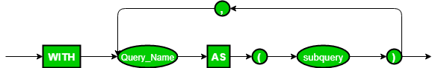

In this query, WITH clause is used to define a temporary relation temporaryTable that has only 1 attribute averageValue. averageValue holds the average value of column Attr1 described in relation Table. The SELECT statement that follows the WITH clause will produce only those tuples where the value of Attr1 in relation Table is greater than the average value obtained from the WITH clause statement.

**Note:**When a query with a WITH clause is executed, first the query mentioned within the  clause is evaluated and the output of this evaluation is stored in a temporary relation. Following this, the main query associated with the WITH clause is finally executed that would use the temporary relation produced.