**STUFF() :**   
In SQL Server, stuff() function is used to delete a sequence of given length of characters from the source string and inserting the given sequence of characters from the specified starting index.

**Syntax:**

STUFF (source_string, start, length, add_string)

**Where:-**   
**1. source_string:**Original string to be modified.   
**2. start:**The starting index from where the given length of characters will be deleted and new sequence of characters will be inserted.   
**3. length:**The numbers of characters to be deleted from the starting index in the original string.   
**4. add_string:**The new set of characters (string) to be inserted in place of deleted characters from the starting index.

**Note:** It is not necessary to have the length of the new string and number of characters to be deleted the same.

**Example 1:**

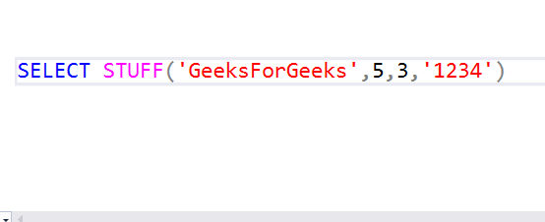

**Output:**

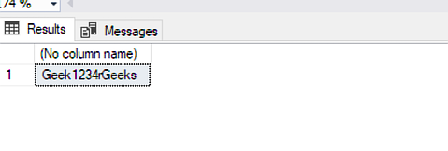

**Example 2:**

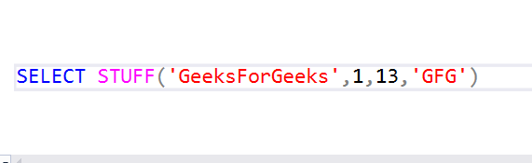

**Output:**

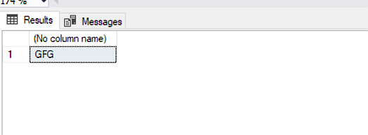

**Example 3:**

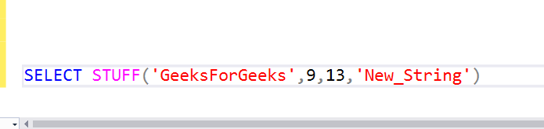

**Output:**

