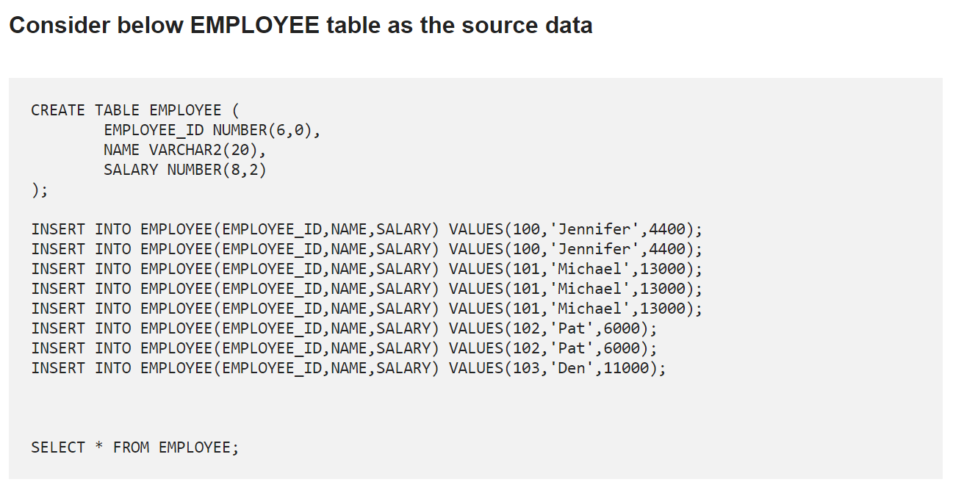

1. **How to select UNIQUE records from a table using a SQL Query?**

select distinct EMPLOYEE_ID,NAME,SALARY from employee

select EMPLOYEE_ID,NAME,SALARY from employee group by EMPLOYEE_ID

1. **How to delete DUPLICATE records from a table using a SQL Query?**

Consider the same EMPLOYEE table as source discussed in previous question

Using ROW_NUMBER Analytic Function.

WITH cte AS (

SELECT

emp_id,

name,

salary,

ROW_NUMBER() OVER (

PARTITION BY

emp_id,

name,

salary

ORDER BY

emp_id

)

FROM

employee

)

DELETE FROM cte

WHERE row_num > 1;