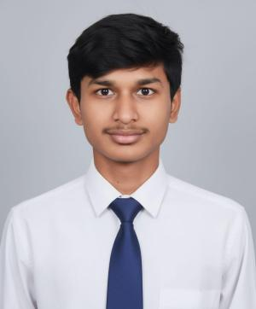
NAME (in caps)
Address: Sweet Dreams Co-living Studio Rooms,
Brilliant School Road, AECS layout, Marathahalli,
Bengaluru, Karnataka – 560037.
Email ID:
Mobile No:
LinkedIn:
GitHub:
LeetCode:
CAREER OBJECTIVE

EDUCATION QUALIFICATION
- Bachelor Of Engineering (B.E)- Computer Science Engineering (Data Science)
CMR Institute of Technology, Bengaluru, Karnataka
Cgpa, 2027[Pursuing]
- Class XII – PCM
College name, City, State
Percentage %, 2023
- Class X
School name, City, State
Percentage %, 2021
TECHNICAL SKILLS
Programming Languages:
Database Management:
Operating Systems:
Data Analysis and Visualization:
Development Tools and IDEs: (add more if needed)
PROJECTS
- Project 1

- Tech Stack:
- Project 2

- Tech Stack:
- Project 3

- Tech Stack:
INTERNSHIPS
- Xyz
Duration:
Designation:
Responsibilities:

CO-CURRICULAR & EXTRACURRICULAR ACTIVITIES
- Hackathons:

- Technical Clubs:

- Certifications:

- Additional Responsibilities:

ACHIEVEMENTS

PERSONAL DETAILS
Date of Birth :
Gender :
Nationality :
Permanent Address :
Linguistic Competency :
Hobbies :

