ICC wants to schedule cricket world cup tournament in 2019. There are total 12 teams participating in it across 6 venues. They decided to go with an automated scheduling software. All the teams should be divided into 4 groups A, B, C, D randomly.

Teams

India

Australia

Pakistan

Sri Lanka

Bangladesh (Associate team)

West Indies

England

New Zealand

South Africa

Zimbabwe (Associate team)

Afghanistan (Associate team)

Ireland (Associate team)

Venues

Melbourne

Sydney

Brisbane

Perth

Hobart

Canberra

Tournament will start from April 8th and has group stages, quarterfinals, semis and finals.

PART 1

The task is to schedule matches automatically with the following rules

* Only one match should be played in a day in a venue and should get minimum 1 day off after match day for pitch preparation for next match.
* Every team should be given minimum 2 days rest after they play the match.
* In group stages every team should play one match against other in the group.
* There should only be maximum of 2 matches scheduled per day in the tournament.
* Each group should have one associate team
* Top 2 of each group will be qualified to quarters and same group teams shouldn’t play in quarters.
* Finals should be in Melbourne.

Output the schedule into a file schedule.txt

PART 2

The tournament begins and each team will play against each other in groups and score of the team should be generated by a random number from 100 – 400 and wickets 0 – 10 . Net runrate is calculated as (total runs scored in all matches divided by 50 minus (number of wickets \* 20))/ 100

* Team get 2 points for each win and 0 for loss and one each for draw in group stages.
* Top two teams will reach quarters and if points are equals then team with highest net runrate will qualify.
* Teams which won in quarters reach semis and which one in semis reach finals

Output the tournament group stages, quarters, semis and finals in matches.txt file

Output in whatever format looks good for you

Example schedule (discard time)

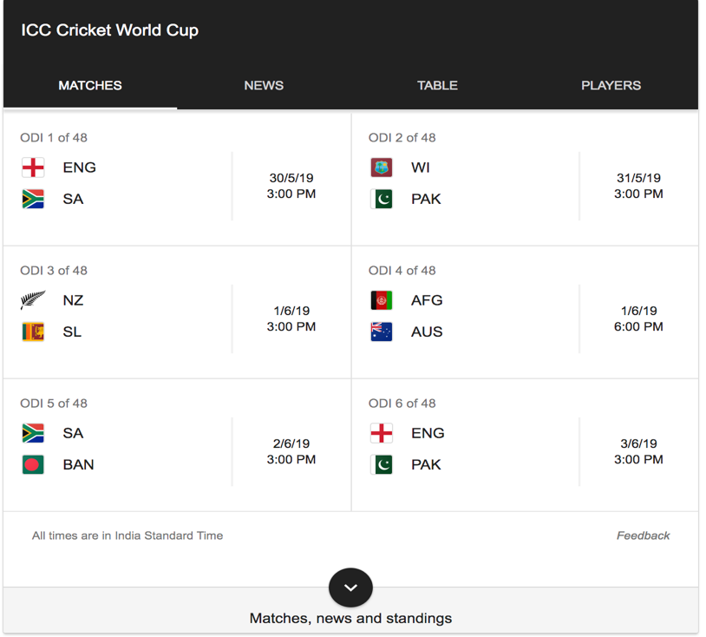

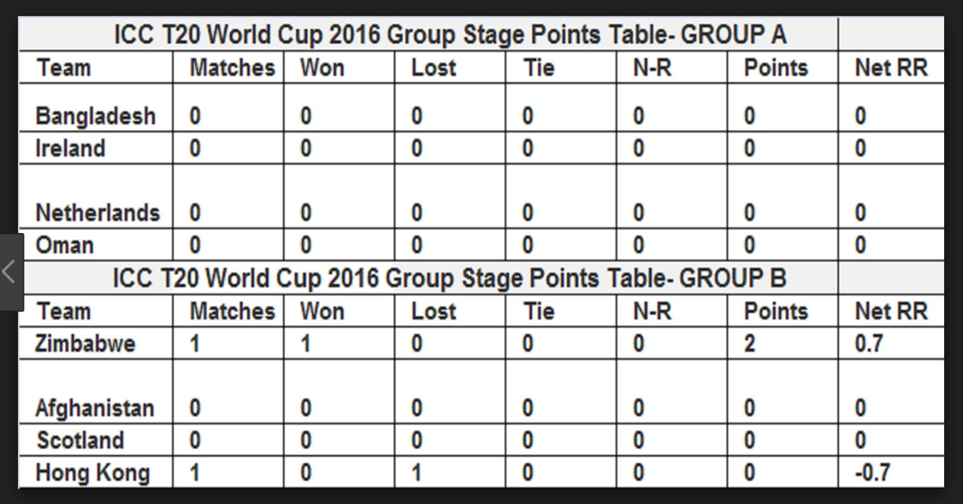

Please do this exercise in TDD