BCSE497J - Project-I

JANSAMADHAN
AI-POWERED CIVIC ISSUE REPORTING SYSTEM
23BCE0659 | ANKIT KUMAR
23BCI0057 | DEVESH SINGHAL
23BCI0078 | MAYANK GUPTA

Project ID:
Under the Supervision of
JAYALAKSHMI M.
Designation: ______________________________
School of Computer Science and Engineering (SCOPE)
B.Tech.
in
Computer Science and Engineering
Specialization: Information Security
School of Computer Science and Engineering

September 2026

ABSTRACT
JanSamadhan is an AI-assisted civic issue reporting prototype for Lucknow, Uttar Pradesh. It connects citizen reporting, complaint classification, priority estimation, possible-duplicate detection, proposed department routing and status tracking in a role-controlled web application. Citizens submit a description, location and optional photograph. Officers manage department queues, while administrators review assignments and monitor reports.
The implementation uses React, Vite and Tailwind CSS with an Express backend, Neon PostgreSQL persistence and a Python FastAPI model service. Two balanced Logistic Regression classifiers use word and character TF-IDF features. The prepared text corpus contains 34,470 examples, comprising 31,014 cleaned CivicComp-HiEn texts and 3,456 authored training examples. A separate ImageNet-pretrained MobileNetV3-Small model is fine-tuned on 12,189 cleaned civic images from Road Issues Detection, TrashNet and TACO. Related texts and images remain within grouped dataset splits to reduce leakage.
On held-out tests, category prediction achieves 77.09% accuracy and 69.09% macro F1; priority prediction achieves 76.40% accuracy and 68.33% macro F1. Image classification achieves 92.79% accuracy and 82.96% macro F1. The integrated application has 29 recorded passing automated tests, supplemented by browser submission and database persistence checks. Uncertain image predictions and ambiguous jurisdiction require human review. The text corpus is Bengaluru-derived and the image benchmark has no independent Lucknow holdout. The current outcome is a controlled academic prototype with internal officer queues; municipal integration and field validation remain future work.
Keywords - Civic complaints, Natural language processing, Transfer learning, Jurisdiction, PostgreSQL.

TABLE OF CONTENTS
Sl. No. | Contents | Page No.
 | Abstract | i
1. | INTRODUCTION | 1
 | 1.1 Background | 1
 | 1.2 Motivation | 1
 | 1.3 Scope of the Project | 1
2. | PROJECT DESCRIPTION AND GOALS | 2
 | 2.1 Literature Review | 2
 | 2.2 Research Gap | 4
 | 2.3 Objectives | 4
 | 2.4 Problem Statement | 4
 | 2.5 Project Plan | 5
3. | TECHNICAL SPECIFICATION | 6
 | 3.1 Requirements | 6
 | 3.1.1 Functional | 6
 | 3.1.2 Non-Functional | 7
 | 3.2 Feasibility Study | 7
 | 3.2.1 Technical Feasibility | 7
 | 3.2.2 Economic Feasibility | 8
 | 3.2.3 Social Feasibility | 8

TABLE OF CONTENTS
Sl. No. | Contents | Page No.
 | 3.3 System Specification | 8
 | 3.3.1 Hardware Specification | 8
 | 3.3.2 Software Specification | 9
4. | DESIGN APPROACH AND DETAILS | 10
 | 4.1 System Architecture | 10
 | 4.2 Design | 15
 | 4.2.1 Data Flow Diagram | 15
 | 4.2.2 Use Case Diagram | 16
 | 4.2.3 Class Diagram | 17
 | 4.2.4 Sequence Diagram | 18
5. | REFERENCES | 19

1. INTRODUCTION

1.1 Background
Municipal service requests describe problems such as missed waste collection, damaged roads, failed public lighting, interrupted water supply and overflowing sewers. A useful reporting system must connect the description to the correct service function while retaining location, evidence and progress history. Research on 311 requests demonstrates the value of automatic text categorization and also identifies ambiguous descriptions and inconsistent labels as practical obstacles [1]. JanSamadhan applies these ideas to a bounded Lucknow pilot. Its language classifiers estimate category and priority, and explicit rules check whether municipal ownership is uncertain. The database records the report and subsequent officer actions. Machine learning supports triage, while the officer remains responsible for reviewing the evidence and recording action. The prototype separates model evaluation from operational outcomes: correct benchmark predictions do not establish that a municipal issue was resolved.

1.2 Motivation
The project addresses the difficulty of turning a citizen narrative into an accountable service workflow. A complaint can use different languages, omit ownership details or resemble a nearby earlier report. A photograph may show a damaged surface without identifying the authority responsible for it. JanSamadhan therefore combines classification with locality checks, a possible-duplicate preview, an explicit departmental role and visible status history. English, Hindi and Hinglish examples support variation in complaint wording. The addition of outdoor-litter photographs addresses an observed weakness of an earlier image model that relied heavily on isolated waste objects. The academic motivation is to implement and evaluate the complete interaction between the website, trained models and persistent database. Improved resolution time or citizen satisfaction remains an intended benefit that requires a future field study.

1.3 Scope of the Project
The pilot accepts configured Lucknow localities and coordinates within its defined geographic bounds. It supports citizen, department-officer and administrator accounts; description and image submission; category and priority prediction; duplicate candidates; proposed department routing; and status tracking. Text classes are Garbage, Road Damage, Streetlight, Water Supply, Sewerage and Other. The image classifier provides seven visual labels and does not establish urgency, ownership, parking legality or the operation of water and electrical assets. Reports and photos persist in Neon PostgreSQL. The evaluation covers prepared external datasets and controlled application tests. Government submission, SMS delivery, voice input, formal service-level analytics and independently labelled Lucknow field evaluation remain outside the implemented scope. The work demonstrates a local academic application with cloud database storage, rather than a statewide operational government service.

2. PROJECT DESCRIPTION AND GOALS

2.1 Literature Review
The selected literature covers civic-text categorization, departmental interpretation, complaint prioritization, community data integration and human oversight. The review also includes the image architecture and contextual litter dataset used in the implemented system. The comparison is qualitative: results from different cities, labels and test sets are not directly comparable to JanSamadhan.
Civic category prediction
Hashemi [1] examines automatic type detection from customer-provided 311 descriptions and standardizes categories across two cities. The study supports supervised text classification as a way to reduce manual categorization effort. It also reports descriptions that lack enough information and cases where the source label appears incorrect. These observations motivate JanSamadhan’s removal of contradictory label groups and its manual-review route for uncertain complaints. The paper does not establish accuracy for the present multilingual Lucknow pilot.
Category and department interpretation
Wang et al. [2] study community-in-the-loop artificial process intelligence using Kansas City 311 data. Their approach connects citizen wording with internal categories and departments through BERT classification, topic grouping and time-related models. The work supports separating citizen-facing descriptions from administrative routing. JanSamadhan uses a lighter TF-IDF classifier and an explicit department directory. This is an implementation choice for the local prototype, not a measured claim that the lighter method outperforms BERT.
Data integration and civic monitoring
Ho et al. [3] present OpenComm for integrating community and 311 data with attention to privacy. Its contribution concerns data harmonization and the quality of information used in civic analysis. JanSamadhan adopts the narrower idea that location and structured records improve monitoring. Its map displays application reports; it does not implement OpenComm’s full integration or privacy-learning techniques. Access control and data minimization are therefore treated as application requirements with explicit limits.
Complaint prioritization
Vairetti et al. [4] combine multicriteria labelling with transformer-based complaint prioritization. The distinction between assigning a priority label and learning to predict it is relevant to this project. JanSamadhan trains a separate priority classifier on the supplied severity annotations, but those annotations are not independently verified emergency decisions. Its danger-cue rules remain a separate safeguard. No customer-satisfaction or financial benefit reported elsewhere is attributed to this prototype.
Multilingual classification and citizen acceptance
Rakhimzhanov, Belginova and Yedilkhan [5] compare large language models and embedding methods for multilingual public-transport complaints. The study describes linguistic variation, code-switching and category ambiguity. These issues support reporting per-class performance and keeping translations together during data splitting. JanSamadhan’s English, Hindi and Hinglish corpus is a different language and domain setting, so its test metrics must be reported independently.
Lehtiö et al. [6] investigate citizen perceptions of AI in smart-city settings through a survey and scenario interviews. Concerns about monitoring, effort, risks and acceptable AI behaviour show why technical accuracy alone is insufficient for acceptance. JanSamadhan exposes the proposed route, keeps officer review, and avoids presenting a photo score as proof of an incident. A citizen usability or acceptance study has not yet been conducted for the application.
Efficient visual recognition
Howard et al. [7] introduce MobileNetV3 using efficient architecture design and search techniques. The project uses the torchvision MobileNetV3-Small implementation initialized with ImageNet weights, then replaces its output layer for seven civic classes. Transfer learning reuses general visual features while adapting the network to the task. The project evaluates classification, not bounding-box detection or segmentation, and does not reproduce the architecture-search experiments from the paper.
Litter in realistic surroundings
Proença and Simões [8] introduce TACO, which provides annotated litter photographs in context. TACO is relevant because roadside litter appears with pavement, buildings and vehicles, whereas isolated waste photographs provide a different visual setting. JanSamadhan combines retained TACO photographs with TrashNet [10] and road-issue images [11]. It uses whole-image labels and groups TACO photographs by acquisition batch. The original object annotations do not make this implementation an object detector.
Synthesis
The reviewed work supports automated categorization, priority modelling and civic analytics. The project’s contribution is an integration of these functions with role-scoped persistence, location-aware duplicate candidates and a traceable officer workflow. The review does not establish that no other system integrates these features. The remaining research need is to measure how this specific combination behaves on independently labelled local data and during an authorized municipal pilot.

2.2 Research Gap
There are three gaps relevant to the present implementation. First, the available complaint corpus is derived from Bengaluru and translated into Hindi and Hinglish, whereas routing is configured for Lucknow. Generalization across cities remains unmeasured. Second, benchmark labels do not resolve municipal asset ownership, and a predicted road problem may concern a PWD, NHAI, LDA or private asset. Third, class imbalance and unfamiliar visual scenes can produce unreliable predictions even when aggregate accuracy is high. The project addresses these gaps partly through grouped evaluation, per-class reporting and manual jurisdiction review. It does not claim to close the local-data or field-validation gaps.

2.3 Objectives
By the Project-I review, integrate citizen reporting, officer actions and administrator monitoring in one authenticated application, with every successfully submitted report retrievable by its identifier.
Train and compare word-only and word-plus-character text classifiers for six complaint categories and three priorities; select by validation macro F1 and report held-out test results.
Fine-tune MobileNetV3-Small for seven visual classes, preserve separate validation and test groups, and expose uncertain outputs for human review.
Implement a possible-duplicate check using category, text similarity, a 150-metre distance limit and a seven-day window, with citizen acknowledgement instead of silent merging.
Persist reports, images and action history in Neon PostgreSQL and verify both authorized access and survival after an API restart.
Display proposed department roles and ownership conditions, while retaining a manual queue for uncertain or out-of-scope cases.

2.4 Problem Statement
Design and evaluate a civic reporting prototype that converts a multilingual complaint and optional image into a reviewable internal service case for the Lucknow pilot. The system must provide category and priority estimates, identify plausible nearby duplicate reports, avoid unsupported ownership assignments, preserve report evidence and allow authorized officers to record progress. Its model scores must remain distinguishable from verified incident facts and municipal resolution outcomes.

2.5 Project Plan
The project proceeds through requirements and literature review, data preparation, model training, application development, integration, verification and report preparation. Dates and scheduling bars are left blank for the team to enter its actual plan. Completed implementation work is described separately from future field-validation work.
Activity | Start | End | Status
Requirements and literature review |  |  | Documented
Text data preparation and models |  |  | Implemented
Image dataset audit and fine-tuning |  |  | Implemented
React interface and Express API |  |  | Implemented
Neon persistence and integration |  |  | Verified in demo
Functional and model evaluation |  |  | Recorded
Project-I report and review |  |  | Prepared
Authorized Lucknow field pilot |  |  | Future work

Gantt Chart
Activity | Period  ____ | Period  ____ | Period  ____ | Period  ____
Literature and requirements
Dataset preparation
Text and image training
Frontend and backend
Database integration
Testing and correction
Documentation and review

Fig. 1. Project Gantt chart
Recorded Team Responsibilities
The presentation assigns backend and database work to Ankit Kumar (23BCE0659), frontend and API integration to Mayank Gupta (23BCI0078), and AI and machine-learning work to Devesh Singhal (23BCI0057). These are the stated team responsibilities for the project.

3. TECHNICAL SPECIFICATION

3.1 Requirements

3.1.1 Functional
ID | Requirement and implemented behaviour
FR1 | Register citizens and authenticate accounts using hashed passwords and session cookies.
FR2 | Enforce citizen ownership, officer department scope and administrator access on the server.
FR3 | Accept a 10–3000 character description, configured locality and valid pilot coordinates.
FR4 | Accept an optional JPEG or PNG; resize large browser input and validate the saved upload.
FR5 | Preview category, priority and proposed routing, with visible input and service errors.
FR6 | Provide image class scores, uncertainty reasons and text/image agreement for officer review.
FR7 | Flag possible duplicates using text, category, distance and time, without silently merging cases.
FR8 | Save the report and optional photo transactionally and immediately display the returned record.
FR9 | Allow officers to view their queue and record permitted status transitions with action notes.
FR10 | Allow authorized priority correction, administrator reassignment and reopening with history.
FR11 | Provide citizen tracking, scoped maps, counts and administrator monitoring.
FR12 | Display dataset provenance, split sizes, held-out metrics and proposed departmental contacts.

The model service is required for analysis and submission. A failed prediction or failed database transaction returns an error; the interface must not claim a report was saved. Reports are internal cases and no government message is sent.

3.1.2 Non-Functional
Security: enforce role and record scope on every protected operation, hash passwords, restrict upload types and use parameterized SQL. The current local demonstration is not a completed production security audit.
Reliability: commit report and photograph changes together, retain report history and show explicit service errors. In-memory sessions require login again after an API restart.
Usability: display field validation near the problem, move focus to the routing preview and preserve visibility of a successfully submitted report. Photo resizing must leave the original local file unchanged.
Reproducibility: retain dataset manifests, split policies, training history, saved weights and metric files. Use fixed random seeds and isolate related examples before evaluation.
Maintainability: separate React presentation, Express workflow, PostgreSQL persistence and Python inference so that model or routing changes can be reviewed independently.
Performance and capacity: the prototype runs one API instance with database-backed persistence. No load-test capacity, service-level latency or availability guarantee has been measured.

3.2 Feasibility Study

3.2.1 Technical Feasibility
The required technologies are already integrated in the working prototype. Text models load from Joblib, the image model loads from a PyTorch checkpoint, and the local FastAPI service returns predictions to Express. The review launcher serves the built frontend and API on port 3001 and runs inference on port 8001. CUDA was used for the recorded image-training run, while the live image service loads its checkpoint on CPU. Neon supplies persistent storage over a TLS connection. This establishes feasibility for the demonstrated single-instance workflow, but it does not establish production scale or multi-instance consistency.

3.2.2 Economic Feasibility
The implementation uses open-source application and machine-learning libraries and existing development hardware. The current Neon project was created under the account’s Free plan. There is no project-specific paid prediction API in the inference path. This reduces direct infrastructure requirements for an academic demonstration, but it is not a measured cost saving. Hosting, database usage beyond plan limits, backups, monitoring, personnel and authorized municipal integration would require a separate operating budget. No numerical budget, return on investment or subscription forecast is asserted.

3.2.3 Social Feasibility
The interface is intended to make reporting and status visibility easier for citizens while preserving officer review. Multilingual text examples provide coverage of English, Hindi and Hinglish wording, although performance still depends on the prepared corpus. Photographs may contain personal information, so access is restricted to authorized accounts. Municipal roles are proposed routing targets and must be confirmed for the zone and asset. Citizen satisfaction, accessibility compliance and adoption have not been measured. Before a field pilot, the team should obtain institutional authorization, define data retention and seek feedback from citizens and municipal staff [6].

3.3 System Specification

3.3.1 Hardware Specification
Component | Recorded development environment
Processor | 12th Gen Intel Core i5-12500H
Graphics | NVIDIA GeForce RTX 3050 Laptop GPU; Intel UHD Graphics
Training execution | CUDA for the saved image-training run
Memory capacity | ____________________________
Storage capacity | ____________________________
Monitor specification | ____________________________

Processor and graphics names were read from the development computer. Unconfirmed capacity values remain blank. These are development-environment details, not benchmarked minimum hardware requirements.

3.3.2 Software Specification
Layer | Technology | Primary implementation files
Frontend | React 19, Vite 6, Tailwind CSS 4, custom CSS | frontend/main.jsx; style.css; vite.config.js
Interface features | Leaflet, Lucide React, browser Fetch and Canvas APIs | frontend/main.jsx; upload-image.js
Backend | Node.js, Express 5, Multer, cookie-parser | backend/server.js
Persistence | Neon PostgreSQL 18, pg, dotenv | backend/postgres.js; backend/store.js
AI API | Python, FastAPI, Uvicorn, Pydantic | ml/service.py
Text models | scikit-learn, NumPy, TF-IDF, Logistic Regression, Joblib | ml/train.py; models.joblib
Image models | PyTorch 2.7.1, torchvision 0.22.1, Pillow, SciPy | ml/train_images.py; ml/vision.py
Model evidence | JSON metrics and CSV manifests | data/model_metrics.json; image_metrics.json
Development | Windows, VS Code, PowerShell, npm, pip | package.json; requirements.txt
Verification | Node test runner, Python unittest | tests; docs/TEST_REPORT.md

Execution and Configuration
START_DEMO.cmd calls scripts/start.ps1, checks prerequisites and starts healthy services only when needed. Express serves the prebuilt dist directory at http://127.0.0.1:3001. During development, npm run dev also starts Vite on its available development port, normally 5173, and forwards API requests to port 3001. The Python API uses port 8001. The launcher starts background processes; closing its terminal does not necessarily terminate those services.
DATABASE_URL is read from the ignored .env file. Its value must not be included in a report or shared package. If absent, the application uses local persistent JSON storage. MongoDB is not the active storage adapter. Model weights are loaded for inference; starting the application does not retrain them.

4. DESIGN APPROACH AND DETAILS

4.1 System Architecture
The browser presents forms and role-specific views. Express checks authorization, validates the report, calls FastAPI, applies the configured department mapping and persists the case. FastAPI provides trained predictions and duplicate analysis. Neon stores users, reports and photographs. Figure 2 shows the boundaries between these components.
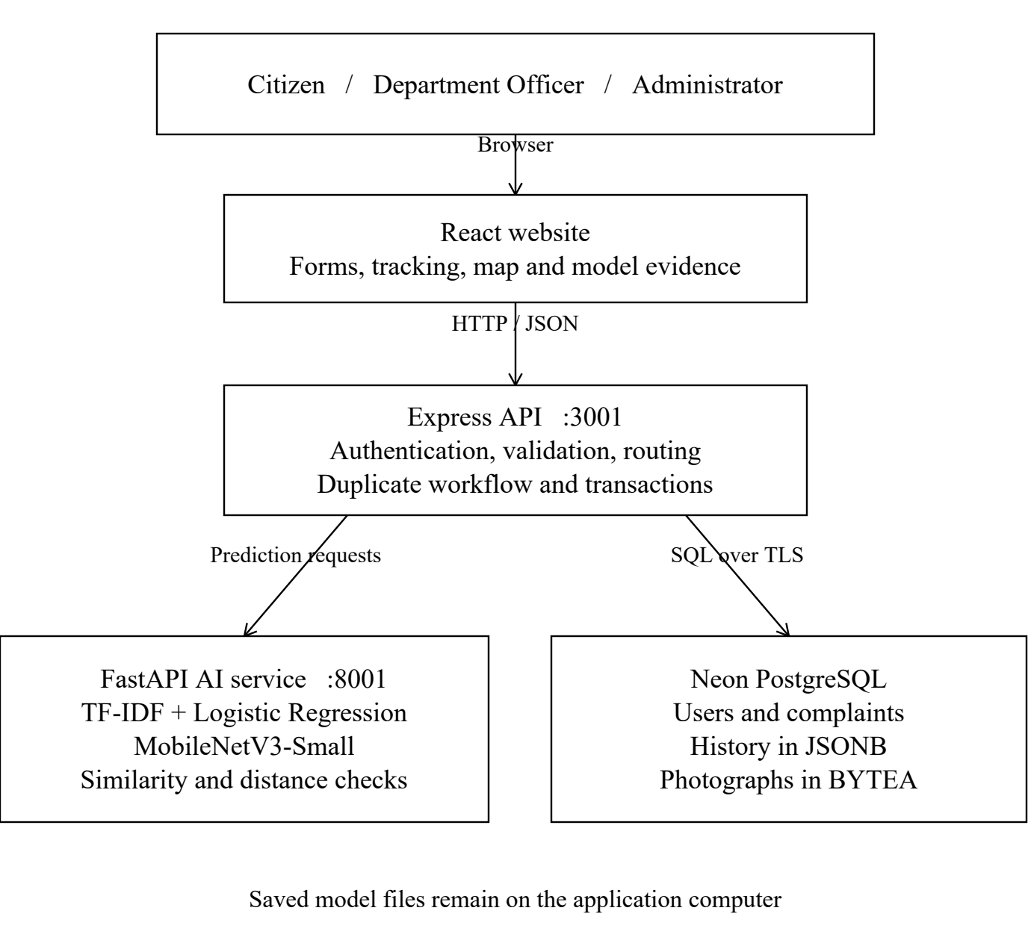
Fig. 2. System architecture
The text prediction and ownership rules determine the proposed route. An image supplies additional visual evidence and uncertainty information; it does not override text routing. The final submission repeats analysis on the server so that a client preview cannot be treated as authoritative saved evidence.
Text Dataset and Preparation
CivicComp-HiEn [9] is the primary external text source. The downloaded train, development and test files contain 11,200 records and 33,600 English, Hindi and Hinglish text slots. The project recombines the files and creates its own grouped split, so its evaluation is not the publisher’s original benchmark. Basic cleaning masks phone, email and URL patterns and removes short or blank text. Related original IDs and normalized texts are grouped before splitting. Contradictory mapped labels cause 619 source records to be excluded; normalized duplicates are removed.
Text data component | Examples
Cleaned external texts | 31,014
Authored training support | 3,456
Combined usable dataset | 34,470
Training split | 25,136
Validation split | 4,677
Test split | 4,657

All translations of related complaints remain in one split. Synthetic support is included only in training. The authoring generator combines issue phrases, urgency contexts and six Lucknow localities. Its full reproducibility file has 3,888 rows, but only 3,456 training rows enter the current models. These are examples rather than independent citizen counts. The external corpus is Bengaluru-derived, and synthetic locality names do not turn it into a real Lucknow dataset.
Text Training and Inference
The pipeline compares word TF-IDF with a union of word and character TF-IDF. Word features use unigrams and bigrams; character features use within-word fragments of lengths three to five. Two balanced Logistic Regression classifiers learn category and priority independently. Vocabulary and inverse-document-frequency weights are fitted on training data only. Validation macro F1 selects the word-plus-character candidate for both targets, and the selected pipelines are saved in ml/models.joblib. Complaint text is the only learned input; label, locality metadata and source severity keywords are not passed as model features.
At inference, predict_proba returns class scores. Low category confidence, Other predictions and ownership cues can route a case to manual review. Explicit danger cues can raise the final priority. Raw model labels are preserved separately from these rule decisions, and benchmark metrics evaluate the raw classifiers.
Image Dataset and Preparation
The image-v2 pipeline combines Road Issues Detection [11], TrashNet [10] and TACO [8]. Of 13,687 inspected files, 12,189 are retained after duplicate, unsupported-scene, dark-image and label-conflict filtering. Source filenames, decoded-pixel hashes and perceptual difference hashes group related images. TACO photographs are also grouped by acquisition batch. The split is stratified at group level, so image counts do not follow an exact 70/15/15 ratio.
Image source or split | Retained images
Road Issues Detection | 8,403
TrashNet | 2,402
TACO | 1,384
Total | 12,189
Training / validation / test | 8,495 / 1,906 / 1,788

Transfer Learning Procedure
MobileNetV3-Small [7] starts from ImageNet-pretrained weights. The final layer is replaced for seven classes. Training images undergo resizing, a random crop to 224 × 224, horizontal flipping, colour jitter and normalization. Validation and test images use deterministic resizing and normalization. Weighted cross-entropy accounts for class imbalance and AdamW updates the parameters. The first two epochs train the classifier with the feature extractor frozen. Subsequent epochs fine-tune CNN weights with smaller learning rates while keeping batch-normalization running statistics fixed.
Eight epochs were recorded using CUDA and batches of 32 images. Epoch 7 achieved the highest validation macro F1, 85.18%, and its checkpoint became the live model. Epoch 8 had lower training loss but worse validation F1, so the final epoch was not selected. The saved weights are in ml/image_model.pt. This is whole-image scene classification, with no object localization and no independently verified Lucknow image holdout.
Score Calibration and Review
A temperature of approximately 1.74 was fitted on validation data to adjust score sharpness. Garbage/litter and pothole suggestions require a score of at least 0.70 and a top-two margin of at least 0.15 under the saved policy. Other classes require review. These validation-derived checks cannot guarantee correctness on arbitrary uploads. Image data licensing and upstream provenance remain documented limitations, and raw external images are excluded from the shared review package.
Model Evaluation
The final test sets are reserved for evaluating selected models. Accuracy measures the fraction of correct predictions. Precision measures correctness among predictions of a class, and recall measures how many actual examples of that class are found. F1 combines precision and recall. Macro F1 gives every class equal weight, which helps expose weak minority classes. Table 1 reports the recorded raw-classifier test results.
Model | Test examples | Accuracy | Macro F1
Text category | 4,657 | 77.09% | 69.09%
Text priority | 4,657 | 76.40% | 68.33%
Image-v2 | 1,788 | 92.79% | 82.96%

Table 1. Held-out model results
Image class | Test support | F1
Garbage / litter | 538 | 96.83%
Street scene / review | 216 | 96.44%
Damaged road sign | 267 | 95.29%
Graffiti | 274 | 93.72%
Pothole | 418 | 91.44%
Parking scene | 12 | 58.82%
Road surface issue | 63 | 48.18%

Table 2. Per-class image results
Text Sewerage has only 15 test examples and an F1 of 26.67%, which is a substantial limitation. Image parking and road-surface classes also remain weak. The image acceptance policy covers 899 of 1,788 test images, or 50.28%, with 96.44% correctness among accepted suggestions. This selective result must not be presented as accuracy over every uploaded image.
On the same 182 held-out TACO litter photographs, the earlier checkpoint recognized 29 as waste/litter and image-v2 recognized 179, corresponding to recall of 15.9% and 98.4%. This is a paired litter-recall comparison, not an overall accuracy improvement across all classes. Saved confusion matrices, class reports and epoch history are available in data/model_metrics.json and data/image_metrics.json.
Jurisdiction and Department Routing
Routing uses roles and ownership conditions rather than unverified personal officer names. The LMC control room is the proposed starting contact for confirming the current zone and responsible authority. The app’s directory records the official contact page and distinguishes historical role structure from current personnel [12], [13]. The table below describes internal routing targets, not government submissions.
Complaint | Proposed desk and role | Ownership condition
Garbage | LMC Sanitation / Health; Zonal Sanitary Officer or Sanitary Inspector | Municipal collection or cleaning responsibility
Road Damage | LMC Engineering; zonal Junior Engineer / Executive Engineer | Municipal road only; review PWD, NHAI, LDA or private assets
Streetlight | LMC street-lighting desk through control room | Public lamps; household supply is outside this queue
Water Supply | Jal Kal Water Supply; relevant zonal Executive Engineer | Confirm municipal water asset and current contact
Sewerage | Jal Kal zonal engineering desk / designated operator | Sewer lines and manholes; open drains require triage
Other or uncertain | Internal grievance triage officer | Confirm competent agency before further assignment

Duplicate Candidates
The duplicate service compares text using cosine similarity of word TF-IDF vectors. A candidate must have the same category, remain unresolved, fall within seven days, be within 150 metres by Haversine distance and meet the configured similarity threshold of 0.72. These thresholds are prototype choices and have not been tuned against an independently labelled duplicate benchmark. A citizen can acknowledge a candidate, but the system preserves a distinct report instead of silently merging or deleting it.
Verification and Remaining Work
The latest verification record contains 15 passing Python tests and 14 passing API tests against an isolated temporary local store. Separate browser and live-Neon checks verified submission, immediate visibility, persistence after API restart and equality of retrieved photo bytes. The temporary test report was removed after checking; automatic complaint seeding is disabled. These checks establish controlled functionality, not load capacity, municipal adoption or real-world resolution effectiveness.

4.2 Design

4.2.1 Data Flow Diagram
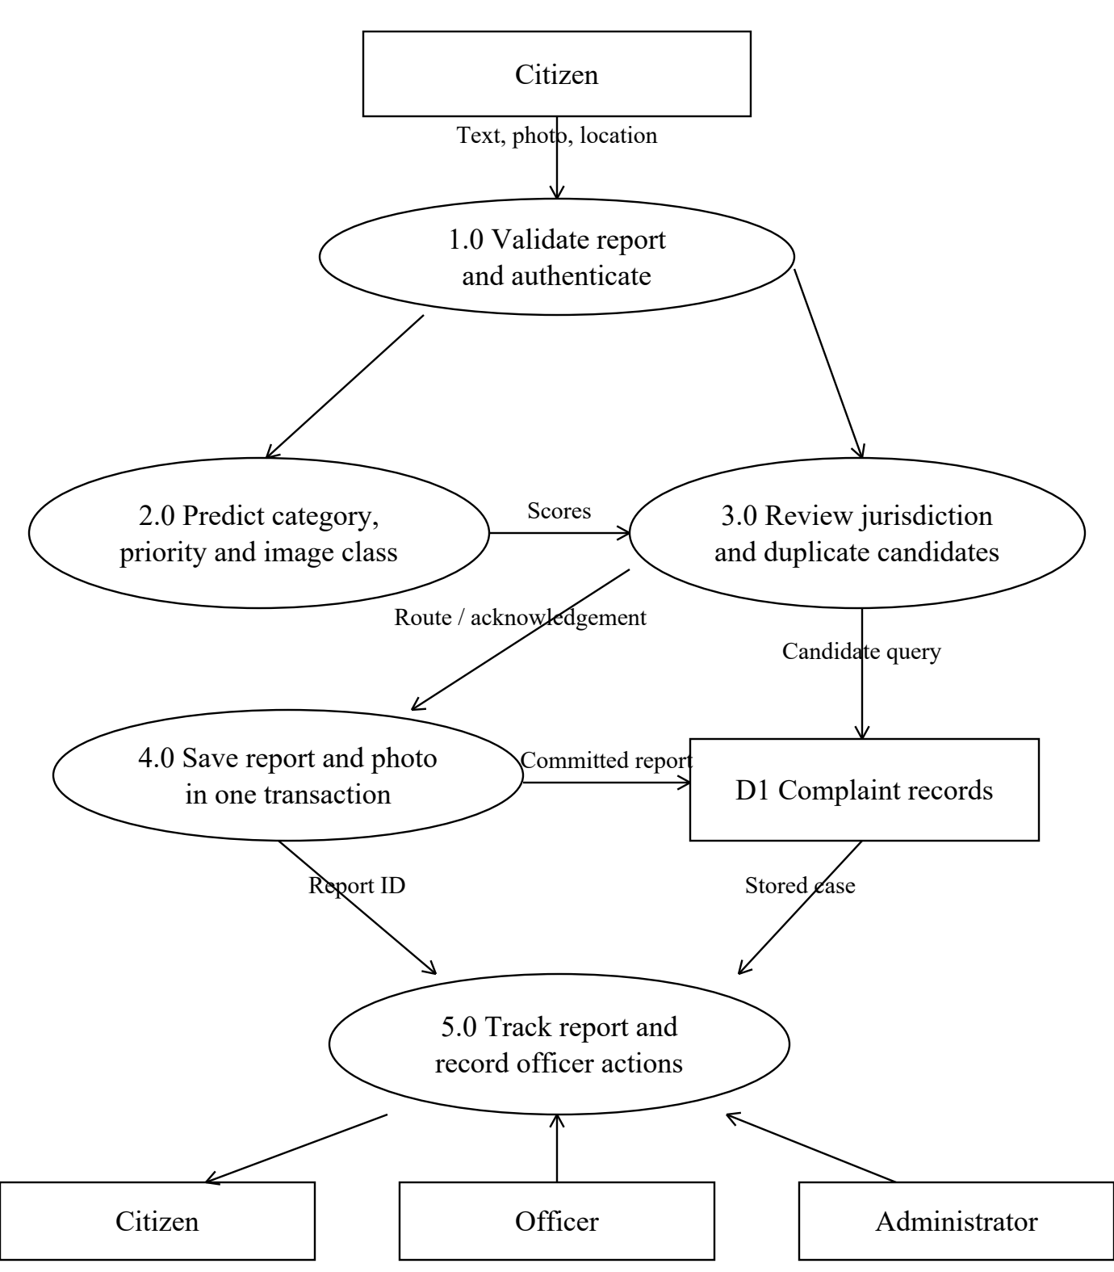
Fig. 3. Report data flow
The data-flow diagram separates citizen input, prediction, routing review, storage and officer action. Candidate reports are read before duplicate suggestions are returned. A successful transaction establishes the saved case; the UI then receives the identifier and record. Citizens read their own reports, officers act within their departments and administrators monitor or correct assignments.

4.2.2 Use Case Diagram
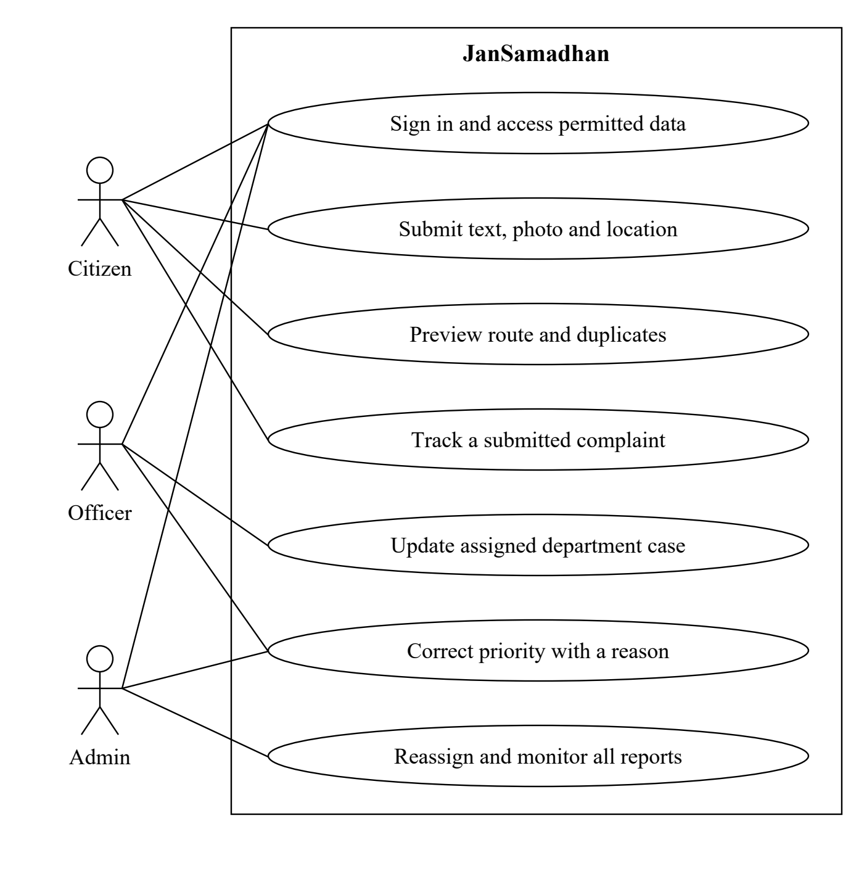
Fig. 4. Role-based use cases
The citizen submits evidence, previews the route and tracks the case. The officer views the assigned department queue, records work and makes permitted priority corrections. The administrator reviews all reports, changes assignments when justified and monitors the map and metrics. Every protected operation is subject to server authorization. Officer and administrator roles are not granted by public registration.

4.2.3 Class Diagram
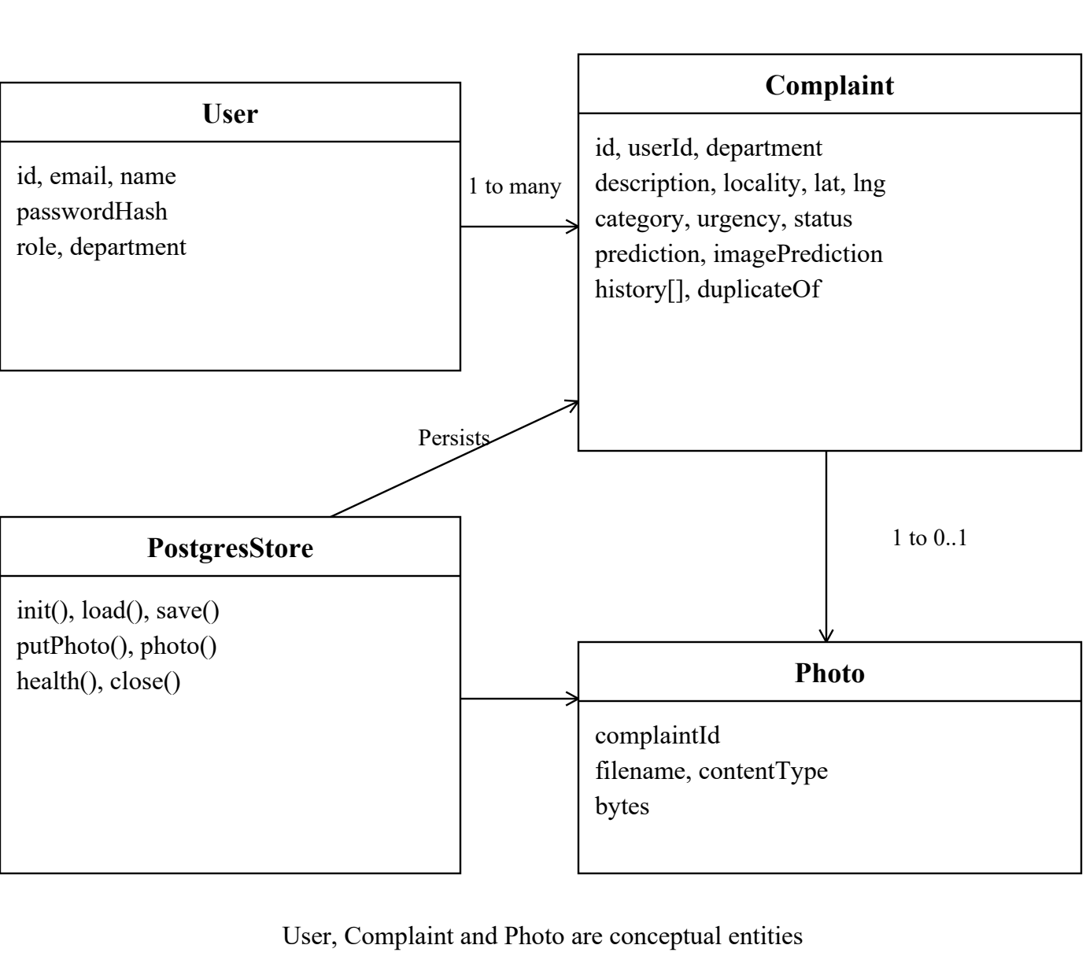
Fig. 5. Conceptual entities and persistence class
User, Complaint and Photo represent the domain entities and database records. They are conceptual model elements rather than a claim that the JavaScript implementation defines three corresponding classes. PostgresStore is an implemented persistence class. One user can own many complaints, and one complaint has at most one stored photograph in the current schema. The complaint JSONB payload retains predictions, duplicate acknowledgement and action history.
Database table | Important structure
jansamadhan.users | Primary key id; unique email; password_hash; role and department
jansamadhan.complaints | Primary key id; user_id foreign key; department, status, timestamps and data JSONB
jansamadhan.photos | complaint_id primary/foreign key; filename, content_type and bytes BYTEA

Deleting a complaint cascades to its linked photo. Parameterized statements run inside a transaction. The single API process maintains a working state loaded from the database and serializes mutations. Multiple independently running API instances would need additional consistency controls.

4.2.4 Sequence Diagram
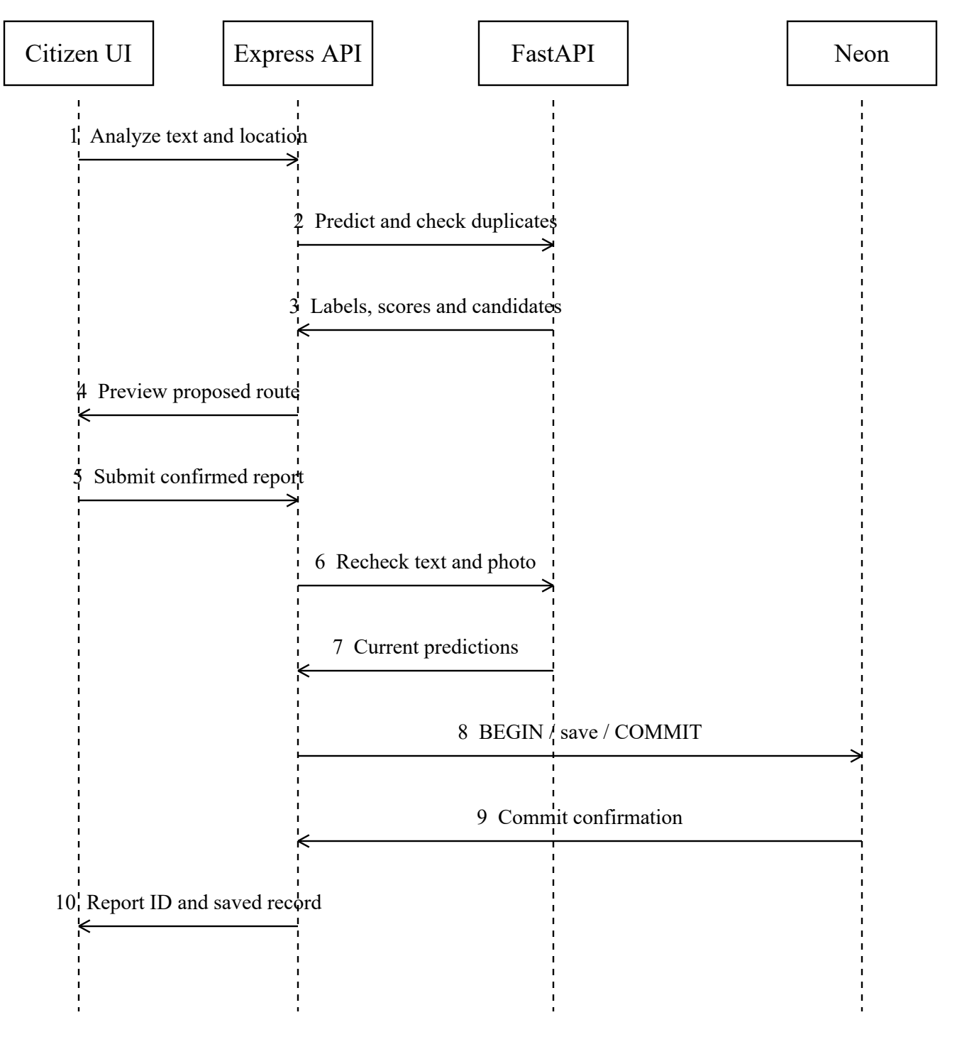
Fig. 6. Analyze and submit sequence
The sequence distinguishes preview from final submission. During submission, the server repeats analysis, validates any photograph and saves the report and photo inside a database transaction. The browser shows success only after the committed record is returned. If the model service or transaction fails, the request returns an error. Later officer actions update the report through the same authorized API and append history.

5. REFERENCES
Journal Articles
[1] M. Hashemi, “Automatic Type Detection of 311 Service Requests Based on Customer Provided Descriptions,” Applied Artificial Intelligence, vol. 36, no. 1, Art. no. 2073717, 2022, doi: 10.1080/08839514.2022.2073717.
[2] Y. Wang, S. R. Nagireddy, C. T. Thota, D. H. Ho, and Y. Lee, “Community-in-the-loop: Creating Artificial Process Intelligence for Co-production of City Service,” Proceedings of the ACM on Human-Computer Interaction, vol. 6, CSCW2, pp. 1–21, 2022, doi: 10.1145/3555176.
[3] D. H. Ho, Y. Lee, S. Nagireddy, C. Thota, B. Never, and Y. Wang, “OpenComm: Open community platform for data integration and privacy preserving for 311 calls,” Sustainable Cities and Society, vol. 83, Art. no. 103858, 2022, doi: 10.1016/j.scs.2022.103858.
[4] C. Vairetti, I. Aránguiz, S. Maldonado, J. P. Karmy, and A. Leal, “Analytics-driven complaint prioritisation via deep learning and multicriteria decision-making,” European Journal of Operational Research, vol. 312, no. 3, pp. 1108–1118, 2024, doi: 10.1016/j.ejor.2023.08.027.
[5] D. Rakhimzhanov, S. Belginova, and D. Yedilkhan, “Automated Classification of Public Transport Complaints via Text Mining Using LLMs and Embeddings,” Information, vol. 16, no. 8, Art. no. 644, 2025, doi: 10.3390/info16080644.
[6] A. Lehtiö, M. Hartikainen, S. Ala-Luopa, T. Olsson, and K. Väänänen, “Understanding citizen perceptions of AI in the smart city,” AI & Society, vol. 38, pp. 1123–1134, 2023, doi: 10.1007/s00146-022-01589-7.
Conference Paper and Preprint
[7] A. Howard et al., “Searching for MobileNetV3,” in Proceedings of the IEEE/CVF International Conference on Computer Vision, 2019, pp. 1314–1324. Available: https://openaccess.thecvf.com/content_ICCV_2019/html/Howard_Searching_for_MobileNetV3_ICCV_2019_paper.html
[8] P. F. Proença and P. Simões, “TACO: Trash Annotations in Context for Litter Detection,” arXiv:2003.06975, 2020. Available: https://arxiv.org/abs/2003.06975
Datasets and Official Web Resources
[9] CivicComp-HiEn research team, “CivicComp-HiEn Hindi-English Civic Complaints,” Kaggle, version 3. Dataset attribution includes Vivek Mathew and Haji Shariefullah via Opencity.in and the CivicComp-HiEn team. License: CC BY-SA 4.0. Available: https://www.kaggle.com/datasets/shyamtripathi373/civiccomp-hien-hindienglish-civic-complaints. Downloaded Sep. 8, 2026.
[10] G. Thung and M. Yang, “TrashNet,” dataset repository. Available: https://github.com/garythung/trashnet. Source and retained-image audit recorded in the project image manifest.
[11] Road Issues Detection Dataset, Kaggle dataset listing, programmerrdai. Available: https://www.kaggle.com/datasets/programmerrdai/road-issues-detection-dataset. Listing and upstream licensing ambiguity are retained in the project dataset limitations.
[12] Lucknow Municipal Corporation, “Helpline,” official contact page. Available: https://lmc.up.nic.in/helpline.aspx. Project contact verification recorded Sep. 8, 2026.
[13] Lucknow Municipal Corporation, historical officer directory. Available: https://lmc.up.nic.in/pdf/amrut/OfficersinLNN.pdf. Used for role structure only, not a current personnel roster.
[14] Jal Kal, Lucknow, “Contact.” Available: https://jklmc.gov.in/Contact.aspx. Direct retrieval was unavailable during project contact verification; current zonal contacts require confirmation.
Project Implementation Evidence
[15] JanSamadhan project repository, saved artifacts and verification records: data/DATA_CARD.md; data/model_metrics.json; data/image_metrics.json; data/images/manifest.csv; docs/TEST_REPORT.md; docs/NEON_SETUP.md; ml/train.py; ml/train_images.py; ml/service.py; backend/server.js; backend/postgres.js. Review snapshot: September 2026.

