**PROJECT TOPIC: Plant Disease Detection**

**Group No.:**76

**Project Group Members:**

1. Rambandhu Sharma (161500438.) **3.** Rajeev Kumar (171599007)
2. Devesh Thakur (161500195)

**Project Supervisor:** Mr. Shashi Shekhar, Asst. Professor

**Objective:** Our main objective it to find a method to detect disease in plants not by conventional method but with the help of machines and technology. As farmers are not able to detect which plant has which disease and they are not fully aware of all the medicines for these. As the see with the naked eye only. Our model can predict the disease and the type of plant with 97% accuracy and can also suggest the proper medicine to be used to cure the disease of plant. All this is possible with the use of new technology of machine learning.

**Tools required:**

**Hardware Requirements:**

* 8GB RAM
* 4GB Graphic Card
* Intel i5

**Software Requirements:**

* Python IDE
* External Libraries of Python (TensorFlow, Keras, OpenCV,tkinter)

**Abstract:** When plants and crops are affected by pests it affects the agricultural production of the country. Usually farmers or experts observe the plants with naked eye for detection and identification of disease. But this method can be time processing, expensive and inaccurate. Automatic detection using image processing techniques provide fast and accurate results. This paper is concerned with a new approach to the development of plant disease recognition model, based on leaf image classification. There are several ways to detect plant pathologies. Some diseases do not have any visible symptoms, or the effect becomes noticeable too late to act, and in those situations, a sophisticated analysis is obligatory. However, most diseases generate some kind of manifestation in the visible spectrum, so the naked eyes examination of a trained professional is the prime technique adopted in practice for plant disease detection.

**Outcome:**

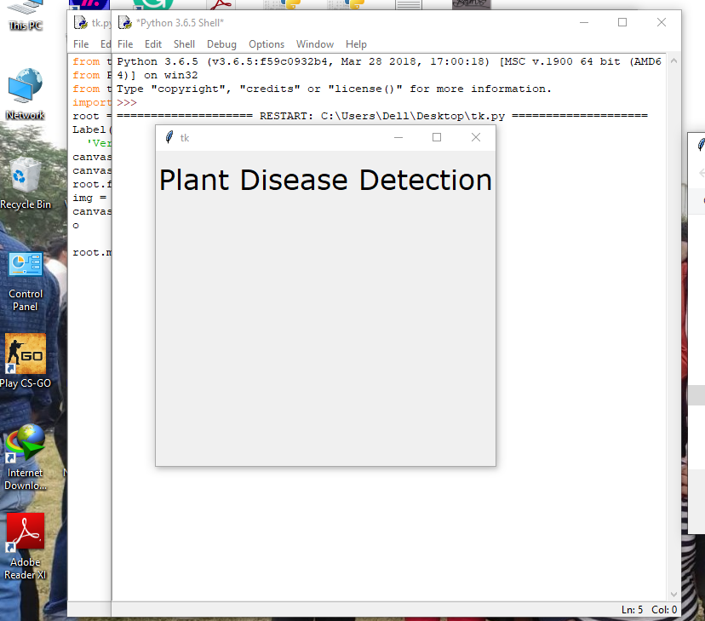

**Open the Tool**

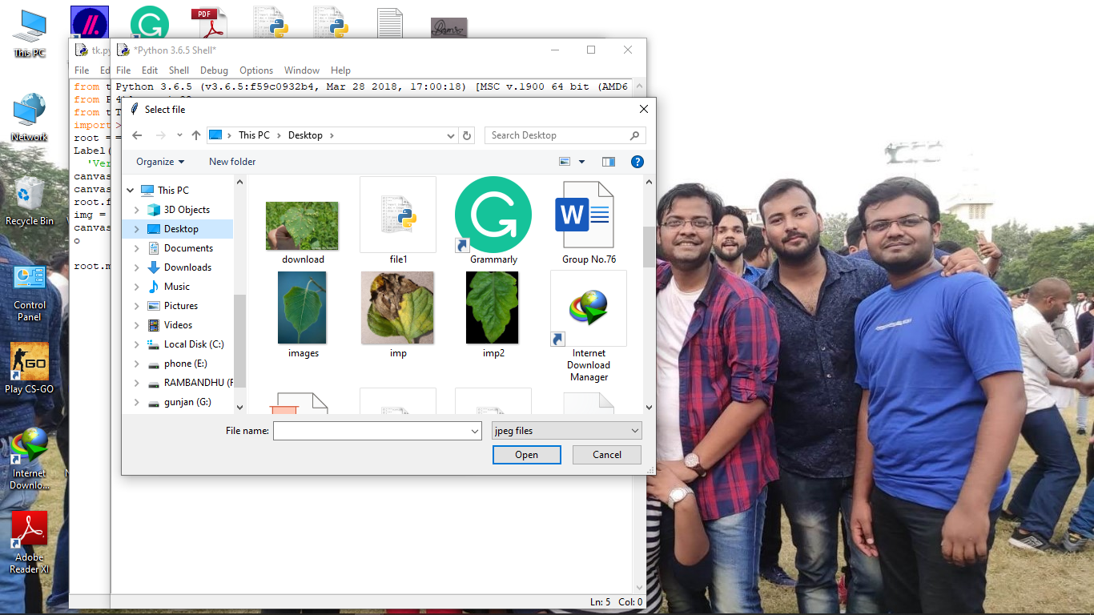

**Taking Image from Folder**

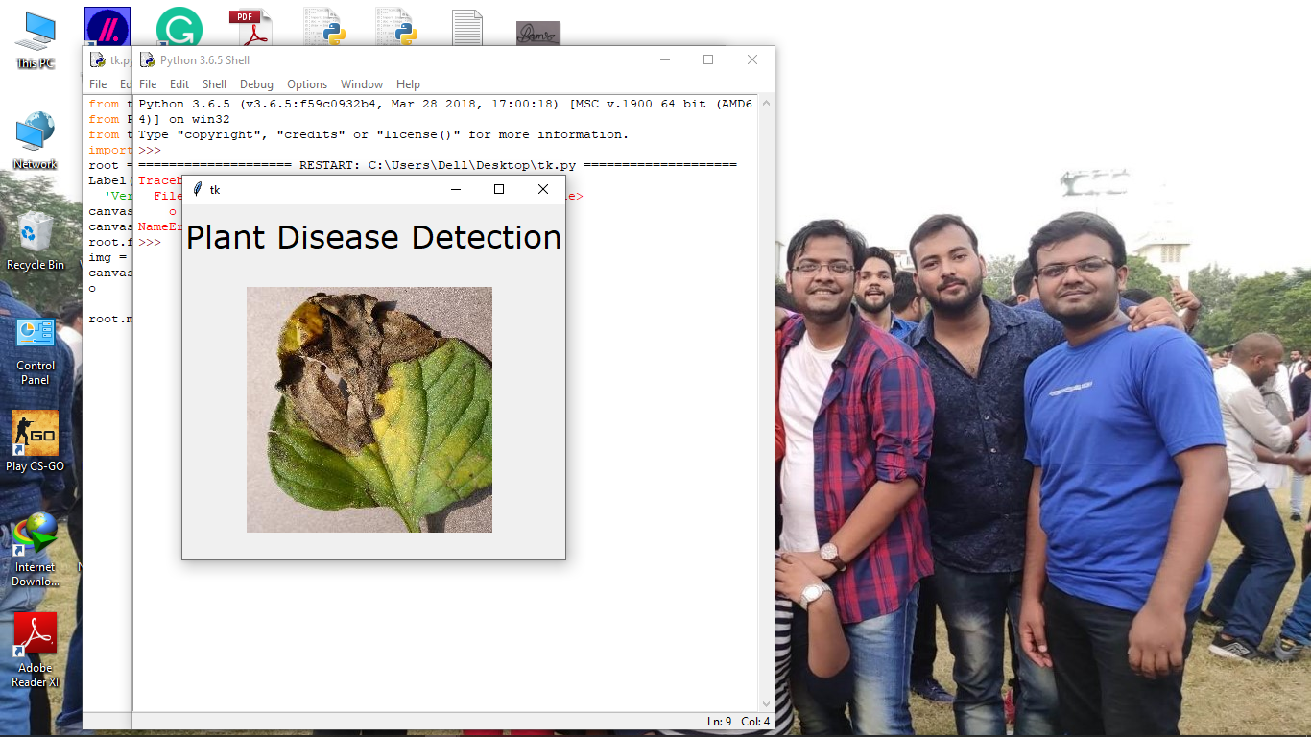**Predicting The disease**

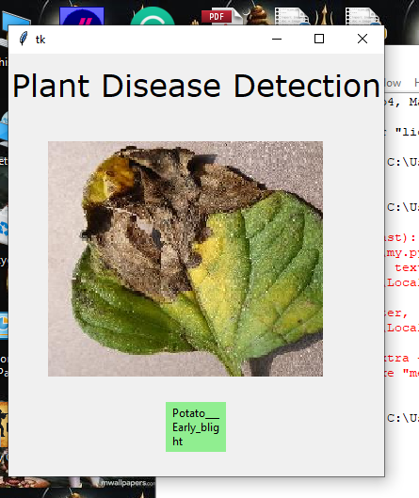

**Predicted Disease of The Leaf**