Crop Yield Prediction System Using Statistics & Machine Learning

Project Title: Crop Yield Prediction System
Subject: Statistical Fundamentals
Student Name: Sanika Aeer, Gaurav Bhirwandekar, Devkumar Yadav, Rehat Bagga, Aniruddha Ambike, Siddhant Bhagwat
Academic Year: 2026-27
Project Guide: Kiran Ma’am

Sr. No. | Section Title | Page No.
1 | Abstract | 3
2 | Introduction | 3
3 | Objectives | 3
4 | System Workflow | 4
5 | Dataset Description | 5
6 | Statistical Concepts Used | 6
7 | Why Crop-Specific separate Trained Models are used? | 7
8 | System Architecture | 8
9 | Implementation | 9- 87
9.1 | Datasets Cleaning & Merging Code | 10- 23
9.2 | Model Training Code | 24- 35
9.3 | Crop Yield Prediction Engine Code | 36-49
9.4 | Tkinter GUI Main Page Code | 50-79
9.5 | Tkinter GUI Detailed View Page Code | 79-94
10 | Statistical Interpretation of Results | 95
11 | User Interface Overview | 96
12 | Outputs | 97-100
13 | Conclusion | 101
14 | Future Scope | 102
15 | References | 103

1. Abstract
This project aims to estimate crop yield using historical agricultural data, weather conditions, and soil nutrient information. The system applies statistical concepts such as correlation, trend analysis, and residual evaluation to understand how different factors influence yield. Machine learning models are used as statistical estimators, with separate models trained for each crop to improve accuracy. In this project, specifically Random Forest Regression Model is used. A Tkinter-based interface presents the prediction along with tables, graphs, and summaries, making the results easy to interpret. The project demonstrates how statistical thinking and data-driven methods can be applied to real-world agricultural problems.
2. Introduction
Agriculture is influenced by several measurable factors such as rainfall, temperature, and soil nutrients. Understanding how these variables relate to crop yield is a core part of statistical analysis. This project uses historical data and basic statistical reasoning to study these relationships and predict yield for a selected crop.
The system combines:
- Statistical analysis
- Crop-specific machine learning models
- A simple graphical interface
The goal is to make yield prediction understandable and accessible, even for users without technical backgrounds.
3. Objectives
- To analyze how weather and soil factors statistically relate to crop yield
- To study trends and correlations in historical data
- To train crop-specific models for better prediction accuracy
- To present results in a clear, organized interface
- To demonstrate statistical concepts through real agricultural data

4. System Workflow:
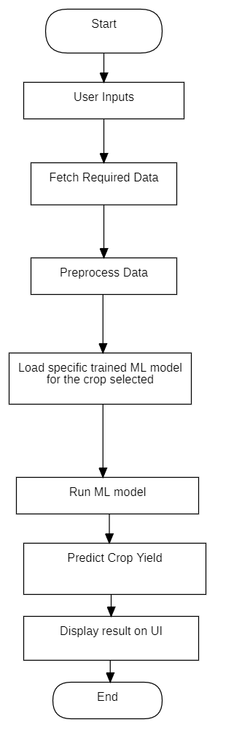
5. Dataset Description
In this project, data from year 1997 to year 2020 has been used spanning across around 70,000+ rows. It contains three main components:
Historical Yield Data
Includes:
- Year
- Crop
- District
- Season
- Yield
Weather Data
Includes:
- Rainfall
- Temperature
Soil Data
Includes:
- Nitrogen (N)
- Phosphorus (P)
- Potassium (K)
- Soil pH
- Organic Carbon
- Micronutrients (Zinc, Iron, Copper, Boron, Manganese, Sulphur)
These datasets were combined so that each record contains all relevant information for a particular crop and year.

6. Statistical Concepts used:
Although machine learning is used for prediction, the foundation of this project is statistical:
Correlation
Weather and soil variables show measurable correlation with crop yield. For example:
- Higher rainfall may increase yield up to a point
- Soil nutrients contribute to long-term yield stability
Trend Analysis
Yield trends over the years help identify:
- Growth patterns
- Declines
- Sudden changes
Residual Analysis
Residual plots help check:
- How far predictions deviate from actual values
- Whether the model is biased
- Whether errors are random or patterned
Error Metrics
The model’s performance is evaluated using:
- MAE – average absolute error
- RMSE – penalizes larger errors
- R² – percentage of variation explained
These are standard statistical measures.

7. Why Crop-Specific separate Trained Models are used?
Different crops respond differently to weather and soil conditions. Statistically, each crop has its own pattern of relationships with the variables.
For example:
- Rice may depend more on rainfall
- Wheat may depend more on temperature
- Sugarcane may depend more on soil nutrients
Because these relationships differ, separate models are trained for each crop. This ensures each crop’s unique statistical behavior is captured correctly.
Random Forest Regression is the model used in this project for predicting crop yield. It is a simple but powerful method that works by combining many small decision trees. Each tree makes its own prediction, and the final output is the average of all these predictions.
The idea behind using many trees instead of one is that individual trees can sometimes make mistakes or get influenced by noise in the data. When many trees work together, the overall prediction becomes more stable and reliable.
Random Forest is also good at handling real-world agricultural data, which often contains variations in rainfall, soil nutrients, and temperature. It can capture non-linear relationships between these variables and yield, making it suitable for this project.
Since each crop behaves differently, a separate Random Forest model is trained for every crop. This allows the model to learn the specific patterns and relationships that apply only to that crop, improving accuracy.

8. System Architecture
Input Layer
User selects:
- State
- District
- Crop
- Season
Data Layer
System gathers:
- Historical yield
- Weather data
- Soil nutrients
Model Layer
Loads the correct crop-specific model and predicts yield.
UI Layer
Tkinter interface displays:
- Prediction
- Historical data
- Weather & soil tables
- Summary
- Graphs

9. Implementation

For the implementation part, many libraries in python has been used. The fundamental programming language used throughout is python. The libraries such as Pandas, Numpy, Scikit-Learn, Matplotlib, Seaborn have been used.

Pandas and Numpy has been used to work with datasets. Specifically for cleaning and merging datasets, these libraries have been used.
Scikit-Learn has been used for using Machine learning models used.
Matplotlib and Seaborn has been used to display graphs.
Tkinter has been used to create the user interface where the user can give inputs and can also see the output displayed.

All these codes have been implemented in Jupyter Notebook and VS code. Dataset cleaning and merging, ML model training has been done in Jupyter Notebook while remaining part of the project is done in VS Code.

9.1 Datasets Cleaning & Merging Code:
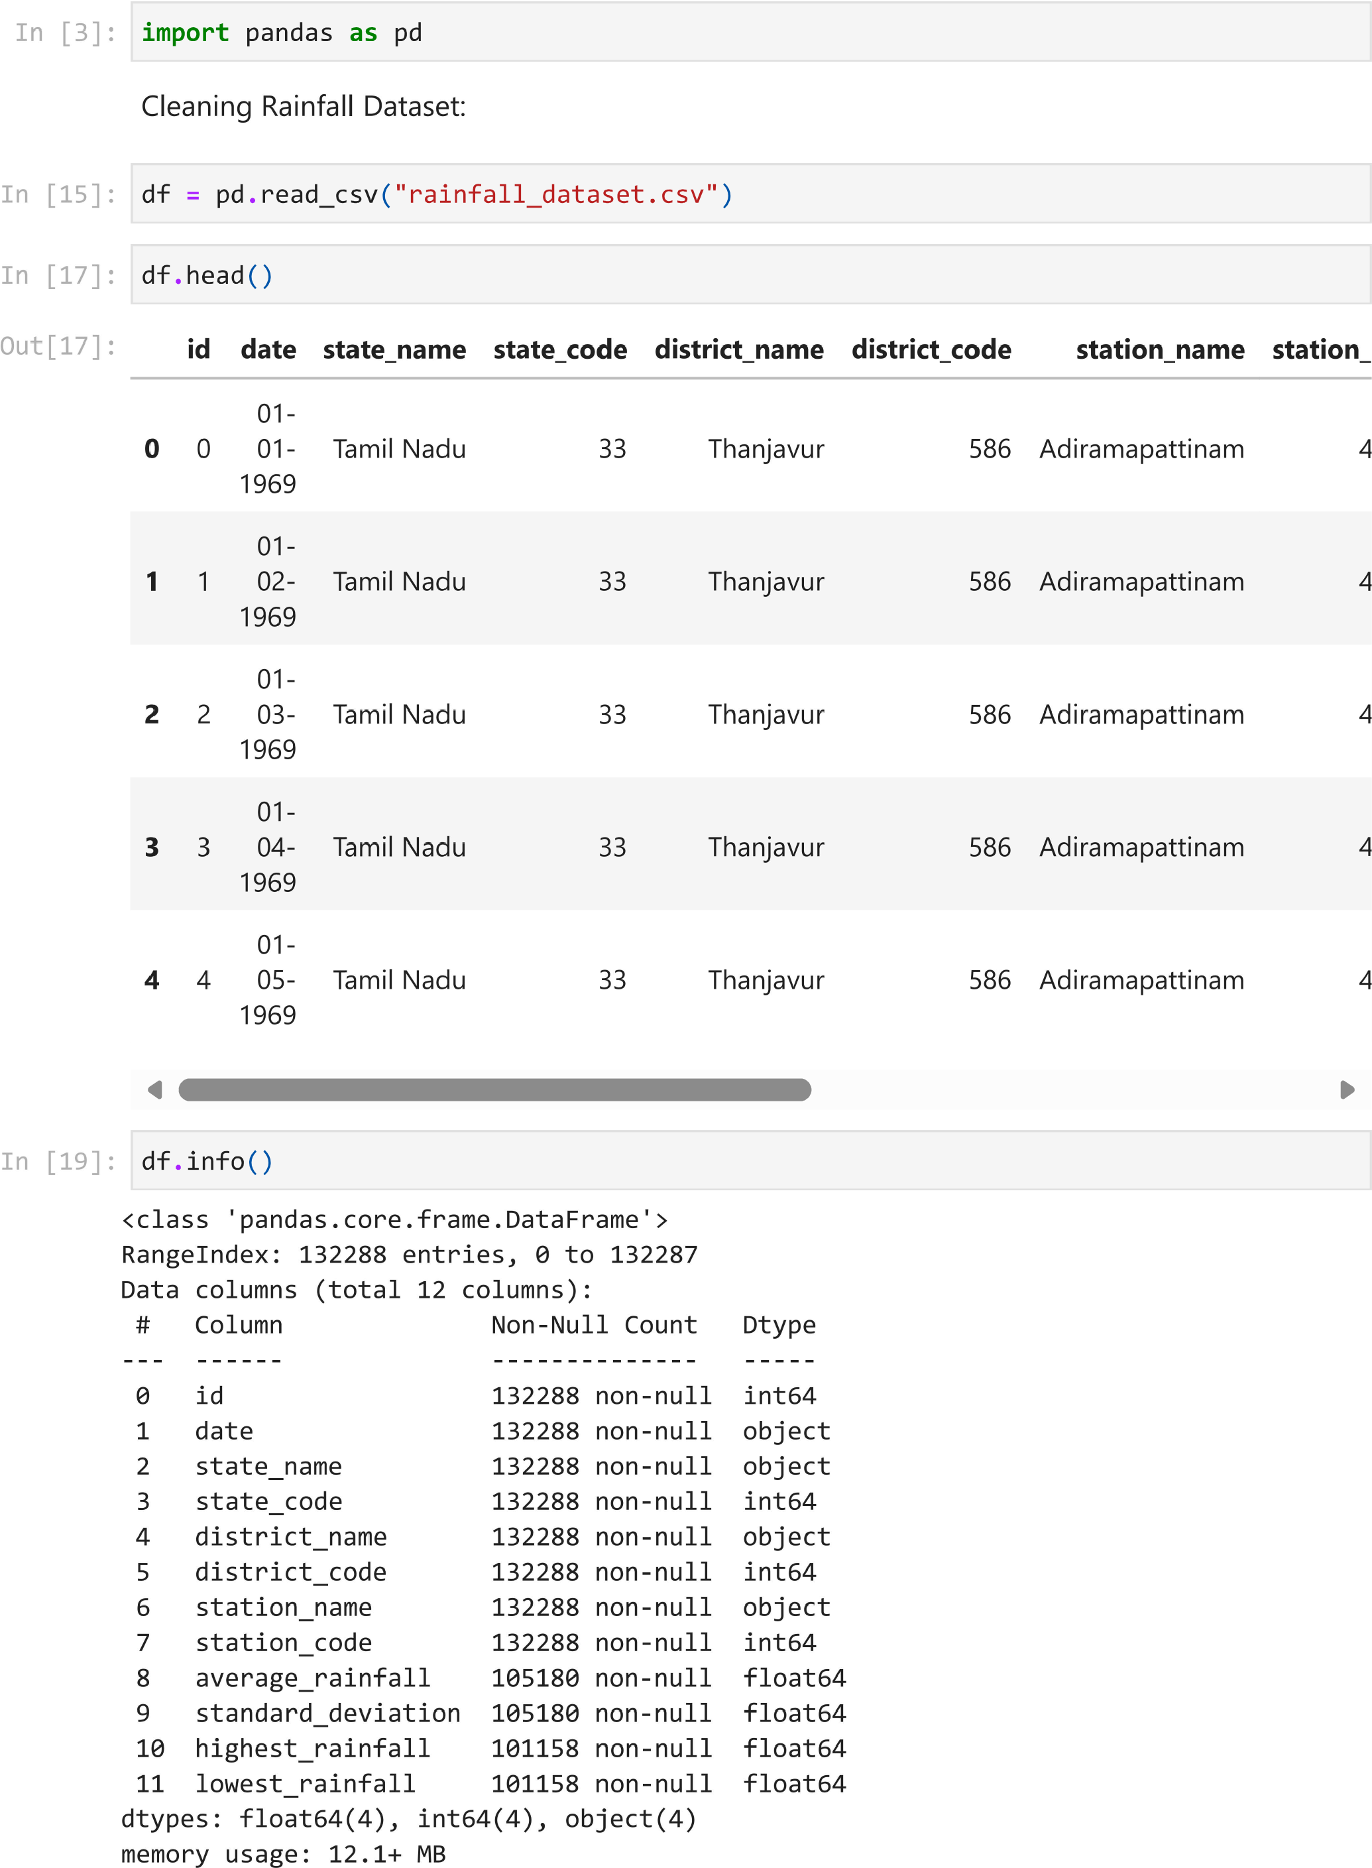
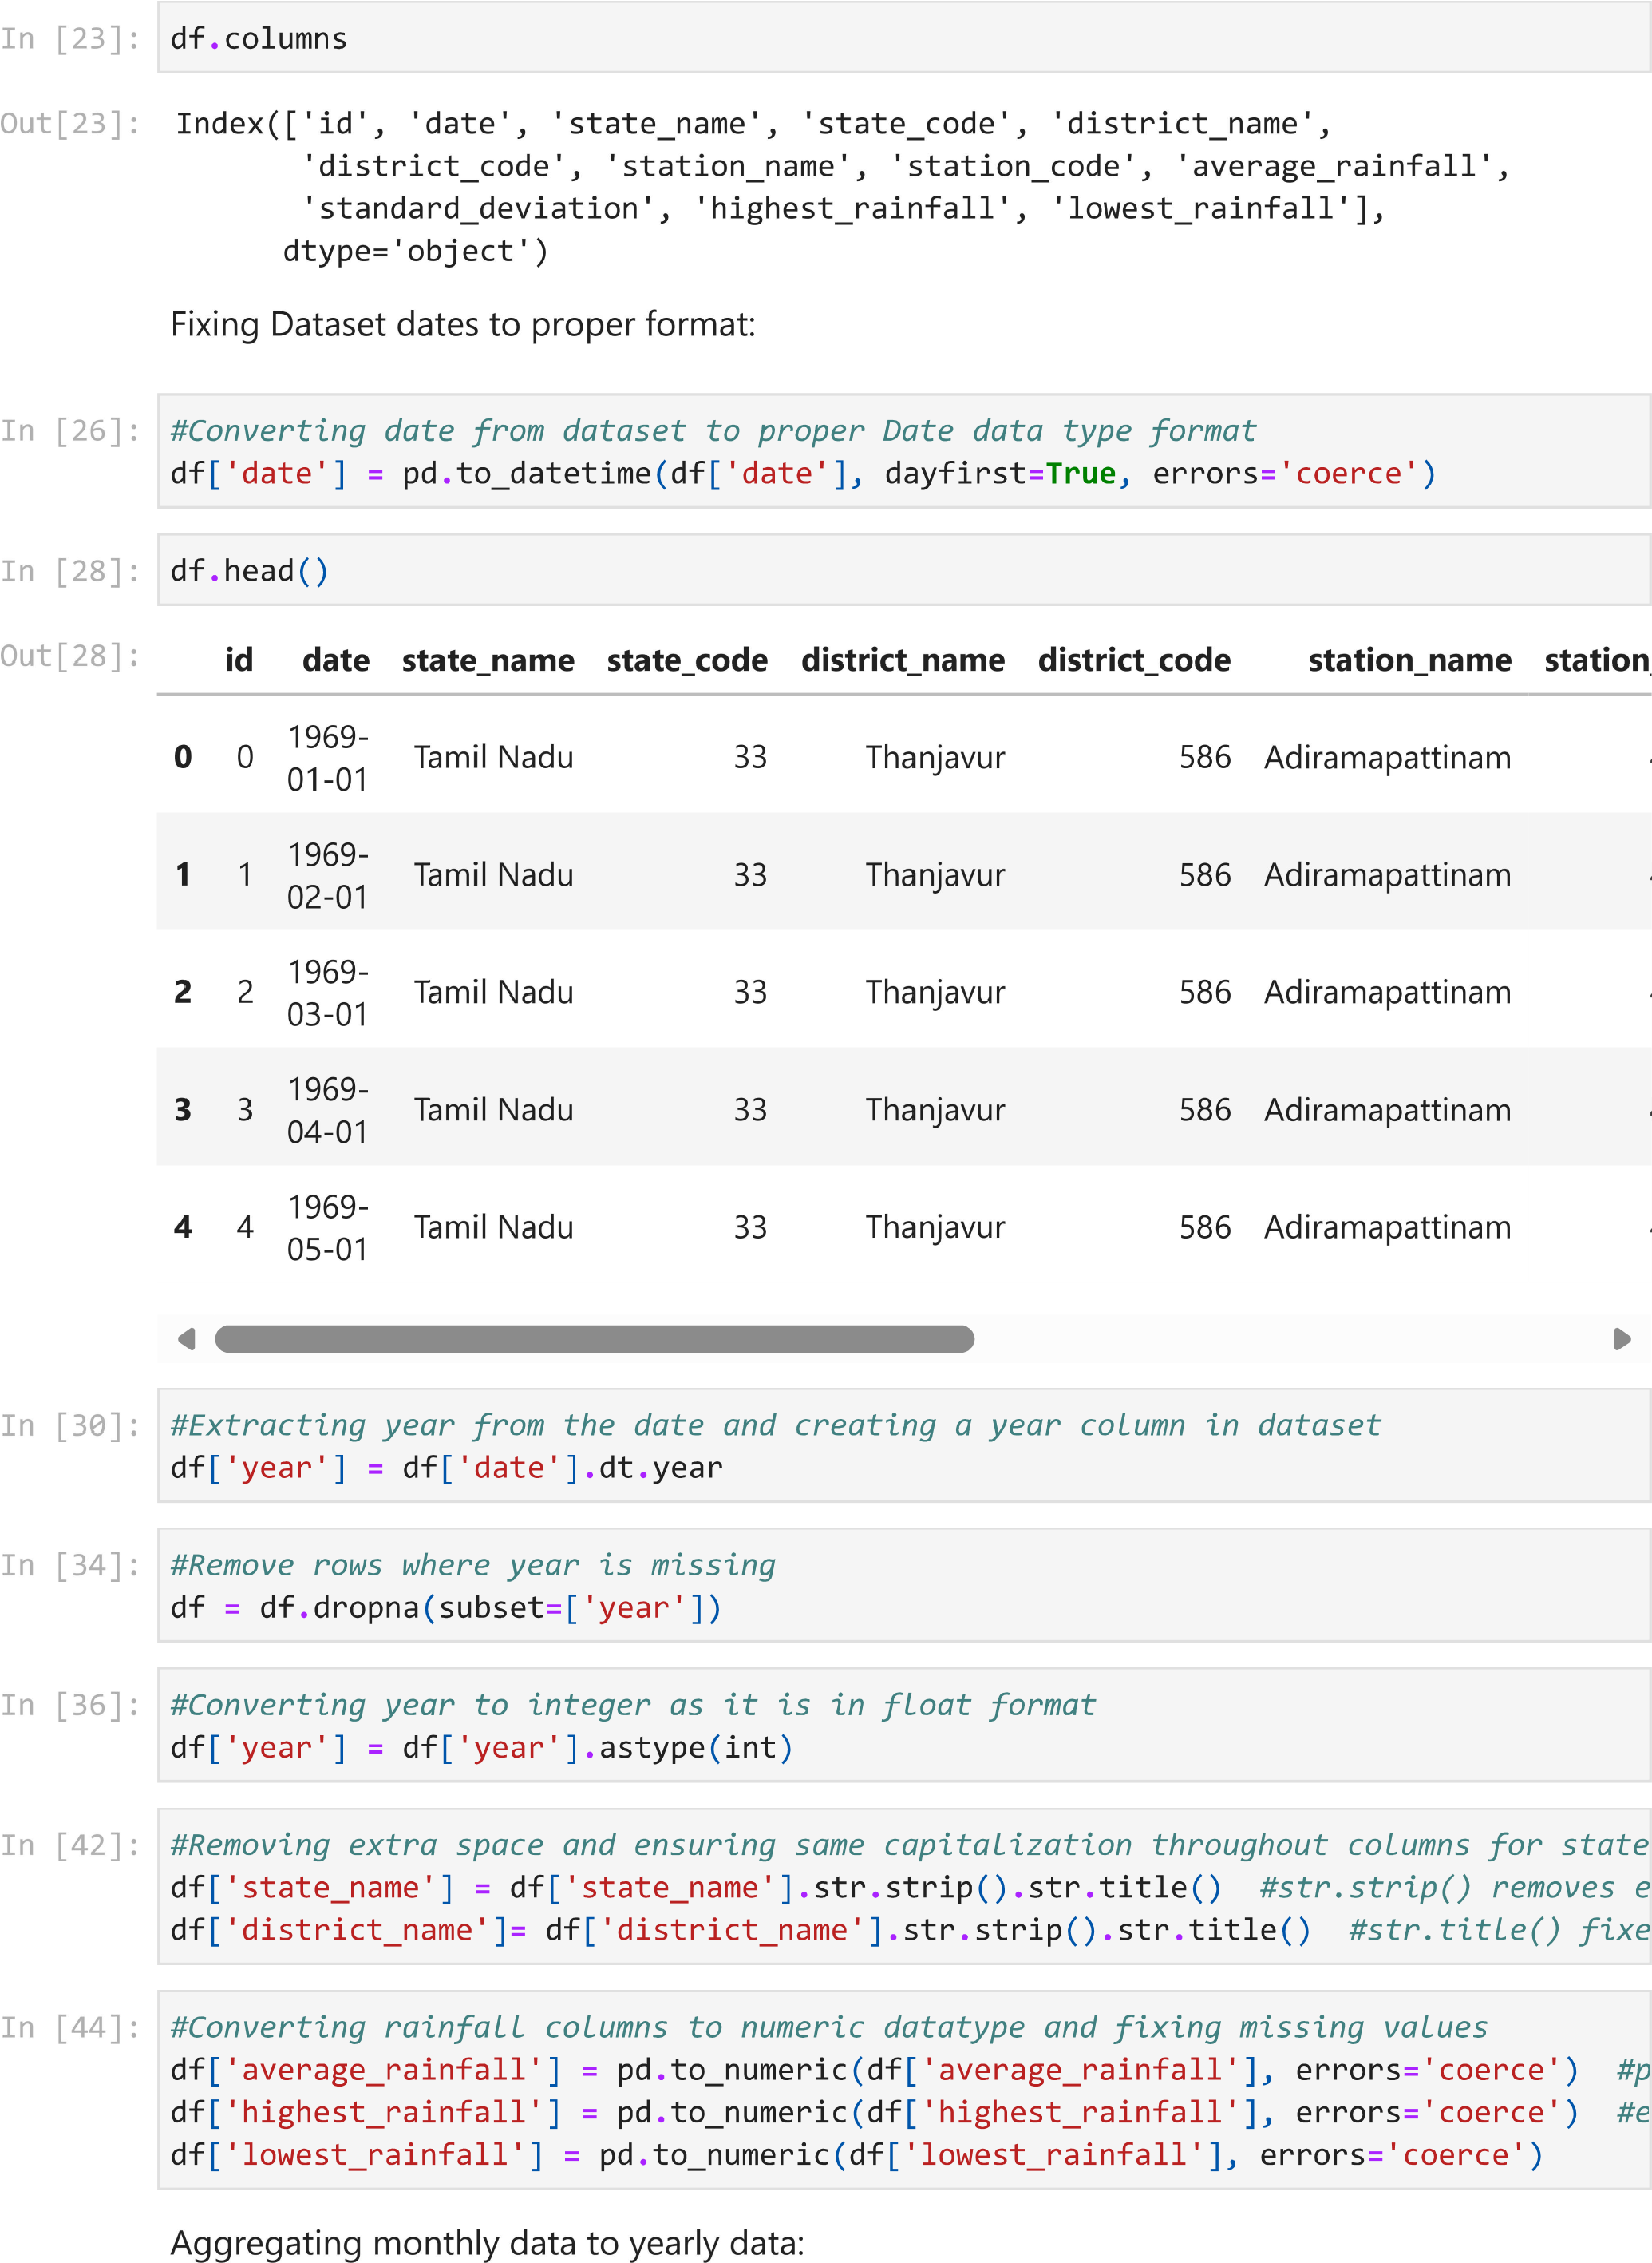
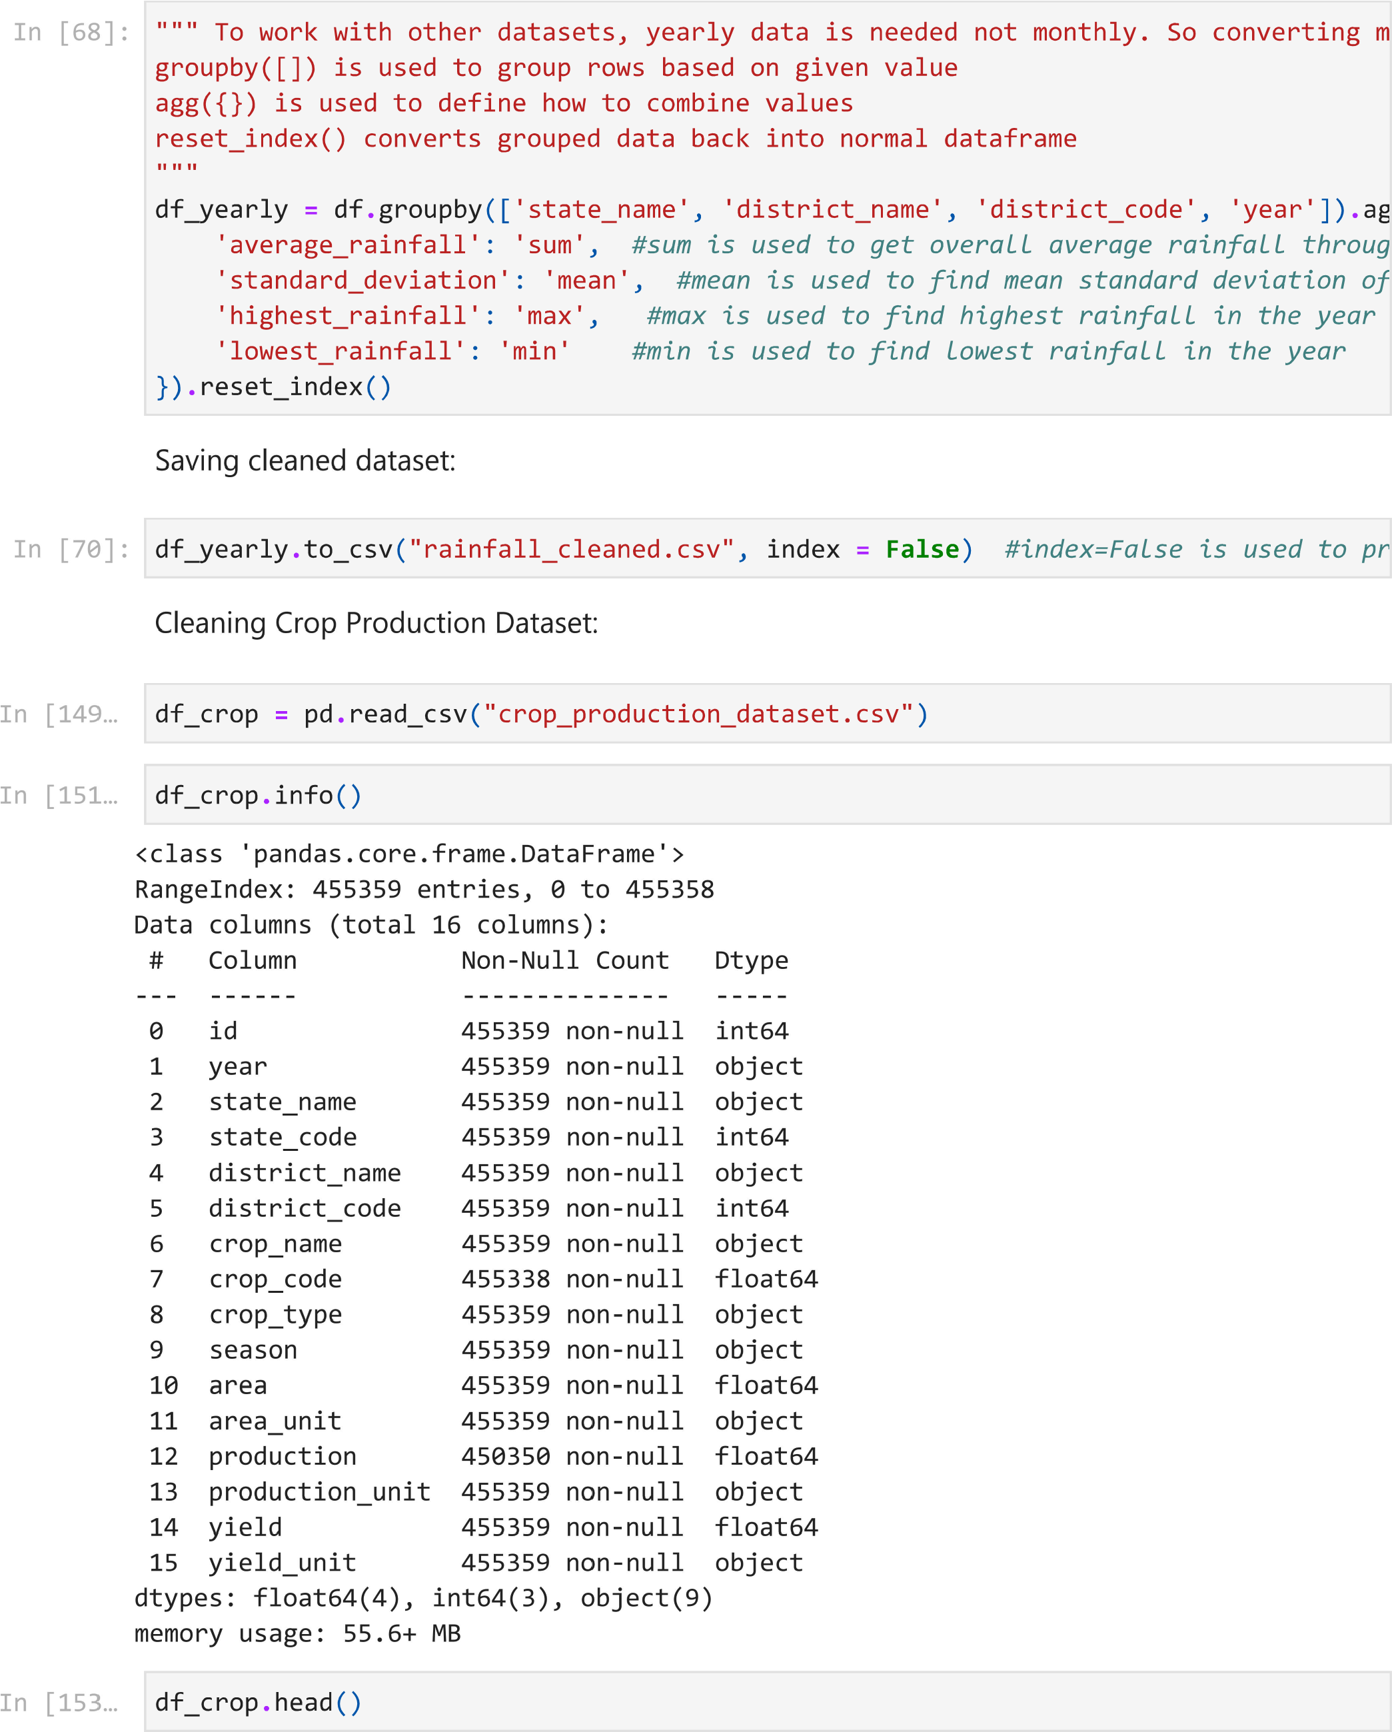
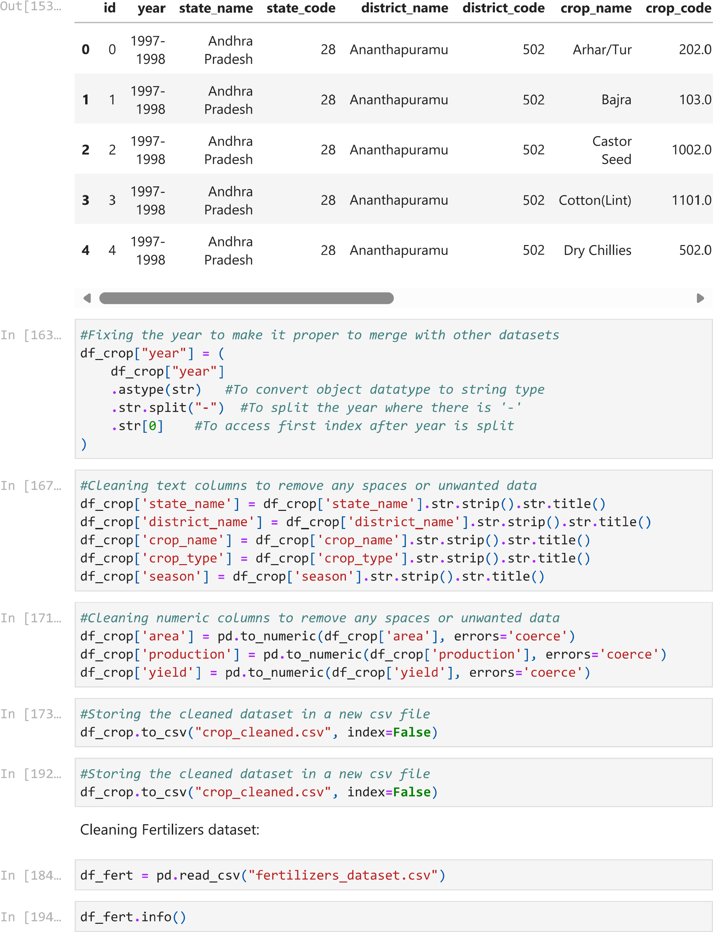
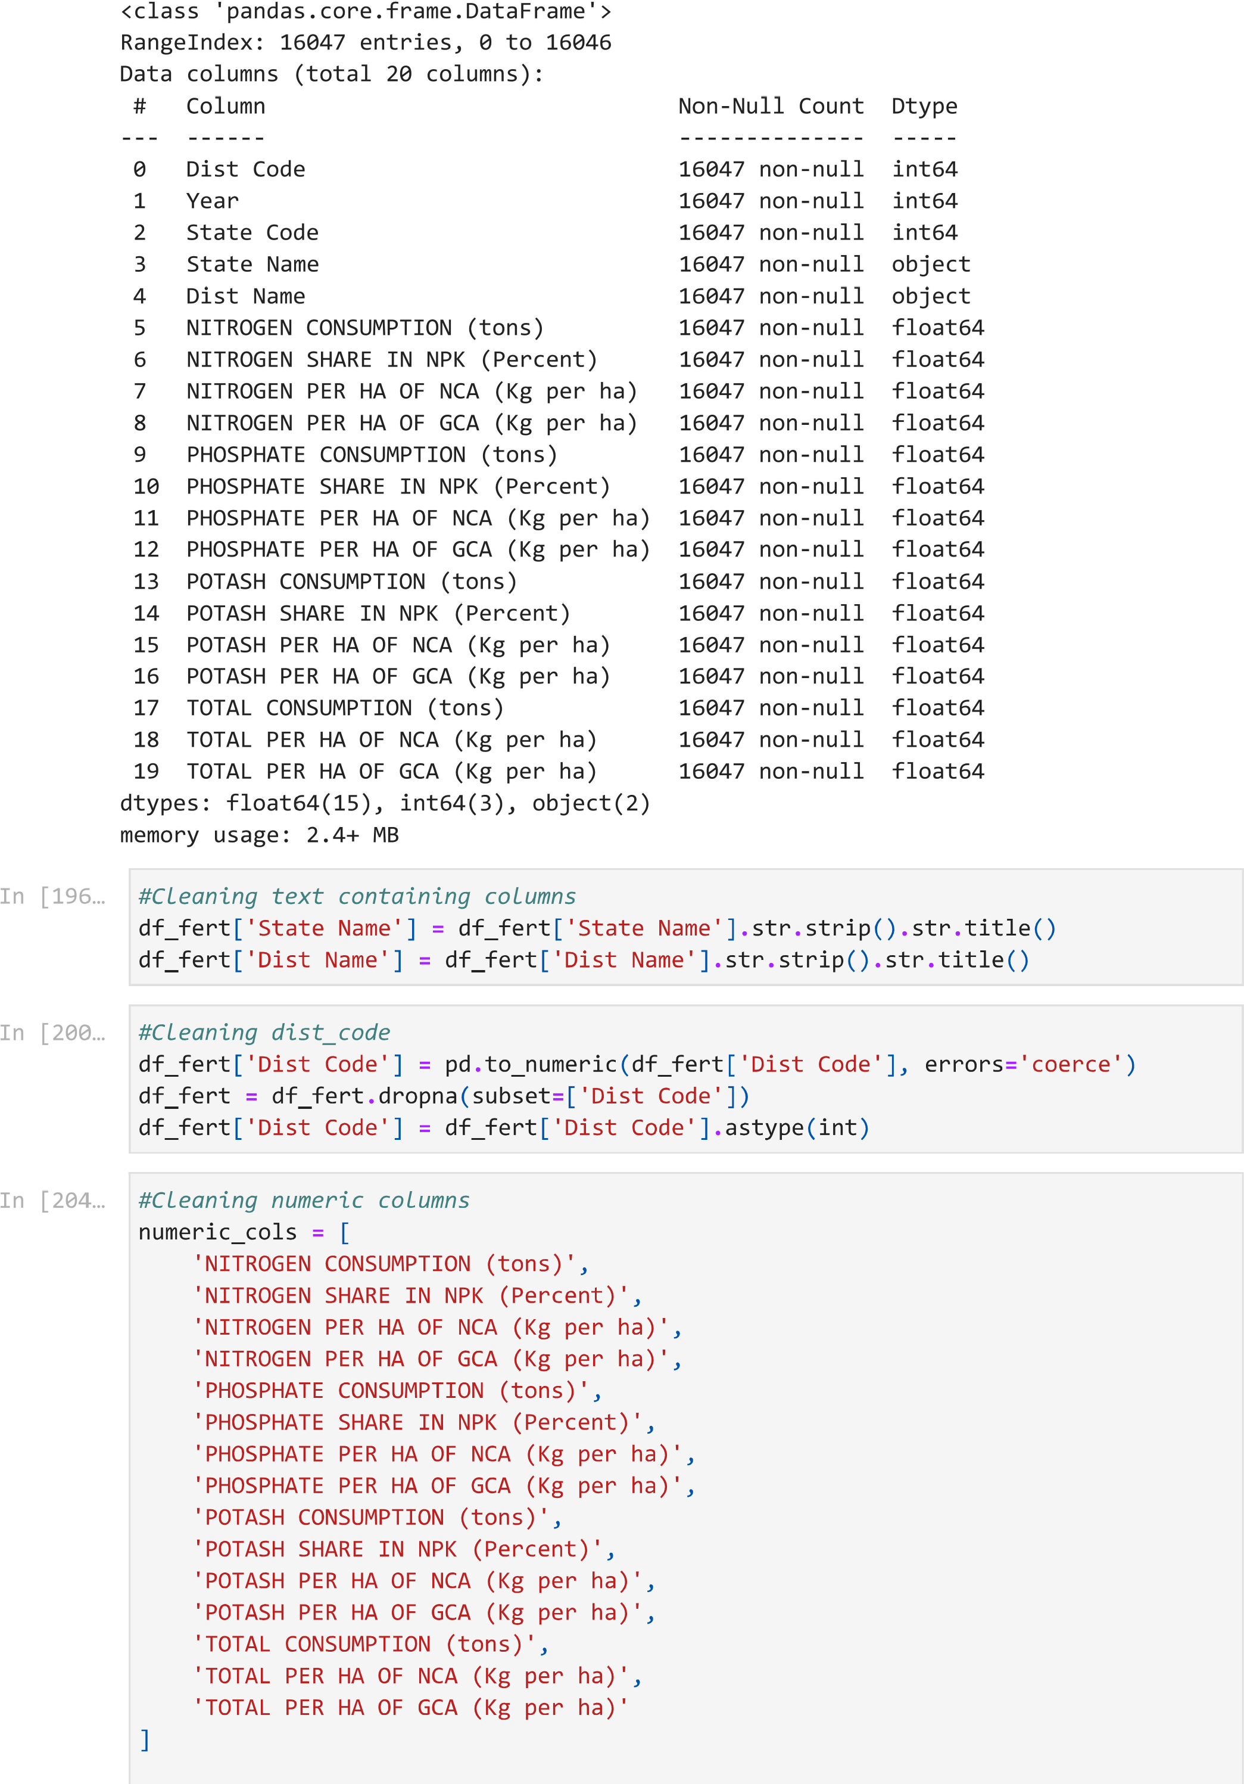
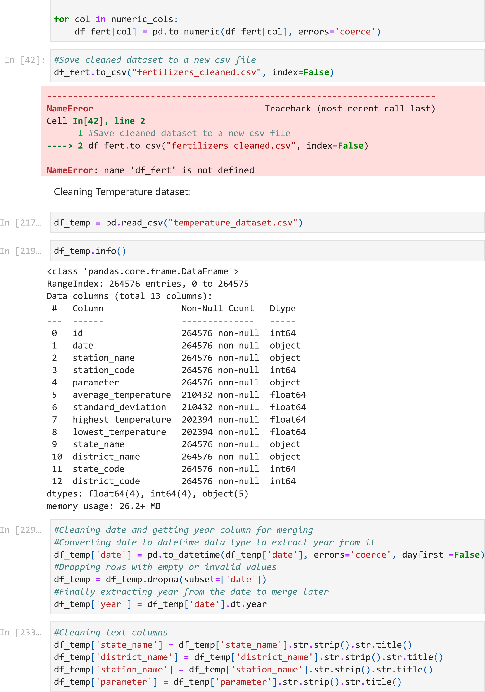
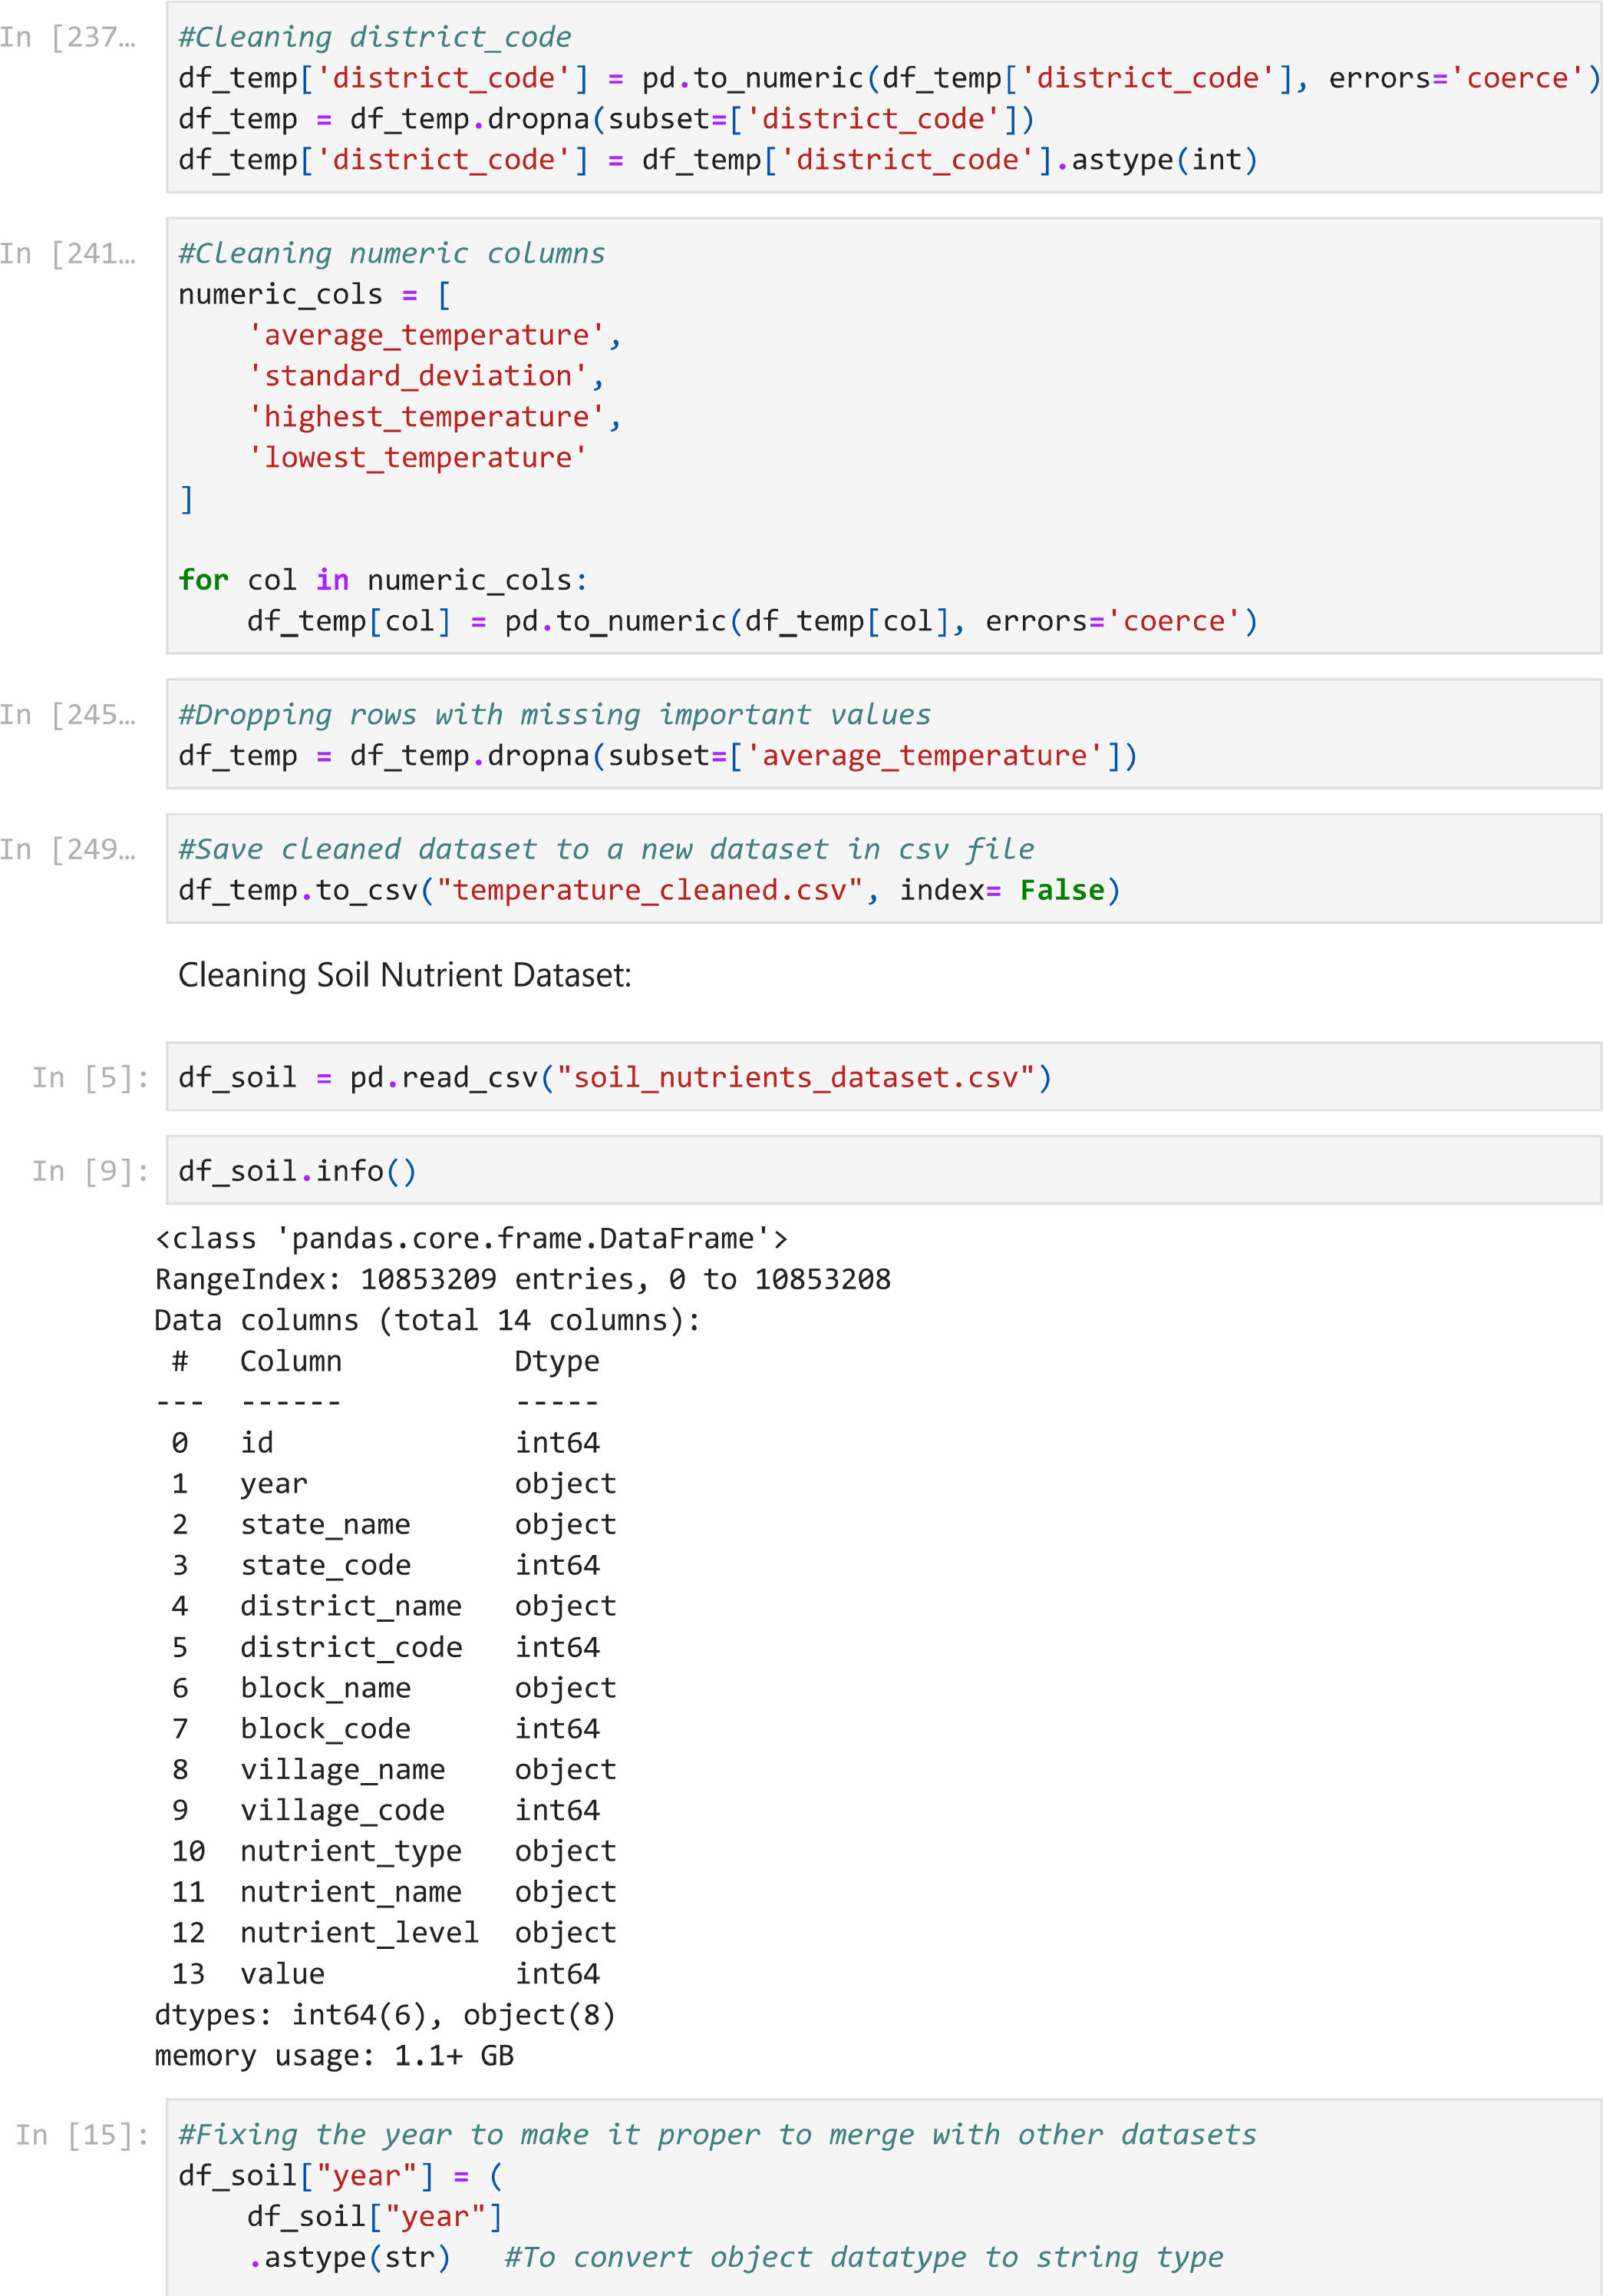

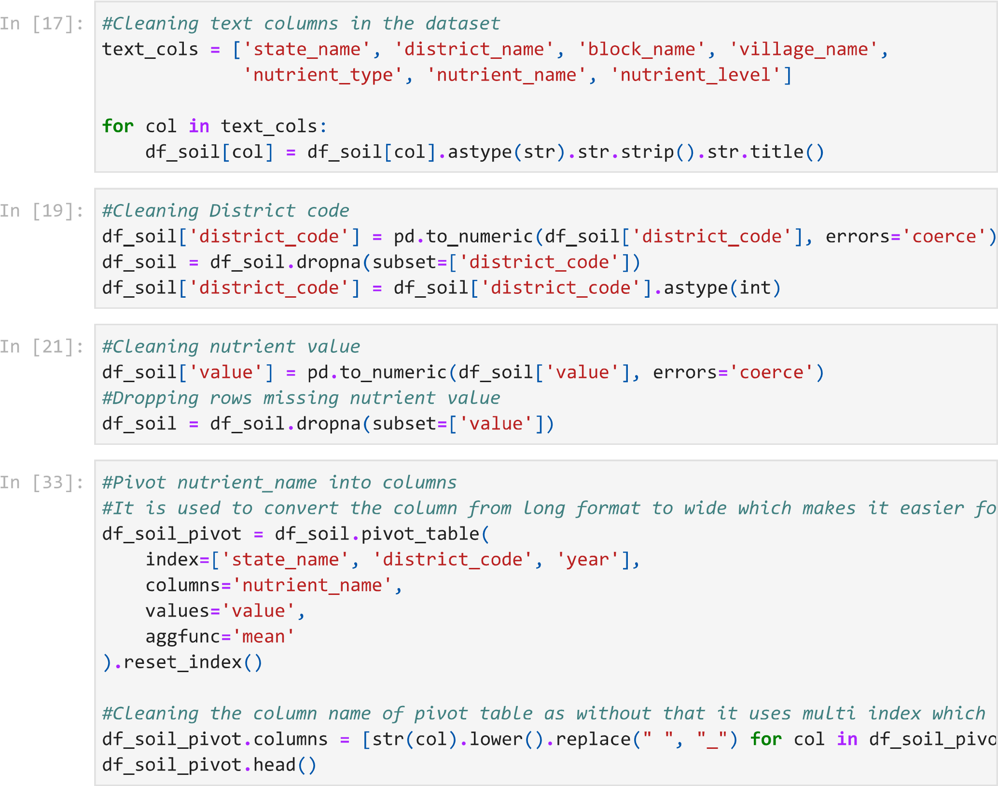
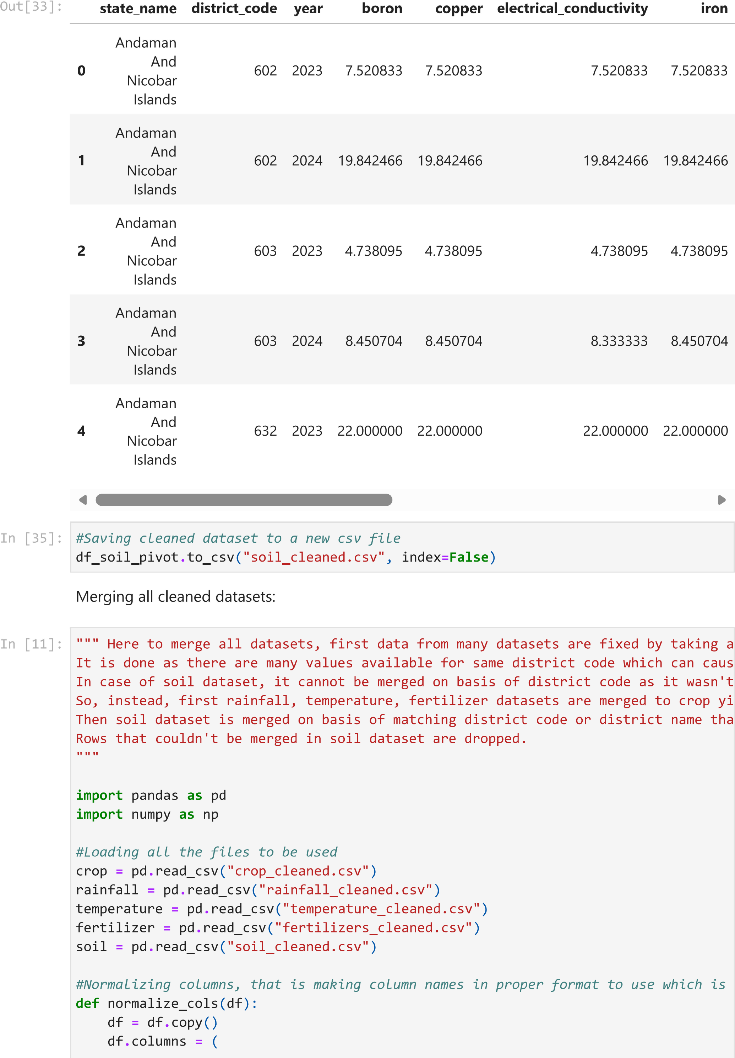
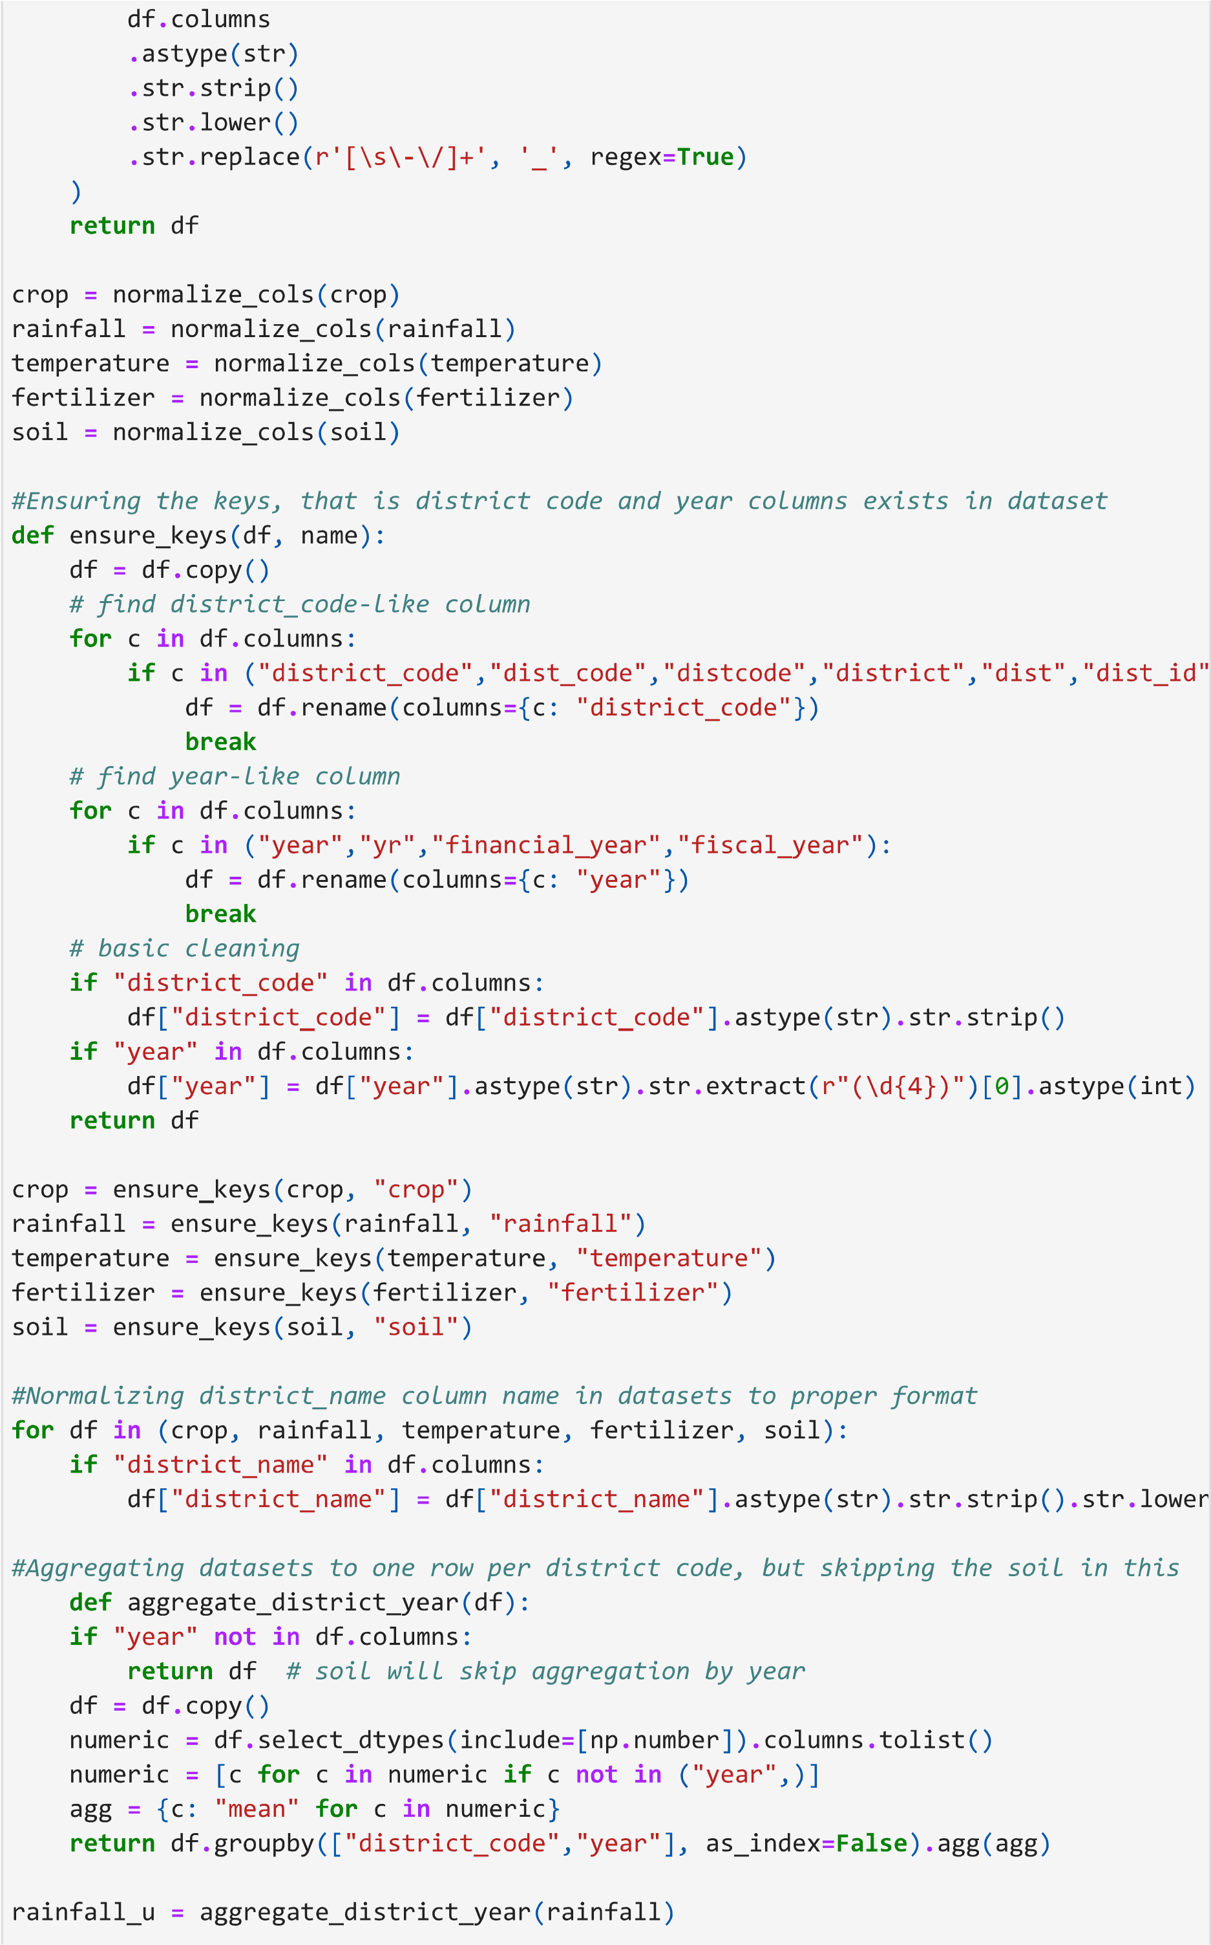
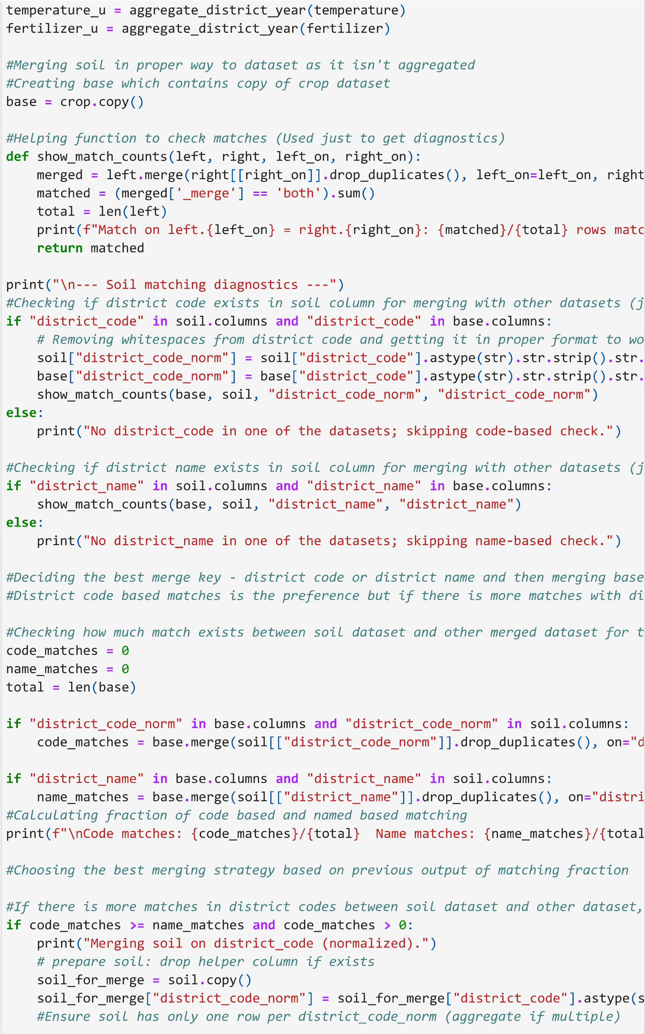
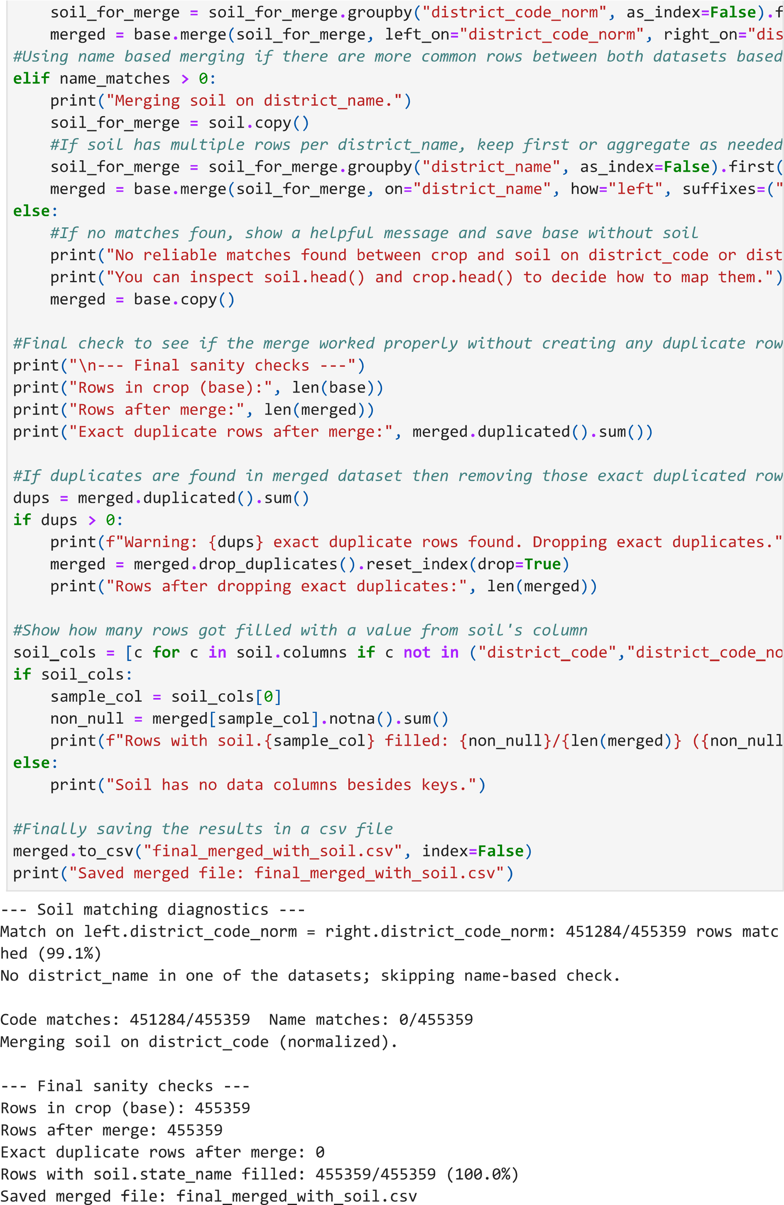
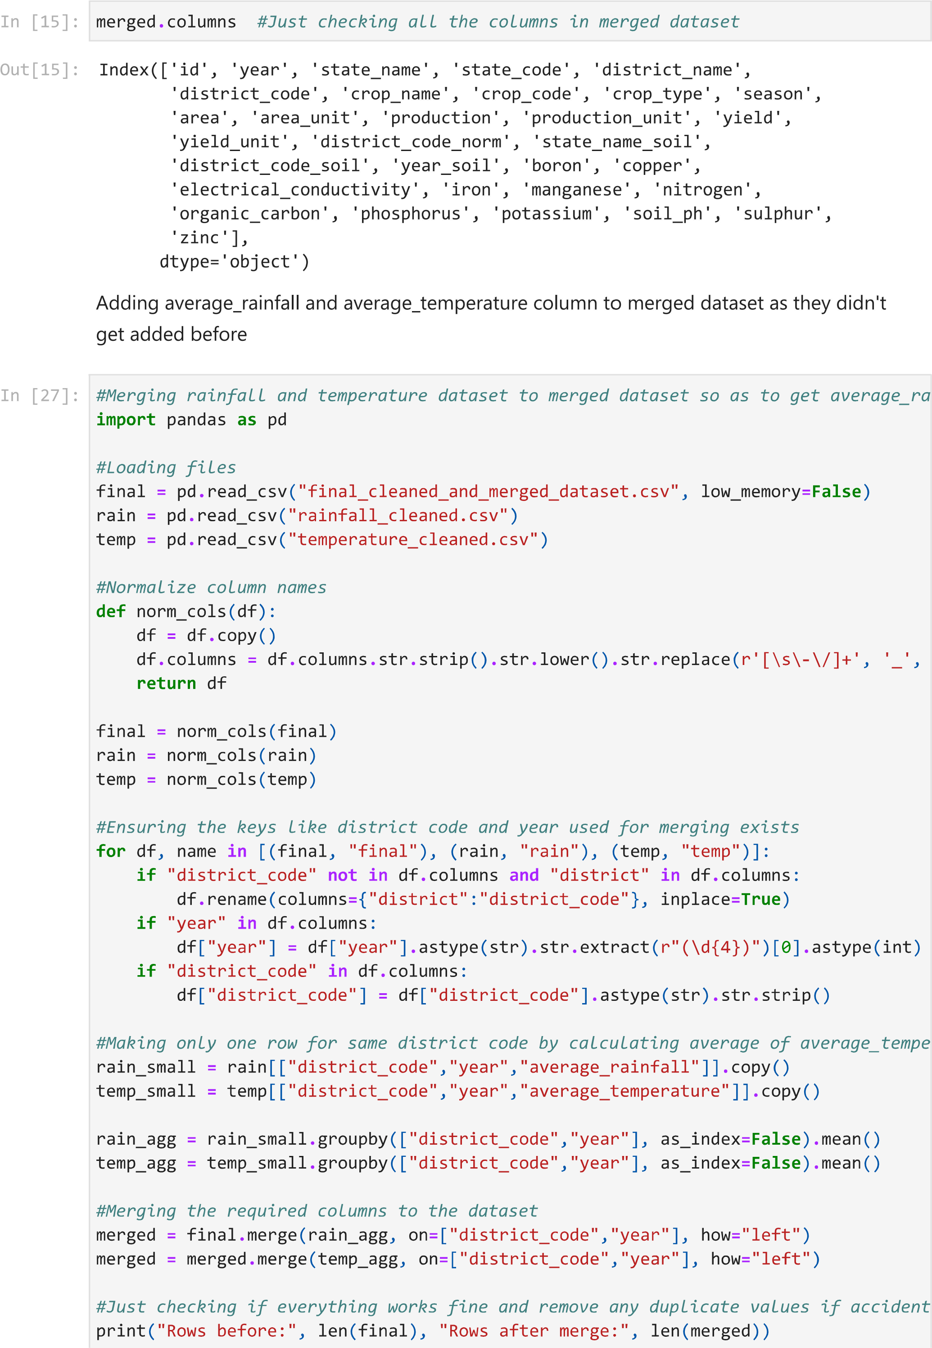
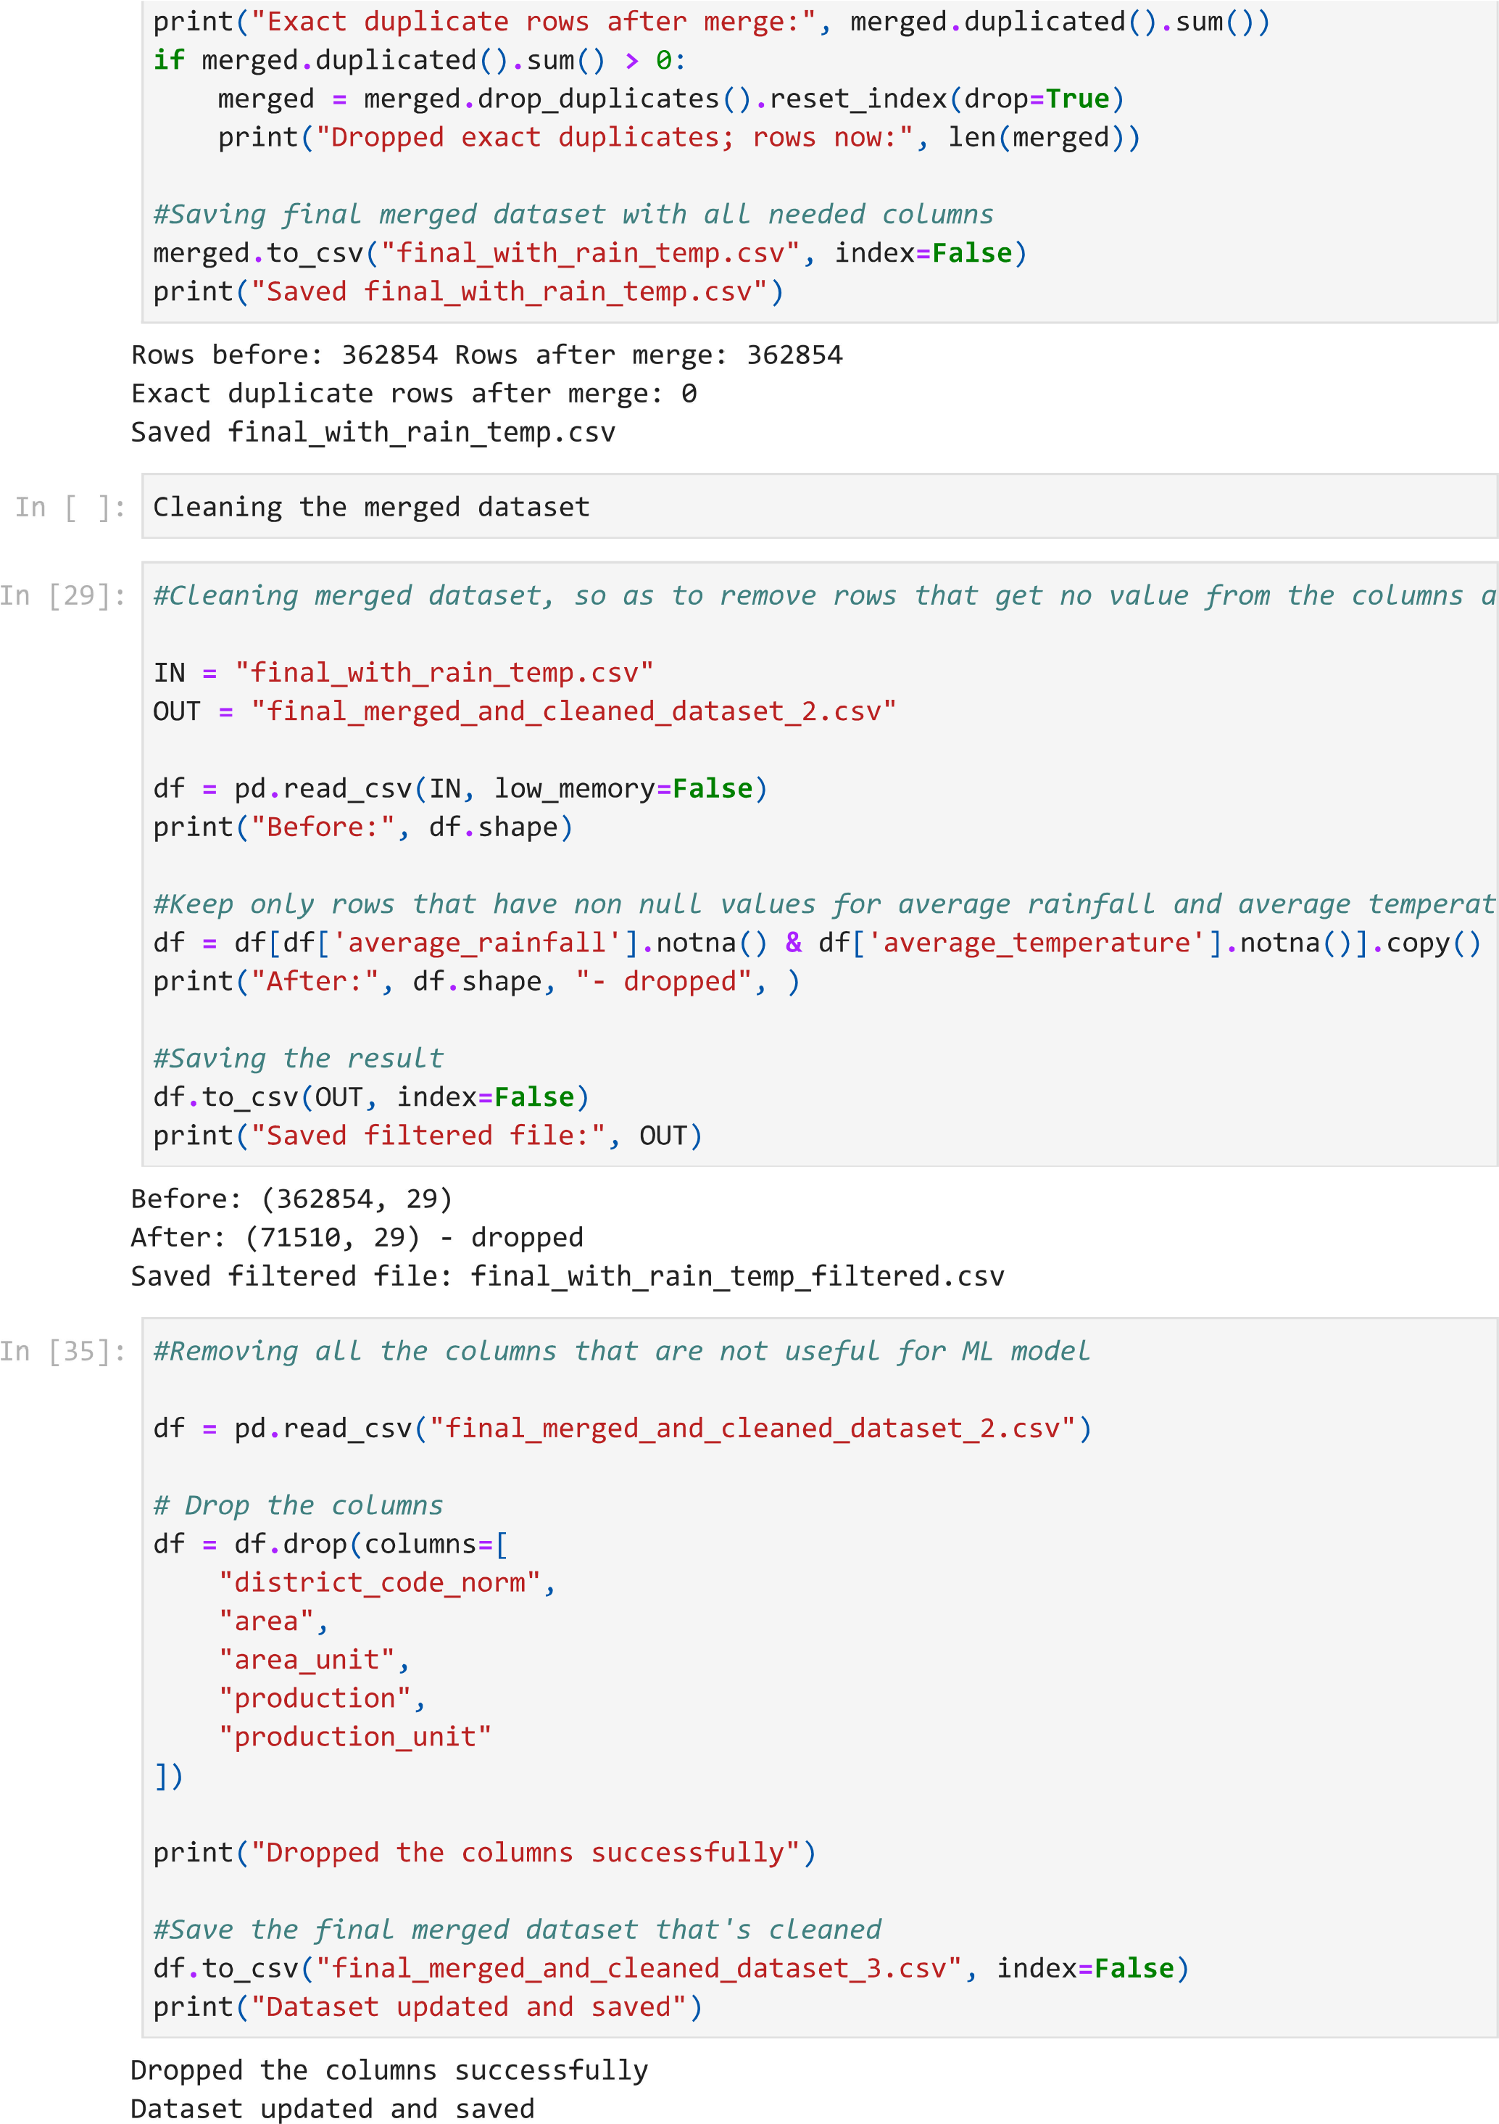

9.2 Model Training Code:
#Creating the models (Linear Regression & Random Forest)

import os
import argparse
import pickle
import joblib
import numpy as np
import pandas as pd

from sklearn.model_selection import train_test_split
from sklearn.linear_model import LinearRegression, Ridge
from sklearn.ensemble import RandomForestRegressor
from sklearn.metrics import (
mean_absolute_error,
mean_squared_error,
r2_score
)

def clean_name(name):
return (
name.lower()
.replace(" ", "_")
.replace("/", "_")
.replace("&", "_")
.replace("(", "")
.replace(")", "")
.replace(".", "")
.replace(",", "")
)

def train_single_model(model_name, crop, X_train, X_test, y_train, y_test, out_dir):
"""Train, evaluate, and save a specific model type for a crop."""
os.makedirs(out_dir, exist_ok=True)

if model_name == "linear":
model = Ridge(alpha=1.0)
elif model_name == "rf":
model = RandomForestRegressor(
n_estimators=300,
max_depth=20,
min_samples_split=5,
min_samples_leaf=2,
random_state=42
)
else:
raise ValueError(f"Unknown model type: {model_name}")

model.fit(X_train, y_train)

# Evaluate model
y_pred = model.predict(X_test)

mae = mean_absolute_error(y_test, y_pred)
mse = mean_squared_error(y_test, y_pred)
rmse = np.sqrt(mse)
r2 = r2_score(y_test, y_pred)

crop_clean = clean_name(crop)
model_file = os.path.join(out_dir, f"{crop_clean}_model.pkl")
metrics_file = os.path.join(out_dir, f"{crop_clean}_metrics.pkl")

joblib.dump(model, model_file)

metrics = {
"mae": float(mae),
"mse": float(mse),
"rmse": float(rmse),
"r2": float(r2),
"training_samples": len(X_train),
"testing_samples": len(X_test)
}

joblib.dump(metrics, metrics_file)

print(f" [{model_name.upper()}] Saved model : {model_file}")
print(f" [{model_name.upper()}] Saved metrics : {metrics_file} (R² = {r2:.4f}, MAE = {mae:.4f})")

def main():
parser = argparse.ArgumentParser(
description="Train Crop Yield Prediction Models (Linear Regression & Random Forest)"
)
parser.add_argument(
"--model",
choices=["linear", "rf", "both", "all"],
default="both",
help="Type of model to train: 'linear', 'rf', or 'both'/'all' (default: both)"
)
parser.add_argument(
"--crop",
type=str,
default=None,
help="Optional: Train for a specific crop name only (e.g. 'Wheat')"
)
BASE_DIR = os.path.dirname(os.path.abspath(__file__))
default_dataset = os.path.join(BASE_DIR, "final_merged_and_cleaned_dataset_3.csv")

parser.add_argument(
"--dataset",
type=str,
default=default_dataset,
help="Path to the dataset CSV file"
)

args = parser.parse_args()

selected_models = []
if args.model in ["linear", "both", "all"]:
selected_models.append("linear")
if args.model in ["rf", "both", "all"]:
selected_models.append("rf")

print(f"Loading dataset from: {args.dataset}")
if not os.path.exists(args.dataset):
raise FileNotFoundError(f"Dataset {args.dataset} not found.")

data = pd.read_csv(args.dataset)

# Fill missing values
for col in data.columns:
if data[col].dtype in ["int64", "float64"]:
data[col] = data[col].fillna(data[col].median())
else:
data[col] = data[col].fillna(data[col].mode()[0])

if args.crop:
matching_crops = [c for c in data["crop_name"].unique() if args.crop.lower() in c.lower()]
if not matching_crops:
print(f"No crop matching '{args.crop}' found.")
return
crop_list = sorted(matching_crops)
else:
crop_list = sorted(data["crop_name"].unique())

print(f"Total crops found: {len(crop_list)}")
print(f"Training models ({', '.join(selected_models)}) for: {crop_list}")

for crop in crop_list:
print(f"\nTraining for crop: {crop}")

crop_data = data[(data["crop_name"] == crop) & (data["yield"] > 0)].copy()

if len(crop_data) < 50:
print(f"Skipping {crop} (not enough data: {len(crop_data)} records)")
continue

X = crop_data.drop(columns=["yield", "yield_unit", "year", "district_code", "crop_code"])
y = crop_data["yield"]

X = pd.get_dummies(X)

X_train, X_test, y_train, y_test = train_test_split(
X, y, test_size=0.2, random_state=42
)

for m in selected_models:
out_dir = os.path.join(BASE_DIR, "models", m)
train_single_model(m, crop, X_train, X_test, y_train, y_test, out_dir)

print("\nTraining completed successfully.")

if __name__ == "__main__":
main()

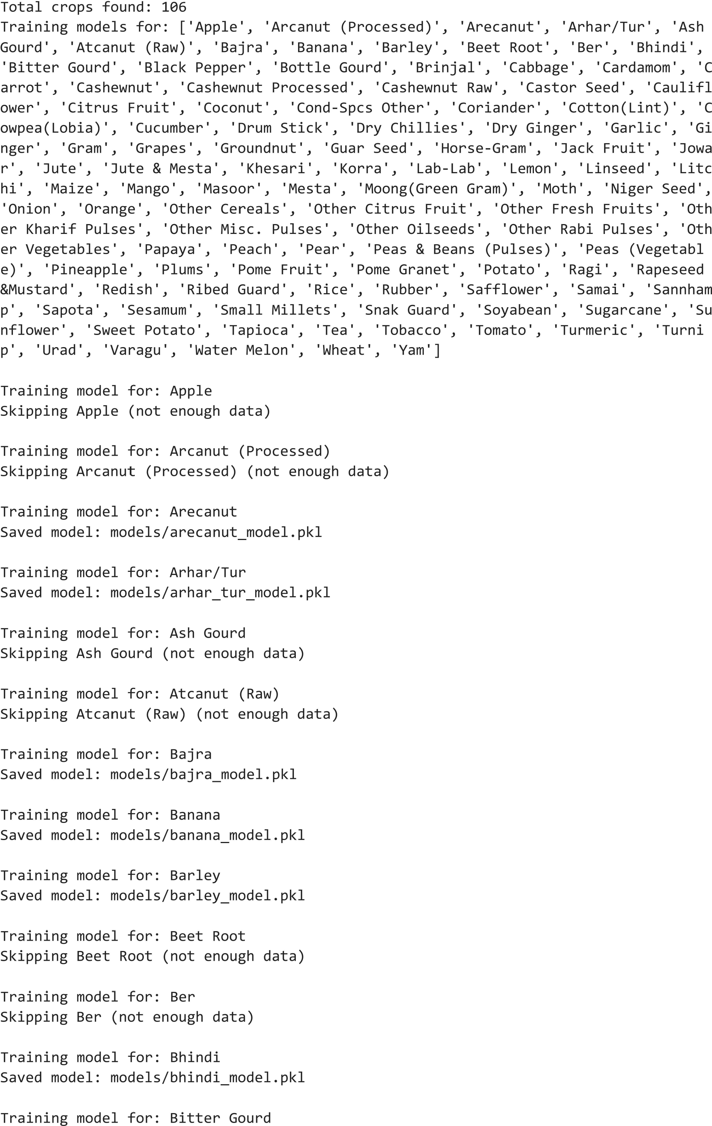
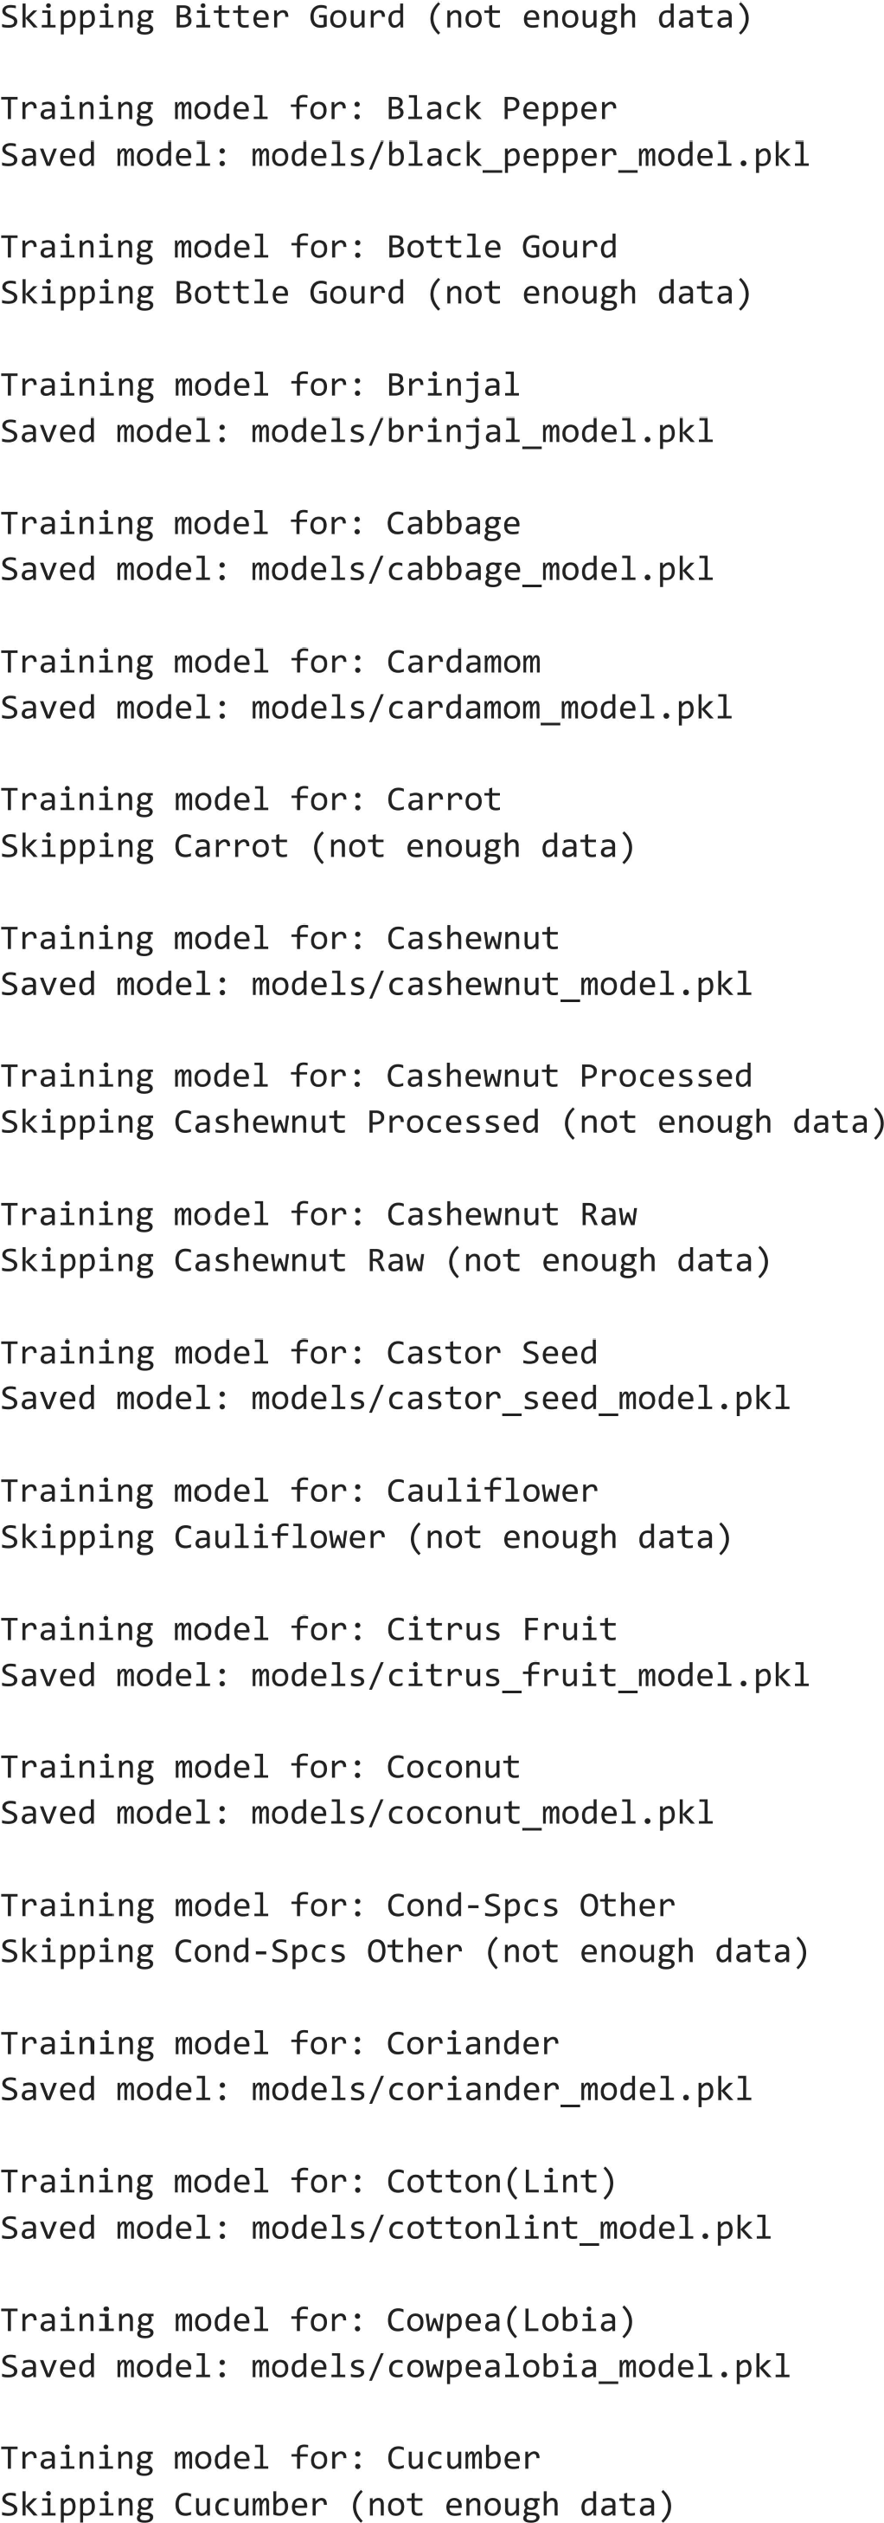
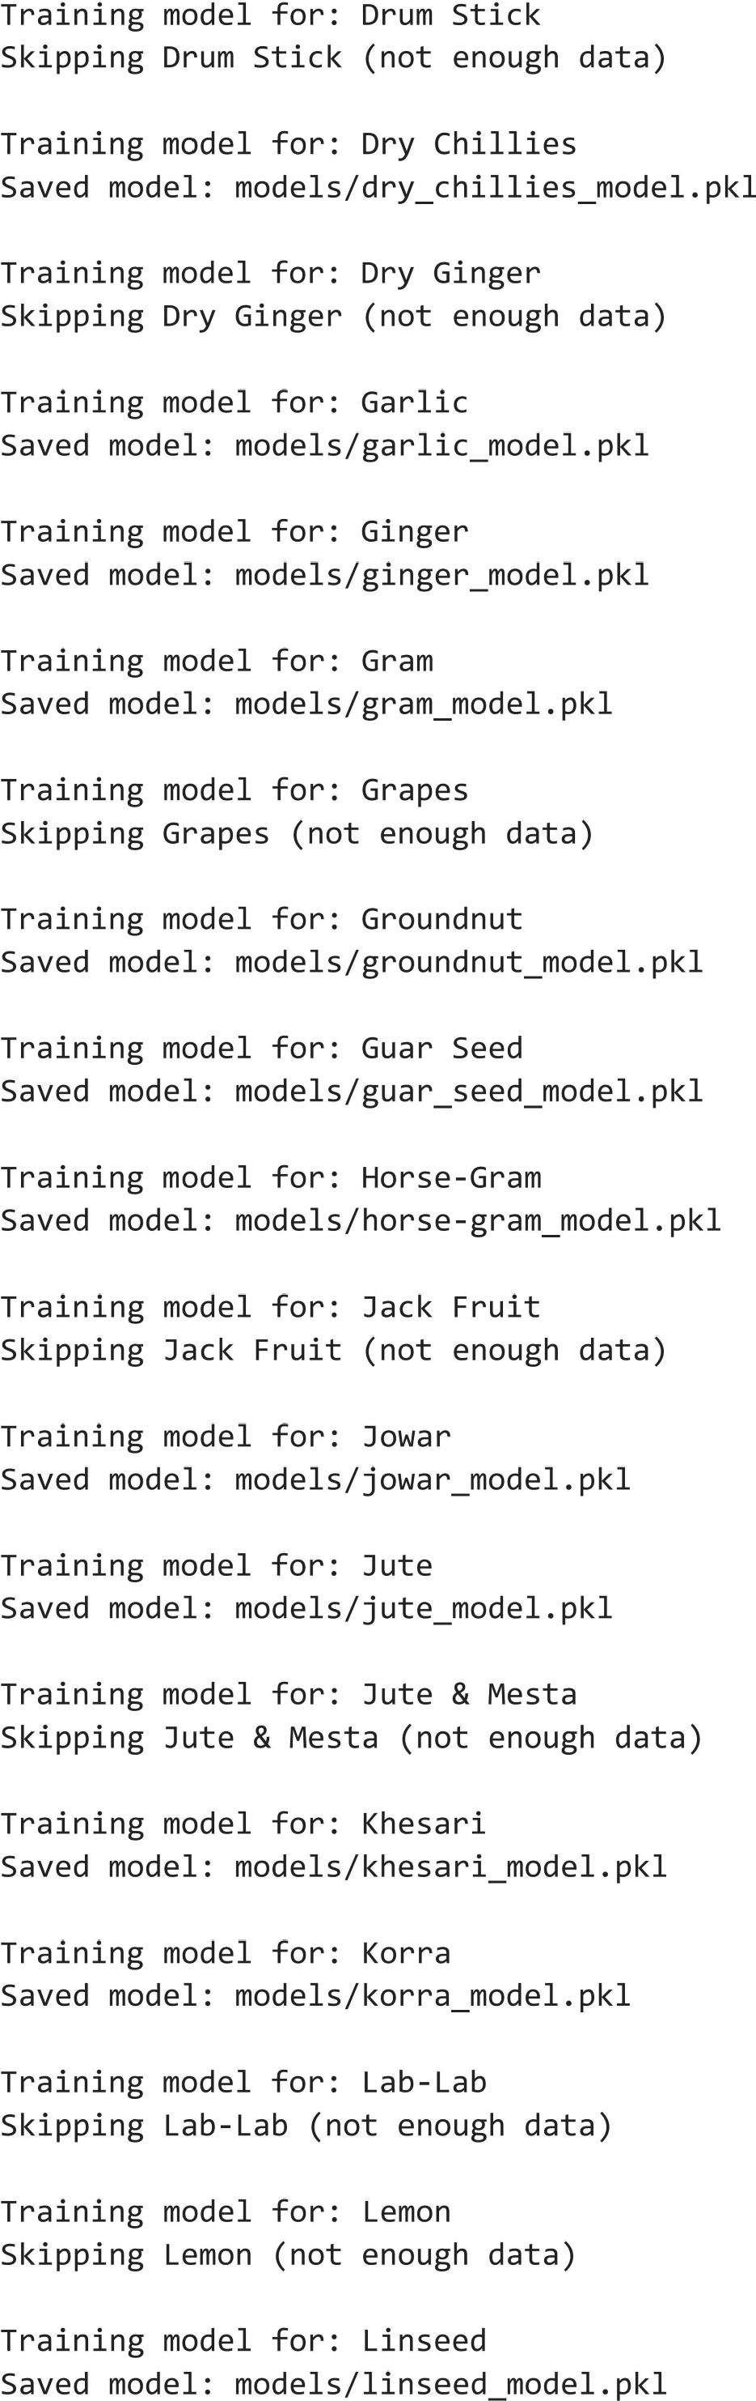
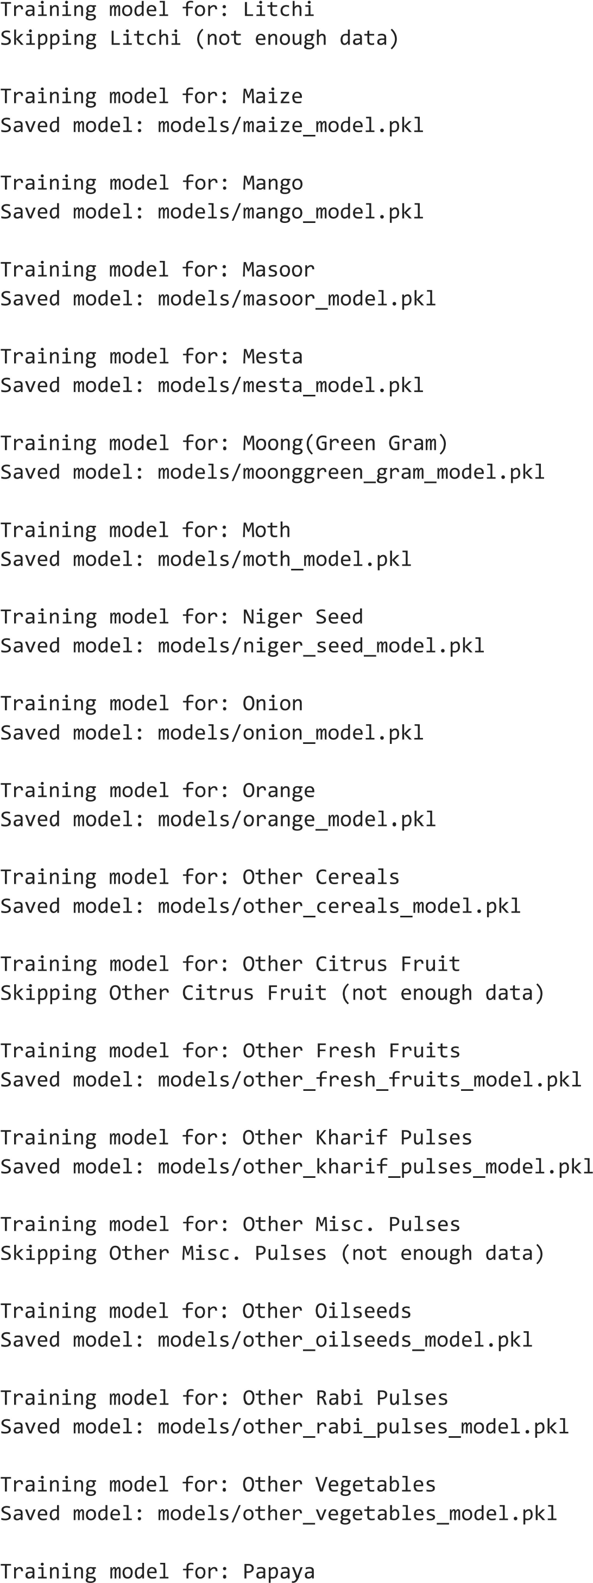
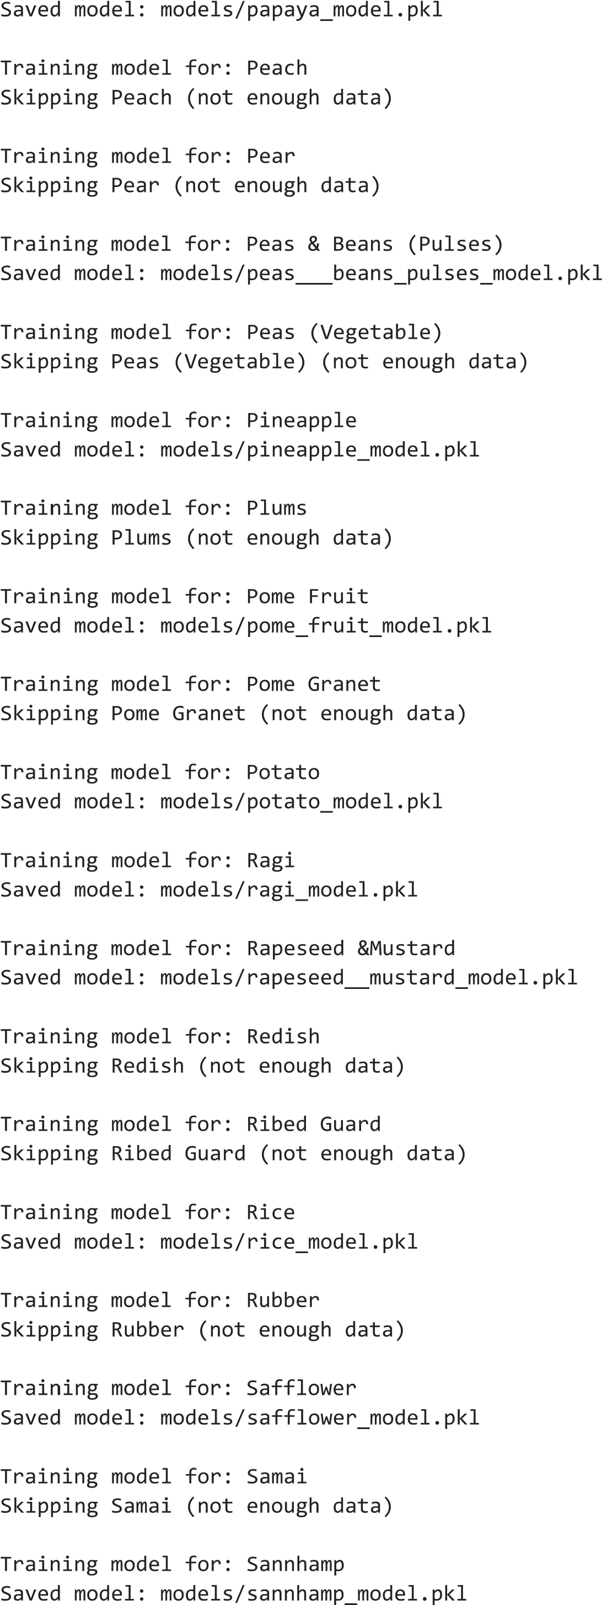
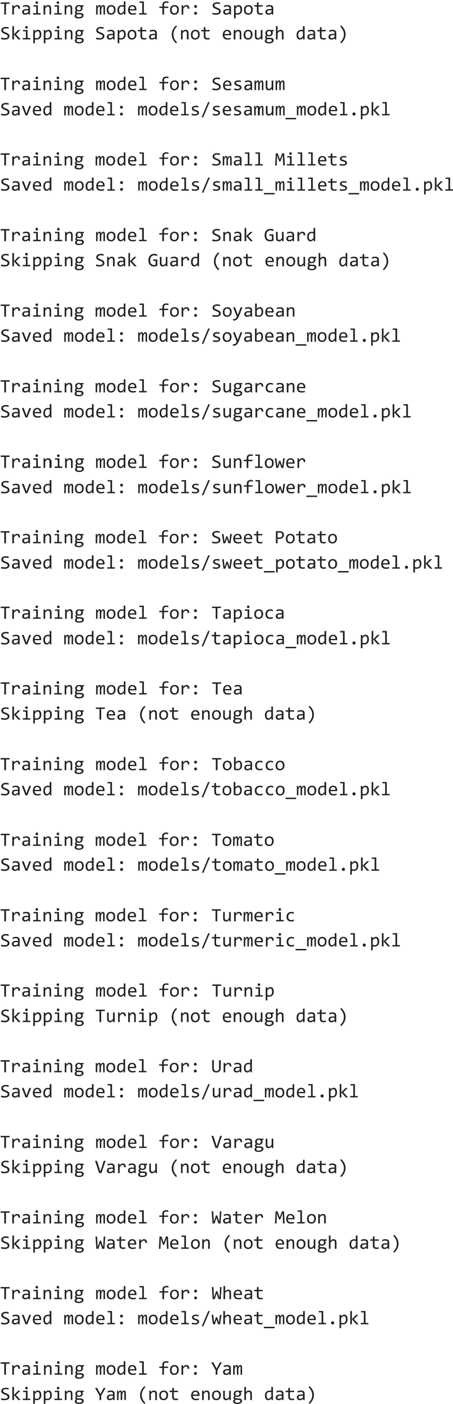


9.3 Crop Yield Prediction Engine Code
# ============================================================
# CROP YIELD PREDICTION - DETAILED REPORT
# ============================================================

import sys
import numpy as np
import pandas as pd
import joblib
import os

# Compatibility shim for NumPy 2.x pickles loaded in NumPy 1.x environments
if int(np.__version__.split(".")[0]) < 2 and "numpy._core" not in sys.modules:
try:
import numpy.core as _core
sys.modules["numpy._core"] = _core
sys.modules["numpy._core.numeric"] = _core.numeric
sys.modules["numpy._core.multiarray"] = _core.multiarray
import numpy.core._multiarray_umath as _umath
sys.modules["numpy._core._multiarray_umath"] = _umath
except Exception:
pass
from sklearn.metrics import (
mean_absolute_error,
mean_squared_error,
r2_score
)

# ============================================================
# LOAD DATASET
# ============================================================

BASE_DIR = os.path.dirname(os.path.abspath(__file__))
DATASET = os.path.join(BASE_DIR, "final_merged_and_cleaned_dataset_3.csv")

data = pd.read_csv(DATASET)

# Fill missing values
for col in data.columns:

if data[col].dtype in ["int64", "float64"]:

data[col] = data[col].fillna(data[col].median())

else:

data[col] = data[col].fillna(data[col].mode()[0])

# ============================================================
# MAIN FUNCTION
# ============================================================

def detailed_prediction(state, district, crop, season, model_type="rf"):

# Normalize model_type
model_type = "linear" if "linear" in str(model_type).lower() else "rf"

# --------------------------------------------------------
# Filter selected crop
# --------------------------------------------------------

crop_data = data[
(data["crop_name"].str.lower() == crop.lower()) &
(data["yield"] > 0)
].copy()

if crop_data.empty:
raise ValueError("No records found for selected crop.")

# --------------------------------------------------------
# Prepare ML data
# --------------------------------------------------------
def clean_name(name):
return (
name.lower()
.replace(" ", "_")
.replace("/", "_")
.replace("&", "_")
.replace("(", "")
.replace(")", "")
.replace(".", "")
.replace(",", "")
)
crop_file = clean_name(crop)

# Check model directory: models/<model_type>/ first, fallback to models/
subfolder = "linear" if model_type == "linear" else "rf"
model_path = os.path.join(BASE_DIR, "models", subfolder, f"{crop_file}_model.pkl")
metrics_path = os.path.join(BASE_DIR, "models", subfolder, f"{crop_file}_metrics.pkl")

if not os.path.exists(model_path):
model_path = os.path.join(BASE_DIR, "models", f"{crop_file}_model.pkl")
if not os.path.exists(metrics_path):
metrics_path = os.path.join(BASE_DIR, "models", f"{crop_file}_metrics.pkl")

if not os.path.exists(model_path):
model_name_str = "Linear Regression" if model_type == "linear" else "Random Forest"
raise FileNotFoundError(f"{model_name_str} model not found for {crop}")

if not os.path.exists(metrics_path):
model_name_str = "Linear Regression" if model_type == "linear" else "Random Forest"
raise FileNotFoundError(f"{model_name_str} metrics file not found for {crop}")

# Load trained model
model = joblib.load(model_path)

# Get feature names stored inside the model
expected_columns = model.feature_names_in_

# Load saved performance metrics
metrics = joblib.load(metrics_path)

mae = metrics["mae"]
mse = metrics["mse"]
rmse = metrics["rmse"]
r2 = metrics["r2"]

training_samples = metrics["training_samples"]
testing_samples = metrics["testing_samples"]
# ============================================================
# FILTER HISTORICAL RECORDS
# ============================================================

filtered = crop_data[
(crop_data["state_name"].str.lower() == state.lower()) &
(crop_data["district_name"].str.lower() == district.lower()) &
(crop_data["season"].str.lower() == season.lower())
].copy()

if filtered.empty:
raise ValueError(
"No historical records found for the selected inputs."
)

latest_year = filtered["year"].max()

filtered = filtered[
filtered["year"].between(
latest_year - 4,
latest_year
)
]

latest = filtered.sort_values("year").iloc[-1]

# ============================================================
# MODEL VALIDATION
# ============================================================

sample = (
filtered
.sort_values("year", ascending=False)
.iloc[[0]]
.copy()
)

actual_yield = sample["yield"].iloc[0]

sample = sample.drop(columns=[
"yield",
"yield_unit",
"year",
"district_code",
"crop_code"
])

sample = pd.get_dummies(sample)

sample = sample.reindex(
columns=expected_columns,
fill_value=0
)

predicted_sample = model.predict(sample)[0]

prediction_error = abs(
actual_yield - predicted_sample
)

# ============================================================
# REPRESENTATIVE FEATURES
# ============================================================

numeric_features = [

"boron",
"copper",
"electrical_conductivity",
"iron",
"manganese",
"nitrogen",
"organic_carbon",
"phosphorus",
"potassium",
"soil_ph",
"sulphur",
"zinc",
"average_rainfall",
"average_temperature"

]

prediction_row = {}

for feature in numeric_features:

prediction_row[feature] = filtered[
feature
].median()

prediction_row["state_name"] = latest["state_name"]

prediction_row["district_name"] = latest["district_name"]

prediction_row["crop_name"] = latest["crop_name"]

prediction_row["season"] = latest["season"]

prediction_row["crop_type"] = latest["crop_type"]

prediction_df = pd.DataFrame([prediction_row])

prediction_df = pd.get_dummies(prediction_df)

prediction_df = prediction_df.reindex(
columns=expected_columns,
fill_value=0
)

# ============================================================
# FINAL PREDICTION
# ============================================================

predicted = model.predict(
prediction_df
)[0]

# ============================================================
# HISTORICAL DATA
# ============================================================

history = filtered[
[
"year",
"yield",
"average_rainfall",
"average_temperature"
]
].copy()

history.columns = [
"Year",
"Yield",
"Rainfall (mm)",
"Temperature (°C)"
]

# ============================================================
# WEATHER & SOIL DATA
# ============================================================

weather = filtered[
[
"year",
"average_rainfall",
"average_temperature",
"nitrogen",
"phosphorus",
"potassium",
"soil_ph",
"organic_carbon",
"zinc",
"iron",
"copper",
"boron",
"manganese",
"sulphur",
"yield"
]
].copy()

weather.columns = [
"Year",
"Rainfall",
"Temperature",
"Nitrogen",
"Phosphorus",
"Potassium",
"Soil pH",
"Organic Carbon",
"Zinc",
"Iron",
"Copper",
"Boron",
"Manganese",
"Sulphur",
"Yield"
]
# ============================================================
# DATASET SUMMARY
# ============================================================

summary = {

"total_records": int(len(data)),

"crop_records": int(len(crop_data)),

"historical_records": int(len(filtered)),

"training_samples": training_samples,

"testing_samples": testing_samples,

"yield_min": float(data["yield"].min()),

"yield_max": float(data["yield"].max()),

"yield_mean": float(data["yield"].mean()),

"historical_mean": float(filtered["yield"].mean()),

"historical_median": float(filtered["yield"].median())

}

# ============================================================
# REPRESENTATIVE FEATURES TABLE
# ============================================================

feature_table = pd.DataFrame(
list(prediction_row.items()),
columns=["Feature", "Value"]
)

# ============================================================
# RETURN EVERYTHING TO GUI
# ============================================================

return {

"prediction": {

"state": state,

"district": district,

"crop": crop,

"season": season,

"model_type": "Linear Regression" if model_type == "linear" else "Random Forest",

"predicted_yield": float(predicted),

"actual_yield": float(actual_yield),

"validation_prediction": float(predicted_sample),

"prediction_error": float(prediction_error)

},

"performance": {

"mae": float(mae),

"mse": float(mse),

"rmse": float(rmse),

"r2": float(r2)

},

"history": history,

"weather": weather,

"features": feature_table,

"summary": summary

}

# ============================================================
# SIMPLE PREDICTION FUNCTION FOR MAIN GUI
# ============================================================

def predict_crop(state, district, crop, season, model_type="rf"):
"""
Lightweight wrapper for the main GUI.
Returns the prediction and metrics for either 'linear' or 'rf'.
"""

result = detailed_prediction(state, district, crop, season, model_type=model_type)

return {
"predicted_yield": result["prediction"]["predicted_yield"],
"model_type": result["prediction"]["model_type"],
"mae": result["performance"]["mae"],
"mse": result["performance"]["mse"],
"rmse": result["performance"]["rmse"],
"r2": result["performance"]["r2"],
"training_samples": result["summary"]["training_samples"],
"testing_samples": result["summary"]["testing_samples"]
}
# ============================================================
# TESTING
# ============================================================

if __name__ == "__main__":

result = detailed_prediction(

"Maharashtra",

"Kolhapur",

"Wheat",

"Rabi"

)

print(result["prediction"])

print(result["performance"])

print(result["summary"])

9.4 Tkinter GUI Main Page Code
import tkinter as tk
from tkinter import ttk, messagebox
import pandas as pd
import os
from crop_yield_prediction import predict_crop

# =====================================================
# LOAD DATASET
# =====================================================

BASE_DIR = os.path.dirname(os.path.abspath(__file__))
CSV_FILE = os.path.join(BASE_DIR, "final_merged_and_cleaned_dataset_3.csv")

if not os.path.exists(CSV_FILE):
messagebox.showerror(
"File Not Found",
f"Cannot find {CSV_FILE}\n\nPlace the CSV in the same folder."
)
raise SystemExit

df = pd.read_csv(CSV_FILE)

df.columns = df.columns.str.strip()

for col in ["state_name", "district_name", "crop_name", "season"]:
df[col] = df[col].astype(str).str.strip()

# =====================================================
# MAIN WINDOW
# =====================================================

root = tk.Tk()

root.title("AI Crop Yield Prediction System")

root.state("zoomed")

root.resizable(False, False)

# =====================================================
# COLORS
# =====================================================

PRIMARY = "#1B5E20"
SECONDARY = "#2E7D32"
BACKGROUND = "#EEF6EE"
CARD = "#FFFFFF"
ACCENT = "#1565C0"
WARNING = "#FB8C00"
DANGER = "#C62828"
TEXT = "#333333"

root.configure(bg=BACKGROUND)

# =====================================================
# STYLE
# =====================================================

style = ttk.Style()

style.theme_use("clam")

style.configure(
"TCombobox",
padding=6,
font=("Segoe UI", 11)
)

style.configure(
"Horizontal.TProgressbar",
thickness=12
)

# =====================================================
# HEADER
# =====================================================

header = tk.Frame(
root,
bg=PRIMARY,
height=70
)

header.pack(fill="x")

header.pack_propagate(False)

tk.Label(
header,
text="🌾 CROP YIELD PREDICTION SYSTEM",
bg=PRIMARY,
fg="white",
font=("Segoe UI", 24, "bold")
).pack(pady=(14, 0))
# =====================================================
# INFORMATION STRIP
# =====================================================

info_bar = tk.Frame(
root,
bg="#E8F5E9",
height=30
)

info_bar.pack(fill="x")

info_bar.pack_propagate(False)

tk.Label(
info_bar,
text=(
f"Dataset Records : {len(df):,} "
f"States : {df['state_name'].nunique()} "
f"Districts : {df['district_name'].nunique()} "
f"Crops : {df['crop_name'].nunique()} "
f"Models : Random Forest & Linear Regression"
),
bg="#E8F5E9",
fg=PRIMARY,
font=("Segoe UI", 10, "bold")
).pack(pady=9)
# =====================================================
# MAIN CONTAINER
# =====================================================

main_container = tk.Frame(
root,
bg=BACKGROUND
)

main_container.pack(
fill="both",
expand=True,
padx=20,
pady=15
)

# =====================================================
# PARAMETER CARD (TOP)
# =====================================================

input_card = tk.Frame(
main_container,
bg=CARD,
bd=2,
relief="groove"
)

input_card.pack(
fill="x"
)

tk.Label(
input_card,
text="📋 Prediction Parameters",
bg=CARD,
fg=PRIMARY,
font=("Segoe UI",16,"bold")
).pack(
pady=(0,0)
)

form = tk.Frame(
input_card,
bg=CARD
)

form.pack(
pady=(0,0)
)

# =====================================================
# PROGRESS ROW
# =====================================================

style.configure(
"Green.Horizontal.TProgressbar",
thickness=6 # Reduce thickness (default was 12)
)

progress_card = tk.Frame(
main_container,
bg=CARD,
bd=2,
relief="groove"
)

progress_card.pack(
fill="x",
pady=(2,2)
)

tk.Label(
progress_card,
text="⚙ Prediction Progress",
bg=CARD,
fg=PRIMARY,
font=("Segoe UI",12,"bold")
).pack(
anchor="w",
padx=15,
pady=(2,4)
)

progress_status = tk.Label(
progress_card,
text="Ready for Prediction",
bg=CARD,
fg="#666666",
font=("Segoe UI",9)
)

progress_status.pack(
anchor="w",
padx=10,
pady=0
)

progress = ttk.Progressbar(
progress_card,
style="Green.Horizontal.TProgressbar",
orient="horizontal",
mode="determinate"
)

progress.pack(
fill="x",
padx=15,
pady=(2,4)
)
# =====================================================
# RESULT AREA
# =====================================================

result_frame = tk.Frame(
main_container,
bg=BACKGROUND
)

result_frame.pack(
fill="both",
expand=True
)

# =====================================================
# PREDICTION CARD
# =====================================================

prediction_card = tk.Frame(
result_frame,
bg=CARD,
bd=2,
relief="groove",
width=560,
height=120
)

prediction_card.pack(
side="left",
fill="both",
expand=True,
padx=(0,10)
)

prediction_card.pack_propagate(False)

# =====================================================
# PERFORMANCE CARD
# =====================================================

performance_card = tk.Frame(
result_frame,
bg=CARD,
bd=2,
relief="groove",
width=560,
height=120
)

performance_card.pack(
side="left",
fill="both",
expand=True
)

performance_card.pack_propagate(False)

# =====================================================
# BUTTON AREA
# =====================================================

button_bar = tk.Frame(
main_container,
bg=BACKGROUND
)

button_bar.pack(
fill="x",
pady=(18,10)
)
# =====================================================
# VARIABLES
# =====================================================

state_var = tk.StringVar()

district_var = tk.StringVar()

crop_var = tk.StringVar()

season_var = tk.StringVar()

states = sorted(
df["state_name"].dropna().unique()
)
# =====================================================
# UPDATE COMBOBOX FUNCTIONS
# =====================================================

def update_districts(event=None):

selected_state = state_var.get()

districts = sorted(
df[df["state_name"] == selected_state]["district_name"]
.dropna()
.unique()
)

district_combo["values"] = districts

district_var.set("")
crop_var.set("")
season_var.set("")

crop_combo["values"] = []
season_combo["values"] = []

def update_crops(event=None):

selected_state = state_var.get()
selected_district = district_var.get()

crops = sorted(
df[
(df["state_name"] == selected_state)
&
(df["district_name"] == selected_district)
]["crop_name"]
.dropna()
.unique()
)

crop_combo["values"] = crops

crop_var.set("")
season_var.set("")

season_combo["values"] = []

def update_seasons(event=None):

selected_state = state_var.get()
selected_district = district_var.get()
selected_crop = crop_var.get()

seasons = sorted(
df[
(df["state_name"] == selected_state)
&
(df["district_name"] == selected_district)
&
(df["crop_name"] == selected_crop)
]["season"]
.dropna()
.unique()
)

season_combo["values"] = seasons

season_var.set("")

# =====================================================
# HORIZONTAL PARAMETER BAR
# =====================================================

parameter_frame = tk.Frame(
form,
bg=CARD
)

parameter_frame.pack(
padx=20,
pady=2
)

label_font = ("Segoe UI",10,"bold")

combo_width = 20

# ---------------- State ----------------

tk.Label(
parameter_frame,
text="📍 State",
bg=CARD,
fg=PRIMARY,
font=label_font
).grid(
row=0,
column=0,
sticky="w",
padx=10
)

state_combo = ttk.Combobox(
parameter_frame,
textvariable=state_var,
width=combo_width,
state="readonly"
)

state_combo["values"] = states

state_combo.grid(
row=1,
column=0,
padx=10,
pady=(2,0)
)

state_combo.bind(
"<<ComboboxSelected>>",
update_districts
)

# ---------------- District ----------------

tk.Label(
parameter_frame,
text="🏙 District",
bg=CARD,
fg=PRIMARY,
font=label_font
).grid(
row=0,
column=1,
sticky="w",
padx=10
)

district_combo = ttk.Combobox(
parameter_frame,
textvariable=district_var,
width=combo_width,
state="readonly"
)

district_combo.grid(
row=1,
column=1,
padx=10,
pady=(2,0)
)

district_combo.bind(
"<<ComboboxSelected>>",
update_crops
)

# ---------------- Crop ----------------

tk.Label(
parameter_frame,
text="🌾 Crop",
bg=CARD,
fg=PRIMARY,
font=label_font
).grid(
row=0,
column=2,
sticky="w",
padx=10
)

crop_combo = ttk.Combobox(
parameter_frame,
textvariable=crop_var,
width=combo_width,
state="readonly"
)

crop_combo.grid(
row=1,
column=2,
padx=10,
pady=(2,0)
)

crop_combo.bind(
"<<ComboboxSelected>>",
update_seasons
)

# ---------------- Season ----------------

tk.Label(
parameter_frame,
text="☀ Season",
bg=CARD,
fg=PRIMARY,
font=label_font
).grid(
row=0,
column=3,
sticky="w",
padx=10
)

season_combo = ttk.Combobox(
parameter_frame,
textvariable=season_var,
width=combo_width,
state="readonly"
)

season_combo.grid(
row=1,
column=3,
padx=10,
pady=(2,0)
)

tk.Label(
input_card,
text="💡 Select State → District → Crop → Season",
bg=CARD,
fg="#666666",
font=("Segoe UI",9)
).pack(
pady=(4,6)
)
# =====================================================
# VALIDATION
# =====================================================

def validate_inputs():

if state_var.get() == "":
messagebox.showerror(
"Missing Input",
"Please select a State."
)
return False

if district_var.get() == "":
messagebox.showerror(
"Missing Input",
"Please select a District."
)
return False

if crop_var.get() == "":
messagebox.showerror(
"Missing Input",
"Please select a Crop."
)
return False

if season_var.get() == "":
messagebox.showerror(
"Missing Input",
"Please select a Season."
)
return False

return True
# =====================================================
# PREDICTION CARD CONTENT
# =====================================================

tk.Label(
prediction_card,
text="🌾 Predicted Crop Yield",
bg=CARD,
fg=PRIMARY,
font=("Segoe UI",18,"bold")
).pack(
pady=(9,4)
)

yield_label = tk.Label(
prediction_card,
text="--",
bg=CARD,
fg=SECONDARY,
font=("Segoe UI",50,"bold")
)

yield_label.pack(pady=(5,0))

tk.Label(
prediction_card,
text="Tonnes / Hectare",
bg=CARD,
fg="#666666",
font=("Segoe UI",13)
).pack()

ttk.Separator(
prediction_card,
orient="horizontal"
).pack(
fill="x",
padx=35,
pady=10
)

prediction_message = tk.Label(
prediction_card,
text="Waiting for prediction...",
bg=CARD,
fg="#555555",
font=("Segoe UI",11),
justify="center"
)

prediction_message.pack(
pady=15
)

# =====================================================
# PERFORMANCE CARD CONTENT
# =====================================================

performance_title = tk.Label(
performance_card,
text="📊 Model Performance",
bg=CARD,
fg=PRIMARY,
font=("Segoe UI",18,"bold")
)
performance_title.pack(
pady=(9,4)
)

metric_row = tk.Frame(
performance_card,
bg=CARD
)

metric_row.pack(
fill="both",
expand=True,
padx=20
)

def metric_card(parent, title, color):

card = tk.Frame(
parent,
bg="#F8FAF8",
bd=1,
relief="solid",
width=150,
height=120
)

card.pack(
side="left",
expand=True,
padx=8,
pady=8
)

card.pack_propagate(False)

tk.Label(
card,
text=title,
bg="#F8FAF8",
fg=color,
font=("Segoe UI",12,"bold")
).pack(
pady=(35,10)
)

value = tk.Label(
card,
text="--",
bg="#F8FAF8",
fg=TEXT,
font=("Segoe UI",24,"bold")
)

value.pack()

return value
mae_label = metric_card(
metric_row,
"📉 MAE",
"#EF6C00"
)

rmse_label = metric_card(
metric_row,
"📊 RMSE",
ACCENT
)

r2_label = metric_card(
metric_row,
"✅ R²",
SECONDARY
)
# =====================================================
# PREDICT FUNCTION
# =====================================================
# =====================================================
# PREDICT FUNCTION
# =====================================================

current_model_type = "rf"

def predict(model_type="rf"):
global current_model_type
current_model_type = model_type

if not validate_inputs():
return

progress["value"] = 0

predict_rf_btn.config(state="disabled")
predict_linear_btn.config(state="disabled")
reset_btn.config(state="disabled")
detail_btn.config(state="disabled")

model_name_label = "Random Forest Regressor" if model_type == "rf" else "Linear Regressor"
performance_title.config(text=f"📊 Performance ({model_name_label})")

stages = [
(f"Loading {model_name_label} Model...", 20),
("Reading Historical Dataset...", 40),
("Processing Input Features...", 60),
("Generating Prediction...", 85),
("Finalizing Results...", 100)
]

try:

for text, value in stages:

progress_status.config(text=text)

while progress["value"] < value:

progress["value"] += 1

root.update_idletasks()

root.after(12)

result = predict_crop(

state_var.get(),

district_var.get(),

crop_var.get(),

season_var.get(),

model_type=model_type

)

prediction = result["predicted_yield"]

if prediction >= 3:

color = SECONDARY

message = "🌱 Excellent Expected Yield"

elif prediction >= 2:

color = WARNING

message = "🌾 Moderate Expected Yield"

else:

color = DANGER

message = "⚠ Low Expected Yield"

yield_label.config(

text=f"{prediction:.3f}",

fg=color

)

prediction_message.config(

text=(
f"{message}\n\n"
f"Model : {result.get('model_type', model_name_label)}\n"
f"Crop : {crop_var.get()} | District : {district_var.get()}\n"
f"Season : {season_var.get()}"
)

)

mae_label.config(

text=f"{result['mae']:.3f}"

)

rmse_label.config(

text=f"{result['rmse']:.3f}"

)

r2_label.config(

text=f"{result['r2']:.3f}"

)

progress_status.config(

text=f"✅ {model_name_label} Prediction Completed Successfully"

)

progress["value"] = 100

except Exception as e:

progress["value"] = 0

progress_status.config(

text="❌ Prediction Failed"

)

messagebox.showerror(

"Prediction Error",

str(e)

)

finally:

predict_rf_btn.config(state="normal")

predict_linear_btn.config(state="normal")

reset_btn.config(state="normal")

detail_btn.config(state="normal")
# =====================================================
# RESET
# =====================================================

def reset():
global current_model_type
current_model_type = "rf"

state_var.set("")

district_var.set("")

crop_var.set("")

season_var.set("")

district_combo["values"] = []

crop_combo["values"] = []

season_combo["values"] = []

yield_label.config(

text="--",

fg=SECONDARY

)

prediction_message.config(

text="Waiting for prediction..."

)

performance_title.config(

text="📊 Model Performance"

)

mae_label.config(text="--")

rmse_label.config(text="--")

r2_label.config(text="--")

progress["value"] = 0

progress_status.config(

text="Ready for Prediction"

)

# =====================================================
# DETAILED VIEW
# =====================================================

def detailed_view():

if not validate_inputs():
return

import detailed_view

detailed_view.show_window(
state_var.get(),
district_var.get(),
crop_var.get(),
season_var.get(),
model_type=current_model_type
)
# =====================================================
# BUTTON CARD
# =====================================================

button_card = tk.Frame(
button_bar,
bg=BACKGROUND
)

button_card.pack(
fill="x",
pady=(2,6)
)

def hover_in(e):
e.widget.config(relief="raised")

def hover_out(e):
e.widget.config(relief="flat")

button_style = {
"fg":"white",
"font":("Segoe UI",10,"bold"),
"width":17,
"height":1,
"cursor":"hand2",
"relief":"flat",
"bd":0
}

predict_rf_btn = tk.Button(
button_card,
text="🌲 Predict (RF)",
bg=SECONDARY,
command=lambda: predict("rf"),
**button_style
)

predict_rf_btn.pack(
side="left",
expand=True,
padx=5
)

predict_linear_btn = tk.Button(
button_card,
text="📈 Predict (Linear)",
bg="#388E3C",
command=lambda: predict("linear"),
**button_style
)

predict_linear_btn.pack(
side="left",
expand=True,
padx=5
)

reset_btn = tk.Button(
button_card,
text="🔄 Reset",
bg=WARNING,
command=reset,
**button_style
)

reset_btn.pack(
side="left",
expand=True,
padx=5
)

detail_btn = tk.Button(
button_card,
text="📊 Detailed View",
bg=ACCENT,
command=detailed_view,
**button_style
)

detail_btn.pack(
side="left",
expand=True,
padx=5
)

exit_btn = tk.Button(
button_card,
text="❌ Exit",
bg=DANGER,
command=root.destroy,
**button_style
)

exit_btn.pack(
side="left",
expand=True,
padx=5
)

for btn in [predict_rf_btn, predict_linear_btn, reset_btn, detail_btn, exit_btn]:

btn.bind("<Enter>", hover_in)

btn.bind("<Leave>", hover_out)
# =====================================================
# KEYBOARD SHORTCUTS
# =====================================================

root.bind(
"<Return>",
lambda e: predict("rf")
)

root.bind(
"<Shift-Return>",
lambda e: predict("linear")
)

root.bind(
"<Escape>",
lambda e: reset()
)

root.bind(
"<F1>",
lambda e: detailed_view()
)

# =====================================================
# FOOTER
# =====================================================

footer = tk.Frame(
root,
bg=PRIMARY,
height=28
)

footer.pack(
fill="x",
side="bottom"
)

footer.pack_propagate(False)

tk.Label(
footer,
text="© 2026 AI Crop Yield Prediction System | Developed using Python • Tkinter • Machine Learning",
bg=PRIMARY,
fg="white",
font=("Segoe UI",9)
).pack(
pady=4
)

# =====================================================
# START
# =====================================================

root.mainloop()

9.5 Tkinter GUI Detailed View Page Code
import tkinter as tk
from tkinter import ttk
import matplotlib.pyplot as plt
from matplotlib.backends.backend_tkagg import FigureCanvasTkAgg
import seaborn as sns
from crop_yield_prediction import detailed_prediction

# ======================================================
# TREEVIEW FUNCTION
# ======================================================

def create_tree(parent, dataframe):

tree_frame = tk.Frame(parent)
tree_frame.pack(fill="both", expand=True)

style = ttk.Style()
style.theme_use("clam")

style.configure("Treeview.Heading",
background="#2E7D32",
foreground="white",
font=("Segoe UI", 11, "bold"),
padding=8)

style.configure("Treeview",
background="white",
foreground="#333333",
rowheight=35,
font=("Segoe UI",10),
fieldbackground="white")

style.map("Treeview",
background=[("selected","#A5D6A7")],
foreground=[("selected","black")])

tree = ttk.Treeview(tree_frame)
tree["columns"] = list(dataframe.columns)
tree["show"] = "headings"

for col in dataframe.columns:
tree.heading(col, text=col)
tree.column(col, width=180, anchor="center") # ⭐ wider columns

for index, row in dataframe.iterrows():
# ⭐ round long floats for cleaner UI
values = [round(v, 3) if isinstance(v, float) else v for v in row]

tag = "evenrow" if index % 2 == 0 else "oddrow"
tree.insert("", "end", values=values, tags=(tag,))

tree.tag_configure("evenrow", background="#F1F8E9")
tree.tag_configure("oddrow", background="white")

scroll_y = ttk.Scrollbar(tree_frame, orient="vertical", command=tree.yview)
scroll_x = ttk.Scrollbar(tree_frame, orient="horizontal", command=tree.xview)

tree.configure(yscrollcommand=scroll_y.set, xscrollcommand=scroll_x.set)

tree.grid(row=0, column=0, sticky="nsew")
scroll_y.grid(row=0, column=1, sticky="ns")
scroll_x.grid(row=1, column=0, sticky="ew")

tree_frame.grid_rowconfigure(0, weight=1)
tree_frame.grid_columnconfigure(0, weight=1)
def _on_shift_mousewheel(event):
tree.xview_scroll(int(-1 * (event.delta / 120)), "units")

tree.bind("<Shift-MouseWheel>", _on_shift_mousewheel)
return tree

# ======================================================
# CARD FUNCTION
# ======================================================

def create_card(parent):
card = tk.Frame(parent, bg="white", bd=2, relief="groove")
card.pack(fill="x", padx=30, pady=10)
return card

# ======================================================
# SCROLLABLE CONTENT
# ======================================================

def create_scrollable_content(parent):

canvas = tk.Canvas(parent, bg="#F4F8F4", highlightthickness=0)
scrollbar = ttk.Scrollbar(parent, orient="vertical", command=canvas.yview)

scroll_frame = tk.Frame(canvas, bg="#F4F8F4")

scroll_frame.bind("<Configure>", lambda e: canvas.configure(scrollregion=canvas.bbox("all")))

window_id = canvas.create_window((0,0), window=scroll_frame, anchor="nw")

canvas.bind("<Configure>", lambda e: canvas.itemconfig(window_id, width=e.width))
canvas.configure(yscrollcommand=scrollbar.set)

canvas.pack(side="left", fill="both", expand=True)
scrollbar.pack(side="right", fill="y")

def _on_mousewheel(event):
canvas.yview_scroll(int(-1*(event.delta/120)), "units")

canvas.bind("<Enter>", lambda e: canvas.bind_all("<MouseWheel>", _on_mousewheel))
canvas.bind("<Leave>", lambda e: canvas.unbind_all("<MouseWheel>"))

return scroll_frame

# ======================================================
# SHOW WINDOW
# ======================================================

def show_window(state, district, crop, season, model_type="rf"):

result = detailed_prediction(state, district, crop, season, model_type=model_type)

model_display_name = result["prediction"].get("model_type", "Machine Learning")

window = tk.Toplevel()
window.title(f"Detailed Crop Yield Report ({model_display_name})")
window.geometry("1300x720")
window.configure(bg="#F4F8F4")
window.resizable(True, True)

header = tk.Frame(window, bg="#1B5E20", height=80)
header.pack(fill="x")

tk.Label(
header,
text=f"🌾 DETAILED CROP YIELD REPORT ({model_display_name.upper()})",
bg="#1B5E20",
fg="white",
font=("Segoe UI",22,"bold")
).pack(pady=18)

style = ttk.Style()
style.theme_use("clam")
style.configure("TNotebook", background="#F4F8F4")
style.configure("TNotebook.Tab", font=("Segoe UI",11,"bold"), padding=(20,10))

notebook = ttk.Notebook(window)
notebook.pack(fill="both", expand=True, padx=20, pady=20)

prediction_tab = tk.Frame(notebook)
history_tab = tk.Frame(notebook)
weather_tab = tk.Frame(notebook)
features_tab = tk.Frame(notebook)
summary_tab = tk.Frame(notebook)

notebook.add(prediction_tab, text="Prediction")
notebook.add(history_tab, text="History")
notebook.add(weather_tab, text="Weather & Soil")
notebook.add(features_tab, text="Features")
notebook.add(summary_tab, text="Summary")

def next_tab():
current = notebook.index(notebook.select())
total = notebook.index("end")
if current < total - 1:
notebook.select(current + 1)

def previous_tab():
current = notebook.index(notebook.select())
if current > 0:
notebook.select(current - 1)

def hover(button, normal, hover_color):
button.bind("<Enter>", lambda e: button.config(bg=hover_color))
button.bind("<Leave>", lambda e: button.config(bg=normal))

def create_tab_layout(tab, title):
container = tk.Frame(tab, bg="#F4F8F4")
container.pack(fill="both", expand=True)

tk.Label(
container,
text=title,
bg="#F4F8F4",
fg="#1B5E20",
font=("Segoe UI",20,"bold")
).pack(pady=(15,10))

content_container = tk.Frame(container, bg="#F4F8F4")
content_container.pack(fill="both", expand=True)

content = create_scrollable_content(content_container)

nav = tk.Frame(container, bg="#F4F8F4")
nav.pack(fill="x", pady=10)

return content, nav

def add_navigation(nav):
center = tk.Frame(nav, bg="#F4F8F4")
center.pack()

def on_close():
plt.close("all")
window.destroy()

window.protocol("WM_DELETE_WINDOW", on_close)

prev = tk.Button(center, text="◀ Previous", bg="#FB8C00", fg="white",
font=("Segoe UI",10,"bold"), width=14, relief="flat",
command=previous_tab)

home = tk.Button(center, text="🏠 Home", bg="#C62828", fg="white",
font=("Segoe UI",10,"bold"), width=14, relief="flat",
command=on_close)

nxt = tk.Button(center, text="Next ▶", bg="#2E7D32", fg="white",
font=("Segoe UI",10,"bold"), width=14, relief="flat",
command=next_tab)

prev.grid(row=0, column=0, padx=15, pady=10)
home.grid(row=0, column=1, padx=15, pady=10)
nxt.grid(row=0, column=2, padx=15, pady=10)

hover(prev, "#FB8C00", "#EF6C00")
hover(home, "#C62828", "#B71C1C")
hover(nxt, "#2E7D32", "#1B5E20")

prediction = result["prediction"]
performance = result["performance"]

# ======================================================
# PREDICTION TAB
# ======================================================

prediction_content, prediction_nav = create_tab_layout(prediction_tab, "🌾 Prediction Overview")

info_card = create_card(prediction_content)

fields = [
("📍 State", prediction["state"]),
("🏙 District", prediction["district"]),
("🌾 Crop", prediction["crop"]),
("☀ Season", prediction["season"]),
("🤖 Model Used", prediction.get("model_type", "Machine Learning"))
]

for i, (label, value) in enumerate(fields):
tk.Label(info_card, text=label, bg="white", fg="#1B5E20",
font=("Segoe UI",12,"bold")).grid(row=i, column=0, padx=20, pady=10, sticky="w")
tk.Label(info_card, text=value, bg="white",
font=("Segoe UI",12)).grid(row=i, column=1, padx=20, sticky="w")

yield_card = create_card(prediction_content)

tk.Label(yield_card, text="🌾 Predicted Yield", bg="#E8F5E9",
fg="#1B5E20", font=("Segoe UI",13,"bold")).pack(pady=(10,5))

tk.Label(yield_card, text=f"{prediction['predicted_yield']:.3f} Tonnes/Hectare",
bg="#E8F5E9", fg="#2E7D32", font=("Segoe UI",24,"bold")).pack(pady=(0,15))

metric_card = create_card(prediction_content)

metrics = [
("📈 Actual Yield", prediction["actual_yield"]),
("🎯 Validation Prediction", prediction["validation_prediction"]),
("❗ Prediction Error", prediction["prediction_error"]),
("📉 MAE", performance["mae"]),
("📊 RMSE", performance["rmse"]),
("✅ R² Score", performance["r2"])
]

for i, (label, value) in enumerate(metrics):
tk.Label(metric_card, text=label, bg="white",
font=("Segoe UI",11,"bold")).grid(row=i, column=0, padx=20, pady=8, sticky="w")
tk.Label(metric_card, text=f"{value:.3f}", bg="white", fg="#1565C0",
font=("Segoe UI",11)).grid(row=i, column=1, padx=20, sticky="w")

add_navigation(prediction_nav)

# ======================================================
# HISTORY TAB
# ======================================================

history_content, history_nav = create_tab_layout(history_tab, "📈 Historical Crop Yield Records")

history_frame = tk.Frame(history_content)
history_frame.pack(fill="both", expand=True, padx=10, pady=10)

create_tree(history_frame, result["history"])
add_navigation(history_nav)

# ======================================================
# WEATHER TAB
# ======================================================

weather_content, weather_nav = create_tab_layout(weather_tab, "☁ Weather & Soil Data")

weather_frame = tk.Frame(weather_content,height=420)
weather_frame.pack(fill="x", expand=True, padx=10, pady=10)
weather_frame.pack_propagate(False)

weather_tree=create_tree(weather_frame, result["weather"])

for col in weather_tree["columns"]:
weather_tree.column(col, stretch=False)

weather_tree.column("Year", width=90)

weather_tree.column("Rainfall", width=170)

weather_tree.column("Temperature", width=180)

weather_tree.column("Nitrogen", width=170)

weather_tree.column("Phosphorus", width=170)

weather_tree.column("Potassium", width=170)

weather_tree.column("Soil pH", width=150)

weather_tree.column("Organic Carbon", width=220)

weather_tree.column("Zinc", width=170)

weather_tree.column("Iron", width=150)
weather_tree.column("Copper", width=150)
weather_tree.column("Boron", width=150)
weather_tree.column("Manganese", width=150)
weather_tree.column("Sulphur", width=150)
weather_tree.column("Yield", width=150)

add_navigation(weather_nav)

# ======================================================
# FEATURES TAB
# ======================================================

features_content, features_nav = create_tab_layout(features_tab, "🧠 Features Used For Prediction")

feature_frame = tk.Frame(features_content)
feature_frame.pack(fill="both", expand=True, padx=10, pady=10)

create_tree(feature_frame, result["features"])
add_navigation(features_nav)

# ======================================================
# SUMMARY TAB
# ======================================================

summary = result["summary"]

summary_content, summary_nav = create_tab_layout(summary_tab, "📋 Dataset Summary")

summary_frame = tk.Frame(summary_content)
summary_frame.pack(fill="both", expand=True, padx=20, pady=20)

dataset_card = create_card(summary_content)

dataset_info = [
("📁 Total Dataset Records", summary["total_records"]),
("🌾 Crop Records Used", summary["crop_records"]),
("📜 Historical Records", summary["historical_records"]),
("🧠 Training Samples", summary["training_samples"]),
("🧪 Testing Samples", summary["testing_samples"])
]

for i, (label, value) in enumerate(dataset_info):
tk.Label(dataset_card, text=label, bg="white", fg="#1B5E20",
font=("Segoe UI",11,"bold")).grid(row=i, column=0, padx=20, pady=8, sticky="w")
tk.Label(dataset_card, text=value, bg="white", fg="#1565C0",
font=("Segoe UI",11)).grid(row=i, column=1, padx=20, sticky="w")

yield_card = create_card(summary_content)

tk.Label(yield_card, text="📈 Dataset Yield Statistics", bg="#E8F5E9",
fg="#1B5E20", font=("Segoe UI",13,"bold")).pack(pady=(10,5))

stats = [
("Minimum Yield", summary["yield_min"]),
("Maximum Yield", summary["yield_max"]),
("Average Yield", summary["yield_mean"])
]

for text, value in stats:
row = tk.Frame(yield_card, bg="#E8F5E9")
row.pack(fill="x", padx=25, pady=4)

tk.Label(row, text=text, bg="#E8F5E9",
font=("Segoe UI",11,"bold")).pack(side="left")
tk.Label(row, text=f"{value:.3f}", bg="#E8F5E9",
fg="#2E7D32", font=("Segoe UI",11)).pack(side="right")

history_card = create_card(summary_content)

history_data = [
("📊 Mean Yield", summary["historical_mean"]),
("📉 Median Yield", summary["historical_median"])
]

for i, (label, value) in enumerate(history_data):
tk.Label(history_card, text=label, bg="white", fg="#1B5E20",
font=("Segoe UI",11,"bold")).grid(row=i, column=0, padx=20, pady=8, sticky="w")
tk.Label(history_card, text=f"{value:.3f}", bg="white",
fg="#1565C0", font=("Segoe UI",11)).grid(row=i, column=1, padx=20, sticky="w")

add_navigation(summary_nav)

# ======================================================
# 📊 GRAPHS TAB (NO FEATURE IMPORTANCE, NO SOIL NUTRIENTS)
# ======================================================

sns.set_style("whitegrid")

graphs_tab = tk.Frame(notebook)
notebook.add(graphs_tab, text="📊 Graphs")

graphs_content, graphs_nav = create_tab_layout(graphs_tab, "📊 Regression Graphs")

graph_frame = tk.Frame(graphs_content, bg="#F4F8F4")
graph_frame.pack(fill="both", expand=True, padx=10, pady=10)

def add_graph(fig, parent):
canvas = FigureCanvasTkAgg(fig, master=parent)
canvas.draw()
widget = canvas.get_tk_widget()
widget.pack(fill="both", expand=True, pady=20)

# Yield Trend
fig1, ax1 = plt.subplots(figsize=(7,4))
ax1.plot(result["history"]["Year"], result["history"]["Yield"], marker="o", color="#2E7D32")
ax1.set_title("Yield Trend Over Years", fontsize=14)
ax1.set_xlabel("Year")
ax1.set_ylabel("Yield (Tonnes/Hectare)")
add_graph(fig1, graph_frame)

# Rainfall vs Yield
fig2, ax2 = plt.subplots(figsize=(7,4))
ax2.scatter(result["weather"]["Rainfall"], result["weather"]["Yield"], color="#1565C0")
ax2.set_title("Rainfall vs Yield", fontsize=14)
ax2.set_xlabel("Rainfall (mm)")
ax2.set_ylabel("Yield (Tonnes/Hectare)")
add_graph(fig2, graph_frame)

# Residual Plot (Simple)
actual = result["history"]["Yield"]
predicted = [prediction["predicted_yield"]] * len(actual)
residuals = actual - predicted

fig3, ax3 = plt.subplots(figsize=(7,4))
ax3.scatter(predicted, residuals, color="#8E24AA")
ax3.axhline(0, color="black", linestyle="--")
ax3.set_title("Residual Plot", fontsize=14)
ax3.set_xlabel("Predicted Yield")
ax3.set_ylabel("Residual (Actual - Predicted)")
add_graph(fig3, graph_frame)

add_navigation(graphs_nav)

10. Statistical Interpretation of Results:
1) Yield Trend
Shows whether yield is increasing, decreasing, or stable over the years.
2) Rainfall vs Yield
Scatter plot showing how rainfall affects yield. A visible pattern indicates correlation.
3) Residual Plot
Shows how close predictions are to actual values. Small residuals indicate good accuracy.
4) Summary Statistics
Helps understand:
- Average yield
- Variation
- Minimum and maximum values
These are basic statistical tools used throughout the project.

11. User Interface Overview
The interface contains multiple tabs:
Prediction Tab
Shows predicted yield and error metrics.
History Tab
Displays historical yield records.
Weather & Soil Tab
Shows weather and soil data in table format.
Features Tab
Shows the variables used for prediction.
Summary Tab
Shows dataset statistics.
Graphs Tab
Includes:
- Yield Trend
- Rainfall vs Yield
- Residual Plot

12. Outputs
- Main Page:
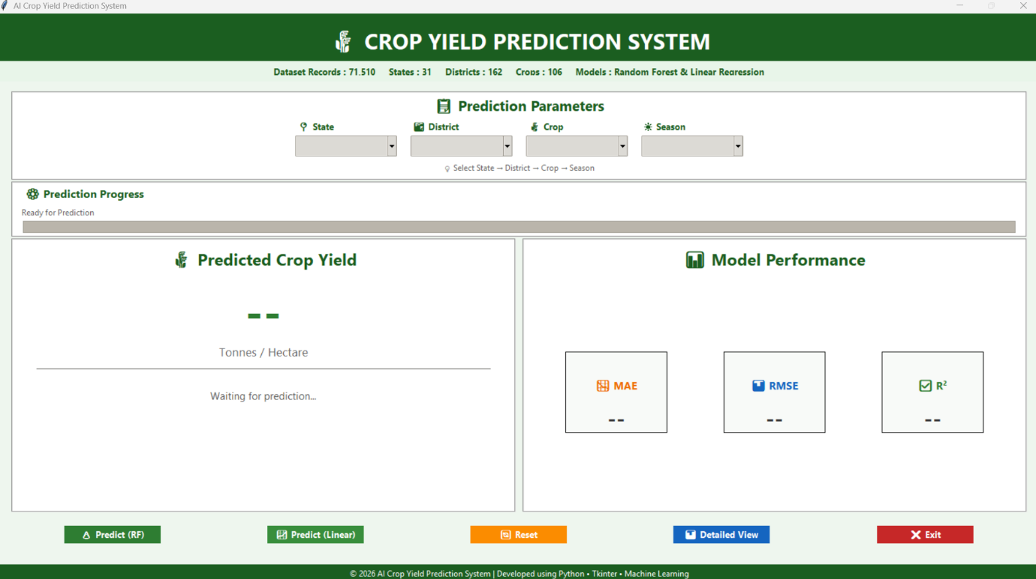
- Crop Yield Prediction using Random Forest Model:
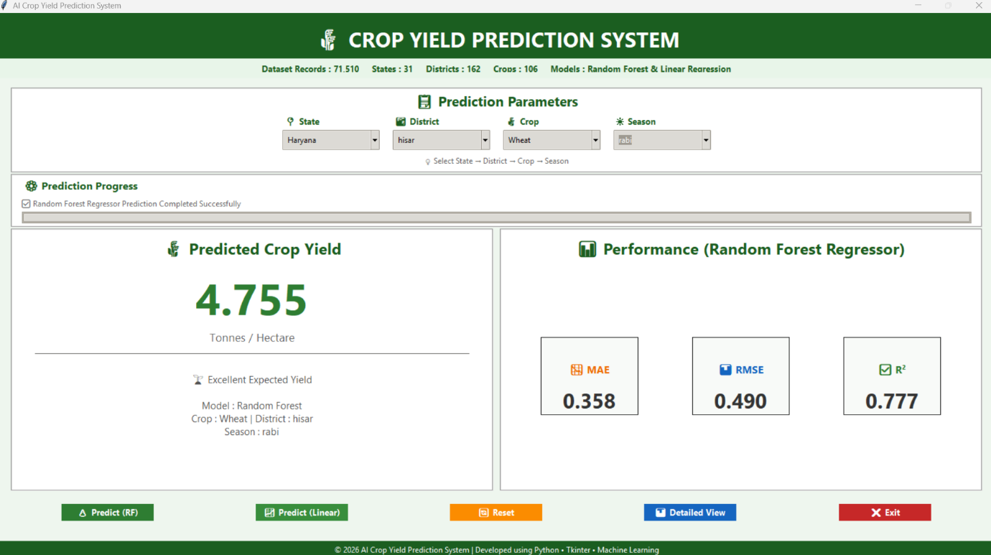

- Detailed View Page of Random Forest Model:
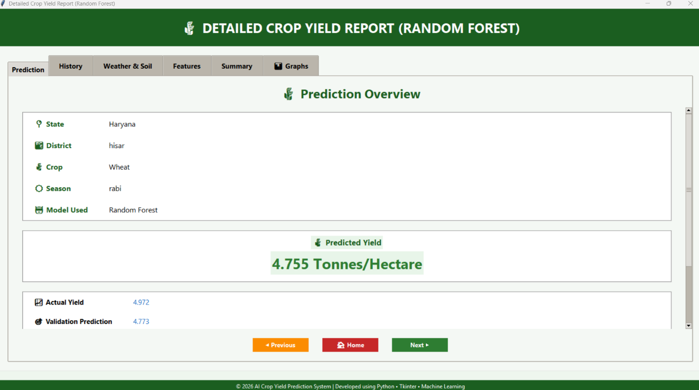
- Detailed Crop Yield Report of Random Forest Model:
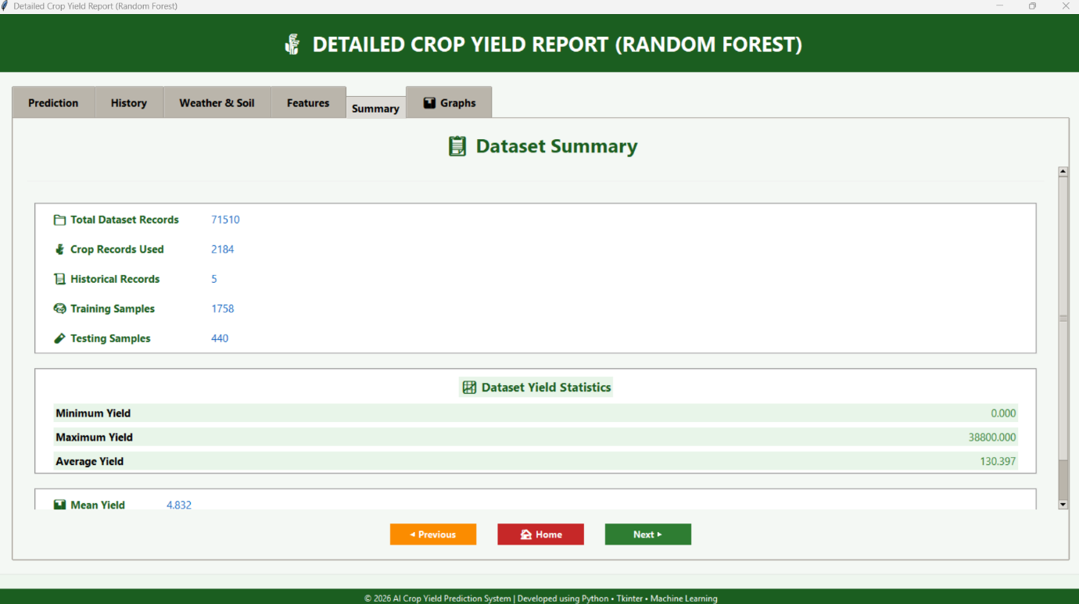

- Crop Yield Prediction using Ridged Model (Linear Regression):
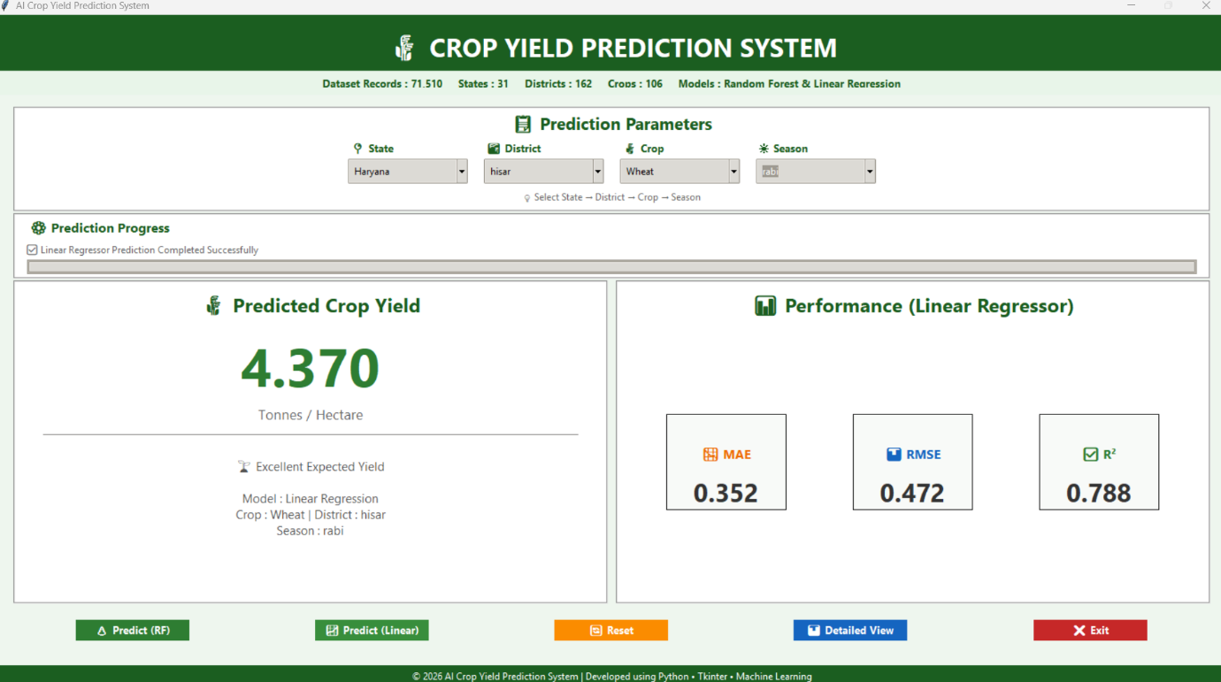
- Detailed View Page of Ridged Model:
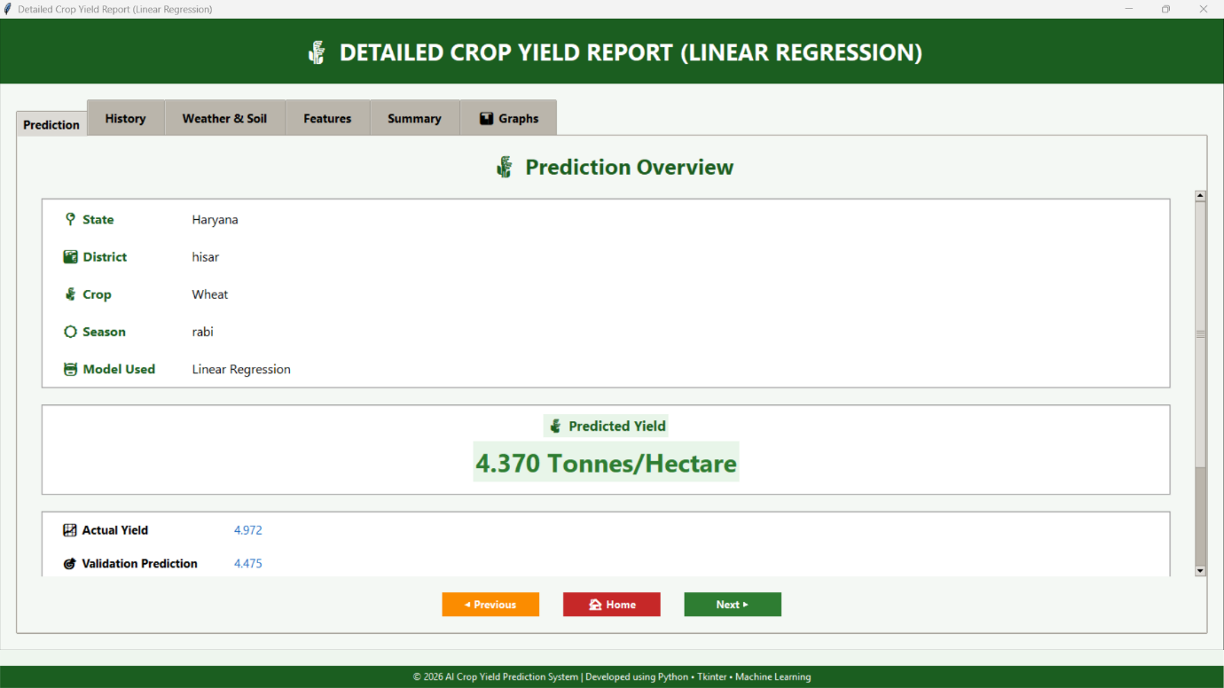

- Detailed Crop Yield Report of Ridged Model:
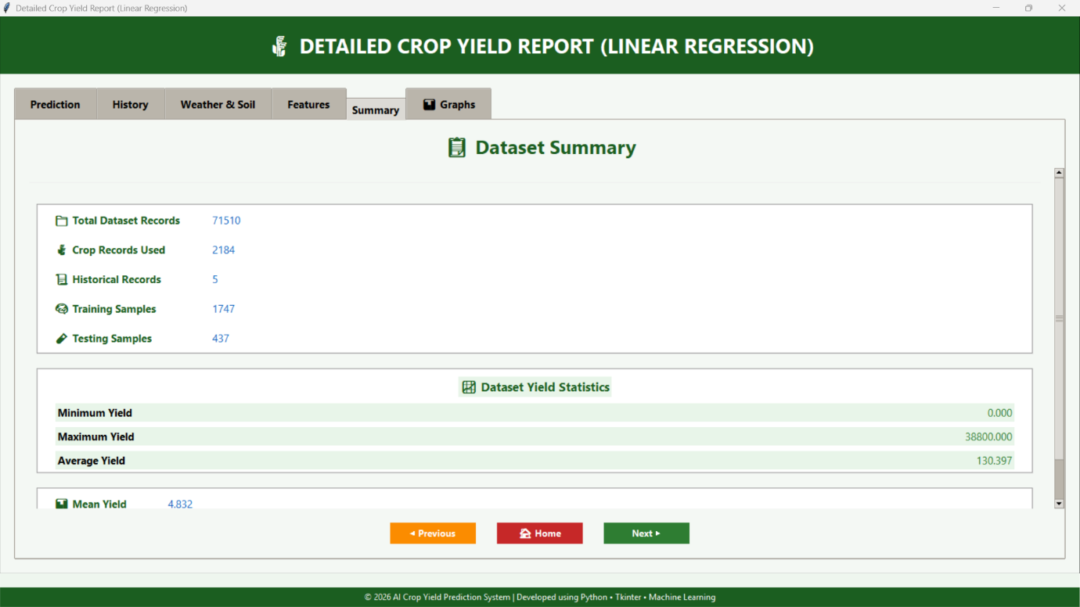

13. Conclusion
This project demonstrates how statistical concepts can be applied to real agricultural data to estimate crop yield.
By analyzing trends, correlations, and residuals, the system provides meaningful insights into how weather and soil conditions affect yield.
Crop-specific models improve accuracy, and the graphical interface makes the results easy to understand.
Overall, the project successfully combines statistical fundamentals with practical data-driven methods.

14. Future Scope
- Add real-time weather data
- Include more crops and larger datasets
- Deploy the system as a web application
- Add soil sensor integration
- Improve accuracy using advanced statistical models

15. References
Data.gov.in – Rainfall in India
https://www.data.gov.in/catalog/rainfall-india
India Data Portal – Fertilizer Sales Dataset
https://ckandev.indiadataportal.com/dataset/fertilizer-sales
India Data Portal – Soil Health Card Dataset
https://ckandev.indiadataportal.com/dataset/soil-health-card/resource/024cf507-4281-4c89-a40e-37b5add3a4df
India Data Portal – Climate Data
https://ckandev.indiadataportal.com/dataset/climate-data
Kaggle – Crop Yield in Indian States Dataset
https://www.kaggle.com/datasets/akshatgupta7/crop-yield-in-indian-states-dataset

