# How to create sprite image and json for marker registration

When registering a marker image, the image is registered in sprite form.

Using the free of charge program, you can easily create sprite images.

## Install marker image creation program

1. Download and install the program for your operating system from https://www.codeandweb.com/texturepacker.  
   (After use, select Use Free Version.)

## Image creation

1. After running the program, drag the image to be used as a marker to Sprites.

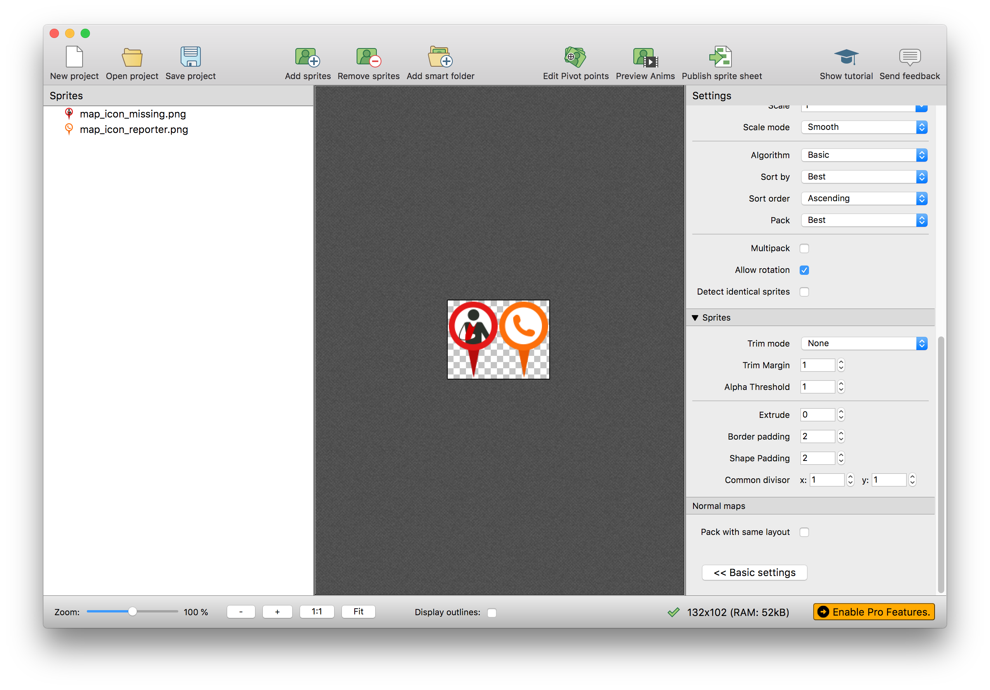

1. On the right tab (Settings), change the border padding and shape padding values in the Sprites section as shown below.  
   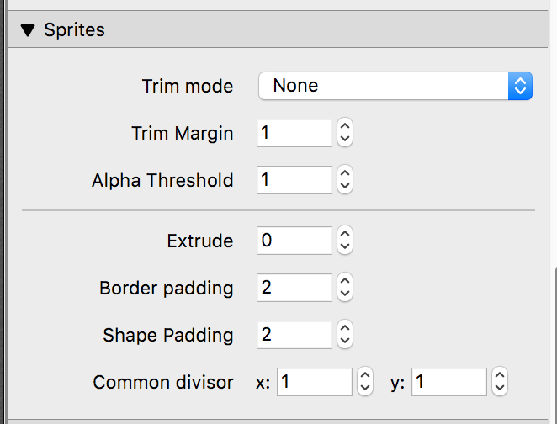  
   - Border Padding : 2  
   - Shape Padding : 2
2. Change the storage location of the result file  
   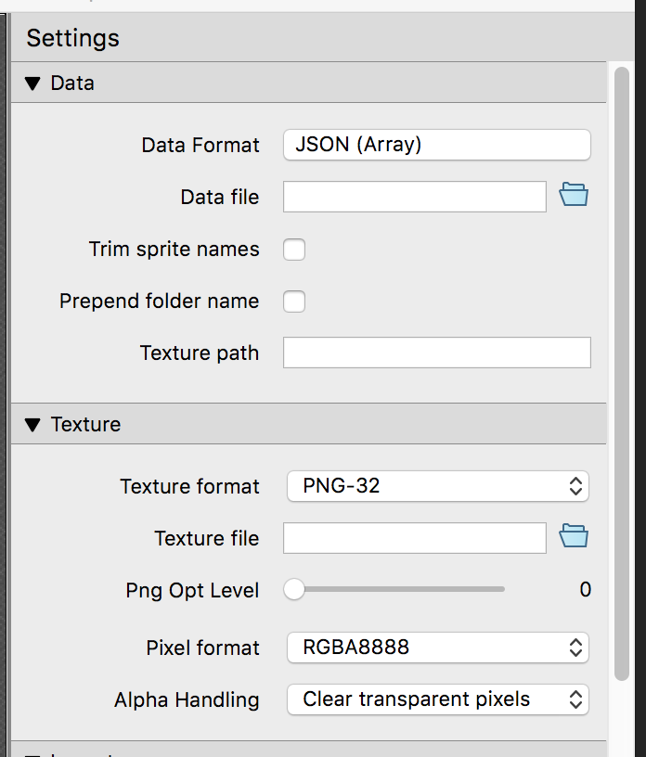
   1. Change storage location for Json :   
      Settings -> Data -> Data file : Click the folder icon to set the save file name.
   2. Change image storage location :  
      Settings -> Texture -> Texture file : Click the folder icon to set the save file name.
   3. Set the maximum image size (If the width / length is greater than 512, it is recommended to reduce the image size to include it within 512)  
      Settings -> Layout -> Force squared : Select the checkbox.  
      Settings -> Layout -> Max size W/H: Change it to 512.
3. Generating results

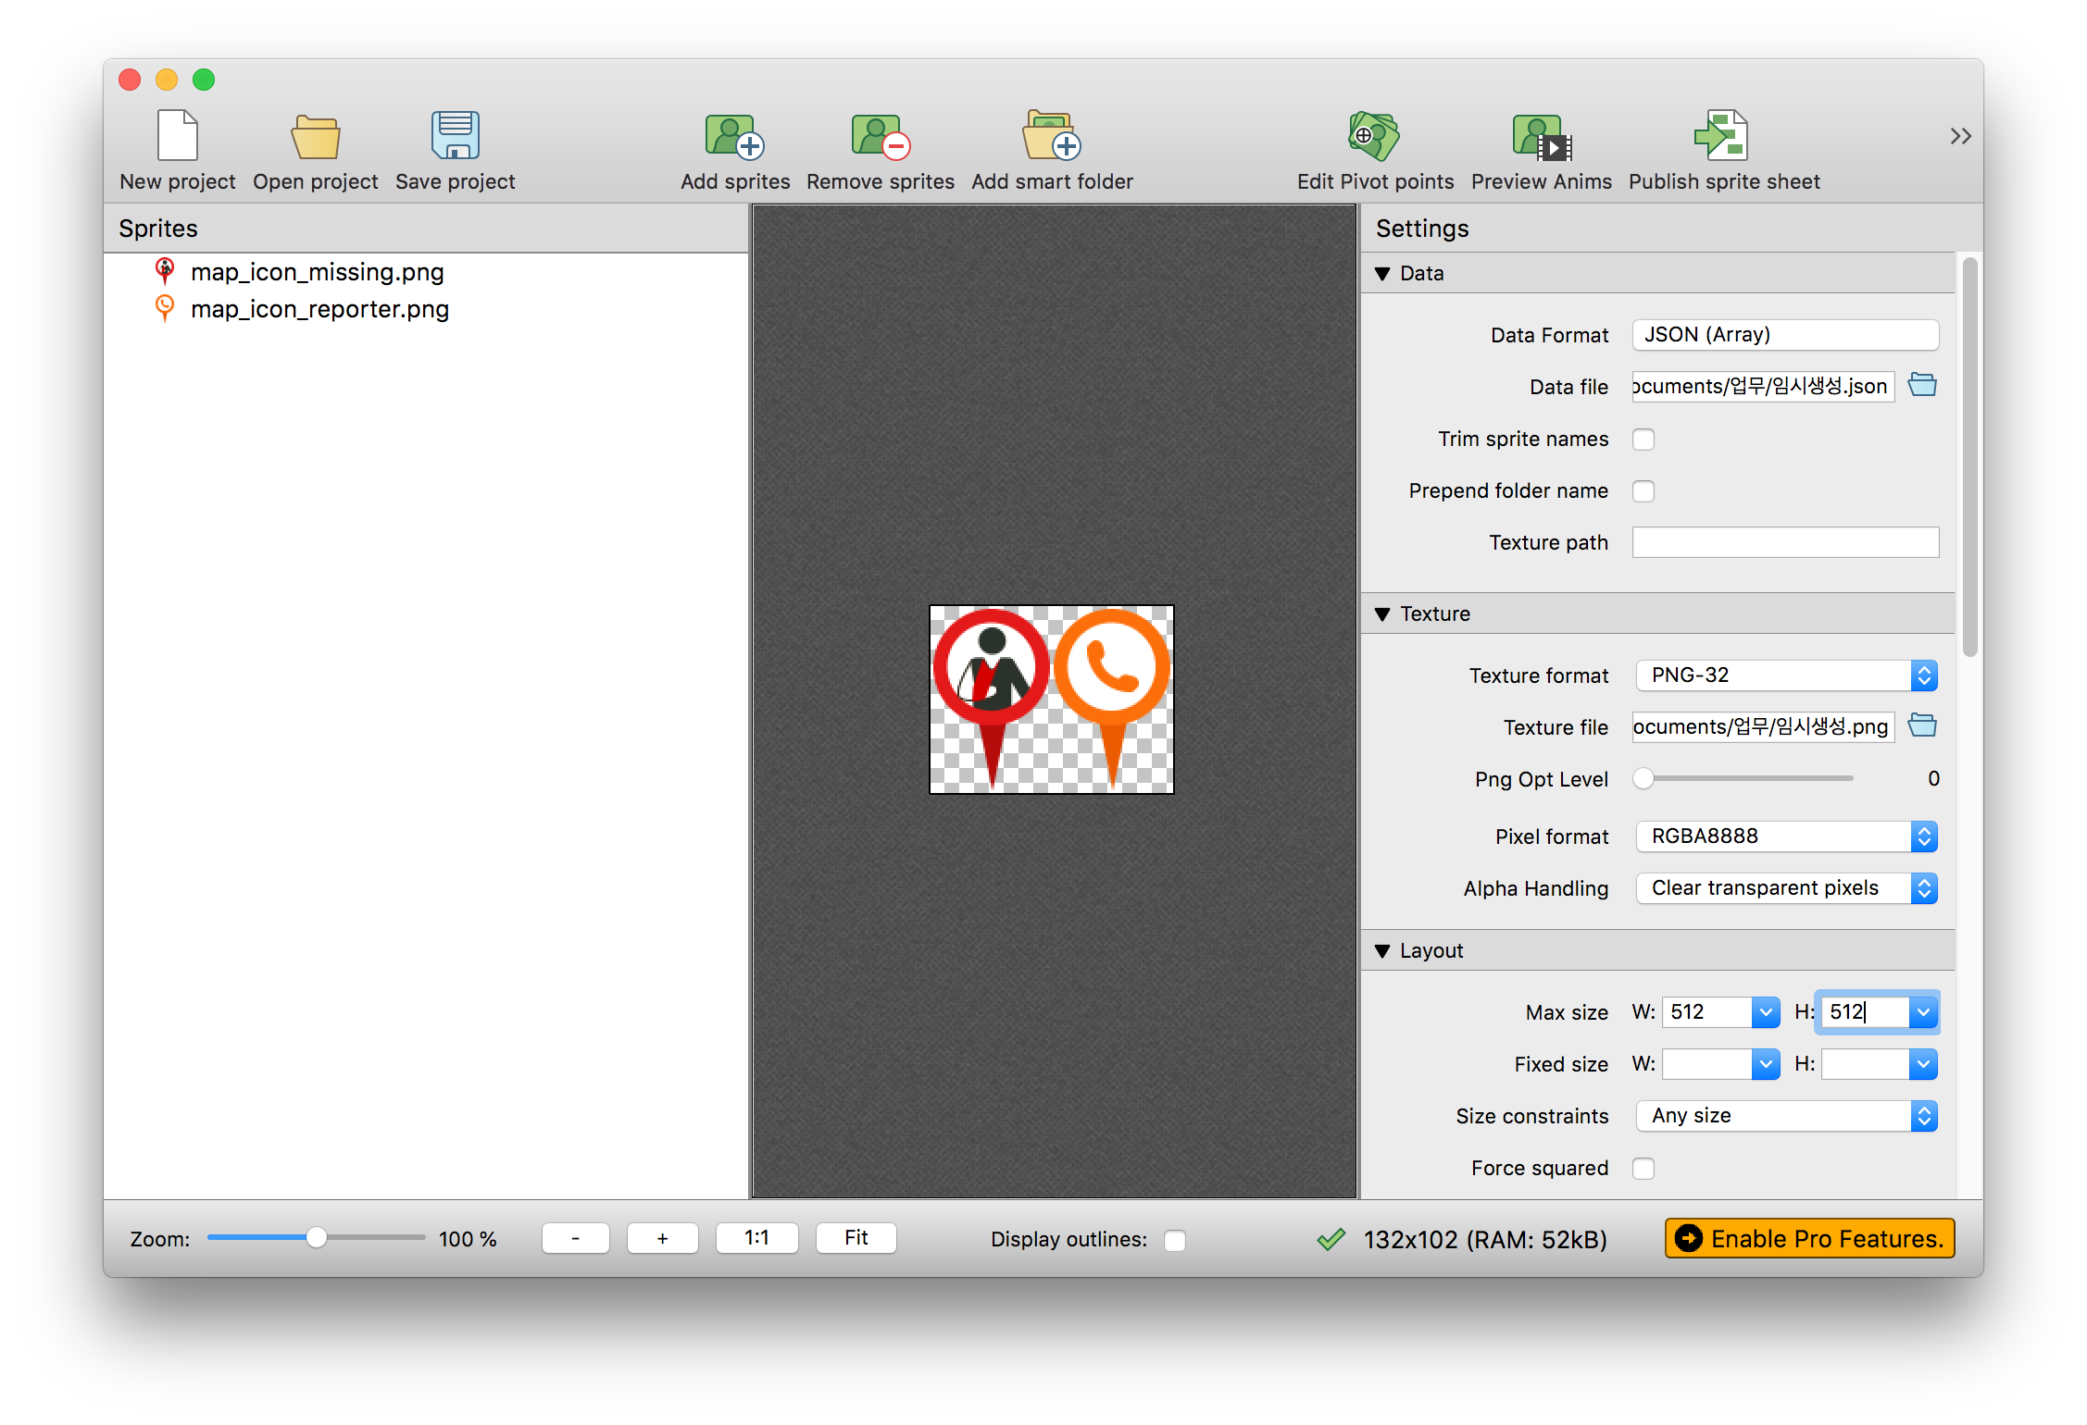

‘ 1) Click the Publish sprite sheet button at the top to create sprite data.  
 - If the creation is successful, you can see the screen below.

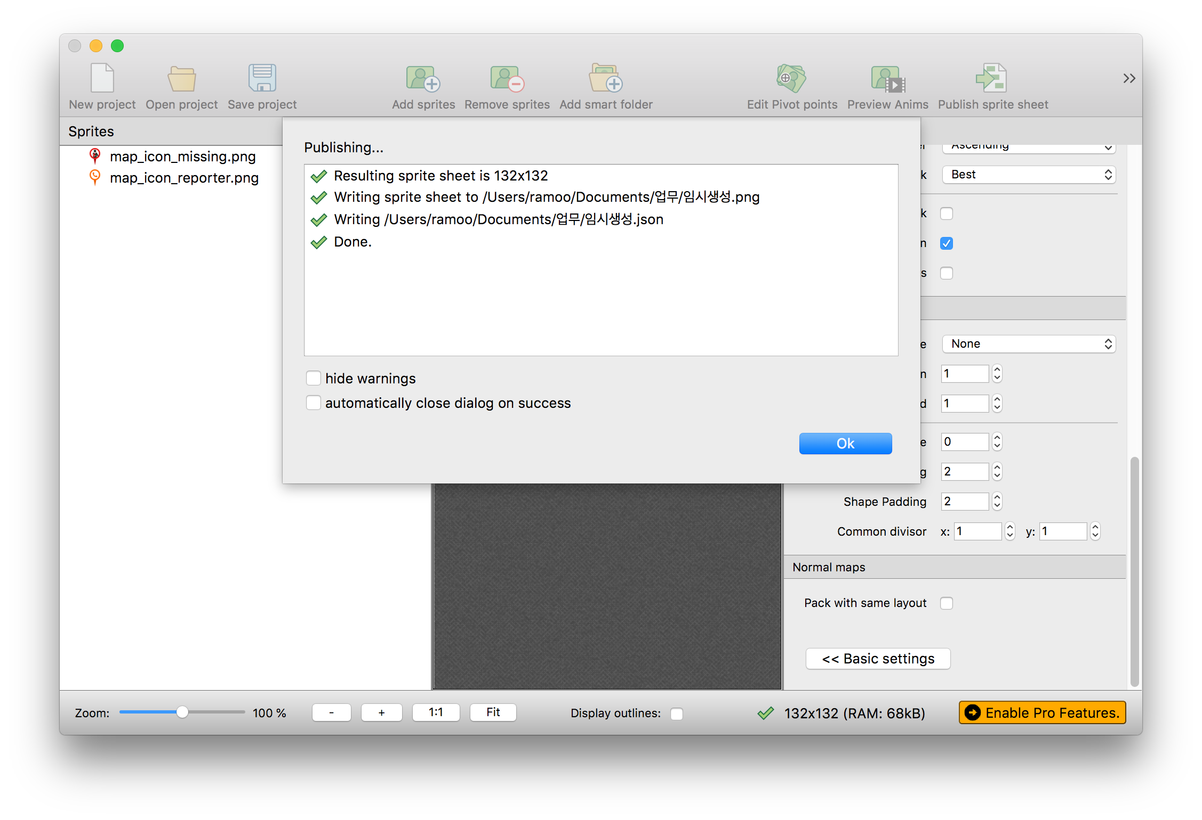

## modify json

Remove unused items in the created json file.

1. Original file content

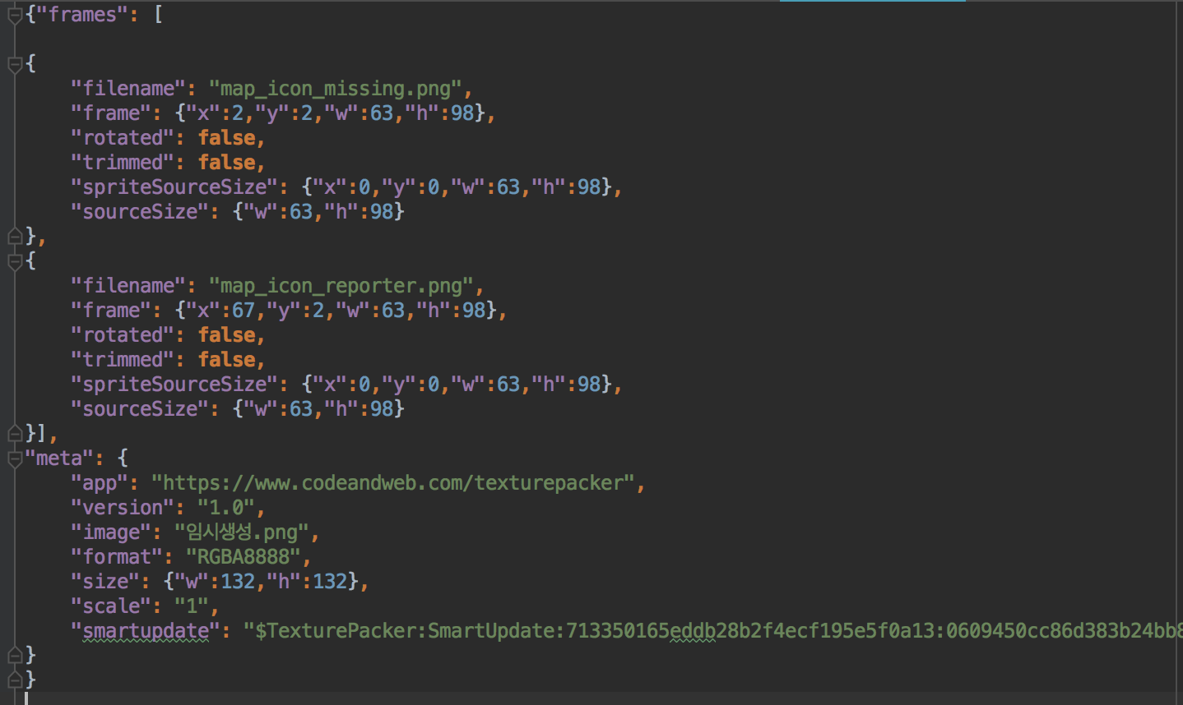

1. Content after removing unnecessary items

