STATE LOGO AREA
 | EXTRAORDINARY  PUBLISHED BY AUTHORITY | 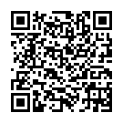

No. 2, CUTTACK, FRIDAY, SEPTEMBER 19, 2025, BAISAKHA, 1, 2505

