STATE LOGO AREA
 | EXTRAORDINARY  PUBLISHED BY AUTHORITY | 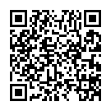

No. 3, CUTTACK, SATURDAY, SEPTEMBER 20, 2025, BHADRA, 1, 2017

