STATE LOGO AREA
 | EXTRAORDINARY  PUBLISHED BY AUTHORITY | 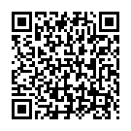

No. 4, CUTTACK, SATURDAY, OCTOBER 11, 2025, BAISAKHA, 1, 2017

