STATE LOGO AREA
 | EXTRAORDINARY  PUBLISHED BY AUTHORITY | 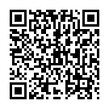

No. 6, CUTTACK, MONDAY, NOVEMBER 10, 2025, BAISAKHA, 1, 2020

