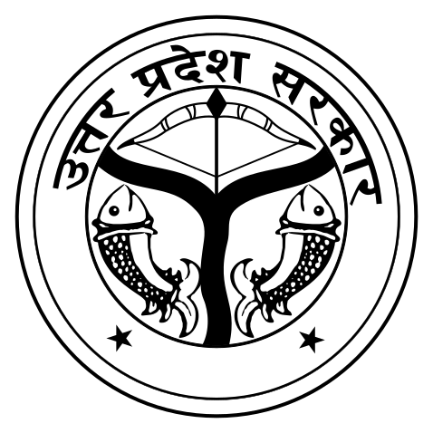
 | EXTRAORDINARY  PUBLISHED BY AUTHORITY | 

No. 7, CUTTACK, MONDAY, NOVEMBER 10, 2025, CHAITRA, 1, 2025

