Welcome to Qv21 Technologies new

Well Data Viewer

# File Import

Press the [Import File] button to Upload either an .xlsx or .csv file.

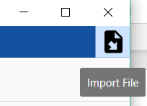

# Well Selection

Select any Well to see it corresponding Tank data.

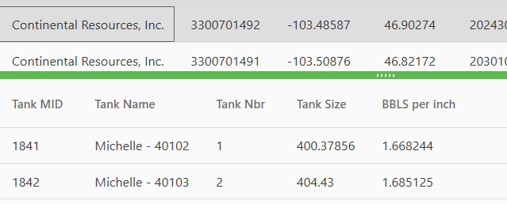

# Editing Data

Double click on any record to edit the data. Selecting away will close the Edit popup.

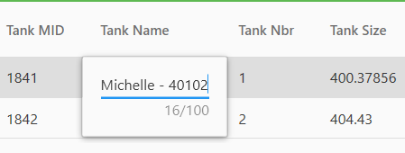

# Splitter

A splitter separates the Grids that can be adjusted if you want to see more data.

