LIFESTYLE DISEASE PREDICTION

We have used same dataset given by you and we have used SVM algorithm to train life style dataset and to run project double click on ‘run.bat’ file to get below screen

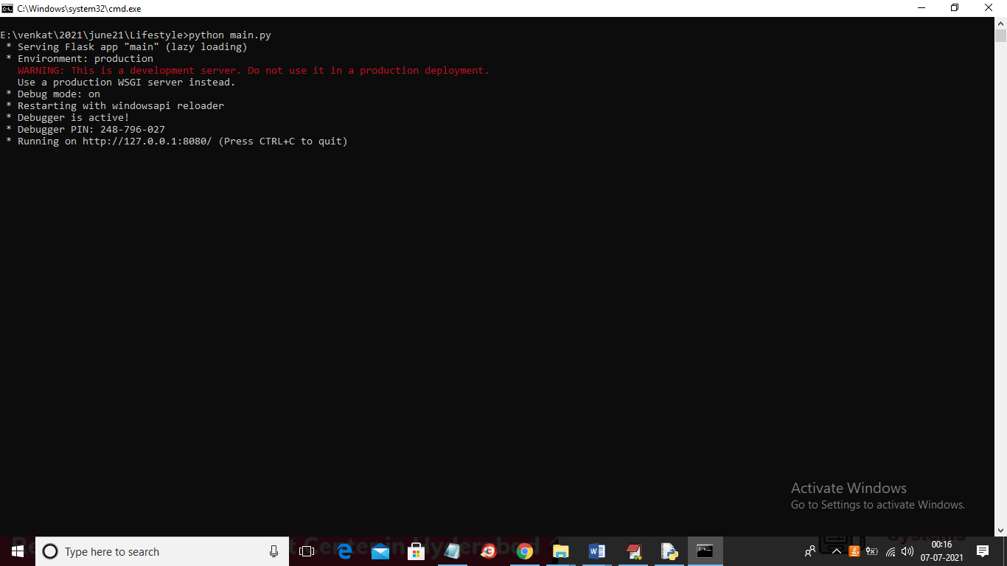

In above screen flask server started and now open browser and enter URL as ‘http://127.0.0.1:8080/index’ and press enter key to get below page

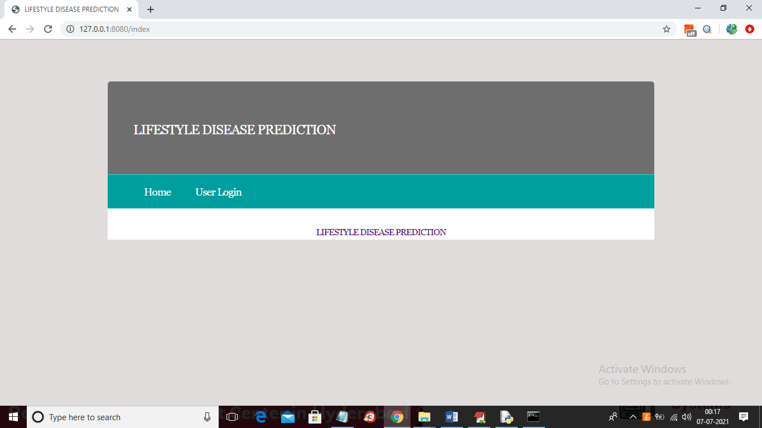

In above screen click on user login link and then enter username and password as ‘admin’ and ‘admin’

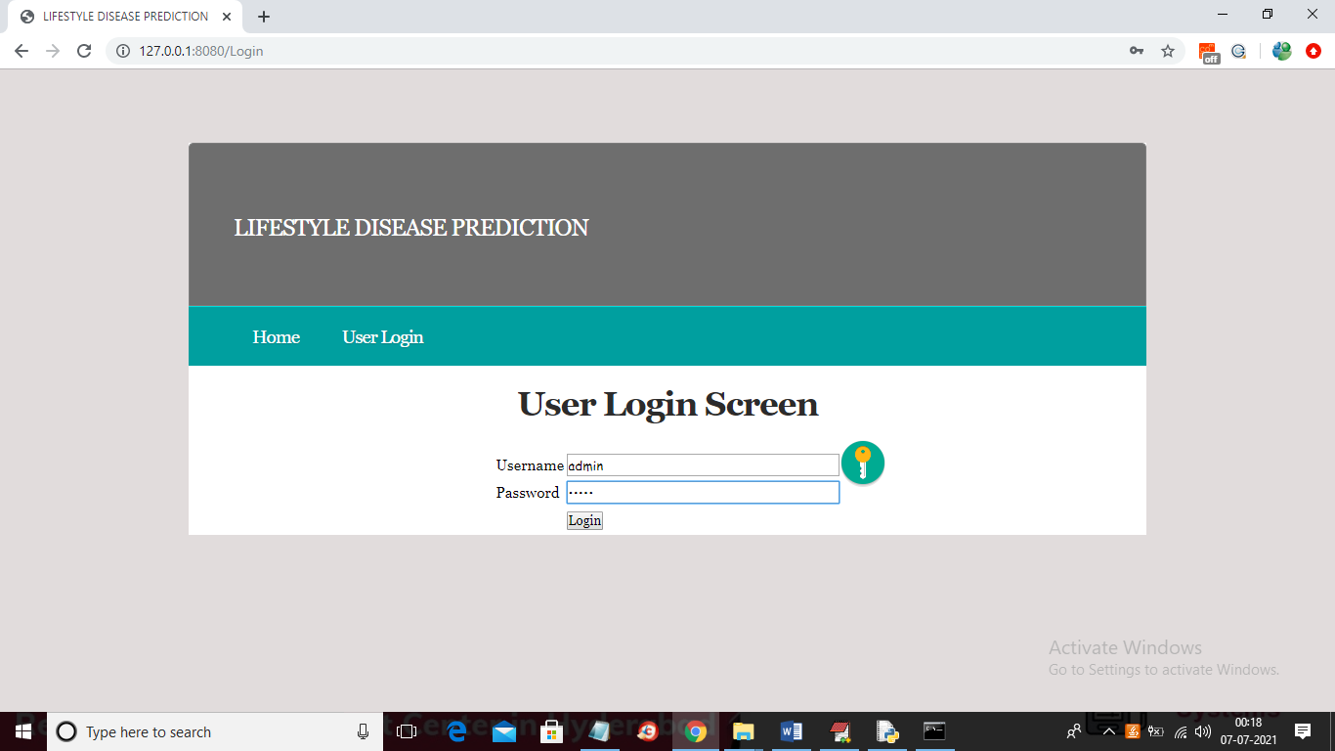

Now in above screen click on ‘Login’ button to get below screen

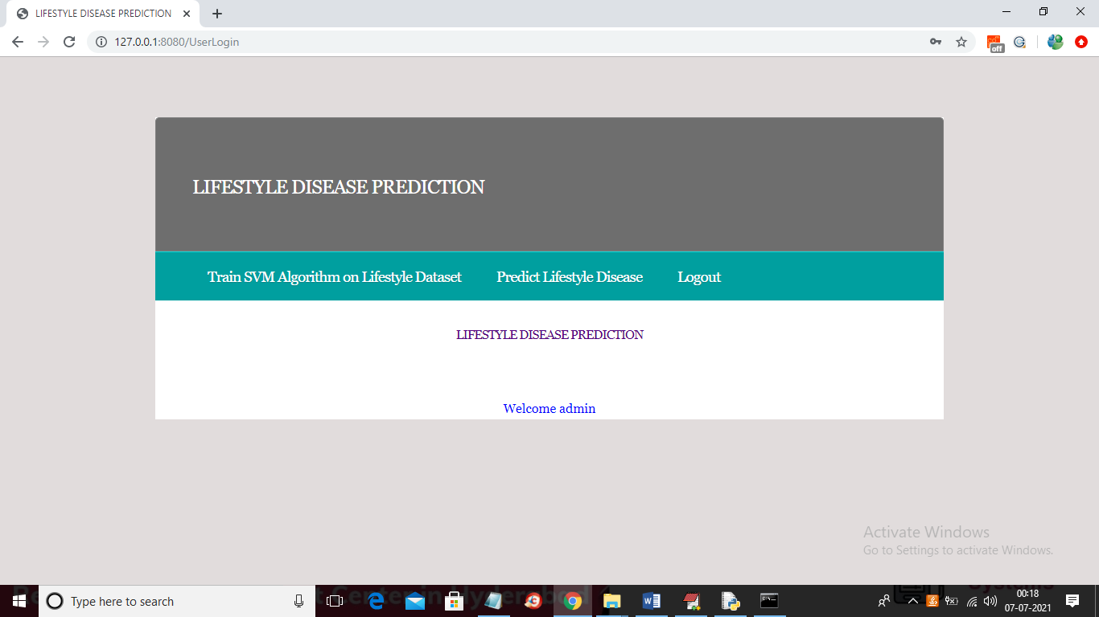

In above screen click on ‘Train SVM Algorithm on Lifestyle Dataset’ link to train dataset with SVM algorithm and then calculate accuracy and confusion matrix

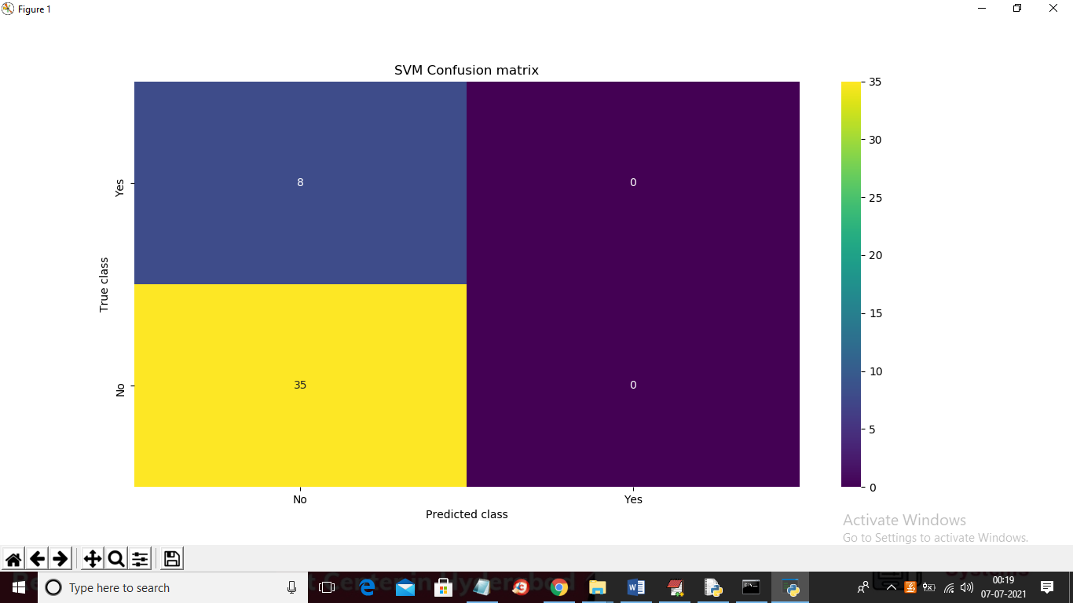

In above screen we can see confusion matrix generated from SVM algorithm after training dataset and now close above graph to get below screen

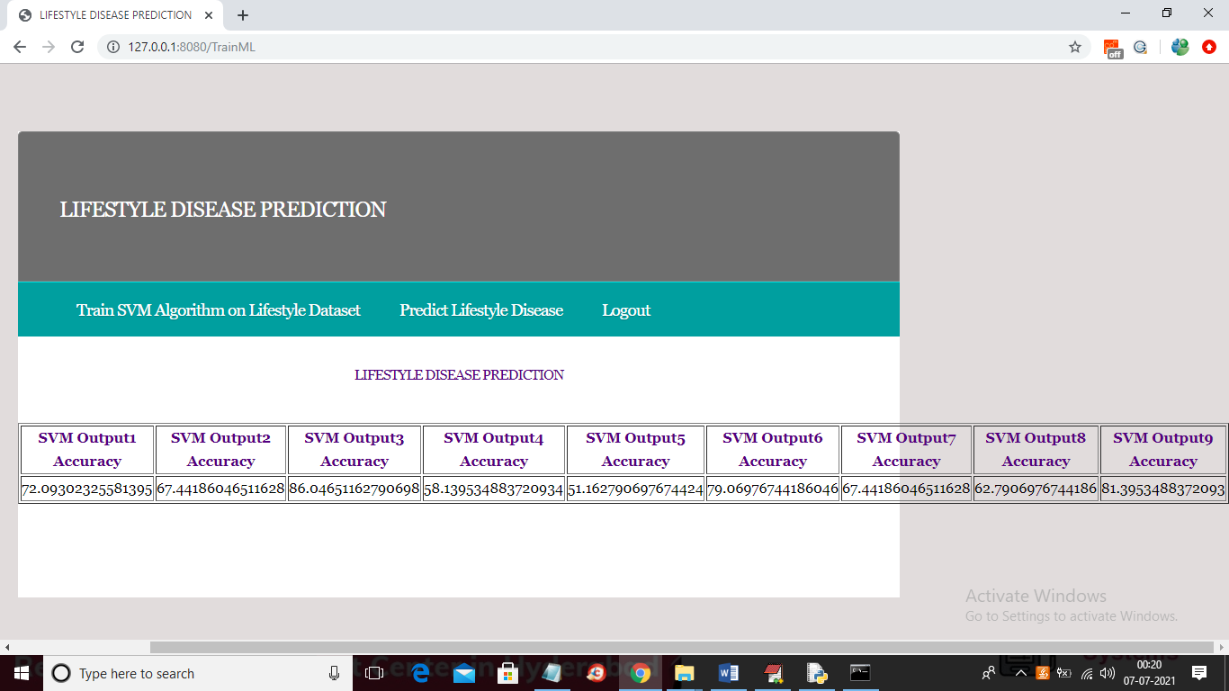

In above screen we can see SVM trained on 9 diseases available in dataset so we are getting accuracy for each disease prediction and the disease names are given in dataset like 'CVD','DM','CKD','COPD','PCOD','HLD','HTN','LC','AD'. In above screen for each disease we got accuracy and now SVM model is ready and now click on ‘Predict Lifestyle Disease’ link to get below screen

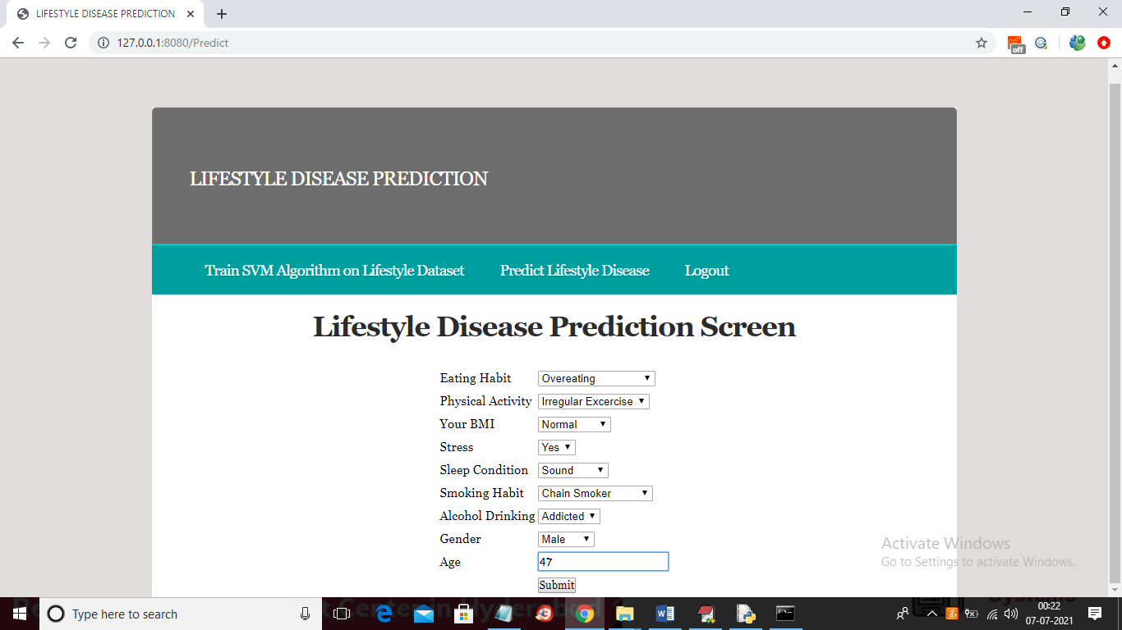

In above screen select desired values and then click on ‘Submit’ button to get below prediction result

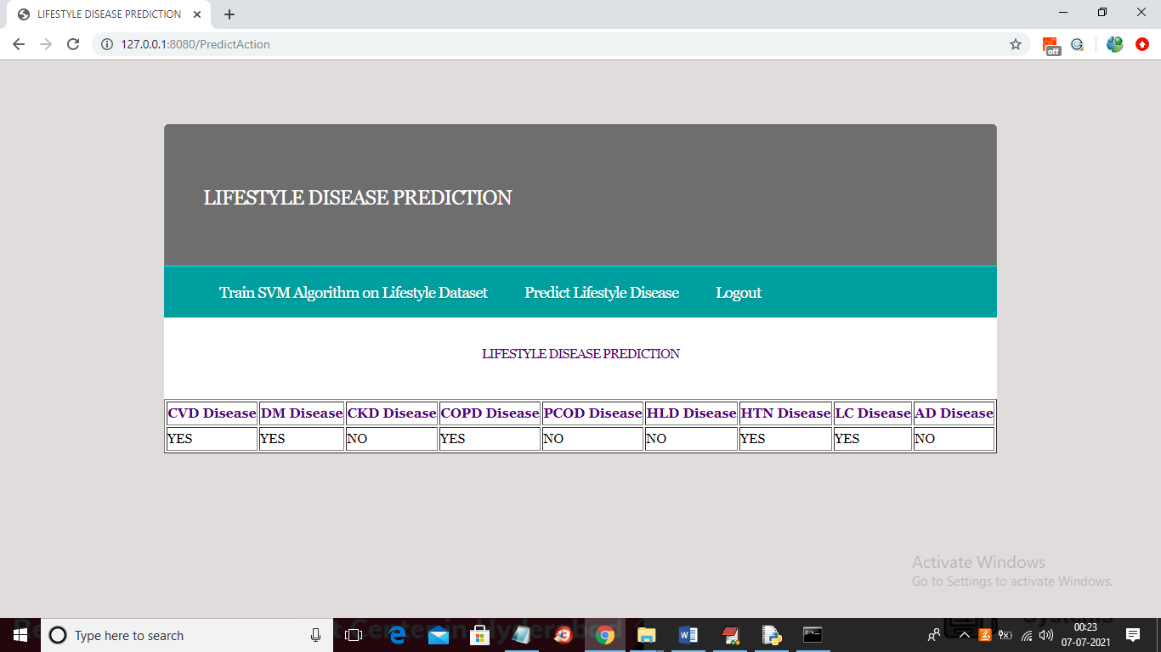

In above screen we can see the disease prediction for selected values and similarly you can select various values to get different results. You need to train only one and predict N number of times.

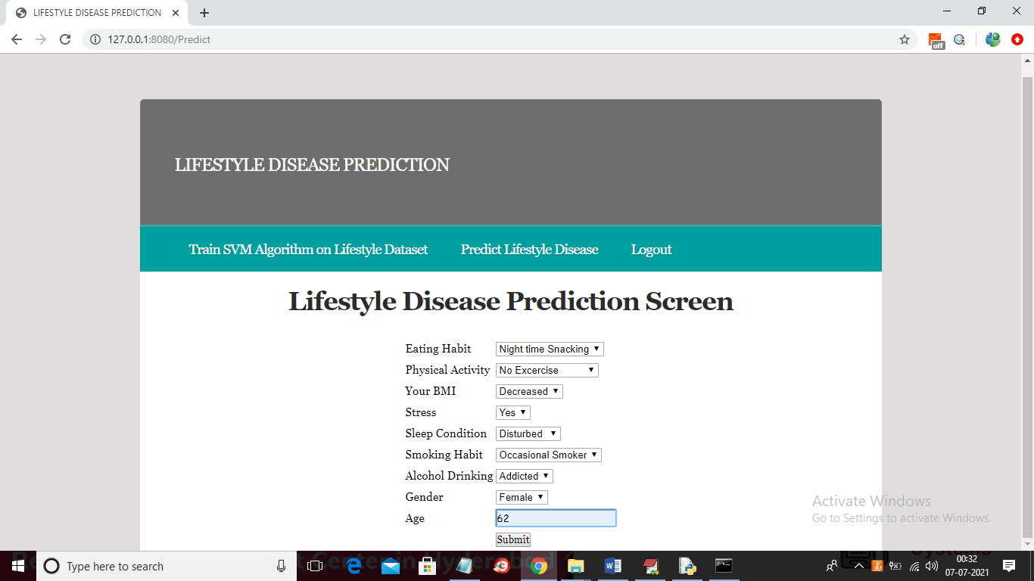

For above selection will get below result

