Professional Multimedia Course
2025 / 2026
REPORT
Short Term Learning Mobility of VET learners
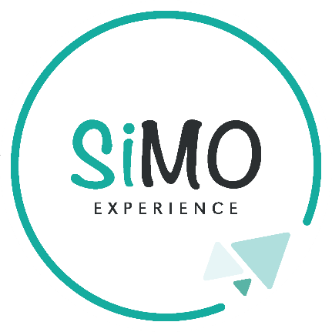

João Miguel Marcondes
Tutor: Hana Repše
Teacher: Maria Genoveva Moreira Oliveira and Maria João Coelho

ÍNDEX
Introduction: 2
Characterization of the company: 3
Description of activities carried out: 4
Conclusion 5
Final considerations: 6

Introduction:
This report was developed the Work-Based Learning component of the Erasmus+ program, which took place in Maribor, Slovenia.

The main objective of this experience was to apply the knowledge acquired throughout my Multimedia technical course, which I am currently completing in my final year, while developing professional skills and gaining experience in an international environment.

During the internship, I carried out a variety of tasks at the host company, Mars Maribor, working primarily at their office. This opportunity allowed me to contribute to the company’s activities while applying and expanding my skills in technology and multimedia.

Throughout the experience, I improved my abilities in research, digital content creation, and the development of PowerPoint presentations. I also had the opportunity to apply my knowledge of tools such as Photoshop and other multimedia software, as well as further develop my photography skills by capturing visual content relevant to the company’s work.

Characterization of the company:
My Work-Based Learning took place at Simo Experience, located in Maribor, Slovenia, as part of the Erasmus program.
Simo Experience is a company that works with international mobility and supports students from various countries who undertake internships in Maribor. The company is responsible for welcoming, guiding, and monitoring students during their Erasmus experience, as well as choosing where they will work, supporting their integration into the country, and organizing the activities carried out during the internship.
In addition, the company also organizes trips, tourist presentations, and activities in Slovenia, both for students and teachers.
During my internship, I was in the office, where I participated in tasks related to tourism research, itinerary preparation, photograph collection, and organization of supporting content. The work environment was welcoming, organized, and professional.

Description of activities carried out:
My experience of one and a half months at MARS Maribor was extremely positive and enriching. During this period, I had the opportunity to record videos, edit them, and actively participate in events held in schools, which allowed me to develop both my technical and communication skills.

I also worked the office environment, where I was responsible for editing video content and organizing visual materials by collecting images and resources from the company’s drive. This helped me improve my workflow, organization, and attention to detail.

The work environment was very welcoming and practical, making it easy to adapt and collaborate with the team. Overall, this experience contributed greatly to my personal and professional growth.

Conclusion
Completing this Erasmus internship in Maribor was a highly positive and enriching experience, both professionally and personally.

Throughout this period, I had the opportunity to apply the knowledge acquired during my three years of study in the Multimedia course in a real work environment, while also developing new practical skills. During my internship at MARS Maribor, I worked on recording and editing videos, as well as participating in events held in schools, which helped me improve my communication and teamwork abilities.

In addition, I carried out tasks within the office, where I was responsible for editing audiovisual content and organizing media by collecting images and materials from the company’s drive. These responsibilities allowed me to strengthen my organization, autonomy, attention to detail, and technical skills in multimedia tools.

The work environment was very welcoming and practical, which made it easy to adapt and collaborate with the team. This experience also gave me the opportunity to engage with a different culture, meet new people, and adapt to a new environment, contributing significantly to my personal development.

Overall, I believe this experience was extremely valuable for my academic and professional journey, and it will certainly be an asset for my future.

Final considerations:
Participating in this Work-Based Learning experience through the Erasmus+ program was extremely important and enriching for my career path.

Throughout this internship, I had the opportunity to develop new skills, gain professional experience, and apply the knowledge acquired during my three years of study in the Multimedia course in a real work environment. At MARS Maribor, I worked on recording and editing videos, as well as participating in events in schools, which allowed me to improve both my technical and communication skills.

This experience contributed significantly to my professional and personal growth, helping me become more autonomous, responsible, and confident. I also had the opportunity to work in an office environment, where I edited audiovisual content and organized materials from the company’s drive, improving my organization and workflow.

In addition, this Erasmus experience allowed me to experience a new culture, meet new people, and adapt to different ways of working within a multimedia context.

I strongly believe that this mobility had a very positive impact on my development and will be an important asset for my academic and professional future.

I would like to thank my tutor Hana Repše, Professor Maria Genoveva Moreira Oliveira, Maria João, MARS Maribor, and all the people who supported and guided me throughout this experience.

Date:__7____ , _de junho____________ 2026

Student Teacher Tutor

João Marcondes
_________________________________ _____________________________ ________________________________

