**Index**

|  |  |  |
| --- | --- | --- |
| No # | Title |  |
| 1 | Automation Framework Structure |  |
| 2 | How to Update Configuration file |  |
| 3 | How to Update Data File in DataSet for Test cases |  |
| 4 | How to use Library functions |  |
| 5 | How to Add New Test Case |  |
| 6 | Rules and common standards for using framework |  |

# Automation Framework Structure

The framework is organized in following directory structure.

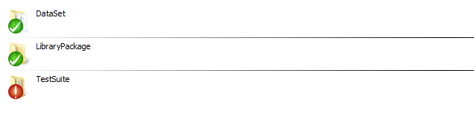

1. DataSet

This directory is being used to store configuration file and all the test case related data.

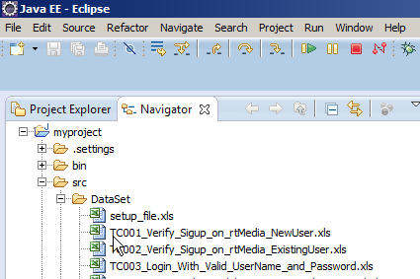

Configuration file is named as ***setup_file.xls*** and contains the set up configuration details like which browser to be used and what baseUrl to be used during test suite run.

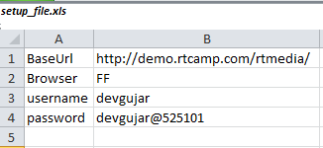

You can use the below code to access the test case data from excel sheets stored in DataSet

// Create Page Object  
rtmediaPageBrowser rtmediaPage = **new** rtmediaPageBrowser();  
  
//Get Test case Data

Hashtable<String, String> excellData = rtmediaPage.GetExcell_Data_As_Hashtable("TC003_Login_With_Valid_UserName_and_Password.xls");

excellData.get("username")

1. LibraryPackage

This directory is used to store all the functions which are required to perform actions in test cases.

Collection of common methods required to perform action and storing them in one pace makes it easier to reuse the code across the test cases.

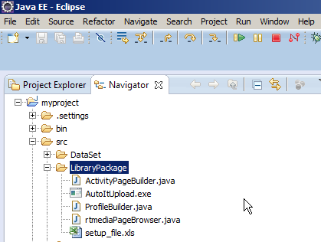

1. LibraryPackage

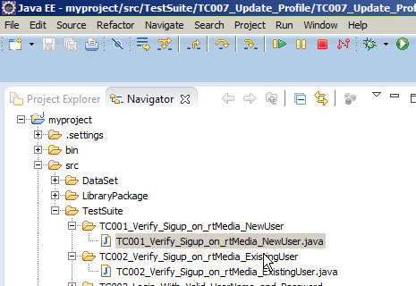

1. **How to Update Configuration file**