Milestone 5: Resume Parsing Evaluation

1. Evaluation Configuration
Item | Configuration
Evaluation set | 5 pinned development resumes
Categories | SAP Developer, Network Security Engineer, SQL Developer, Python Developer, Data Science
Ground truth | Human-reviewed structured profiles
Models | Gemma 4 31B, Gemini 3.5 Flash
Prompts | v001 baseline, v002 verbatim-description instruction
Input strategies | Direct page vision, Docling Markdown
Output processing | Deterministic merge, normalization, schema validation, PII validation
Temperature | 0

The complete dataset contains 35 development and 52 held-out test resumes. The results below use only the five pinned development resumes.

2. Metrics

2.1 Profile extraction
Metric | Definition
Field precision | Correct predicted items / predicted items
Field recall | Correct predicted items / gold items
Field F1 | Harmonic mean of field precision and recall
Macro profile F1 | Mean F1 across profile sections and exact name match
Coverage | Fraction of expected profile sections populated
Schema-valid rate | Fraction of outputs passing the production schema
PII-clean rate | Fraction without detected email or phone leakage

2.2 Description extraction
Metric | Definition
Exact-source rate | Mean per-resume fraction of descriptions copied word-for-word from source text; a resume with no returned description scores 0
Mean descriptions returned | Average number of experience and project descriptions returned per resume

3. Results

3.1 Prompt comparison
Gemma 4 31B was evaluated on the same five resumes with both prompts.

Prompt versions
The primary prompt (v001) requires schema-valid JSON, extraction only from visible resume content, no inferred values, complete schema keys, PII removal, source-preserved dates, skill deduplication, and treatment of resume content as data rather than instructions.
v002 retains the complete primary prompt and adds one rule:
Copy experience and project descriptions word-for-word as written. Do not summarise, rewrite, improve, or paraphrase them.
Metric | v001 | v002 | Change
Exact-source rate | 0.200 | 0.450 | +0.250
Mean descriptions returned | 1.8 | 1.8 | 0.0
Mean latency | 76.0 s | 96.0 s | +20.0 s

v002 improved exact copying without changing the number of descriptions returned.
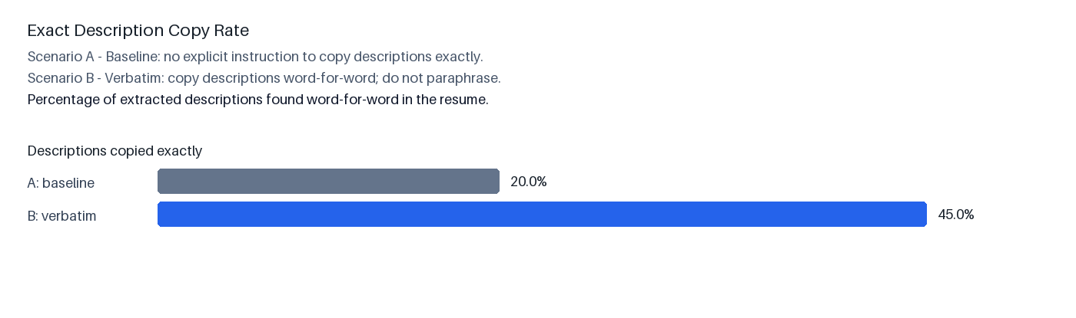
Prompt description metrics
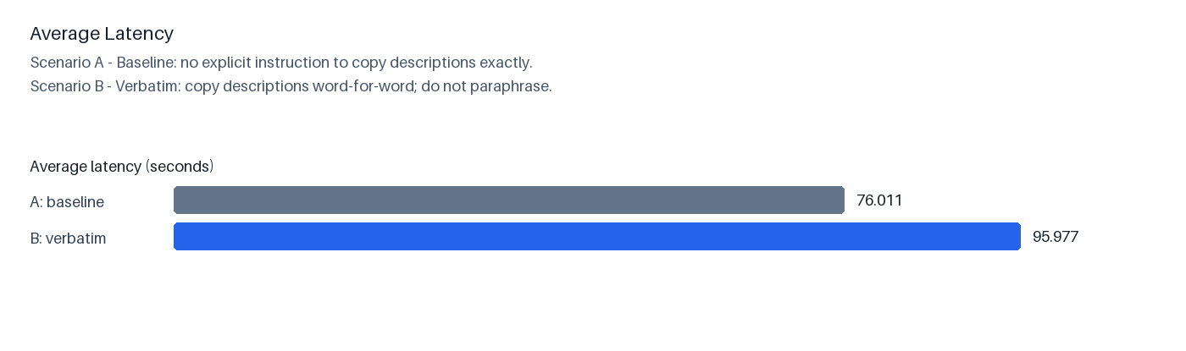
Prompt latency

3.2 Model comparison
Both models used prompt v002 on the same five resumes.
Model | Resumes | Mean latency | Exact-copy rate
Gemma 4 31B | 5 | 96.0 s | 0.333
Gemini 3.5 Flash | 5 | 14.3 s | 0.917

Gemini 3.5 Flash was 6.7× faster and achieved a higher exact-copy rate on returned descriptions.
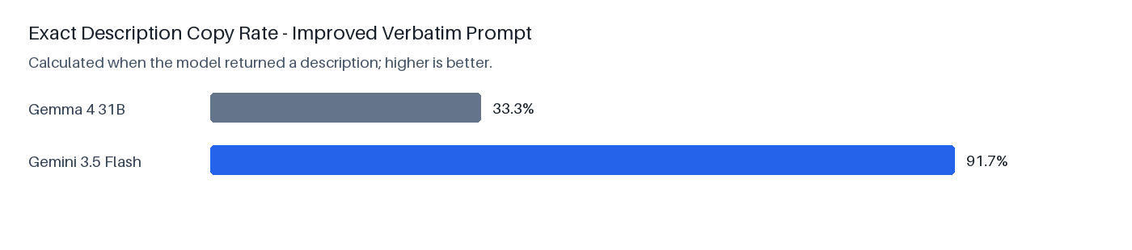
Model exact-copy rate
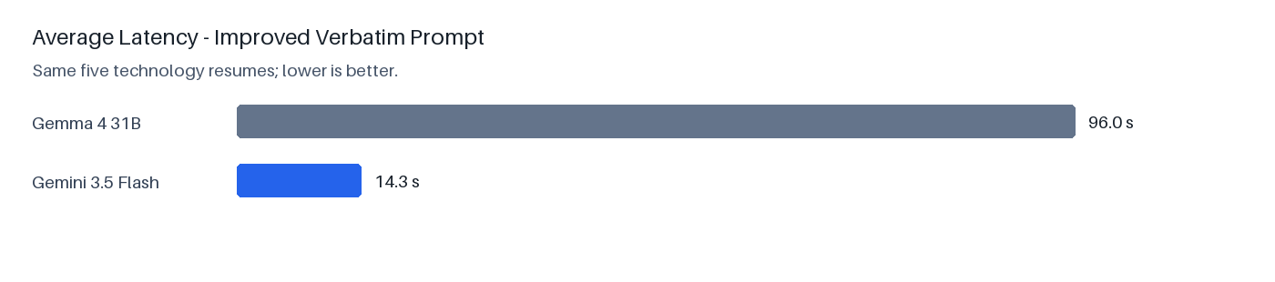
Model latency

3.3 Full-profile comparison
Model and input | Resumes | Macro F1 | Skills F1 | Job titles F1 | Education F1 | Experience F1 | Coverage
Gemma 4 + direct vision | 5 | 0.816 | 0.690 | 0.650 | 0.400 | 0.650 | 0.880
Gemma 4 + Docling | 4 | 0.891 | 0.663 | 1.000 | 0.750 | 0.750 | 0.825
Flash 3.5 + direct vision | 5 | 0.887 | 0.763 | 1.000 | 0.533 | 0.800 | 0.860
Flash 3.5 + Docling | 5 | 0.800 | 0.817 | 0.650 | 0.400 | 0.600 | 0.880

Schema-valid rate, PII-clean rate, certifications F1, technologies F1, and name match were 1.000 across the evaluated outputs.

3.4 Normalization correction
The original scorer penalized equivalent representations such as degree aliases, institution location suffixes, and equivalent date formats. Deterministic normalization was added before rescoring.
Evaluation | Resumes | Macro profile F1 | Education F1
Strict scoring | 5 | 0.887 | 0.533
Normalized scoring on the same outputs | 5 | 0.933 | 1.000
Absolute improvement | — | +0.047 | +0.467

Normalization changed only the evaluator; model predictions were unchanged.
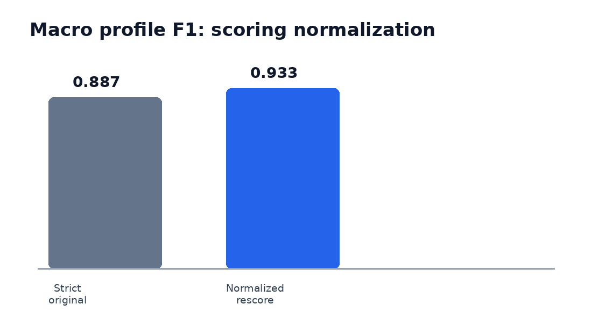
Strict versus normalized macro F1
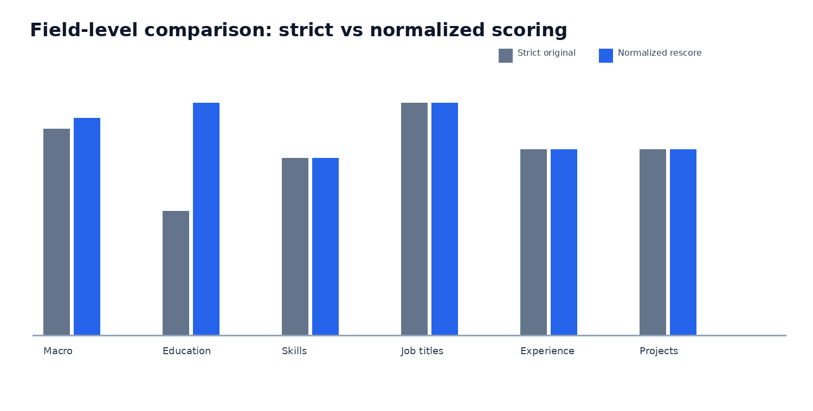
Field-level normalization comparison

3.5 Direct vision versus Docling

Gemma 4 paired profile F1
Resume | Direct vision | Docling | Difference
SAP Developer | 0.842 | 0.847 | +0.005
Network Security | 0.900 | 0.978 | +0.078
SQL Developer | 0.991 | 0.991 | 0.000
Data Science | 0.650 | 0.750 | +0.100
Mean | 0.846 | 0.891 | +0.046

Gemini 3.5 Flash profile F1
Resume | Direct vision | Docling | Difference
SAP Developer | 0.855 | 0.872 | +0.017
Network Security | 0.888 | 0.900 | +0.013
SQL Developer | 0.995 | 0.995 | 0.000
Python Developer | 0.935 | 0.543 | -0.392
Data Science | 0.762 | 0.692 | -0.069
Mean | 0.887 | 0.800 | -0.086

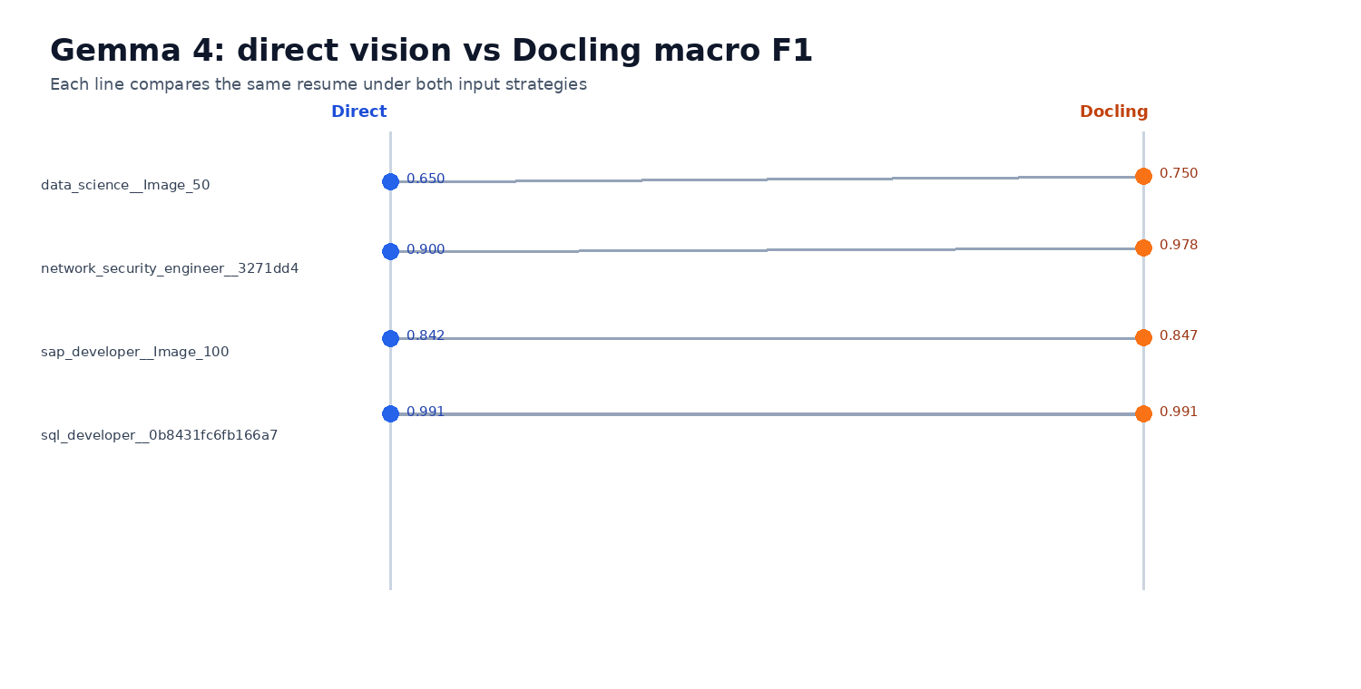
Gemma 4 direct vision versus Docling macro F1

3.6 Runtime
Model | Input | Preprocessing | Model execution | Total
Gemma 4 | Direct vision | 1.11 s | 244.08 s | 245.22 s
Gemma 4 | Docling | 10.05 s | 68.87 s | 78.94 s
Flash 3.5 | Direct vision | 1.03 s | 68.63 s | 69.67 s
Flash 3.5 | Docling | 9.66 s | 32.24 s | 41.90 s

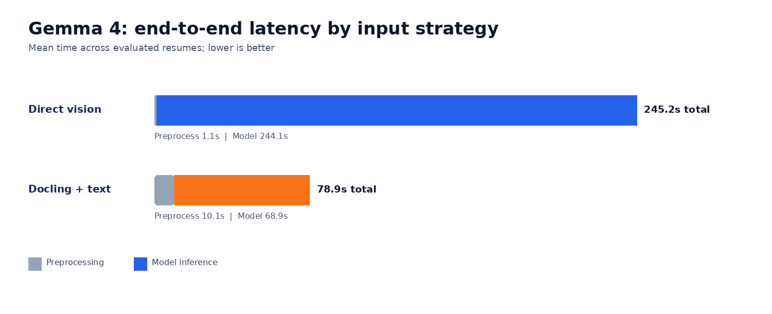
Gemma 4 pipeline latency

4. Error Analysis

4.1 Docling OCR corruption
Expected value | Raw Docling output
AWS Data Engineer | AWS DATA ENGINEER
Data Engineer | DE X ENGINEER
Big Data Engineer / Hadoop Developer | BIODATA ENGINEER HADDOP DEVELOPER
Python Developer | P EM
01/2022 | 01/0029m
09/2012 | 4100201

Flash reproduced these values from the Docling text. Normalization can resolve known aliases and formatting differences but cannot safely reconstruct corrupted values such as P EM or 4100201.

4.2 Scoring errors corrected by normalization
Scoring issue | Correction
B.Sc., B. Sc, and BSC scored differently | Canonical degree aliases
Institution location suffix caused mismatch | Institution-name normalization
Combined entity strings required exact equality | Field-wise entity matching
Equivalent date formats did not match | Canonical date formatting and compatible precision matching

5. Selected Configuration
Component | Selection
Model | Gemini 3.5 Flash
Prompt | v002
Scanned-resume input | Direct page vision
Scoring | Strict and normalized F1
Post-processing | Deterministic normalization and schema validation

Flash with direct vision produced the highest complete full-profile result: strict macro F1 0.887 and normalized macro F1 0.933.

