Prompt and Model Experimentation Summary

1. Prompt experimentation
The initial extraction prompt did not explicitly require descriptions to be copied from the resume. Consequently, the model sometimes paraphrased experience and project descriptions.
The following rule was added to the improved prompt:
Copy experience and project descriptions word-for-word as written. Do not summarise, rewrite, improve, or paraphrase them.
Both prompts were tested using the same five technology resumes and the same Gemma 4 31B model.
Prompt | Exact description copy rate
Scenario A: original prompt | 20%
Scenario B: improved verbatim prompt | 45%
The exact copy rate increased by 25 percentage points after adding the explicit instruction. This shows that prompt wording materially affected extraction behaviour.
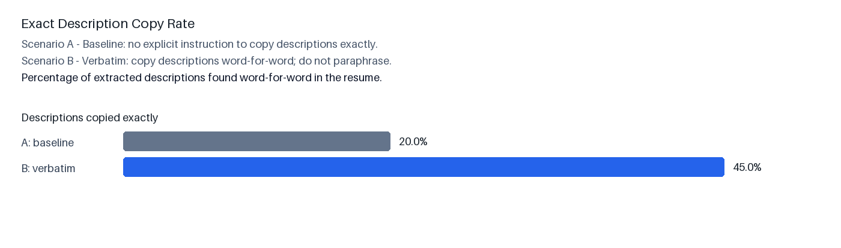
Figure 1. Exact description copy rate by prompt version.
Prompt | Average latency
Scenario A: original prompt | 76.0 seconds
Scenario B: improved verbatim prompt | 96.0 seconds
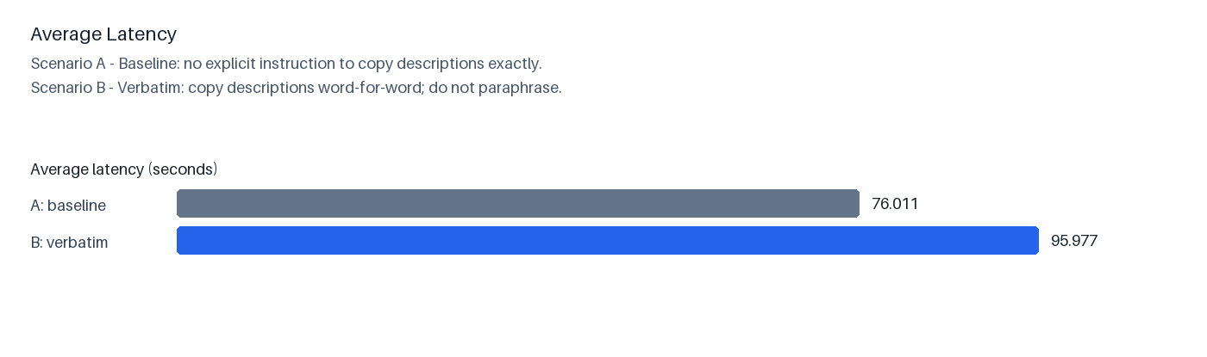
Figure 2. Average latency by prompt version.

2. Model comparison using the improved prompt
The improved verbatim prompt was kept fixed while the model was changed from Gemma 4 31B to Gemini 3.5 Flash. Both models processed the same five technology resumes.
Model | Successful runs | Average latency | Exact copy rate*
Gemma 4 31B | 5/5 | 96.0 seconds | 33.3%
Gemini 3.5 Flash | 5/5 | 14.3 seconds | 91.7%
*For the direct model comparison, exact copy rate is calculated over resumes where the model returned at least one description.
Gemini 3.5 Flash was approximately 6.7 times faster and produced substantially more descriptions that matched the resume word-for-word. It was therefore selected for the implemented description-extraction configuration.
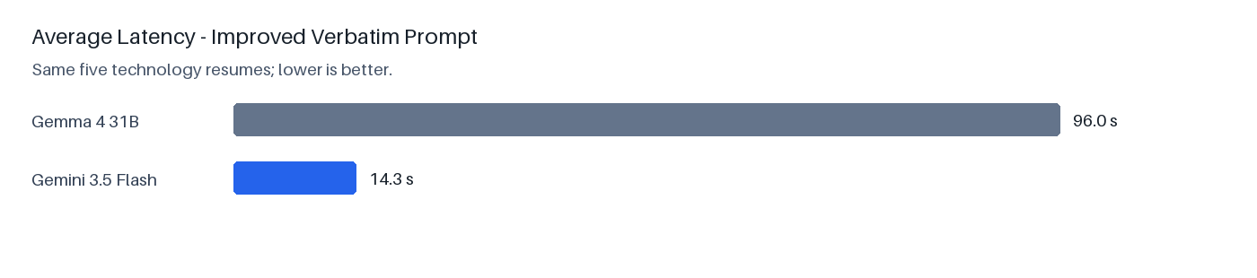
Figure 3. Average latency comparison using the improved prompt.
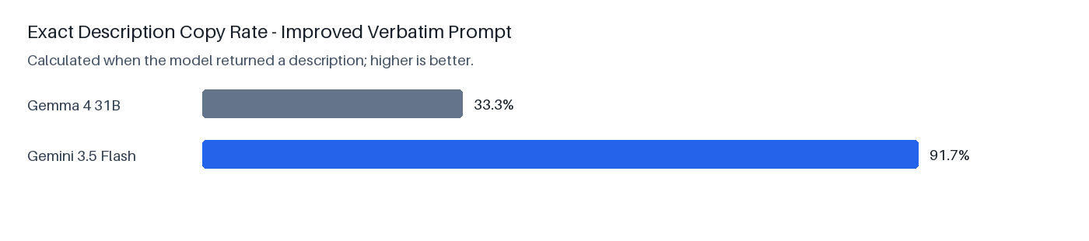
Figure 4. Exact description copy rate comparison using the improved prompt.

3. Example implementation output
A complete extracted JSON example is included separately as gemini35_verbatim/sample_extracted_resume.json. Direct identifiers and identifying dates were redacted; the extracted structure and non-identifying fields are unchanged.

4. Reproducibility
.venv/bin/python -u experiments/run_description_ab.py --model gemini-3.5-flash --versions v002 --experiment gemini35_verbatim_raw --results gemini35_verbatim.jsonl
.venv/bin/python experiments/analyze_model_comparison.py

