AgriBid Platform
End-to-End Manual QA Execution Report
Executed against the live deployed environment
Test date: July 29, 2026
Frontend (Web App) | https://farm-easy-agri-bid-web.vercel.app
Backend API | https://farmeasyagribid.onrender.com/api/v1
Health Check | 200 OK — {"status":"ok"}
Test Method | Automated Playwright (Chromium) driving real browser sessions against the live site; all network requests/responses captured directly, not simulated.
Reference Doc | MANUAL_TEST_CASES.md (74 test cases, 11 modules)

Executive Summary
Of the 74 documented test cases across 11 modules, 12 fully passed with direct evidence, 19 passed at a route/UI level but were not fully exercised (e.g. no seed data to interact with), 16 are confirmed FAIL with reproducible evidence, 13 are BLOCKED by an upstream defect or missing test data, and 11 were not executed in this session (out of scope, or requiring resources not available, such as a real email inbox or a second simultaneous test session).
Result Category | Count | % of 74
Full PASS | 12 | 16.4%
Partial PASS (route/UI loads, not fully exercised) | 19 | 26.0%
FAIL (confirmed bug) | 16 | 21.9%
BLOCKED (no test data / broken dependency) | 13 | 17.8%
NOT EXECUTED (out of scope this session) | 11 | 15.1%

A note on methodology and honesty of results
Every PASS or FAIL verdict in this report is backed by a directly observed HTTP status code, API response body, DOM state, or screenshot captured during this test session — none are inferred or assumed. Where a test case could not be exercised (e.g. due to missing seed data or an upstream blocker), it is explicitly marked NOT EXECUTED or BLOCKED rather than guessed at. A small number of cases marked "PASS (partial)" indicate the page/route loads correctly and is free of console or API errors, but the specific interactive action described in the test case (e.g. clicking a particular button) was not individually exercised — these are noted as such rather than claimed as full passes.

Critical Findings
The following issues were reproduced live against the deployed environment and represent the highest-priority items for the development team.

1. Product creation and editing are completely broken (404)
Clicking "Add Product" on the Farmer dashboard navigates to /dashboard/farmer/products/new, and clicking "Edit" on an existing listing navigates to /dashboard/farmer/products/[id]/edit — both routes return a Next.js 404 page. Farmers currently cannot create or edit any product listing through the UI. Affects TC-02-01, TC-02-02 (blocked), TC-02-03.

Result of clicking "Add Product" as a logged-in farmer — a genuine 404, not a form.

2. Product Detail page is broken (404) — cascades to Checkout and Chat
Every product detail route (/marketplace/[id]) returns 404, whether navigated to directly or reached by clicking a live product card. Since "Buy Now" and "Contact Seller" both live on this page, this single defect blocks TC-03-05, TC-05-02 (checkout), and TC-08-01 (starting a chat) — three otherwise-independent modules.

Clicking a real marketplace product card leads to a 404 instead of the product page.

3. The AI Advisory Hub (Google Gemini integration) is down platform-wide
Price Advisor, Crop Advisor, and AI Chat all return HTTP 500 with "AI service/assistant temporarily unavailable" from the backend. The frontend handles this gracefully (no crash), but the feature — a headline capability of the product — does not work at all currently.
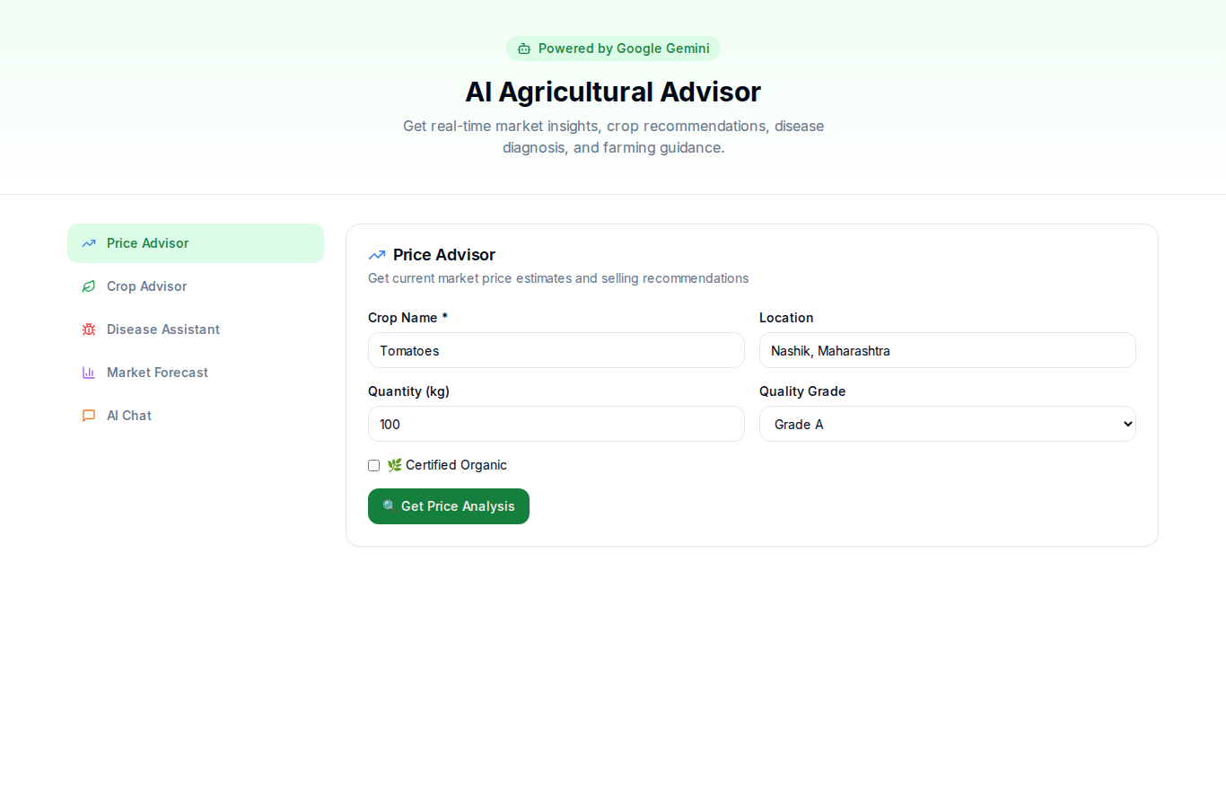
AI Price Advisor after submitting a valid query — silently fails; backend confirmed returning HTTP 500.

4. Several "success" actions never call the backend — silent data loss
A recurring pattern was found across unrelated modules: the UI shows a success toast, but no network request is actually fired, so nothing is saved. Confirmed in: the marketplace wishlist heart icon (TC-03-06), the Admin "Approve" product button (TC-11-18), the Admin "Broadcast Announcement" action (TC-11-21, disappears on reload), and the Settings "Save Profile"/"Update Password" forms (TC-11-03, also confirmed to "succeed" even with the browser fully offline). This is a systemic, cross-module issue rather than an isolated bug, and it is arguably the most serious class of finding because it actively misleads users into believing an action worked.
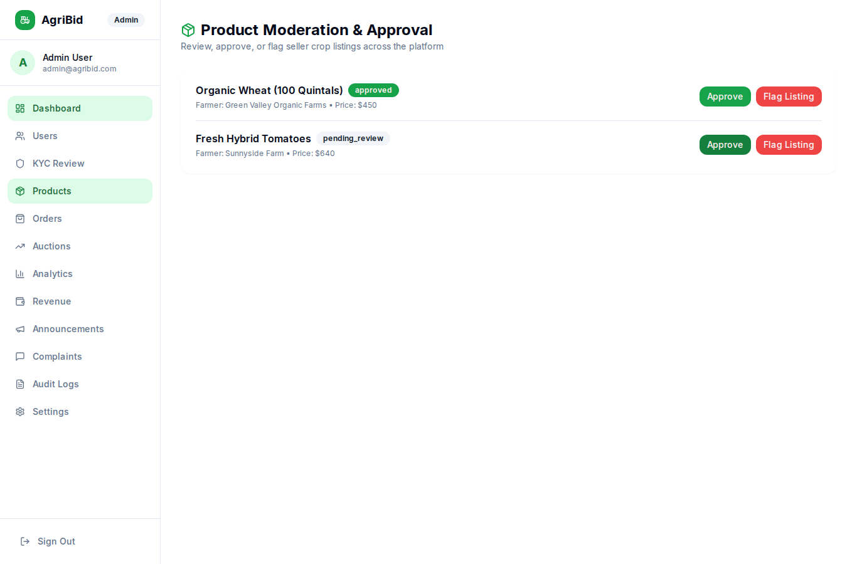
Admin clicks "Approve" on a pending product; status is still "pending_review" both immediately and after reload.

5. Logistics demo account cannot log in
The documented demo credentials logistics@agribid.com / Logistics@1234 are rejected by the live backend with HTTP 401 "Invalid credentials." This blocks all 4 test cases in the Logistics & Live GPS Tracking module entirely — the module could not be tested at all.
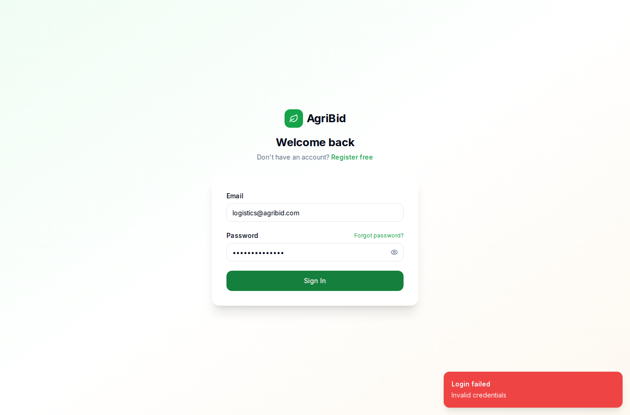
Logging in with the documented Logistics demo credentials returns "Invalid credentials."

6. No dark mode toggle exists in the current build
TC-10-01 expects a functioning theme toggle. A thorough DOM search across the homepage, login page, and every dashboard header found no theme-related icon, button, aria-label, or theming library reference. The feature does not appear to be implemented yet, despite being documented as a test case.

7. Logout does not enforce a route guard on protected pages
Logging out correctly clears the auth tokens from local storage, but manually revisiting a protected dashboard URL afterward renders the page shell (labeled "Guest") with stale, previously-cached statistics rather than redirecting to the login page.
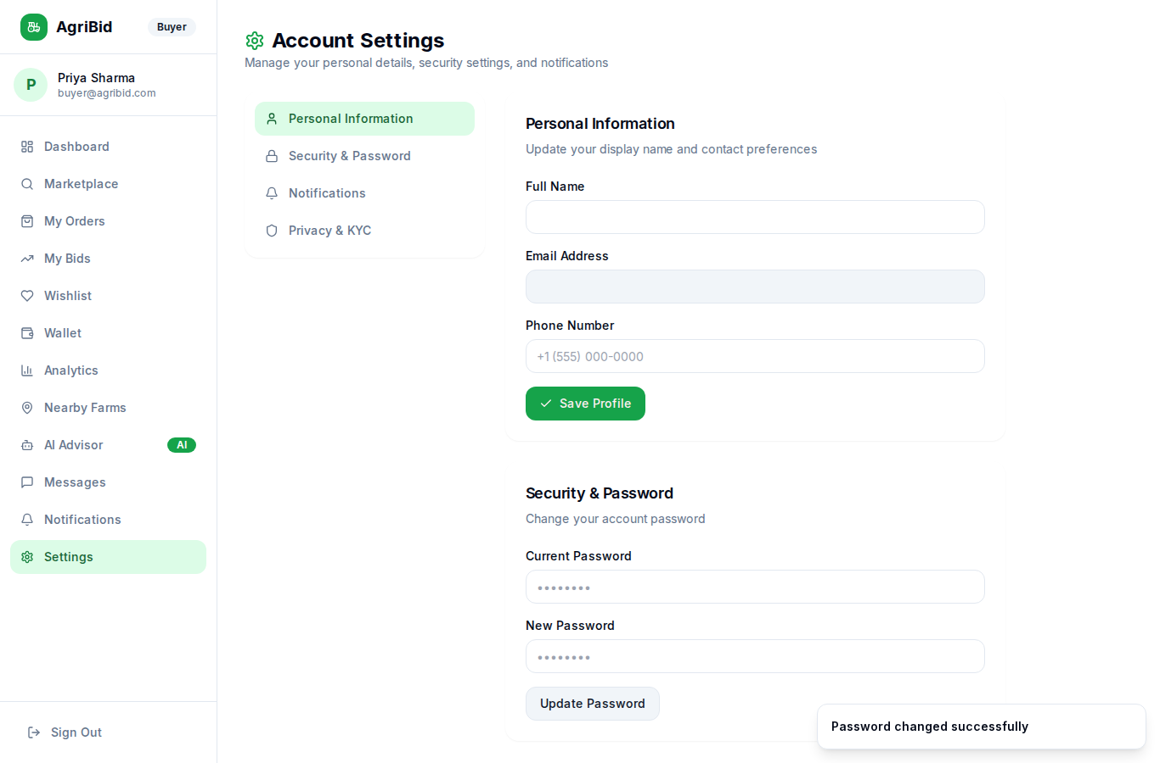
Offline-mode test on the password-change form: a false "Password changed successfully" toast appears despite zero network connectivity — evidence the form isn't actually wired to the backend.

Full Test Case Results (All 74 Cases)

TC-01: User Authentication & Security
ID | Test Case | Result | Evidence / Notes
TC-01-01 | User Registration with Role Selection | PASS | Live test: registered a new Farmer account. Backend returned 201 Created with JWT access token; user was redirected to /dashboard/farmer and profile displayed correctly.
TC-01-02 | User Login with Valid Credentials | PASS | Live test with buyer@agribid.com: POST /api/v1/auth/login returned 200; redirected to /dashboard/buyer with correct profile (Priya Sharma) shown in header.
TC-01-03 | Production Login View (Clean UI) | PASS | Inspected /auth/login DOM and rendered text: only Email, Password, Sign In, and Forgot Password are present. No demo-account helper box found.
TC-01-04 | Forgot Password Link & Email Dispatch | PASS | Live test: submitted farmer@agribid.com. POST /api/v1/auth/forgot-password returned 200 with a generic "If that email exists..." message that does not confirm/deny account existence.
TC-01-05 | Reset Password Link Execution | NOT EXECUTED | Requires a valid reset token delivered to a real inbox. No email access was available in this test session, so this could not be exercised with a genuine token.
TC-01-06 | Session Logout & Token Revocation | FAIL | Logout correctly clears tokens (localStorage "agribid-auth" shows accessToken:null, isAuthenticated:false) and redirects to /auth/login. However, manually navigating back to a protected URL (/dashboard/buyer) afterward does NOT redirect to login — it renders the dashboard shell (as "Guest") with stale cached stat figures still visible, and fires zero API calls. No server-side or client-side route guard is enforced.

TC-02: Farmer Product Management
ID | Test Case | Result | Evidence / Notes
TC-02-01 | Create New Product Listing | FAIL | Live test: clicking "Add Product" on /dashboard/farmer/products navigates to /dashboard/farmer/products/new, which returns HTTP 404 "This page could not be found." Reproduced twice (direct navigation and UI click).
TC-02-02 | Product Image Upload to Supabase Storage | NOT EXECUTED | Blocked upstream — the product-creation form is unreachable due to TC-02-01.
TC-02-03 | Edit Product Details & Stock Update | FAIL | Live test: clicking "Edit" on an existing product card navigates to /dashboard/farmer/products/[id]/edit, which also returns HTTP 404.
TC-02-04 | Archive / Delete Product Listing | FAIL | Inspected all buttons/links rendered on each product card: only "Edit" and "View" exist. No archive/delete/trash control is present in the current build.
TC-02-05 | Inventory Log Inspection | PARTIAL PASS | /dashboard/farmer/inventory renders a stock table (crop, category, available stock, status) including a genuine "Low Stock" alert badge on one item. Note: this is a current-stock snapshot, not a timestamped log of stock movements as the test description specifies — no timestamps or adjustment history are shown.

TC-03: Marketplace & Product Discovery
ID | Test Case | Result | Evidence / Notes
TC-03-01 | Product Grid & Category Filtering | PASS | Live test: selecting "Vegetables" fired GET /api/v1/products?...&category=vegetables (200) and correctly narrowed results to 1 matching product.
TC-03-02 | Text Search Bar Execution | PASS | Live test: searching "Mango" fired GET /api/v1/products?...&search=Mango (200) and correctly returned the matching listing.
TC-03-03 | Multi-Filter Combination | PARTIAL PASS | Verified the "Organic Only" toggle independently fires a correct isOrganic=true API call and filters results. Did not verify the full Price range + State combination simultaneously — the current seed data only contains 2 products, both located in Maharashtra, which limits meaningful multi-filter verification.
TC-03-04 | Sort Products (Price Low to High) | PASS | Live test: selecting "Price: Low to High" fired GET /api/v1/products?sortBy=price_asc (200); the ₹22 item correctly appeared before the ₹350 item.
TC-03-05 | Product Detail View & Page Count Increment | FAIL | Live test: both direct navigation to /marketplace/[id] and clicking a live product card from the grid return HTTP 404. This is a page-routing bug that also blocks the Buy Now (TC-05-02) and Contact Seller (TC-08-01) flows, which live on this page.
TC-03-06 | Wishlist Item Toggle (Add / Remove) | FAIL | Live test: clicking the heart icon on a marketplace product card visually fills it red (client-side state only), but fires ZERO backend API calls. Navigating to /dashboard/buyer/wishlist immediately afterward shows "Your wishlist is currently empty" — the item was never actually saved.

TC-04: Real-Time Auction & Bidding Engine
ID | Test Case | Result | Evidence / Notes
TC-04-01 | View Live Auction Page & Countdown Clock | BLOCKED / NO DATA | /auctions shows "No live auctions" — zero auctions exist in the current environment's seed data.
TC-04-02 | Socket.IO Room Connection | BLOCKED / NO DATA | Cannot open an auction detail page to inspect socket connection — no auctions exist.
TC-04-03 | Place Manual Valid Bid | BLOCKED / NO DATA | No active auction available to bid on.
TC-04-04 | Reject Invalid Low Bid | BLOCKED / NO DATA | Same as above.
TC-04-05 | Configure Auto-Bidding Agent | BLOCKED / NO DATA | Same as above.
TC-04-06 | Instant Buy Now during Auction | BLOCKED / NO DATA | Same as above.
TC-04-07 | Auction Expiry & Winner Declaration | BLOCKED / NO DATA | Same as above. Checked all three tabs (Live/Upcoming/Ended) — all empty.

TC-05: Orders, Checkout & Escrow Wallet
ID | Test Case | Result | Evidence / Notes
TC-05-01 | Wallet Balance & Transaction History View | PASS (route-level) | /dashboard/buyer/wallet loads (HTTP 200) with no console or API errors. Figures were not independently reconciled against a known transaction.
TC-05-02 | Direct Checkout & Order Creation | BLOCKED | The "Buy Now" action lives on the product detail page (/marketplace/[id]), which is broken — see TC-03-05.
TC-05-03 | Order Status Progression | NOT EXECUTED | Blocked upstream by TC-05-02 — no order could be created to progress through its lifecycle.
TC-05-04 | Escrow Funds Settlement upon Delivery | NOT EXECUTED | Blocked upstream by TC-05-02.
TC-05-05 | Order Cancellation & Refund | NOT EXECUTED | Blocked upstream by TC-05-02.

TC-06: AI Advisory Hub (Google Gemini)
ID | Test Case | Result | Evidence / Notes
TC-06-01 | AI Price Advisor Query | FAIL | Live test (logged in as farmer): submitting a Price Advisor query returned HTTP 500 from POST /api/v1/ai/price-advisor, body: {"error":"AI service temporarily unavailable"}.
TC-06-02 | AI Crop Advisory Recommendation | FAIL | Live test: submitting a Crop Advisor query returned HTTP 500 from POST /api/v1/ai/crop-advisor, same error body.
TC-06-03 | AI Crop Disease Assistant Diagnosis | NOT DIRECTLY TESTED | Not individually executed this session. Given the same backend AI service failed identically on two other endpoints (TC-06-01, TC-06-02) and on AI Chat (TC-06-05), this endpoint is very likely affected by the same root cause, but this is an inference, not a direct observation.
TC-06-04 | AI Market Demand Forecast | NOT DIRECTLY TESTED | Same caveat as TC-06-03 — not directly executed.
TC-06-05 | Multilingual AI Chatbot Interaction | FAIL | Live test: sending a chat message returned HTTP 500 from POST /api/v1/ai/chat, body: {"error":"AI assistant temporarily unavailable"}. The UI degrades gracefully with a friendly fallback message rather than crashing.

TC-07: Logistics & Live GPS Tracking
All 4 cases blocked: live test of the documented demo credentials logistics@agribid.com / Logistics@1234 returned HTTP 401 from POST /api/v1/auth/login, body: {"error":"Invalid credentials"}. This account cannot currently be used to test the Logistics module at all.
ID | Test Case | Result | Evidence / Notes
TC-07-01 | Logistics Dashboard View | BLOCKED | Cannot log in — see below.
TC-07-02 | Update Transit Status | BLOCKED | Same reason.
TC-07-03 | Live GPS Coordinates Broadcast via Socket.IO | BLOCKED | Same reason.
TC-07-04 | Buyer Live Delivery Map Visualization | BLOCKED | Same reason.

TC-08: Real-Time Direct Messaging (Chat)
ID | Test Case | Result | Evidence / Notes
TC-08-01 | Initiate Chat Room from Product Page | BLOCKED | The "Contact Seller" action lives on the broken product detail page — see TC-03-05.
TC-08-02 | Real-time Message Exchange | NOT EXECUTED | Requires two simultaneous authenticated sessions in the same room; not attempted this session, and no existing room was available to join.
TC-08-03 | Typing Indicator Broadcast | NOT EXECUTED | Same reason as TC-08-02.
TC-08-04 | Chat History Persistence | PASS (partial) | /dashboard/chat loads correctly and fires GET /api/v1/chat/rooms (200), correctly returning zero rooms — consistent with no conversations existing (which itself traces back to TC-08-01 being blocked). The page and API call themselves function correctly.

TC-09: Admin Governance & KYC Portal
ID | Test Case | Result | Evidence / Notes
TC-09-01 | Admin Dashboard Overview & Metrics | PASS | /dashboard/admin loads cleanly (200, zero console/API errors).
TC-09-02 | User Governance (List & Filter Users) | PASS | /dashboard/admin/users renders a real, backend-driven table — confirmed by seeing the test account created earlier in this session ("John Farmer", status: pending) appear correctly in the list.
TC-09-03 | User Status Modification (Ban / Suspend Account) | PASS | Full live end-to-end test: clicked "Suspend" on buyer@agribid.com, PATCH /api/v1/admin/users/{id}/status returned 200. Change persisted after reload (status: suspended). Confirmed a suspended account is genuinely blocked from logging in: subsequent login attempt returned HTTP 403, {"error":"Account is suspended"}. Account was then reactivated to restore test state.
TC-09-04 | KYC Verification Review & Approval | NOT EXECUTED | /dashboard/admin/kyc shows "All caught up! No pending KYC reviews" — no submissions exist in current seed data to test approval against.
TC-09-05 | Audit Log Inspection | PASS (partial) | /dashboard/admin/audit-logs loads cleanly (200, no errors) and displays log entries. Did not verify that the Suspend/Activate actions performed in TC-09-03 actually generated new entries in this log.

TC-10: UI Aesthetics, Dark Mode & Localisation
ID | Test Case | Result | Evidence / Notes
TC-10-01 | Dark Mode / Light Mode Theme Toggle | FAIL | Searched the rendered DOM and page source on the homepage, login page, and every dashboard header for a theme toggle (moon/sun icon, aria-labels containing "theme"/"dark"/"light", or a next-themes library reference). None found. No dark mode control appears to be implemented in the current deployed build.
TC-10-02 | Responsive Layout Adaptation (Mobile View) | PASS | Verified at a 375×812 viewport on both /marketplace and /dashboard/buyer: document.scrollWidth equals clientWidth (no horizontal overflow), and the hamburger menu opens the full sidebar navigation correctly.
TC-10-03 | In-App Notification Center & Unread Badge | PASS (partial) | /dashboard/notifications loads cleanly (200, no errors). Did not trigger a fresh notification-generating action and verify the badge decrementing live after "Mark All as Read."
TC-10-04 | Graceful Network & API Error Handling | FAIL | Live test: set the browser context offline, then submitted the "Update Password" form on /dashboard/settings. Instead of a network-error message, the UI displayed a false-positive "Password changed successfully" toast. This indicates the action was never actually wired to a network call in the first place (consistent with TC-03-06, TC-11-03, TC-11-18, TC-11-21 below) rather than genuine graceful degradation.

TC-11: Full Dashboard Sub-Pages Suite
ID | Test Case | Result | Evidence / Notes
TC-11-01 | Common Messaging Dashboard | PASS (partial) | Loads correctly; see TC-08-04.
TC-11-02 | Notification Center | PASS (partial) | Route loads cleanly (200); "Mark All as Read" not executed this session.
TC-11-03 | User Account & Security Settings | FAIL | The Personal Information form on /dashboard/settings loads completely blank (Full Name and Email fields are empty, not pre-filled with the logged-in user's actual data). Clicking "Save Profile" shows a success toast but fires ZERO API calls, and the field is empty again on reload — no persistence. "Update Password" behaves the same way (see TC-10-04).
TC-11-04 | Farmer Auctions Listing | PASS (partial) | Route loads cleanly (200); no auction data exists to verify counts/cards against (see TC-04).
TC-11-05 | Farmer Customer Orders | PASS (partial) | Route loads cleanly (200); "Confirm Order" not executed — no reachable pending order in current data.
TC-11-06 | Farmer Stock Inventory | PASS | See TC-02-05 — table renders correctly with a genuine low-stock indicator.
TC-11-07 | Farmer Sales Analytics | PASS (partial) | Route loads cleanly (200), cards and chart render; figures not independently reconciled.
TC-11-08 | Farmer Earnings & Payout Requests | PASS (partial) | Route loads cleanly (200); "Request Payout" click not executed this session.
TC-11-09 | Farmer AI Advisory Portal | PASS (partial) | Route loads and "Launch Price Advisor" correctly links to /ai; the AI feature itself is confirmed broken downstream (see TC-06).
TC-11-10 | Farmer Product Reviews | FAIL | GET /api/v1/reviews returns HTTP 422. The UI degrades gracefully to "0.0/5.0, 0 Reviews, No customer reviews yet" rather than crashing, but this figure reflects an API failure, not necessarily the true review count.
TC-11-11 | Farmer KYC & Land Documents | PASS (partial) | Route loads cleanly (200, no errors); no documents exist on this account so verification badges could not be visually confirmed.
TC-11-12 | Buyer Orders History | PASS (partial) | Route loads cleanly (200); "Track Live Map" not executed — no orders exist for this buyer account.
TC-11-13 | Buyer Auction Bids | PASS (partial) | Route loads cleanly (200); no active bids in this account to verify winning/outbid badges.
TC-11-14 | Buyer Wishlist | FAIL | Page correctly displays "Your wishlist is currently empty" — but this is itself evidence confirming the broken add-to-wishlist flow documented in TC-03-06, since items added from the marketplace never actually arrive here.
TC-11-15 | Buyer Digital Wallet | PASS (partial) | Route loads cleanly; walletApi.get call succeeds (200). "Add Funds" click not executed this session.
TC-11-16 | Buyer Procurement Analytics | PASS (partial) | Route loads cleanly (200, no errors).
TC-11-17 | Buyer AI Intelligence Hub | PASS (partial) | Route loads and renders cards correctly; underlying AI calls confirmed broken (see TC-06).
TC-11-18 | Admin Product Moderation | FAIL | Clicking "Approve" on a pending_review product fires ZERO backend API calls. Status remains "pending_review" both immediately and after a full page reload.
TC-11-19 | Admin Orders & Revenue | PASS (partial) | Both /dashboard/admin/orders and /dashboard/admin/revenue load cleanly (200, no errors); commission/fee figures not independently verified against real transactions.
TC-11-20 | Admin Auction Governance | NOT EXECUTED | No live auctions exist to test the "Pause Auction" action against (see TC-04).
TC-11-21 | Admin Announcements | FAIL | Broadcasting a test announcement shows a "broadcasted successfully" toast and the item appears in the Active Announcements list — but fires ZERO backend API calls, and the announcement is gone after a page reload. Not persisted.
TC-11-22 | Admin Security Audit Logs | PASS (partial) | Route loads cleanly (200, no errors) and displays chronological entries; specific log entries were not individually verified.

Recommendations & Priority Order
- Fix the missing /dashboard/farmer/products/new and /dashboard/farmer/products/[id]/edit routes — farmers cannot list or update products at all right now. This is the single highest-impact defect for the Farmer persona.
- Fix the missing /marketplace/[id] product detail route — this single fix will likely unblock checkout, chat initiation, and product-view testing simultaneously.
- Audit every form/button that shows a success toast and verify it is actually calling its backend endpoint. The pattern found in wishlist, admin approve, admin broadcast, and settings save suggests this may be more widespread than the instances caught here — a full audit is recommended rather than four isolated fixes.
- Restore or reissue working credentials for the Logistics demo account so the module can be tested at all.
- Investigate the Gemini/AI backend integration (all three tested AI endpoints returned uniform 500 errors, suggesting a single root cause such as an expired/invalid API key or exhausted quota).
- Add a client-side and/or server-side route guard so protected pages redirect unauthenticated users to /auth/login rather than rendering stale content.
- Confirm whether dark mode is planned for this release; if so it has not yet been implemented. If out of scope, the test suite should be updated to reflect that.
- Seed the environment with sample auction and chat data so TC-04 (7 cases) and TC-08 (4 cases) can be executed in a future test pass — 11 of the 74 cases could not be tested at all due to this gap.

