



**L. D. College of Engineering**

**Opp. Gujarat University, Navrangpura, Ahmedabad - 380015**

**LAB MANUAL**

# Branch: Computer Engineering

**IoT – INTERNET OF THINGS (3160716)**

**Semester: VI**

# Faculty Details:

**Prof. (Dr.) Chirag Thakar**

**Prof. Rajyalakshmi Jaiswal**

**Prof. Amita Shah**

Certificate

***This is to certify that Shri/Ms.______________________________***

***Enrollmement No. __________________ of BE Sem class has***

***satisfactorily completed the course in_____Internet of Things (3160716) thin four walls of L. D.***

***College of Engineering, Ahmedabad – 380015.***

***Date of Submission :- ______________________________***

***Staff in – Charge :- _____________________________________________________________***

***Head of Department :- ________________________________________________________***

**INDEX**

|  |  |  |  |  |  |  |
| --- | --- | --- | --- | --- | --- | --- |
| **Sr.**  **No.** | **CO** | **AIM** | **Date** | **Pag**  **e No.** | **Grade** | **Sign** |
| **1** | **CO1** | Study the pin design of a) Arduino UNO micro controller b) Raspberry Pi | **02/02/2023** |  |  |  |
| **2** | **CO1** | To interface LED/Buzzer with Arduino/ Raspberry Pi and write programs to turn ON LED for 1 sec after every 5 secs. | **09/02/2023** |  |  |  |
| **3** | **CO1** | To interface DHT11 sensor with Arduino. Write program to print temperature and humidity reading. | **16/02/2023** |  |  |  |
| **4** | **CO1** | To interface OLED with Arduino. Write program to print temperature and humidity reading. |  |  |  |  |
| **5** | **CO1** | To interface Bluetooth with Arduino/ Raspberry Pi and write a program to send sensor data to smartphone using Bluetooth. |  |  |  |  |
| **6** | **CO2** | Write program on Arduino/ Raspberry Pi for MQTT publishing process. |  |  |  |  |
| **7** | **CO2** | Write program on Arduino/ Raspberry Pi for  MQTT subscription process. |  |  |  |  |
| **8** | **CO2** | Study any one IoT technology like FASTag, tracking and monitoring. Write its detailed communication protocols used. |  |  |  |  |
| **9** | **CO3** | Write program on Arduino/ Raspberry Pi to upload temperature and humidity data to the Thingspeak cloud. |  |  |  |  |
| **10** | **CO4** | **Case Study :**   1. Pick and study a real life challenge in a application area. 2. Write the Problem. |  |  |  |  |

|  |  |  |  |  |  |  |
| --- | --- | --- | --- | --- | --- | --- |
|  |  | 1. Analyze how the problem can be solved using IoT. 2. Assume that you have to develop the IoT solution for the problem -List the choice of selection of items like sensor, microcontroller, and communication protocol based on parameters like cost, efficiency, performance and size. |  |  |  |  |
| **11** | **CO5** | Develop a project on IoT application using  Arduino or Raspberry Pi with Tinkercad simulation software tool. |  |  |  |  |

**L. D. College of Engineering, Ahmedabad**

**Department of Computer Engineering**

**Subject Name: Internet of Things Subject Code:3160716 Term: 2022-23**

|  |  |  |  |  |  |
| --- | --- | --- | --- | --- | --- |
| **Rubrics ID** | **Criteria** | **Marks** | **Good** | **Satisfactory** | **Need Improvement** |
| RB1 | Regularity | 02 | High (>70%) | Moderate (40-  70%) | Poor (0-40%) |
| RB2 | Problem Analysis & Development of the Solution | 04 | Apt & Full Identification of the Problem & Complete  Solution for the Problem | Limited Identification of the Problem  / Incomplete  Solution for the Problem | Very Less Identification of the Problem / Very Less  Solution for the Problem |
| RB3 | Viva | 04 | All questions responded  Correctly | Delayed & partially correct  response | Very few questions  answered correctly |

SIGN OF FACULTY

**L. D. College of Engineering, Ahmedabad**

**Department of Computer Engineering**

LABORATORY PRACTICALS ASSESSMENT

## Subject Name: Internet of Things Subject Code:3160716 Term: 2022-23

**Enrollment Number: Name:**

|  |  |  |  |  |  |  |  |  |
| --- | --- | --- | --- | --- | --- | --- | --- | --- |
| **Srno** | **Title** | **CO** | **Date** | **Marks Out of 20** | | | **Total** | **Signature** |
| **RB1 (2)** | **RB1 (4)** | **RB1 (4)** |
| **1** | **Practical 1** | **CO1** |  |  |  |  |  |  |
| **2** | **Practical 2** | **CO1** |  |  |  |  |  |  |
| **3** | **Practical 3** | **CO1** |  |  |  |  |  |  |
| **4** | **Practical 4** | **CO1** |  |  |  |  |  |  |
| **5** | **Practical 5** | **CO1** |  |  |  |  |  |  |
| **6** | **Practical 6** | **CO2** |  |  |  |  |  |  |
| **7** | **Practical 7** | **CO2** |  |  |  |  |  |  |
| **8** | **Practical 8** | **CO2** |  |  |  |  |  |  |
| **9** | **Practical 9** | **CO3** |  |  |  |  |  |  |
| **10** | **Practical 10** | **CO4** |  |  |  |  |  |  |
| **11** | **Practical 11** | **CO5** |  |  |  |  |  |  |

|  |  |  |
| --- | --- | --- |
|  | **Total** | **Sign** |
| **CO1** |  |  |
| **CO2** |  |  |
| **CO3** |  |  |
| **CO4** |  |  |
| **CO5** |  |  |

## GUJARAT TECHNOLOGICAL UNIVERSITY, AHMEDABAD, COURSE CURRICULUM

**COURSE TITLE: INTERNET OF THINGS (3160716)**

**(Code: 3160716)**

|  |  |
| --- | --- |
| **Degree Programs in which this course is offered** | **Semester in which offered** |
| Computer Engineering | 6th Semester |

## COURSE OUTCOMES

|  |  |  |
| --- | --- | --- |
| Sr.  No. | CO statement | Marks % weightage |
| CO-1 | Demonstrate the architecture and functioning of IoT systems  including the sensors and microcontrollers with their interfacing and software need considering application areas. | 20 |
| CO-2 | Diagnose the various IoT protocols with detailing of their  elements and overall functioning within IoT systems for efficient communication. | 20 |
| CO-3 | Design an IoT system to take the benefit of the Clouds for  computing and storage considering security issues. | 20 |
| CO-4 | Leverage the benefits of IoT technologies for automating the  various real-life challenges in various application areas. | 20 |
| CO-5 | Develop the software components of IoT system using  Arduino/Raspberry Pi Programming. | 20 |

1. **TEACHING AND EXAMINATION SCHEME**

**Distribution of Theory**

|  |  |  |  |  |  |
| --- | --- | --- | --- | --- | --- |
| **Marks** | | | | | |
| R  Level | U  Level | A  Level | N  Level | E  Level | C  Level |
| 20 | 30 | 20 | - | - | - |

## SUGGESTED LEARNING RESOURCES

* 1. **LIST OF BOOKS**
     1. Internet of Things, Vasudevan, Nagrajan and Sundaram, Wiley India
     2. IoT Fundamentals, David Hence at el, Cisco Press
     3. 21 IoT Experiments, Yashavant Kanetkar, Shrirang Korde, BPB
     4. IoT Based Projects, Rajesh Singh at el, BPB
     5. Internet of Things with ARDUINO and BOLT, Ashwin Pajankar, BPB
     6. Star Expert IoT Specialist, STAR CERTIFICATION Nina Godbole and Sunit Belpure, Publication Wiley

## LIST OF SOFTWARE / LEARNING WEBSITES

* + 1. https:/[/www.tutorialspoint.com/int](http://www.tutorialspoint.com/internet_of_things/index.htm)e[rnet_of_things/index.htm](http://www.tutorialspoint.com/internet_of_things/index.htm)
    2. https:/[/www.iotworldtoda](http://www.iotworldtoday.com/)y[.com/](http://www.iotworldtoday.com/)
    3. https://aws.amazon.com/iot/
    4. https:/[/www.cisco.com/](http://www.cisco.com/c/en_in/solutions/internet-of-things/overview.html)c[/en_in/solutions/internet-of-things/overview.html](http://www.cisco.com/c/en_in/solutions/internet-of-things/overview.html)
    5. https:/[/www.cisco.com/](http://www.cisco.com/c/en_in/solutions/internet-of-things/iot-network-)c[/en_in/solutions/internet-of-things/iot-network-](http://www.cisco.com/c/en_in/solutions/internet-of-things/iot-network-) connectivity.html

**Practical 1**

## Aim: Study the pin design of a) Arduino UNO micro controller b) Raspberry Pi.

**Theory and Procedure:**

**Signature of faculty: Grade:**

# Practical 2

## Aim: To interface LED/Buzzer with Arduino/ Raspberry Pi and write programs to turn ON LED for 1 sec after every 5 secs.

**Theory and Procedure:** Demonstrate it in Tinker cad software. **Components required:**

1. [An LED](http://www.avantlink.com/click.php?tt=cl&mi=10609&pw=136735&ctc&url=https%3A%2F%2Fwww.jameco.com%2Fwebapp%2Fwcs%2Fstores%2Fservlet%2FProduct_10001_10001_18041_-1) (any color works fine)
2. [A 220 Ohm Resistor](http://www.avantlink.com/click.php?tt=cl&mi=10609&pw=136735&ctc&url=https%3A%2F%2Fwww.jameco.com%2Fwebapp%2Fwcs%2Fstores%2Fservlet%2FProduct_10001_10001_690700_-1)
3. [An alligator clip](http://www.avantlink.com/click.php?tt=cl&mi=10609&pw=136735&ctc&url=https%3A%2F%2Fwww.jameco.com%2Fwebapp%2Fwcs%2Fstores%2Fservlet%2FProduct_10001_10001_18041_-1) (not essential but makes the circuit easier)
4. Fourteen small and smooth rocks from the a western pacific island (not essential but adds an esoteric feel)

NOTE: On most Arduino boards there is an LED soldered right by pin 13 – it is actually connected to pin 13 – so ifyou do not have an LED laying around (or a resistor for that matter), you can use the board mounted LED – it willblink with the same sketch.

**STEP-BY-STEP INSTRUCTIONS**

1. Insert the short leg of the LED into the GND pin on your Arduino (use the GND pin closest to pin 13).
2. Connect the 220 Ohm resistor to pin 13 on the Arduino. It doesn’t matter which way you connect theresistor.
3. Use the alligator clip to connect the long leg of the LED to the other leg of the resistor. If you do not have analligator clip, twist the two leads together as best you can to get a steady electrical connection.
4. Plug the Arduino board into your computer with a USB cable.
5. Open up the Arduino IDE.
6. Open the sketch for this section.
7. Click the Verify button on the top left. It should turn orange and then back to blue.
8. Click the Upload button. It will also turn orange and then blue once the sketch has finished uploading to yourArduino board.
9. Now monitor the Arduino board – the LED should be blinking.

**Code:**

**Signature of faculty: Grade:**

# Practical 3

## Aim: To interface DHT11 sensor with Arduino. Write program to print temperature and humidity reading.

**Theory and Procedure:**

## DHT11 Sensor

DHT11 sensor measures and provides humidity and temperature values serially over a singlewire.

* + It can measure relative humidity in percentage (20 to 90% RH) and temperature in degreeCelsius in the range of 0 to 50°C.
  + It has 4 pins; one of which is used for data communication in serial form.
  + Pulses of different TON and TOFF are decoded as logic 1 or logic 0 or start pulse or end of aframe.

For more information about the DHT11 sensor and how to use it, refer the topic [DHT11](http://www.electronicwings.com/sensors-modules/dht11)sensor in the sensors and modules topic.

Connection of Ardunio with DHT11 sensor

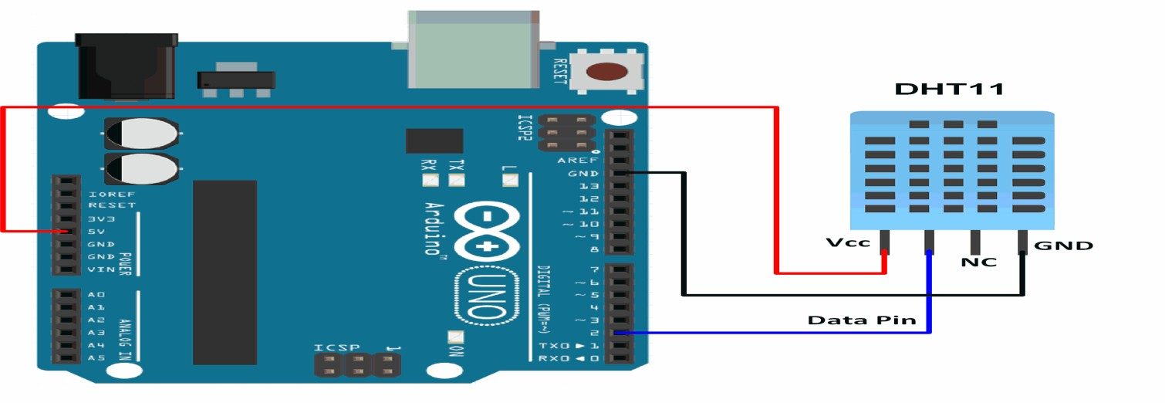

### Code:

### Output:

**Signature of faculty: Grade:**

# Practical 4

## Aim: To interface OLED with Arduino. Write program to print temperature and humidity reading.

**Theory and Procedure:**

An OLED (Organic Light Emitting Diode) display is a thin, lightweight display technology that

uses organic materials to emit light when an electric current is applied. The Arduino is a

microcontroller board that can be programmed using the Arduino Integrated Development

Environment (IDE) to control various sensors and other devices. The DHT11 is a low-cost

digital temperature and humidity sensor that communicates with the Arduino using a single

wire protocol.

To interface an OLED display with an Arduino, we need to connect the display to the I2C

pins on the Arduino board. The I2C protocol allows the Arduino to communicate with the

OLED display using only two wires - SDA (serial data) and SCL (serial clock).

### Code:

### Output:

**Signature of faculty: Grade:**

# Practical 5

## Aim: To interface Bluetooth with Arduino/ Raspberry Pi and write a program to send sensor data to smartphone using Bluetooth.

**Theory and Procedure:**

Bluetooth is a wireless technology used for short-range communication between devices.

Bluetooth can be used to interface Arduino or Raspberry Pi with a smartphone, allowing the devices to exchange data wirelessly. The Arduino or Raspberry Pi can be connected to various sensors and the

collected sensor data can be transmitted to a smartphone over Bluetooth.

To interface Bluetooth with an Arduino or Raspberry Pi, we need to use a Bluetooth module that

supports serial communication. The HC-05 Bluetooth module is a popular choice for this purpose.

The HC-05 module communicates with the Arduino or Raspberry Pi using UART communication.

Step-wise Procedure:

Connect the HC-05 Bluetooth module to the Arduino or Raspberry Pi using the following connections:

VCC to 5V

GND to GND

TXD to RXD (Arduino pin 0/Raspberry Pi GPIO 15)

RXD to TXD (Arduino pin 1/Raspberry Pi GPIO 14)

Power on the Bluetooth module and set it to "AT mode" by pressing the button on the module for a few seconds. In AT mode, we can configure the module using AT commands.

Connect the Arduino or Raspberry Pi to the sensor(s) you want to collect data from. Collect the data using appropriate sensors and store them in variables.

**Code:**

### Output:

**Signature of faculty: Grade:**

# Practical 6

## Aim: Write program on Arduino/ Raspberry Pi for MQTT publishing process.

**Theory and Procedure:**

MQTT is MQ Telemetry Transport which is a lightweight open messaging protocol that provides resource-constrained network clients with a simple way to distribute telemetry information in low-bandwidth environments.

An MQTT client can publish messages as soon as it connects to a broker. When a client sends a message to an MQTT broker for publication, the broker reads the message, acknowledges the message, and processes the message**.** Processing by the broker includes determining which clients have subscribed to the topic and sending the message to them.

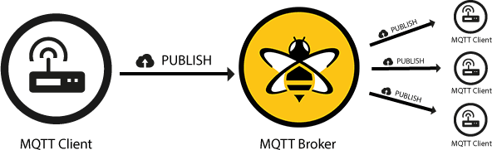

**Code:**

### Output:

**Signature of faculty: Grade:**

# Practical 7

## Aim: Write program on Arduino/ Raspberry Pi for MQTT subscription process.

**Theory and Procedure:**

Once published there should be clients to subscribe to topics of the messages. To receive messages on topics of interest, the client sends a **SUBSCRIBE** message to the MQTT broker. This subscribe message is very simple, it contains a unique packet identifier and a list of

subscriptions. To confirm each subscription, the broker sends a **SUBACK** acknowledgement message to the client.

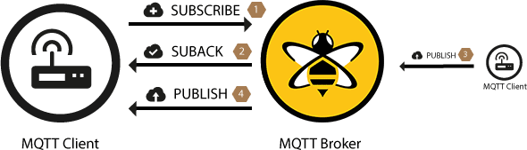

**Code:**

### Output:

**Signature of faculty: Grade:**

# Practical 8

## Aim: Study any one IoT technology like fastag or tracking and monitoring. Write its detailed communication protocols.

**Theory and Procedure:**

**Signature of faculty: Grade:**

# Practical 9

## Aim: Write program on Arduino/ Raspberry Pi to upload temperature and humidity data to the thingspeak cloud.

**Theory and Procedure:**

Step 1: Use Arduino Uno microcontroller or Rasberry pi

Step 2: Use DTH11 sensor for recording temperature and humidity data

Step3: Use ESP8266 is a cost-effective and highly integrated Wi-Fi MCU for IoT applications. Step 4: Use Thingspeak cloud to visualize data

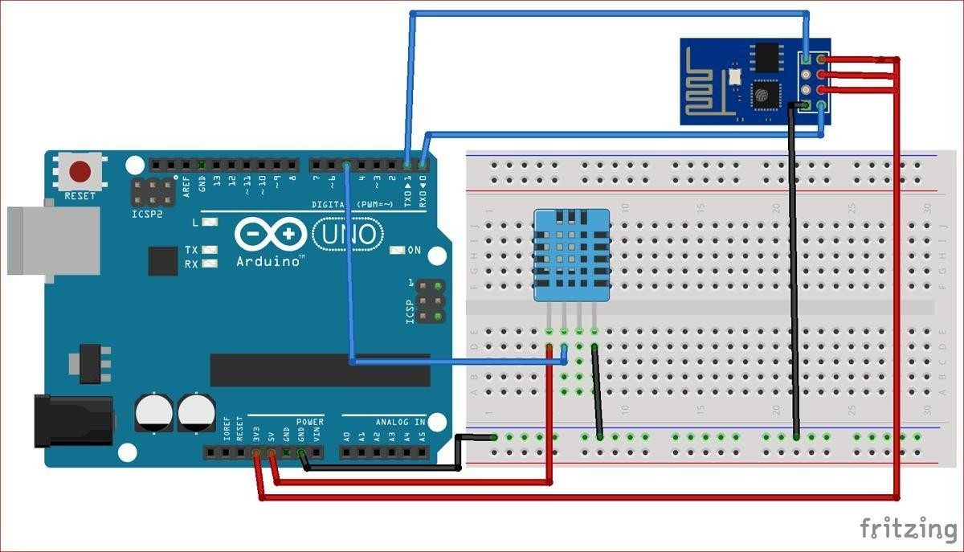

**Code:**

### Output:

**Signature of faculty: Grade:**

# Practical 10

**Aim: Case Study:**

1. Study and pick a real life challenge in an application area.
2. Write the Problem.
3. Analyze how the problem can be solved using IoT.
4. Assume that you have to develop the IoT solution for the problem -List the choice of selection of items like sensor, microcontroller, and communication protocol based on parameters like cost, efficiency, performance and size.

**Theory and Procedure:**

**Signature of faculty: Grade:**

# Practical 11

**Aim: Develop a project on IoT application using Arduino or Raspberry Pi with Tinker cad simulation software tool.**

**Theory and Procedure:**

Step 1: Name of the project

Step 2: Information on the working principle of the project Step 3: Team/ group name with enrollment no

Step 4: Develop the application in Tinker cad software Step 5: write the code to perform the project

**Signature of faculty: Grade:**