|  |  |
| --- | --- |
|  | **L. D. College of Engineering** |
| **Opp. Gujarat University, Navrangpura, Ahmedabad - 380015** |

**Lab Manual**

**Branch: Computer Engineering Microprocessor and Interfacing (3160712)**

**Semester VI**

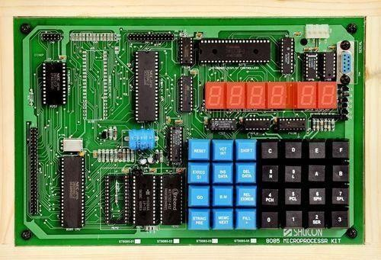

**Faculties:**

### Prof Parth R Dave

1. **Prof Zishan Noorani**

***Certificate***

***Shri/Ms***

***This is to certify that***

***___________________________________________________________***

Microprocessor and Interfacing (3160712)

Computer Engineering Department, L. D. College of Engineering, Ahmedabad-15

***Enrollmement No. ________________________________________ of BE***

***Sem ________ class has satisfactorily completed the course in_______________________________*____*_________________________________***

***within four walls of L. D. College of Engineering, Ahmedabad – 380015.***

# Date of Submission :- __________________________________________________________

***Staff in – Charge :- _____________________________________________________________***

# Head of Department :- ________________________________________________________

|  |  |  |
| --- | --- | --- |
| PM-LD | **L D COLLEGE OF ENGINEERING AHMEDABAD COMPUTER ENGINEERING DEPARTMENT**  --- | computer dept symbol.png |

**Vision and Mission of the Department**

## VISION

To achieve academic excellence in Computer Engineering by providing value-based education.

## MISSION

* 1. To produce graduates according to the needs of industry, government, society and scientific community.
  2. To develop partnership with industries, research and development organizations and government sectors for continuous improvement of faculties and students.
  3. To motivate students for participating in reputed conferences, workshops, seminars and technical events to make them technocrats and entrepreneurs.
  4. To enhance the ability of students to address the real-life issues by applying technical expertise, human values and professional ethics.
  5. To inculcate habit of using free and open-source software, latest technology and soft skills so that they become competent professionals.
  6. To encourage faculty members to upgrade their skills and qualification through training and higher studies at reputed universities.

**L. D. College of Engineering, Ahmedabad Department of Computer Engineering**

|  |  |
| --- | --- |
| **Subject Name: Microprocessor and Interfacing** | **Subject Code: 3160712** |
| **Term: 2022-23** |  |

|  |  |  |  |  |  |
| --- | --- | --- | --- | --- | --- |
| **Rubrics ID** | **Criteria** | **Marks** | **Good (2)** | **Satisfactory (1)** | **Need Improvement (0)** |
| RB1 | Regularity | 05 | High (>70%) | Moderate (40-  70%) | Poor (0-40%) |
| RB2 | Problem Analysis & Development of the Solution | 05 | Apt & Full Identification of the Problem & Complete Solution for the Problem | Limited Identification of the Problem / Incomplete Solution for the Problem | Very Less Identification of the Problem / Very Less Solution for the Problem |
| RB3 | Testing of the Solution | 05 | Correct Solution as required | Partially Correct Solution for the Problem | Very less correct solution for the problem |
| RB4 | Mock viva test | 05 | All questions responded Correctly | Delayed & partially correct response | Very few questions answered correctly |

SIGN OF FACULTY

### List Of Practical

B.E (Computer Engineering) SEMESTER: - VI TERM: - Jan-2023 SUBJECT: - **Microprocessor and Interfacing (3160712)**

|  |  |  |
| --- | --- | --- |
| **Sr.**  **No** | **Practical** | **CO** |
| 1 | Write an assembly language program to add 2 8-bit numbers. Also use ADC to add the final answer along with carry. Save the final answer at particular memory location. | CO3 |
| 2 | Write an assembly language program to subtract 2 8-bit numbers. Save the final answer at particular memory location. | CO3 |
| 3 | Write an assembly language program to subtract 2 8-bit numbers using 2’s complement method  and 1’s complement method. Save the final answer at particular memory location. | CO3 |
| 4 | Write an assembly language program to multiply 2 8-bit numbers. Save the final answer at  particular memory location. | CO3 |
| 5 | Write an assembly language program to divide 2 8-bit numbers. Save the quotient and remainder  at particular memory location. | CO3 |
| 6 | Write an assembly language program to find SQUARE of 8-bit number. Save the final answer  at particular memory location. | CO3 |
| 7 | Write an assembly language program to find FACTORIAL of 8-bit number. Save the final  answer at particular memory location. | CO3 |
| 8 | Write an assembly language program to multiply 2 8-bit numbers. Save the final answer at particular memory location 200A H. Check if the final answer sets EVEN PARITY flag than add the data available at 200A H and largest no between multiplier and multiplicand. If final answer sets ODD PARITY flag add the data available at 200A H and smaller no between  multiplier and multiplicand. | CO3 |
| 9 | Write an assembly language program that can checks whether the given number is positive or  negative, if number is positive then store 99H at memory location 2000H otherwise store 98H at memory location 2000H. | CO3 |
| 10 | Write an assembly language program to understand the functionality of DAA instruction. Save  final answer before DAA instruction and after DAA instruction at particular memory location. | CO3 |
| 11 | Write an assembly language program to count total no. of 1’s in given 8-bit number. Save the  final answer at particular memory location. | CO3 |
| 12 | Write an assembly language program to count total no. of 0’s in given 8-bit number. Save the  final answer at particular memory location. | CO3 |
| 13 | Write an assembly language program to compare two numbers. If first number is greater than second number than store 97H at particular memory location, if both the numbers are equal than  store 98H at particular memory location and if first number is smaller than second number than store 99H at particular memory location. | CO3 |
| 14 | Write an assembly language program to count no of 1’s in two 8-bit numbers separately. Save both the answer at particular memory location. Finally do multiplication between them and save the final answer at 3000h memory location. | CO3 |
| 15 | Write an assembly language program to add two 8-bit numbers. If addition sets Carry Flag (CF)  than multiply the final answer by 05H else by 0AH. Save the final answer at particular memory location. | CO3 |
| 16 | Write an assembly language program to sort 10 numbers that are available at consecutive memory location from 2000H to 2009H. Store the sorted list at the same memory location. | CO3 |

|  |  |  |
| --- | --- | --- |
| 17 | Write an assembly language program to search a given number in list of 10 numbers stored at consecutive memory location 2000H to 2009H. If match found than store 99H at memory location 200A else 98H. | CO3 |
| 18 | Write an assembly language program to fetch 10 values from memory location 2000H to 2009H. Add all the even value from the list and add all the odd values from the list. Store the answer of even no addition at 2015H location and store the answer of odd no addition at 2016H memory  location. Do subtraction of data available at 2015H and 2016H and save the final answer at 2017H memory location. | CO3 |
| 19 | Write an assembly language program to fetch 10 values from memory location 2000H to 2009H. Add all the numbers that are available at odd memory location and add all the numbers that are available at even memory location. Store the answer of even location addition at 2015H location and store the answer of odd location addition at 2016H memory location. Do division of data  available at 2015H and 2016H and save the quotient and remainder at particular memory location. | CO3 |
| 20 | Write an assembly language program to generate Fibonacci Series at a particular memory block. | CO3 |

#### Subject Name: Microprocessor and Interfacing

**Term: 2022-23**

#### Enroll. No.: Class:

|  |  |  |  |  |  |  |  |  |
| --- | --- | --- | --- | --- | --- | --- | --- | --- |
| **Pract. No.** | **CO**  **No.** | **RB1** | **RB2** | **RB3** | **RB4** | **Total** | **Date** | **Faculty Sign** |
| **1.** | CO3 |  |  |  |  |  |  |  |
| **2.** | CO3 |  |  |  |  |  |  |  |
| **3.** | CO3 |  |  |  |  |  |  |  |
| **4.** | CO3 |  |  |  |  |  |  |  |
| **5.** | CO3 |  |  |  |  |  |  |  |
| **6.** | CO3 |  |  |  |  |  |  |  |
| **7.** | CO3 |  |  |  |  |  |  |  |
| **8.** | CO3 |  |  |  |  |  |  |  |
| **9.** | CO3 |  |  |  |  |  |  |  |
| **10.** | CO3 |  |  |  |  |  |  |  |
| **11.** | CO3 |  |  |  |  |  |  |  |
| **12.** | CO3 |  |  |  |  |  |  |  |
| **13.** | CO3 |  |  |  |  |  |  |  |
| **14.** | CO3 |  |  |  |  |  |  |  |
| **15.** | CO3 |  |  |  |  |  |  |  |
| **16.** | CO3 |  |  |  |  |  |  |  |
| **17.** | CO3 |  |  |  |  |  |  |  |
| **18.** | CO3 |  |  |  |  |  |  |  |
| **19.** | CO3 |  |  |  |  |  |  |  |
| **20.** | CO3 |  |  |  |  |  |  |  |

**Rationale:** The modern digital systems including computer systems are designed with microprocessor as central device connected to memory and I/O devices. The subject introduces the students with basics of microprocessor, microprocessor architecture and programming, interfacing microprocessor with memory and various I/O (Input/Output) devices.

#### Course Outcomes:

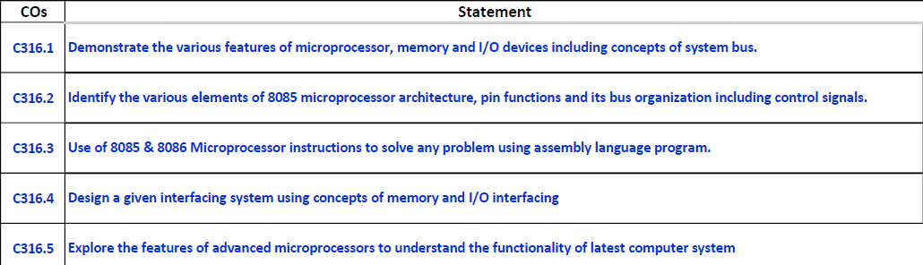

**Practical 1**

**AIM**: Write an assembly language program to add 2 8-bit numbers. Also use ADC to add the final answer along with carry. Save the final answer at particular memory location.

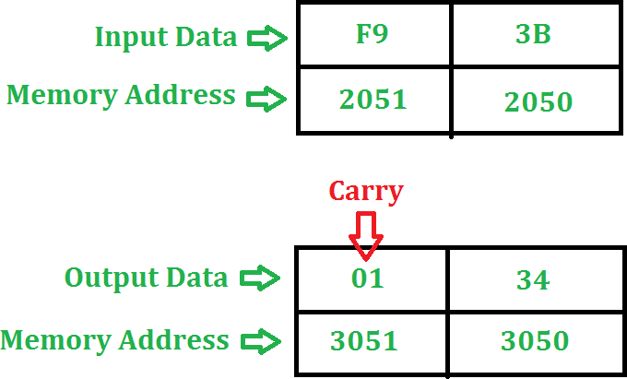

#### Algorithm:

* 1. Load the first number from memory location 2050 to accumulator.
  2. Move the content of accumulator to register H.
  3. Load the second number from memory location 2051 to accumulator.
  4. Then add the content of register H and accumulator using “ADD” instruction and storing result at 3050
  5. The carry generated is recovered using “ADC” command and is stored at memory location 3051

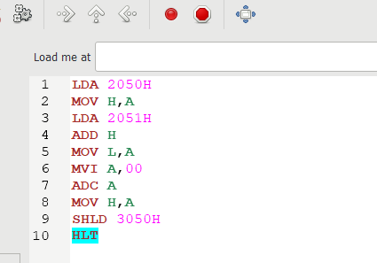

#### OUTPUT:

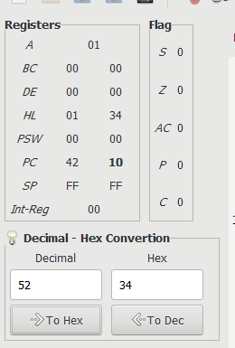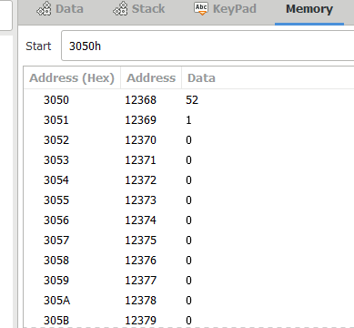

**Practical 2**

**AIM**: Write an assembly language program to subtract 2 8-bit numbers. Save the final answer atparticular memory location.

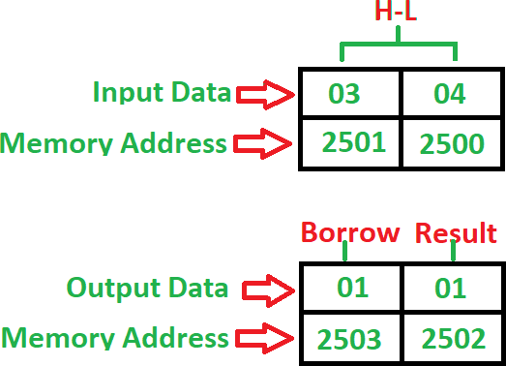

**Algorithm:**

1. Load 00 in a register C (for borrow)
2. Load two 8-bit number from memory into registers
3. Move one number to accumulator
4. Subtract the second number with accumulator
5. If borrow is not equal to 1, go to step 7
6. Increment register for borrow by 1
7. Store accumulator content in memory
8. Move content of register into accumulator
9. Store content of accumulator in other memory location
10. Stop

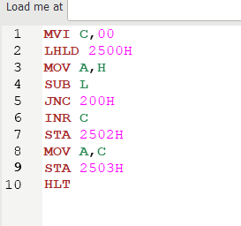

#### OUTPUT:

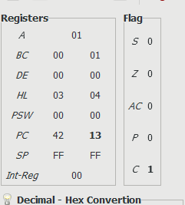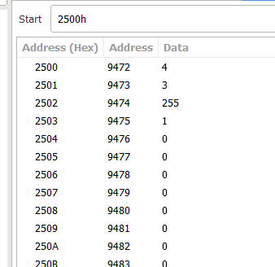

**Practical 3**

**AIM**: Write an assembly language program to subtract 2 8-bit numbers using 2’s complement method and 1’s complement method. Save the final answer at particular memory location.

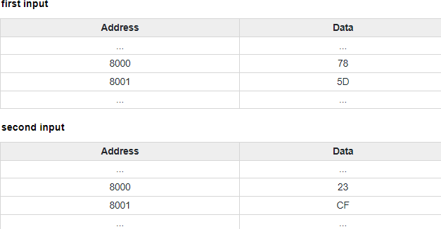

## 1’S COMPLEMENT PROGRAM:

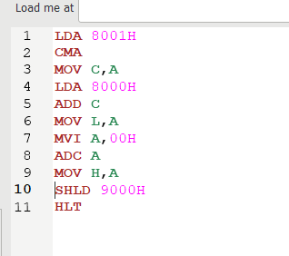

#### OUTPUT:

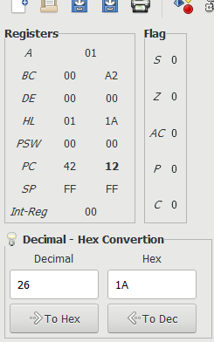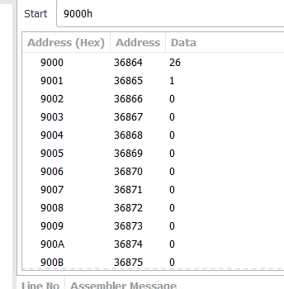

**2’S COMPLEMENT PROGRAM:**

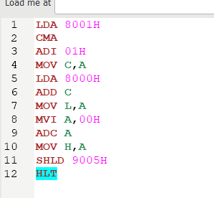

#### OUTPUT:

