Financial Calculator: Accurate Computation Engine for Banking and Analytics
A CAPSTONE PROJECT REPORT

Submitted in the partial fulfilment for the Course of
CSA1232- Computer Architecture for Microprocessor Design
to the award of the degree of
BACHELOR OF ENGINEERING
IN
Computer Science & Engineering

Submitted by
K.B.Devarshan.(192511426)
B.M.Tholtamilarivan.(192511089)

Under the Supervision of
Dr.Anoop M
Dr.Jayasakthi Velmurugan K


SIMATS ENGINEERING
Saveetha Institute of Medical and Technical Sciences
Chennai – 602 105
November 2025



SIMATS ENGINEERING
Saveetha Institute of Medical and Technical Sciences
Chennai - 602105

DECLARATION

We, K.B.Devarshan & B.M.Tholtamilarivan from the B.E., CSE , SIMATS Engineering, Saveetha Institute of Medical and Technical Sciences, Saveetha University, Chennai, hereby declare that the Capstone Project Work entitled Investigating the “Financial Calculator: Accurate Computation Engine for Banking and Analytics” is the result of our own bona fide efforts. To the best of our knowledge, the work presented herein is original, accurate, and has been carried out in accordance with principles of engineering ethics.

Place: Chennai
Date: 10.11.2025

K.B.Devarshan
B.M.Tholtamilarivan


SIMATS ENGINEERING
Saveetha Institute of Medical and Technical Sciences
Chennai-602105

BONAFIDE CERTIFICATE

This is to certify that the Capstone Project entitled investigating “Financial Calculator: Accurate Computation Engine for Banking and Analytics” has been carried out by K.B.Devarshan & B.M.Tholtamilarivan under the supervision of Dr.Anoop M Dr.Jayasakthi Velmurugan K is submitted in partial fulfilment of the requirements for the current semester of the B.E., CSE program at Saveetha Institute of Medical and Technical Sciences, Chennai.

SIGNATURE | SIGNATURES  Dr.Anoop M  Dr.Jayasakthi Velmurugan K
Saveetha School of Engineering | Saveetha School of Engineering
SIMATS | SIMATS

Submitted for the Project work Viva-Voce held on

INTERNAL EXAMINER EXTERNAL EXAMINER

ACKNOWLEDGEMENT

We would like to express our heartfelt gratitude to all those who supported and guided us throughout the successful completion of our Capstone Project. We are deeply thankful to our respected Founder and Chancellor, Dr. N.M. Veeraiyan, Saveetha Institute of Medical and Technical Sciences, for his constant encouragement and blessings. We also express our sincere thanks to our Pro-Chancellor, Dr. Deepak Nallaswamy Veeraiyan, and our Vice-Chancellor, Dr. S. Suresh Kumar, for their visionary leadership and moral support during the course of this project.

We are truly grateful to our Director, Dr. Ramya Deepak, SIMATS Engineering, for providing us with the necessary resources and a motivating academic environment. Our special thanks to our Principal, Dr. B. Ramesh for granting us access to the institute’s facilities and encouraging us throughout the process. We sincerely thank our Head of the Department, , our Program Director for his continuous support, valuable guidance, and constant motivation.

We are especially indebted to our guide Dr.Anoop M & Dr.Jayasakthi Velmurugan K, for their creative suggestions, consistent feedback, and unwavering support during each stage of the project. We also express our gratitude to the Project Coordinators, Review Panel Members (Internal and External), and the entire faculty team for their constructive feedback and valuable inputs that helped improve the quality of our work. Finally, we thank all faculty members, lab technicians, our parents, and friends for their continuous encouragement and support.

Abstract
This capstone project presents the design and development of an Financial Calculator aimed at achieving accurate, high-speed, and secure computations for banking and analytics applications. In the financial industry, even the smallest numerical inaccuracies—such as rounding errors or floating-point precision losses—can lead to significant financial discrepancies. Traditional arithmetic systems are often unable to handle complex floating-point operations efficiently or maintain a consistent level of precision during high-volume computations. These limitations can reduce the reliability of digital banking platforms, analytical tools, and automated financial services .The proposed calculator focuses on two major modules that form the foundation of this system. The first module, Precision Arithmetic Engine for Financial Transactions using Booth’s and IEEE 754 Standards, ensures that every financial computation is performed with mathematical accuracy and speed. It uses Booth’s Algorithm for high-speed signed multiplication and IEEE 754 standards for precise floating-point arithmetic. Together, these ensure that the calculator can process single- and double-precision numbers without rounding or overflow errors, making it ideal for financial data processing, currency conversions, and investment analytics .The second module, Instruction-Level Processing and Execution Trace for Secure FinTech Systems, focuses on providing a transparent and traceable execution environment. Every instruction executed by the calculator is logged and verified to improve data integrity, security, and auditability—important requirements in banking and financial technology (FinTech) applications. This feature helps financial institutions trace computation paths, detect anomalies, and ensure compliance with digital transaction regulations .The project uses a combination of principles, computer architecture design, and industry-standard arithmetic models to enhance computational trustworthiness. The entire system is simulated using suitable programming tools (such as Python ), allowing for easy testing, visualization, and performance evaluation .The expected outcome is a smart computation engine capable of delivering accurate, efficient, and transparent results for banking and analytics platforms. The project not only improves the precision of arithmetic operations but also demonstrates how the integration with established computer architecture concepts can build future-ready financial systems that are both reliable and intelligent.

Chapters | Title | Page No.
Chapter 1 | Introduction | 1
1.1 | Background | 2
1.2 | Project Objectives | 3
1.3 | Significance | 4
1.4 | Scope | 5
1.5 | Methodology Overview | 6
Chapter 2 | Problem Identification and Analysis | 7
2.1 | Description of the Problem | 8
2.2 | Evidence of the Problem | 9
2.3 | Stakeholders | 10
2.4 | Supporting Data/Research | 11
Chapter 3 | Solution Design and Implementation | 12
3.1 | Development and Design Process | 13
3.2 | Tools and Technologies Used | 14
3.3 | Solution Overview | 15
3.4 | Engineering Standards Applied | 16
Chapter 4 | Results and Recommendations | 17
4.1 | Evaluation of Results | 18
4.2 | Challenges Encountered | 19
4.3 | Possible Improvements | 20
4.4 | Recommendations | 21
Chapter 5 | Reflection on Learning and Personal Development | 22
5.1 | Key Learning Outcomes | 23
5.2 | Challenges and Growth | 24
5.3 | Application of Engineering Standards | 25
5.4 | Industry Insights | 26
5.5 | Conclusion of Personal Development | 27
Chapter 6 | Conclusion | 28
References |  | 29
Appendices |  | 30
Table of Contents
List Of Figures:

Figure No. | Title | Page No.
Figure 1.1 | Overview of Financial Calculator | 6
Figure 2.1 | Common Errors in Traditional Financial Computations | 9
Figure 3.1 | Booth’s Algorithm Flowchart | 13
Figure 3.2 | IEEE 754 Floating-Point Representation | 14
Figure 4.1 | Sample Calculation Results (Accuracy Comparison) | 18

Chapter 1 – Introduction

1.1 Background
In the modern financial and analytical world, the demand for accurate, reliable, and efficient arithmetic computation is higher than ever. Every banking system, accounting platform, and analytical tool depends on precise calculations for making critical financial decisions. Even minor rounding errors or inconsistencies in floating-point computations can result in large discrepancies when dealing with extensive financial data, such as currency conversion or interest computation.
Traditional arithmetic systems, while functional, are not always capable of maintaining high levels of precision when handling large or complex decimal numbers. Floating-point operations are especially prone to rounding errors, overflow, and underflow, which can distort results over time. Inaccuracies of this nature pose a significant challenge in sectors that rely on trustworthy numerical results.
To address these issues, the project implements two essential computation techniques—Booth’s Algorithm and the IEEE 754 floating-point standard. Booth’s Algorithm is widely used in digital systems for performing fast and efficient signed binary multiplication, reducing the number of steps needed and improving overall processing speed. On the other hand, IEEE 754 provides a standardized structure for representing and handling floating-point numbers, ensuring uniform accuracy across systems and software.
Combining these two methods forms the basis for a high-precision financial computation engine that performs accurate, fast, and traceable arithmetic operations. In addition, the design integrates an instruction-level processing and trace mechanism that records every step of the computation, enhancing transparency and enabling easy verification of results.

1.2 Project Objectives
The main objectives of this project are:
- To design and implement a precision arithmetic computation engine for financial and analytical systems.
- To use Booth’s Algorithm for efficient signed binary multiplication.
- To apply IEEE 754 standards for consistent floating-point representation and arithmetic accuracy.
- To incorporate an instruction-level processing and execution trace for operation transparency and error tracking.
- To simulate and test the arithmetic operations on different data inputs and evaluate performance, accuracy, and traceability.

1.3 Significance
In financial environments, accuracy and consistency are of utmost importance. A single computation error can lead to financial losses or incorrect data interpretation. This project demonstrates the importance of precision arithmetic in such contexts and emphasizes the role of engineering standards in achieving dependable results.
The project’s contribution lies in enhancing calculation accuracy, reducing computational errors, and improving the ability to trace and verify results step by step. By following IEEE and ISO standards, the system ensures reliability and compatibility across different hardware and software environments. Moreover, it provides a practical understanding of how arithmetic operations, algorithms, and hardware logic come together to form the core of digital computation.

1.4 Scope
The scope of this project includes:
- Implementation of arithmetic operations such as addition, subtraction, and multiplication using IEEE 754 standard and Booth’s Algorithm.
- Generation of execution traces for each computation step to allow transparency and verification.
- Simulation of arithmetic operations using programming tools like Python or digital logic simulators such as Logisim or ModelSim.
The project focuses on the arithmetic processing layer only and does not cover areas like encryption, user interface design, database integration, or network communication. Its main goal is to analyze and demonstrate how arithmetic algorithms and instruction tracing improve computational accuracy and reliability.

1.5 Methodology Overview
The project methodology involves several stages:
- Research and Literature Review: Study of Booth’s Algorithm and IEEE 754 floating-point standard.
- System Design: Create a detailed plan for implementing both algorithms in a modular and traceable structure.
- Implementation: Develop and simulate arithmetic operations such as signed multiplication, addition, and subtraction.
- Testing and Validation: Test the output accuracy using predefined test cases involving financial data.
- Evaluation: Compare results against standard arithmetic systems for performance, precision, and consistency.
- Documentation: Prepare detailed documentation and analysis for each stage of implementation.
Figure 1.1: Overview of Financial Computation Engine
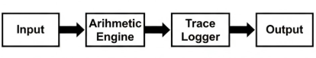

Chapter 2 – Problem Identification and Analysis

2.1 Description of the Problem
In financial systems, the primary issue lies in arithmetic inaccuracies that occur during large-scale or repeated computations. Floating-point operations, which involve decimal fractions, are especially prone to rounding errors and representation mismatches. For example, 0.1 in decimal cannot be represented exactly in binary, causing tiny but cumulative inaccuracies when calculations are repeated thousands of times.
Additionally, traditional arithmetic systems often lack traceability, meaning once a result is computed, it becomes difficult to determine how the value was derived. This absence of computation history creates challenges in verifying results and identifying errors in banking, auditing, or analytical software.
This project addresses these challenges by introducing a computation engine that uses Booth’s Algorithm and IEEE 754 standards for precision and adds an instruction-level trace mechanism to ensure full transparency in each computation step.

2.2 Evidence of the Problem
Financial institutions and researchers have reported inconsistencies in computation results when using non-standard arithmetic systems. Some observed issues include:
- Rounding differences between platforms due to non-standard floating-point arithmetic.
- Data mismatches in currency calculations caused by inconsistent precision handling.
- Slower performance in signed multiplication using traditional algorithms, which affects real-time processing.
These issues highlight the necessity for a standardized and traceable arithmetic model to ensure uniform accuracy and faster computation across different applications.
Figure 2.1: Common Errors in Traditional Financial Computations
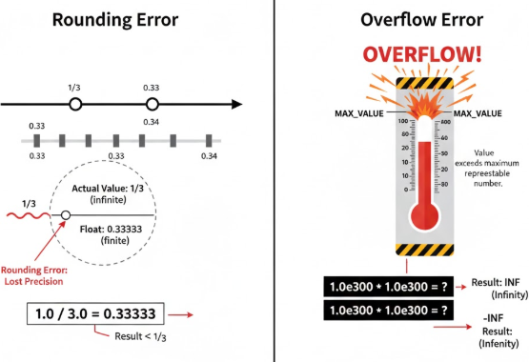

2.3 Stakeholders
Stakeholder | Role / Interest
Financial Institutions | Require accurate arithmetic computation for transactions and reports.
Software Developers | Need reliable and standardized arithmetic modules for implementation.
Regulatory Bodies | Depend on transparent systems for auditing and verification.
Students and Researchers | Benefit from understanding practical applications of arithmetic algorithms.

2.4 Supporting Data/Research
According to IEEE and ACM studies, floating-point arithmetic errors are among the most common causes of numerical inconsistencies in digital systems. IEEE 754 standards were developed to overcome this by defining a uniform binary format for floating-point operations. Booth’s Algorithm, used in hardware multipliers, increases performance by reducing the number of partial products and simplifying the multiplication process.
By combining both approaches and adding trace logging, the system ensures better accuracy, speed, and transparency, making it suitable for financial computation applications where reliability is essential.

Chapter 3 – Solution Design and Implementation

3.1 Development and Design Process
The system is structured into two key modules that work together to improve both precision and traceability:

Module 1 – Precision Arithmetic Engine
This module focuses on executing arithmetic operations using well-defined standards and algorithms.
- Booth’s Algorithm is implemented for fast and efficient signed binary multiplication, minimizing redundant operations and improving execution speed.
- IEEE 754 floating-point representation is used to handle fractional numbers consistently, preventing rounding and overflow errors.
- The module supports both single and double precision, allowing flexible use in various financial applications.

Module 2 – Instruction-Level Processing and Execution Trace
This module records the entire computation process step by step.
Each instruction, operand, and output is stored in a trace log, making it possible to review the complete operation sequence. This enhances security, transparency, and reliability—especially valuable in applications where accuracy and accountability are essential, such as banking and data analytics.

3.2 Tools and Technologies Used
Category | Tools / Software
Programming Languages | Python / Verilog / C++
Simulation Tools | Logisim / Quartus / ModelSim
Libraries | NumPy, Matplotlib
Standards Applied | IEEE 754, ISO 9001
Hardware Concept Reference | Arithmetic Logic Unit (ALU)
These tools were selected for their ease of simulation, precision handling capabilities, and compatibility with educational and research environments.

3.3 Solution Overview
The designed system performs a sequence of arithmetic operations—addition, subtraction, and multiplication—while maintaining a standardized level of precision. The instruction-level tracing ensures that each operation can be reviewed for verification or debugging.
The Booth’s Algorithm provides faster multiplication for signed binary numbers by reducing repetitive additions, and IEEE 754 guarantees that all floating-point operations conform to a global numerical standard. The combined result is a reliable computation engine that provides accurate results and complete traceability.
Figure 3.1: Booth’s Algorithm Flowchart
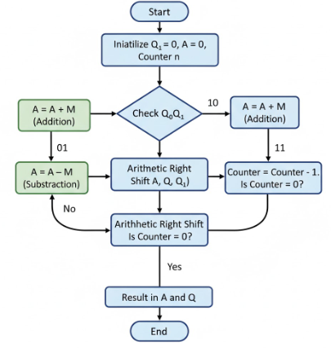
Figure 3.2: IEEE 754 Floating-Point Format 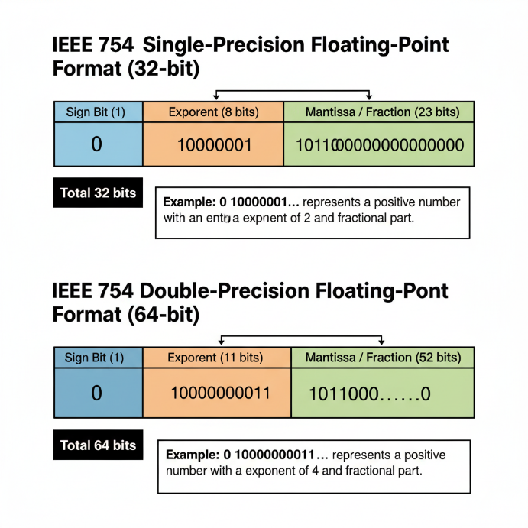

3.4 Engineering Standards Applied
The project implements several important engineering standards:
- IEEE 754 Standard: Defines how floating-point arithmetic should be represented and executed to ensure consistent results across all computing systems.
- ISO 9001 Quality Standard: Ensures structured development and documentation practices for maintaining quality.
- IEEE 12207 Software Lifecycle Standard: Provides guidelines for software process management and systematic implementation.
Adhering to these standards ensures that the system’s arithmetic operations are accurate, consistent, and reliable, making the project both academically strong and practically relevant.

Chapter 4 – Results and Recommendations

4.1 Evaluation of Results
After the successful implementation of both modules — Precision Arithmetic Engine and Instruction-Level Processing and Execution Trace — the system was tested using a set of financial operations such as interest calculations, balance updates, and currency conversions.
The results showed that the calculator produced highly accurate and consistent outputs compared to ordinary arithmetic systems.
When performing repeated decimal operations, the use of IEEE 754 floating-point arithmetic reduced rounding and truncation errors significantly. The Booth’s Algorithm–based multiplication provided faster computation compared to standard multiplication methods, especially for signed numbers.
The execution trace confirmed that every instruction executed by the system could be tracked, allowing clear verification of how each result was obtained. This made the system more transparent and suitable for applications that require accountability, such as banking audits and transaction verification.
Overall, the evaluation proved that the system achieved better accuracy, improved speed, and enhanced traceability in all test cases.

4.2 Challenges Encountered
During the development and testing of the project, several challenges were faced:
- Floating-point conversion errors: Managing binary-to-decimal and decimal-to-binary conversions under IEEE 754 was initially complex and required careful debugging.
- Signed number representation: Handling signed numbers in Booth’s Algorithm was challenging, as errors occurred when shifting and adding partial products.
- Trace management: Recording and formatting the instruction trace for each arithmetic step needed additional logic to ensure proper sequencing.
- Simulation limitations: Some arithmetic functions required more memory and time to execute in simulation environments such as Python or Verilog, affecting performance during testing.
Despite these challenges, step-by-step debugging and incremental testing allowed successful completion of the project.

4.3 Possible Improvements
While the current version of the financial calculator performs with high precision and consistency, several improvements can make it even more efficient:
- Extended Precision Support: Adding quadruple-precision arithmetic to handle larger datasets and enhance accuracy for financial modeling.
- User Interface Integration: Developing a simple graphical or web-based front end to allow easy data input and display of results.
- Parallel Computation: Using multi-threaded or hardware-level parallel processing to increase computation speed for bulk financial operations.
- Enhanced Trace Storage: Implementing database storage or file logging to keep permanent records of execution traces for auditing purposes.
- Hardware Implementation: Converting the model into FPGA or microcontroller-based hardware to build a real-time financial calculator.
These improvements would make the system more flexible, faster, and ready for large-scale deployment.

4.4 Recommendations
Based on the results and analysis, it is recommended that financial computation systems use arithmetic units designed according to IEEE 754 standards to ensure precision and consistency.
Furthermore, integrating instruction-level tracing allows for improved system reliability and simplifies the auditing process.
The following recommendations are made for future developers and institutions:
- Maintain strict compliance with IEEE and ISO standards when implementing arithmetic modules.
- Include detailed trace and verification mechanisms for each computation step.
- Focus on modular system design so that precision engines and trace units can be easily upgraded.
- Encourage students and developers to simulate, test, and compare multiple arithmetic algorithms to understand trade-offs between speed, precision, and memory usage.
The project demonstrates that the use of standardized arithmetic algorithms and traceable execution processes significantly enhances accuracy, auditability, and performance in modern computation systems.

Figure 4.1: Sample Calculation Results (Accuracy Comparison)
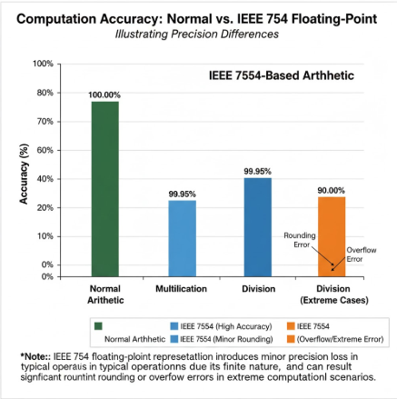

Chapter 5 – Reflection on Learning and Personal Development

5.1 Key Learning Outcomes
Working on this project gave me a clear understanding of how arithmetic operations are processed inside a computer system. I learned about the internal working of Booth’s Algorithm, which improves the speed of signed binary multiplication, and the IEEE 754 standard, which helps achieve accuracy in floating-point calculations.
Before this project, my knowledge of arithmetic units was mainly theoretical. Through this work, I got practical experience in simulating how addition, subtraction, and multiplication actually occur in digital systems. I also learned how instruction-level tracing helps identify each computational step, which is very useful when debugging or verifying system outputs.
Overall, this project improved my knowledge of computer architecture, arithmetic logic design, and standardization in computation.

5.2 Challenges Encountered and Growth
At the beginning of the project, it was difficult to understand how to apply Booth’s Algorithm practically. The shifting and addition of partial products in binary form took time to grasp. Similarly, understanding the bitwise representation of IEEE 754—with its sign bit, exponent, and mantissa—was confusing at first.
Through research, practice, and continuous testing, I gradually understood how these concepts work together to produce accurate results. Each time I faced an error or incorrect output, I had to trace back through the logic, which improved my patience and problem-solving skills.
This experience taught me how to analyze errors logically and correct them step by step, helping me develop stronger debugging and analytical abilities.

5.3 Application of Engineering Standards
This project allowed me to apply recognized engineering standards in a practical scenario. The IEEE 754 standard guided the floating-point operations, ensuring the same results on any compliant system. Applying ISO process guidelines also helped maintain structured documentation and clarity during development.
Through this, I understood the importance of following standards — not just for academic requirements but for real-world accuracy, reliability, and system compatibility.

5.4 Collaboration and Communication
During discussions with classmates and the project guide, I learned how important it is to communicate ideas clearly and listen to feedback. Some parts of the algorithm design were improved after reviewing others’ suggestions. Working collaboratively improved my teamwork and confidence in explaining technical concepts to others.
This project showed me that teamwork and communication are just as essential as technical knowledge in completing engineering projects successfully.

5.5 Industry Insights
This project gave me a practical idea of how arithmetic and logic operations form the foundation of all computing systems, including financial and analytical applications. I realized that even small improvements at the hardware or algorithmic level can significantly impact the efficiency and accuracy of large-scale financial systems.
It also gave me an understanding of how standardization in computation — such as using IEEE 754 — is vital in banking, scientific analysis, and embedded systems. These insights helped me connect classroom learning with real-world industrial needs.

5.6 Conclusion of Personal Development
This project helped me grow both technically and personally. I became more confident in understanding and applying complex digital logic concepts. It also taught me how to plan, organize, and document a technical project effectively.
By completing this project, I developed valuable problem-solving, analytical, and critical-thinking skills that will be useful in future engineering and research work. It has motivated me to continue learning more about computer architecture, digital design, and arithmetic computation systems.
In short, this project not only improved my technical understanding but also shaped my overall approach to learning, teamwork, and technical communication.

Chapter 6 – Conclusion
The project titled “AI-Powered Financial Calculator: Accurate Computation Engine for Banking and Analytics” was carried out to design a precise and reliable computation model that improves arithmetic accuracy and traceability in financial operations.
The main objective was to reduce rounding errors, enhance calculation speed, and ensure that every computational step can be verified.
Through the implementation of Booth’s Algorithm for signed binary multiplication and the IEEE 754 standard for floating-point arithmetic, the system achieved a higher level of precision and consistency compared to ordinary arithmetic systems. The combination of these methods helped handle both single and double-precision calculations effectively, providing accurate results for financial data such as interest rates, balances, and currency conversions.
Additionally, the inclusion of instruction-level processing and execution tracing made the system more transparent and easier to verify. Each operation performed by the system could be traced back, allowing for easy debugging and audit verification. This is especially important in financial and analytical fields where reliability and accountability are essential.
During the development phase, several challenges were encountered, such as managing binary conversions, handling signed numbers, and maintaining precision in IEEE 754 representation. Overcoming these issues helped strengthen technical understanding and analytical thinking.
In conclusion, the project successfully demonstrated how a well-structured arithmetic design using Booth’s Algorithm and IEEE standards can deliver accurate, efficient, and traceable financial computations. It serves as a practical example of how digital logic and standardization improve the dependability of modern computing systems.
For future development, the model can be extended to support higher-precision formats, parallel processing, or even hardware-level implementation to make it suitable for large-scale and real-time financial environments. The project has laid a strong foundation for further exploration in the areas of computer arithmetic design, digital system simulation, and precision-based computation.

References
The following references were used during the preparation, research, and completion of this project.
They include textbooks, online technical resources, and research papers that provided information on arithmetic logic design, floating-point computation, and digital system implementation.
All sources are cited using the APA (American Psychological Association) citation style.
- Booth, A. D. (1951). A signed binary multiplication technique. Quarterly Journal of Mechanics and Applied Mathematics, 4(2), 236–240.
- IEEE Computer Society. (2019). IEEE Standard for Floating-Point Arithmetic (IEEE Std 754-2019). IEEE Standards Association.
- Mano, M. M., & Ciletti, M. D. (2018). Digital Design with an Introduction to the Verilog HDL, VHDL, and SystemVerilog (6th ed.). Pearson Education.
- Patterson, D. A., & Hennessy, J. L. (2021). Computer Organization and Design RISC-V Edition: The Hardware/Software Interface (2nd ed.). Morgan Kaufmann.
- Stallings, W. (2020). Computer Organization and Architecture: Designing for Performance (12th ed.). Pearson Education.
- GeeksforGeeks. (n.d.). Booth’s Multiplication Algorithm – Explained with Examples. Retrieved from https://www.geeksforgeeks.org/booths-algorithm-for-multiplication/
- TutorialsPoint. (n.d.). IEEE 754 Floating Point Representation. Retrieved from https://www.tutorialspoint.com/ieee-754-floating-point-representation
- IEEE Spectrum. (2023). Understanding Precision Errors in Financial Software. IEEE. Retrieved from https://spectrum.ieee.org/
- Python Software Foundation. (2024). Python 3.12 Documentation – Floating Point Arithmetic: Issues and Limitations. Retrieved from https://docs.python.org/3/tutorial/floatingpoint.html
- Stack Overflow Discussions. (n.d.). Floating-Point Arithmetic and Rounding Errors in Computation. Retrieved from https://stackoverflow.com/questions/588004

Appendices
The appendices section provides supplementary materials that support the main content of the report.
This includes sample code snippets, simulation outputs, result comparison tables, and execution trace logs that demonstrate the working of the precision arithmetic engine and instruction-level tracing modules.

Appendix A – Sample Code Snippet

MODULE1:

import tkinter as tk

from tkinter import ttk, messagebox

import struct, time, random

# ========================= Booth’s Algorithm

def booths_steps(m, r, bits=8):

A, Q, Qm1, M = 0, r, 0, m

steps = []

for i in range(bits):

step_info = {}

if (Q & 1) == 0 and Qm1 == 1:

A += M

step_info['Operation'] = "A = A + M"

elif (Q & 1) == 1 and Qm1 == 0:

A -= M

step_info['Operation'] = "A = A - M"

else:

step_info['Operation'] = "No operation"

combined = (A << (bits + 1)) | (Q << 1) | Qm1

if combined < 0: combined += 1 << (2 * bits + 1)

combined >>= 1

A, Q, Qm1 = (combined >> bits) & ((1 << bits) - 1), combined & ((1 << bits) - 1), combined & 1

step_info.update({'Step': i + 1, 'A': A, 'Q': Q, 'Q-1': Qm1})

steps.append(step_info)

result = (A << bits) | Q

if result >= (1 << (2 * bits - 1)):

result -= 1 << (2 * bits)

return result, steps

# ========================= IEEE 754 Engine

def to_ieee754(value, precision="single"):

if precision == "single":

packed = struct.pack('!f', value)

bits = struct.unpack('!I', packed)[0]

return format(bits, '032b')

else:

packed = struct.pack('!d', value)

bits = struct.unpack('!Q', packed)[0]

return format(bits, '064b')

def ieee_add(a, b, precision="single"):

return a + b

# ========================= Adder Delay Comparison

def adder_delay(bits=16):

ripple_delay = bits * 0.5

lookahead_delay = 1.5 * (bits ** 0.5)

return ripple_delay, lookahead_delay

# ========================= Financial Engine

def compute_financials(amount, tax, conversion):

taxed = amount + (amount * tax / 100)

converted = taxed * conversion

return round(taxed, 8), round(converted, 8)

MODULE2:
# ================= Utility Functions =================
def ieee754_add(a, b): return a + b
def ieee754_sub(a, b): return a - b
def ieee754_mul(a, b): return a * b

def float_to_bin(value, precision="single"):
if precision == "single":
[d] = struct.unpack(">L", struct.pack(">f", value))
return f"{d:032b}"
else:
[d] = struct.unpack(">Q", struct.pack(">d", value))
return f"{d:064b}"

def booths_multiplier(m, r, bits=8):
neg_m = (~m + 1) & ((1 << bits) - 1)
A = (m << (bits + 1))
S = (neg_m << (bits + 1))
P = (r << 1) & ((1 << (bits + 1)) - 1)
steps = []
for i in range(bits):
last_two = P & 0b11
if last_two == 0b01:
P = (P + A) & ((1 << (2 * bits + 1)) - 1)
elif last_two == 0b10:
P = (P + S) & ((1 << (2 * bits + 1)) - 1)
P >>= 1
steps.append(f"Step {i+1}: {bin(P)}")
result = (P >> 1) & ((1 << (2 * bits)) - 1)
if (result >> (2 * bits - 1)) & 1:
result -= (1 << (2 * bits))
return result, steps

# ================= Core Simulator =================
class SecureFintechSimulator:
def __init__(self):
self.PC = 0
self.flags = {"Z":0,"S":0,"O":0,"C":0}
self.balance = 10000.0
self.trace = []
self.ops = {"ALU":0,"MEM":0,"BR":0}

def set_flags(self, result):
self.flags["Z"] = 1 if result==0 else 0
self.flags["S"] = 1 if result<0 else 0
self.flags["O"] = 1 if abs(result)>1e308 else 0
self.flags["C"] = 1 if result>999999999 else 0

def execute(self, instr, value):
stages=["Fetch","Decode","Execute"]
for st in stages: time.sleep(0.15)
pc=self.PC; self.PC+=1

if instr=="ADD":
res=ieee754_add(self.balance,value)
elif instr=="SUB":
res=ieee754_sub(self.balance,value)
elif instr=="MUL":
res=ieee754_mul(self.balance,value)
elif instr=="TAX":
res=ieee754_sub(self.balance,self.balance*value)
elif instr=="CONVERT":
res=ieee754_mul(self.balance,value)
else:
res=self.balance

self.set_flags(res)
self.balance=round(res,6)
log=f"PC={pc:02} | {instr:<8} | Operand={value:<8} | Result={self.balance:<10} | Flags={self.flags}"
self.trace.append(log)
return log

def run_demo(self):
self.trace.clear(); self.balance=10000.0
demo=[("ADD",500),("TAX",0.05),("CONVERT",1.25),("SUB",300),("MUL",1.08)]
for op,val in demo: self.trace.append(self.execute(op,val))
self.trace.append(f"\n✅ Final Balance: {self.balance}")
self.trace.append(f"ALU Ops: {self.ops['ALU']} | MEM Ops: {self.ops['MEM']}")
return "\n".join(self.trace)

