SMART System

Entity Relationship Diagram (ERD)
School Management and Reporting Tool · smart_db · PostgreSQL · S.Y. 2026-2027

1. Core Academic Entities — ERD Diagram
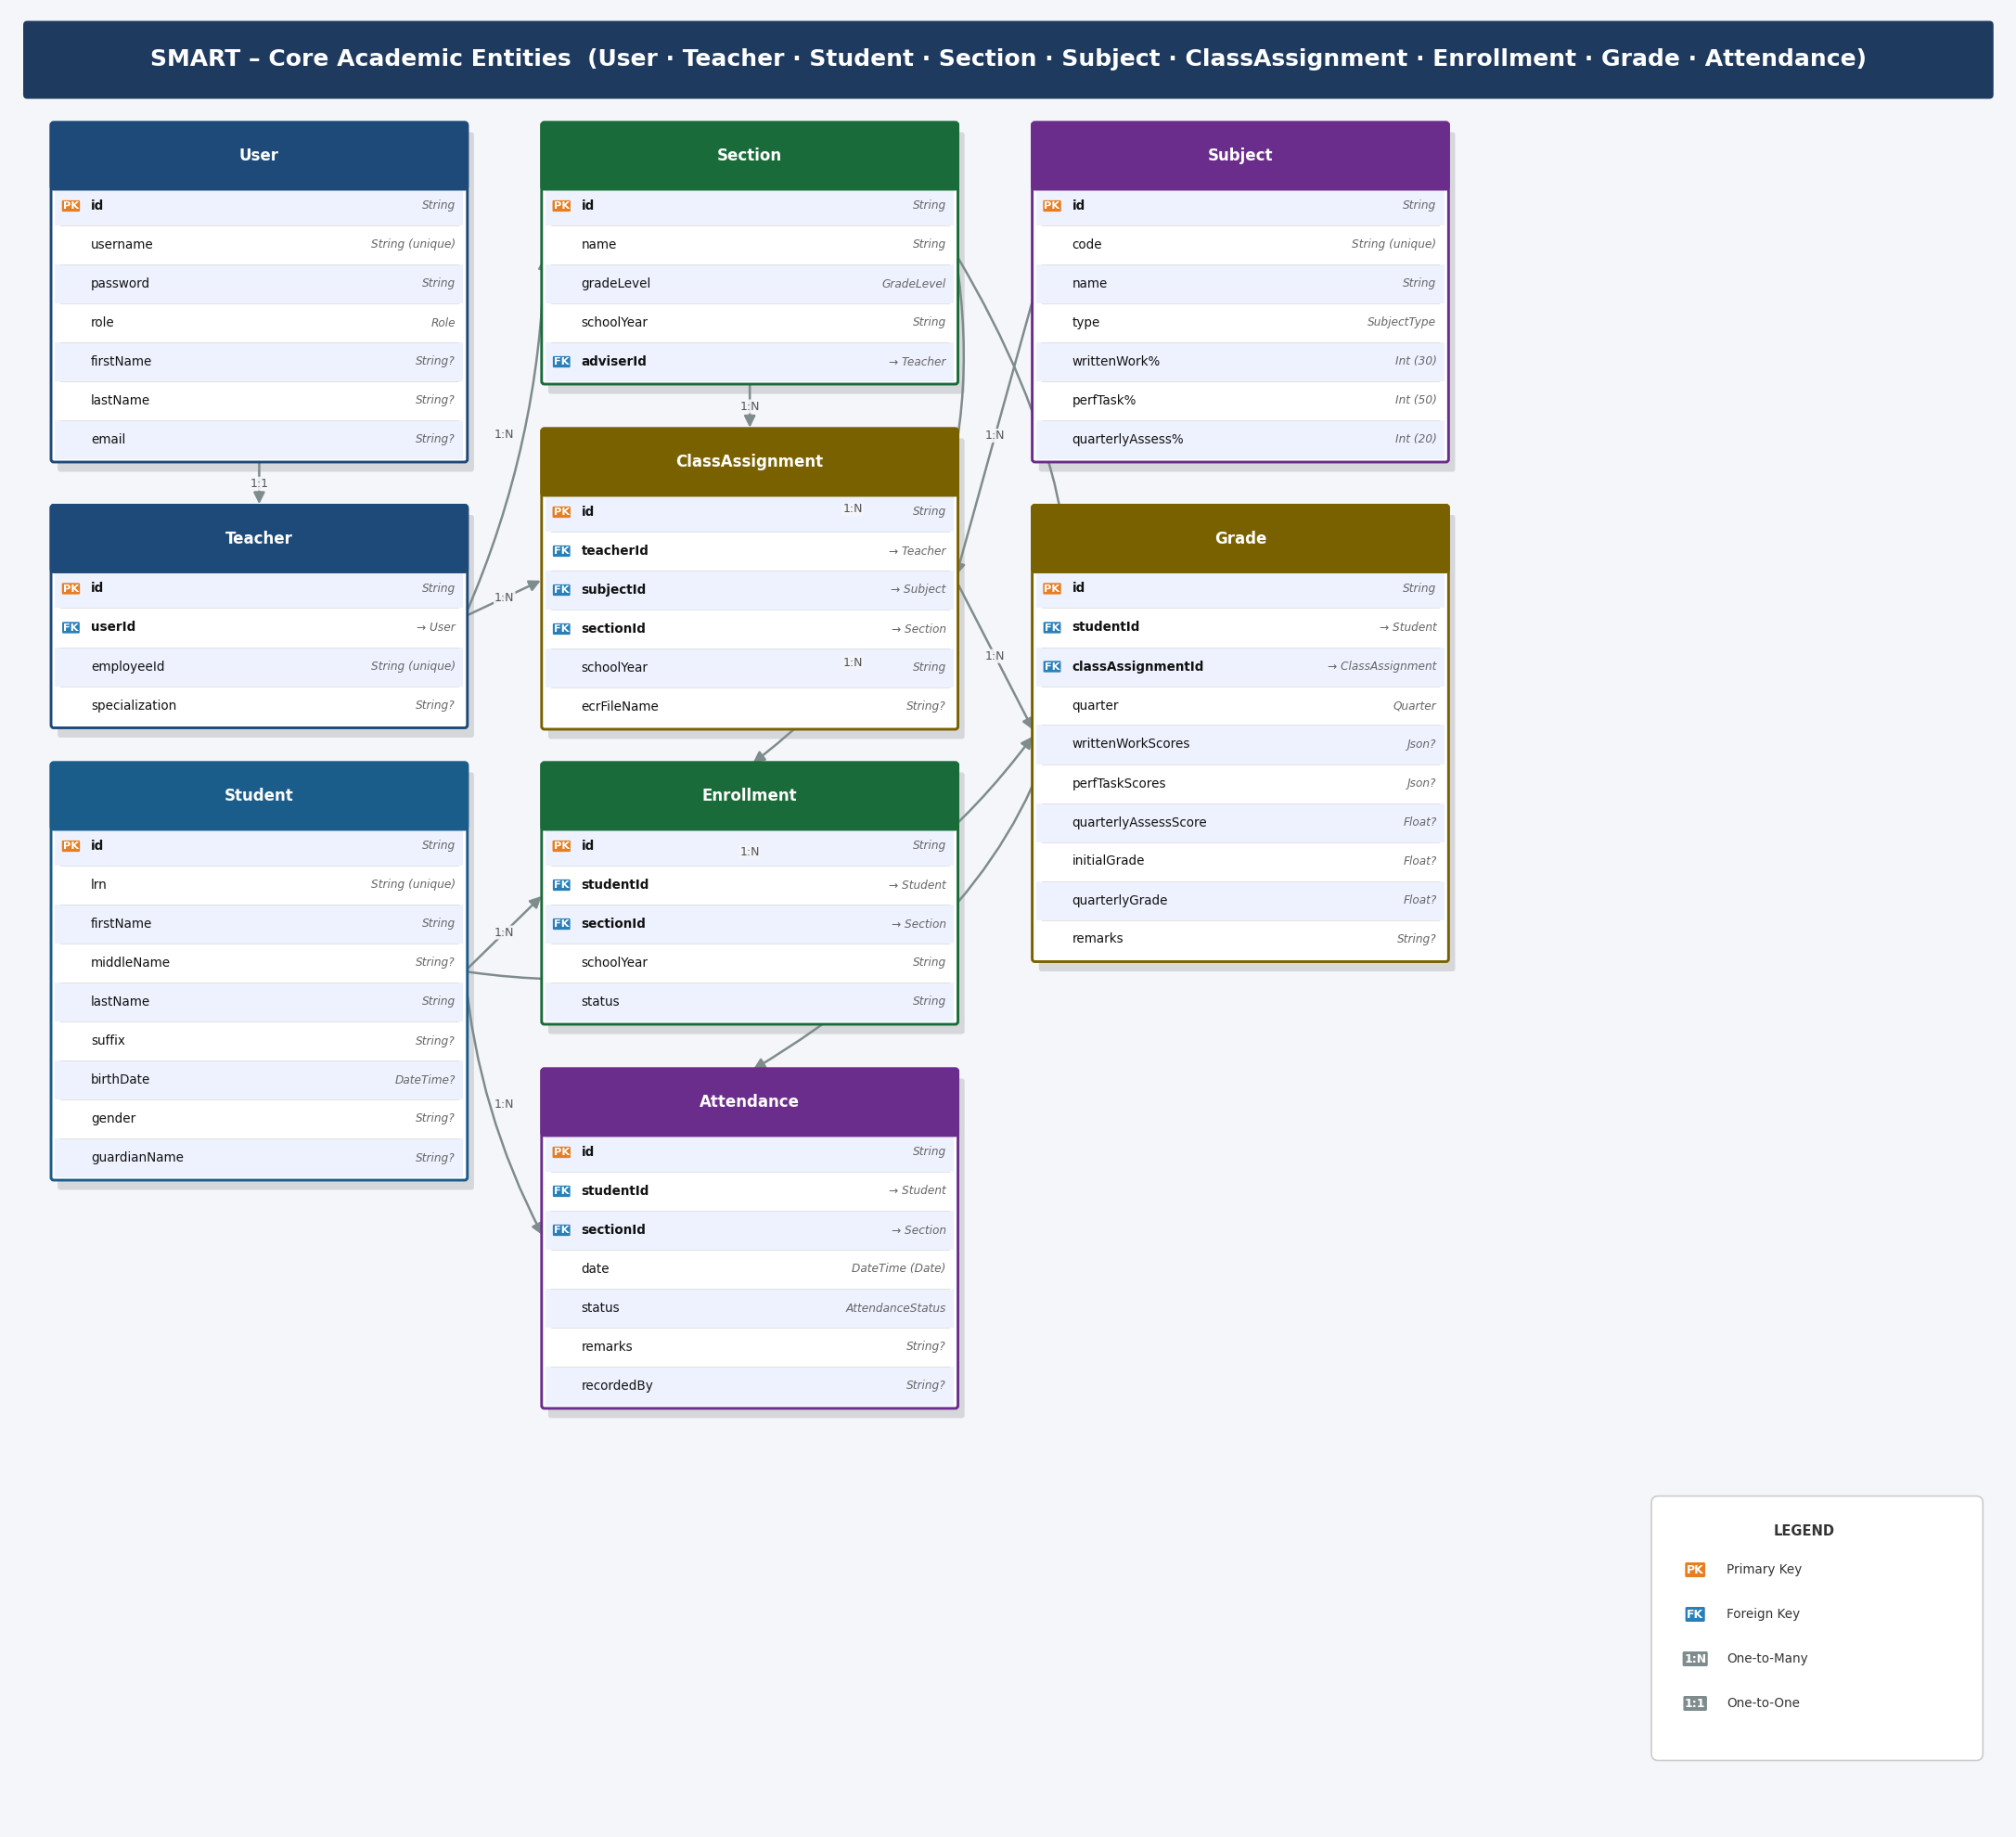

2. Configuration & Administration Entities — ERD Diagram
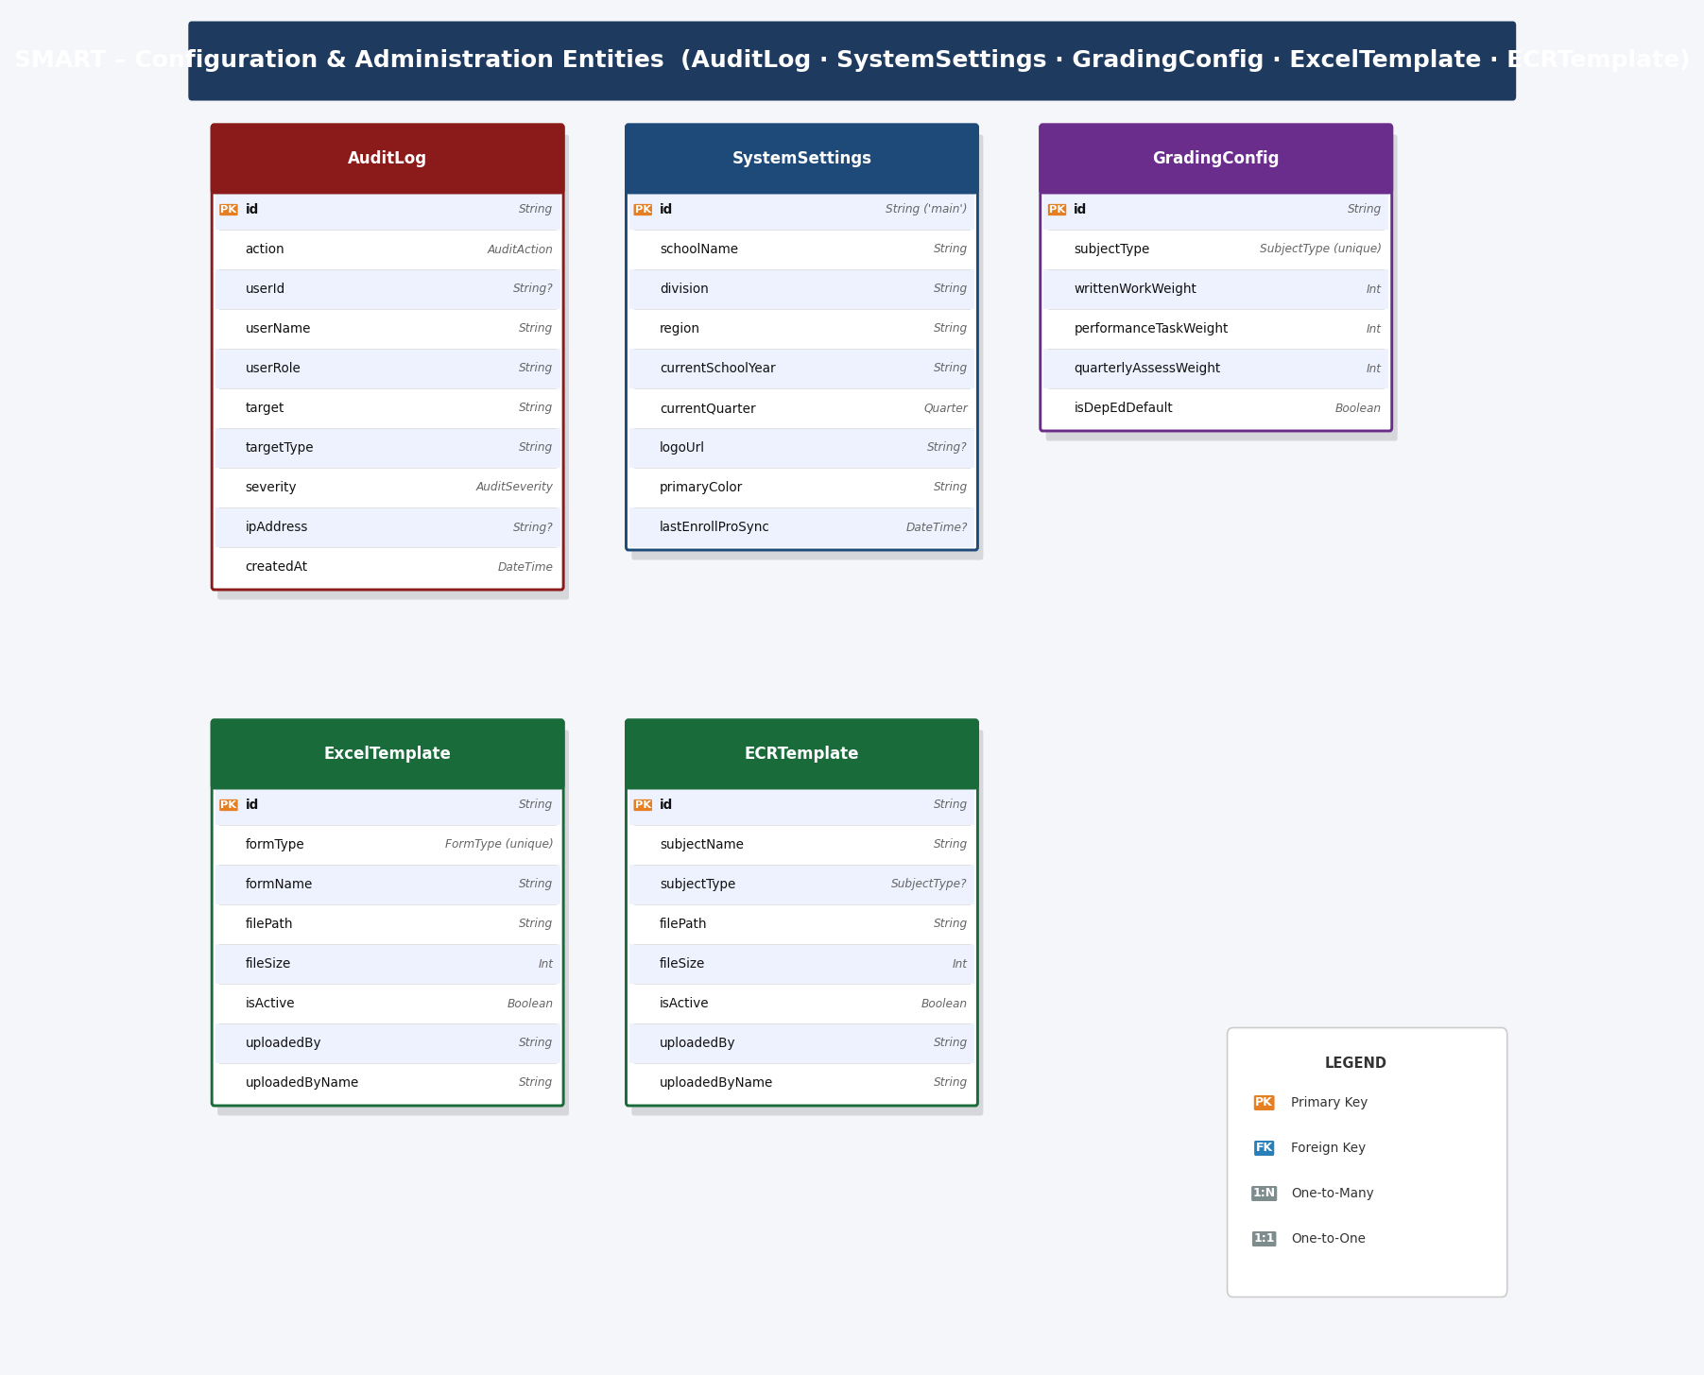

3. Entity Summary
Entity | Fields | Description
User | 9 | System user accounts. All authenticated users (teacher, admin, registrar) have a User record.
Teacher | 6 | Teacher profile linked 1-to-1 with a User. Holds the DepEd employee ID.
Student | 13 | Student records identified by LRN (Learner Reference Number).
Section | 8 | Class sections (e.g. Grade 8-3 MAKAKALIKASAN) scoped by school year.
Subject | 10 | Academic subjects with DepEd grading component weights.
ClassAssignment | 10 | Maps one teacher to one subject in one section for a given school year.
Enrollment | 8 | Records a student's enrollment in a section for a given school year.
Grade | 17 | Quarterly grade record per student per class assignment.
Attendance | 10 | Daily attendance record per student per section.
AuditLog | 13 | Immutable audit trail for all security-relevant actions in the system. Links to User when the actor still exists.
SystemSettings | 30 | Singleton record (id='main') holding school-wide configuration.
GradingConfig | 8 | DepEd grading component weights per subject type (overridable per school).
ExcelTemplate | 15 | DepEd School Form templates (SF1–SF10) uploaded by a User for Excel export generation.
ECRTemplate | 14 | Excel Class Record (ECR) templates per subject, uploaded by a User for grade export.

4. Entity Field Details

User
Key | Field Name | Type | Description
PK | id | String | Unique identifier (CUID)
 | username | String | Unique login username
 | password | String | Bcrypt-hashed password
 | role | Role | TEACHER | ADMIN | REGISTRAR
 | firstName | String? | First name
 | lastName | String? | Last name
 | email | String? | Email address
 | createdAt | DateTime | Record created timestamp
 | updatedAt | DateTime | Record last updated timestamp

Teacher
Key | Field Name | Type | Description
PK | id | String | Unique identifier
FK | userId | String | → User.id (cascade delete)
 | employeeId | String | DepEd Employee ID (unique)
 | specialization | String? | Teaching specialization
 | createdAt | DateTime | Record created timestamp
 | updatedAt | DateTime | Record last updated timestamp

Student
Key | Field Name | Type | Description
PK | id | String | Unique identifier
 | lrn | String | Learner Reference Number (unique)
 | firstName | String | First name
 | middleName | String? | Middle name
 | lastName | String | Last name
 | suffix | String? | Name suffix (Jr., III, etc.)
 | birthDate | DateTime? | Date of birth
 | gender | String? | Male / Female
 | address | String? | Home address
 | guardianName | String? | Parent / guardian full name
 | guardianContact | String? | Parent / guardian contact number
 | createdAt | DateTime | Record created timestamp
 | updatedAt | DateTime | Record last updated timestamp

Section
Key | Field Name | Type | Description
PK | id | String | Unique identifier
 | name | String | Section name (e.g. 8-3 MAKAKALIKASAN)
 | gradeLevel | GradeLevel | GRADE_7 | GRADE_8 | GRADE_9 | GRADE_10
 | schoolYear | String | School year label (e.g. 2026-2027)
FK | adviserId | String? | → Teacher.id (class adviser, nullable)
 | createdAt | DateTime | Record created timestamp
 | updatedAt | DateTime | Record last updated timestamp
 | [unique] |  | UNIQUE (name, gradeLevel, schoolYear)

Subject
Key | Field Name | Type | Description
PK | id | String | Unique identifier
 | code | String | Subject code, unique (e.g. FIL7)
 | name | String | Full subject name
 | description | String? | Optional description
 | type | SubjectType | CORE | MAPEH | TLE | MATH_SCIENCE
 | writtenWorkWeight | Int | Written work % weight (default 30)
 | perfTaskWeight | Int | Performance task % weight (default 50)
 | quarterlyAssessWeight | Int | Quarterly assessment % weight (default 20)
 | createdAt | DateTime | Record created timestamp
 | updatedAt | DateTime | Record last updated timestamp

ClassAssignment
Key | Field Name | Type | Description
PK | id | String | Unique identifier
FK | teacherId | String | → Teacher.id (cascade delete)
FK | subjectId | String | → Subject.id (cascade delete)
FK | sectionId | String | → Section.id (cascade delete)
 | schoolYear | String | School year label (e.g. 2026-2027)
 | ecrFileName | String? | Linked ECR template filename
 | ecrLastSyncedAt | DateTime? | Last ECR template sync timestamp
 | createdAt | DateTime | Record created timestamp
 | updatedAt | DateTime | Record last updated timestamp
 | [unique] |  | UNIQUE (teacherId, subjectId, sectionId, schoolYear)

Enrollment
Key | Field Name | Type | Description
PK | id | String | Unique identifier
FK | studentId | String | → Student.id (cascade delete)
FK | sectionId | String | → Section.id (cascade delete)
 | schoolYear | String | School year label (e.g. 2026-2027)
 | status | String | ENROLLED | WITHDRAWN | TRANSFERRED | etc.
 | createdAt | DateTime | Record created timestamp
 | updatedAt | DateTime | Record last updated timestamp
 | [unique] |  | UNIQUE (studentId, sectionId, schoolYear)

Grade
Key | Field Name | Type | Description
PK | id | String | Unique identifier
FK | studentId | String | → Student.id (cascade delete)
FK | classAssignmentId | String | → ClassAssignment.id (cascade delete)
 | quarter | Quarter | Q1 | Q2 | Q3 | Q4
 | writtenWorkScores | Json? | Array of {name, score, maxScore}
 | perfTaskScores | Json? | Array of {name, score, maxScore}
 | quarterlyAssessScore | Float? | Raw quarterly assessment score
 | quarterlyAssessMax | Float? | Max score for quarterly assessment (default 100)
 | writtenWorkPS | Float? | Written work percentage score
 | perfTaskPS | Float? | Performance task percentage score
 | quarterlyAssessPS | Float? | Quarterly assessment percentage score
 | initialGrade | Float? | Calculated initial grade
 | quarterlyGrade | Float? | Final quarterly grade (rounded)
 | remarks | String? | Passed | Failed | Incomplete | etc.
 | createdAt | DateTime | Record created timestamp
 | updatedAt | DateTime | Record last updated timestamp
 | [unique] |  | UNIQUE (studentId, classAssignmentId, quarter)

Attendance
Key | Field Name | Type | Description
PK | id | String | Unique identifier
FK | studentId | String | → Student.id (cascade delete)
FK | sectionId | String | → Section.id (cascade delete)
 | date | DateTime (Date) | Attendance date (date only, no time)
 | status | AttendanceStatus | PRESENT | ABSENT | LATE | EXCUSED
 | remarks | String? | Optional remark / reason
 | recordedBy | String? | User ID of teacher who recorded attendance
 | createdAt | DateTime | Record created timestamp
 | updatedAt | DateTime | Record last updated timestamp
 | [unique] |  | UNIQUE (studentId, sectionId, date)

AuditLog
Key | Field Name | Type | Description
PK | id | String | Unique identifier
 | action | AuditAction | CREATE | UPDATE | DELETE | LOGIN | LOGOUT | CONFIG
FK | userId | String? | Optional actor user ID (FK to User.id, null for system or legacy actions)
 | userName | String | Actor display name
 | userRole | String | Actor role at time of action
 | target | String | Human-readable description of affected entity
 | targetType | String | Entity type (e.g. Student, Grade, Section)
 | targetId | String? | Affected record ID
 | details | String | Human-readable action description
 | ipAddress | String? | Client IP address
 | severity | AuditSeverity | INFO | WARNING | CRITICAL
 | metadata | Json? | Additional structured payload
 | createdAt | DateTime | Event timestamp

SystemSettings
Key | Field Name | Type | Description
PK | id | String | Fixed primary key: 'main'
 | schoolName | String | Official school name
 | schoolId | String | DepEd school ID
 | division | String | DepEd division
 | region | String | DepEd region
 | address | String? | School address
 | contactNumber | String? | School contact number
 | email | String? | School email
 | currentSchoolYear | String | Active school year (e.g. 2026-2027)
 | currentQuarter | Quarter | Active grading quarter (Q1–Q4)
 | logoUrl | String? | Path to school logo file
 | primaryColor | String | Brand primary colour (hex)
 | secondaryColor | String | Brand secondary colour (hex)
 | accentColor | String | Brand accent colour (hex)
 | sessionTimeout | Int | Session timeout in minutes
 | maxLoginAttempts | Int | Max failed login attempts before lock
 | passwordMinLength | Int | Minimum password length
 | requireSpecialChar | Boolean | Require special character in password
 | autoAdvanceQuarter | Boolean | Auto-advance quarter on end date
 | lastEnrollProSync | DateTime? | Last EnrollPro branding sync timestamp
 | q1StartDate | DateTime? | Q1 start date
 | q1EndDate | DateTime? | Q1 end date
 | q2StartDate | DateTime? | Q2 start date
 | q2EndDate | DateTime? | Q2 end date
 | q3StartDate | DateTime? | Q3 start date
 | q3EndDate | DateTime? | Q3 end date
 | q4StartDate | DateTime? | Q4 start date
 | q4EndDate | DateTime? | Q4 end date
 | createdAt | DateTime | Record created timestamp
 | updatedAt | DateTime | Record last updated timestamp

GradingConfig
Key | Field Name | Type | Description
PK | id | String | Unique identifier
 | subjectType | SubjectType | CORE | MAPEH | TLE | MATH_SCIENCE (unique)
 | writtenWorkWeight | Int | Written work component % weight
 | performanceTaskWeight | Int | Performance task component % weight
 | quarterlyAssessWeight | Int | Quarterly assessment component % weight
 | isDepEdDefault | Boolean | True if using DepEd standard weights
 | createdAt | DateTime | Record created timestamp
 | updatedAt | DateTime | Record last updated timestamp

ExcelTemplate
Key | Field Name | Type | Description
PK | id | String | Unique identifier
 | formType | FormType | SF1–SF10 (unique per form type)
 | formName | String | Display name (e.g. School Form 1)
 | description | String? | Template description
 | filePath | String | Absolute server-side file path
 | fileName | String | Original uploaded filename
 | fileSize | Int | File size in bytes
 | placeholders | Json? | Array of placeholder keys in the template
 | instructions | String? | Usage instructions for this template
 | isActive | Boolean | Whether template is active / in use
 | sheetName | String? | Target Excel sheet name for injection
FK | uploadedBy | String | Uploader user ID (FK to User.id)
 | uploadedByName | String | Display name of uploader
 | createdAt | DateTime | Record created timestamp
 | updatedAt | DateTime | Record last updated timestamp

ECRTemplate
Key | Field Name | Type | Description
PK | id | String | Unique identifier
 | subjectName | String | Subject display name
 | description | String? | Template description
 | filePath | String | Absolute server-side file path
 | fileName | String | Original uploaded filename
 | fileSize | Int | File size in bytes
 | placeholders | Json? | Array of placeholder keys in the template
 | instructions | String? | Usage instructions
 | isActive | Boolean | Whether template is active / in use
 | subjectType | SubjectType? | Optional subject type classification
FK | uploadedBy | String | Uploader user ID (FK to User.id)
 | uploadedByName | String | Display name of uploader
 | createdAt | DateTime | Record created timestamp
 | updatedAt | DateTime | Record last updated timestamp

5. Relationships Summary
From Entity | Cardinality | To Entity | Relationship Description | FK Field
User | 1 : 1 | Teacher | User has one Teacher profile | Teacher.userId → User.id
User | 1 : N | AuditLog | User can create many audit log entries | AuditLog.userId → User.id
User | 1 : N | ExcelTemplate | User can upload many SF templates | ExcelTemplate.uploadedBy → User.id
User | 1 : N | ECRTemplate | User can upload many ECR templates | ECRTemplate.uploadedBy → User.id
Teacher | 1 : N | Section | Teacher advises one or more Sections | Section.adviserId → Teacher.id
Teacher | 1 : N | ClassAssignment | Teacher has many Class Assignments | ClassAssignment.teacherId → Teacher.id
Subject | 1 : N | ClassAssignment | Subject used in many Class Assignments | ClassAssignment.subjectId → Subject.id
Section | 1 : N | ClassAssignment | Section has many Class Assignments | ClassAssignment.sectionId → Section.id
Section | 1 : N | Enrollment | Section has many Enrollments | Enrollment.sectionId → Section.id
Student | 1 : N | Enrollment | Student has many Enrollments | Enrollment.studentId → Student.id
Student | 1 : N | Grade | Student has many Grade records | Grade.studentId → Student.id
Student | 1 : N | Attendance | Student has many Attendance records | Attendance.studentId → Student.id
Section | 1 : N | Attendance | Section has many Attendance records | Attendance.sectionId → Section.id
ClassAssignment | 1 : N | Grade | Class Assignment has many Grades | Grade.classAssignmentId → ClassAssignment.id

6. Enumeration Types
Enum Name | Allowed Values
Role | TEACHER | ADMIN | REGISTRAR
Quarter | Q1 | Q2 | Q3 | Q4
GradeLevel | GRADE_7 | GRADE_8 | GRADE_9 | GRADE_10
SubjectType | CORE | MAPEH | TLE | MATH_SCIENCE
AttendanceStatus | PRESENT | ABSENT | LATE | EXCUSED
AuditAction | CREATE | UPDATE | DELETE | LOGIN | LOGOUT | CONFIG
AuditSeverity | INFO | WARNING | CRITICAL
FormType | SF1 | SF2 | SF3 | SF4 | SF5 | SF6 | SF7 | SF8 | SF9 | SF10

