February 16, 2015

Dear Sir or Madam,

We would like to thank the Editor, Associate Editor and reviewers for their comments and recommendations on this submission. The changes addressing the reviewer comments have strengthened the paper in the following ways:

1. Discussing recent literature on the topic of validated brain extraction in CT and discussing previous literature more in detail.
2. Adding a second reader to assess the robustness of our results to a different gold standard.
3. Using this second reader’s manual segmentation to assess the consistency of manual segmentation of brain tissue in CT.
4. Adding a description of the FI parameter that was varied in the BET algorithm.
5. Discussing the potential generalizability of our proposed method to other populations than those analyzed.

Thank you for your consideration.

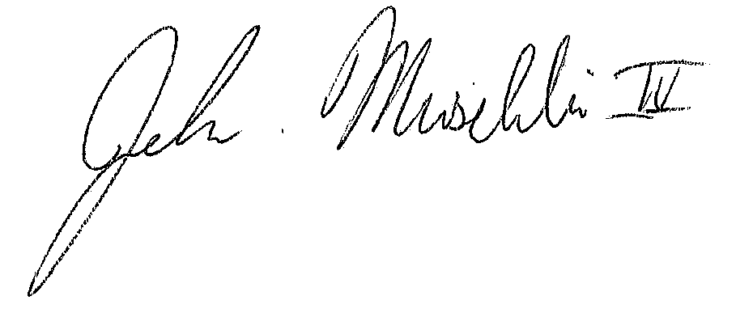

John Muschelli, ScM

PhD Candidate

Department of Biostatistics

Johns Hopkins Bloomberg School of Public Health