SBD Deployment Pipeline

Deployment plan check-in bypass for code-only changes
This document describes the current SBD deployment trigger process, the limitation raised by the development team, and the proposed alternative that removes the need for a deployment plan (DP) check-in when only code has changed and the DP itself is unmodified.

1. Background
Deployments are driven by a CHANGEID.xml deployment plan (DP), which contains the application, file paths, target servers, and environment details for a given change. Today, a deployment is initiated only when a DP is checked in to the Git-Blit repository with a commit message tagged {sbd-deploy:CHANGEID.xml}. A post-commit hook detects this tag and triggers the SBD-ETL-MODEL-RELEASE job, which parses the DP and populates the CI/CD build queue for approval.
Concern raised: when a change only involves code (no DP modification), the team is still required to check in the DP - typically as a no-op commit - purely to fire the post-commit hook. This adds an unnecessary step and creates confusing commit history.

2. Existing process
The existing flow depends entirely on a fresh commit to trigger the pipeline. The core trigger logic (function getTriggerDetails) runs git log --grep against the {sbd-deploy:...} tag to find the commit that should be processed.
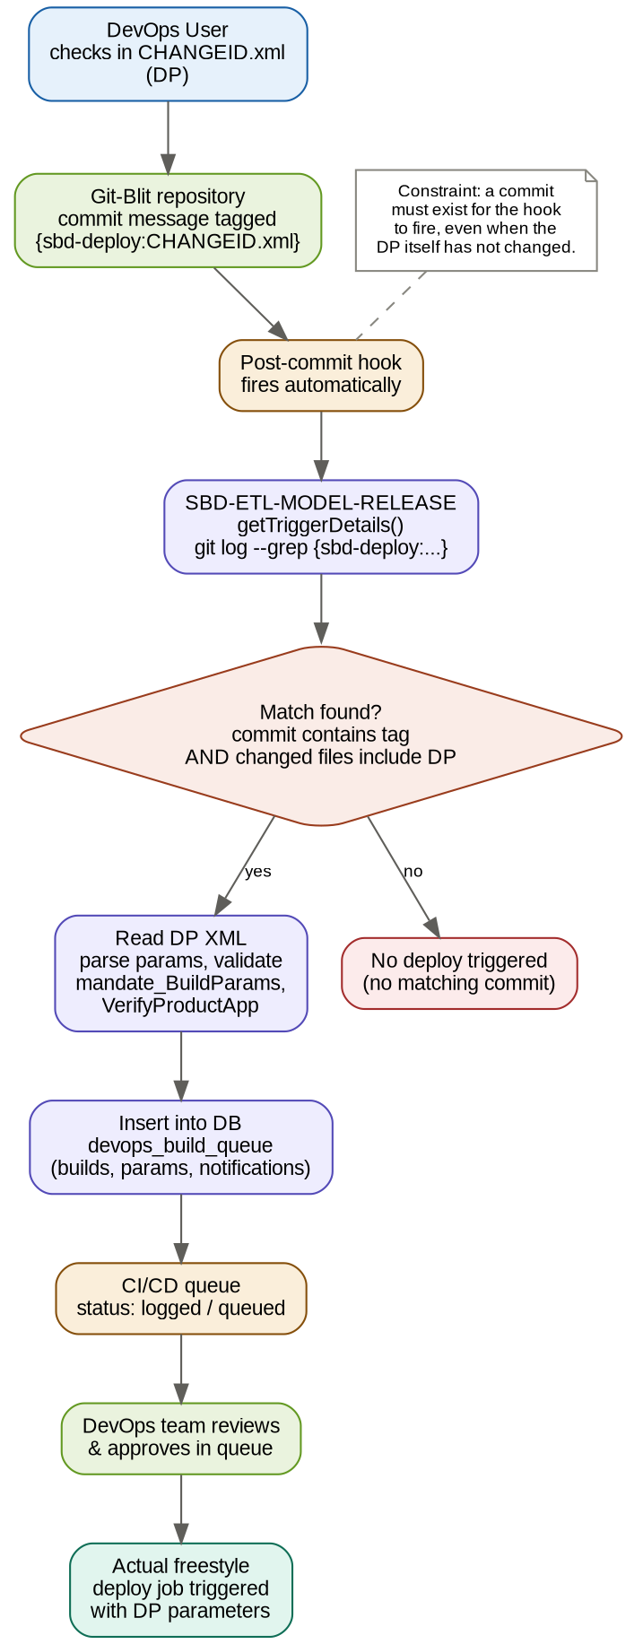

2.1 Key steps
- DevOps user checks in CHANGEID.xml with the {sbd-deploy:CHANGEID.xml} tag in the commit message.
- Git-Blit's post-commit hook fires and calls SBD-ETL-MODEL-RELEASE.
- getTriggerDetails() searches recent git log entries for a commit matching the tag.
- If found, the DP filename is extracted and cross-checked against the commit's changed files.
- The DP XML is read, parameters are parsed and validated (mandate_BuildParams, VerifyProductApp).
- Commit metadata (hash, author, email, timestamp, files, message) and DP parameters are inserted into devops_build_queue (builds, params, notifications).
- The entry appears in the CI/CD approval queue; once approved, the actual freestyle deploy job runs.

2.2 Limitation
Every trigger requires a real commit, because the search logic is git-log based. There is no path to re-run this process using only a CHANGE_ID when the DP has not changed.

3. Proposed process
A new job, Deploy-Trigger-ByChangeID, accepts only CHANGE_ID (and ENV) as input. It reads the already checked-in DP directly from the repository - no commit required - and reuses the exact same parameter-parsing, validation, and database-insert logic already used by SBD-ETL-MODEL-RELEASE.
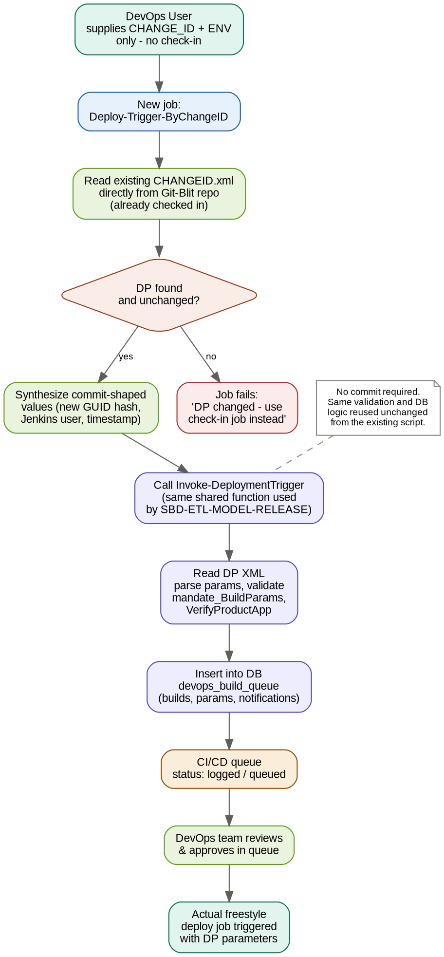

3.1 Key steps
- DevOps user runs Deploy-Trigger-ByChangeID with CHANGE_ID and ENV - no check-in.
- The job reads the existing CHANGEID.xml directly from the Git-Blit repository path.
- A staleness check confirms the DP has not changed since its last recorded run for this CHANGE_ID; if it has changed, the job fails and directs the user to the check-in job instead.
- Commit-shaped metadata is synthesized in place of real git log values:
  - c_hash: a newly generated GUID, to avoid colliding with any real or prior commit hash
  - c_name / c_email: the Jenkins build user who triggered the job
  - c_datetime: the current timestamp
  - c_files: the DP filename itself, satisfying the existing file-consistency check
  - c_message: a descriptive note, e.g. "Manual re-trigger via Deploy-Trigger-ByChangeID (no DP change)"
- These values are passed into the existing Invoke-DeploymentTrigger function - the same function SBD-ETL-MODEL-RELEASE already calls - so parameter parsing, mandate_BuildParams validation, VerifyProductApp, and the DB insert are all reused unchanged.
- The resulting entry appears in the same CI/CD approval queue, in the same way, and follows the same approval and deploy flow as today.

3.2 What does not change
- The DP file format and its parameters.
- The mandate_BuildParams validation rules.
- The VerifyProductApp product/application check.
- The database schema and insert logic (devops_build_queue, .params, .notifications_queue).
- The DevOps approval queue and the downstream freestyle deploy job.

3.3 What changes
- A new job accepts CHANGE_ID (+ ENV) and skips the git-log search entirely.
- Commit metadata is synthesized rather than read from git, since no commit occurs.
- A new staleness check guards against using this path when the DP has actually changed.
- The check-in job (existing process) remains unchanged and is still used for initial deployments or DP modifications.

4. Side-by-side comparison
Aspect | Existing process (DP check-in required) | Proposed process (Deploy-Trigger-ByChangeID)
Trigger | Commit to Git-Blit repo with commit message tagged {sbd-deploy:CHANGEID.xml} | Manual Jenkins job run with CHANGE_ID and ENV parameters; no commit needed
Precondition | A new commit must exist, even if the DP content is unchanged | DP must already exist in the repo and be unchanged since its last run
Detection logic | getTriggerDetails() runs git log --grep to find matching commits | Job reads the DP file directly from the repo path; no git-log search
Commit metadata | Real values from git log: hash, author, email, timestamp, files, message | Synthesized values: new GUID as hash, Jenkins build user, current timestamp, DP filename as files
DP validation | Confirms DP filename appears in the commit's changed files | Confirms DP file exists on disk and has not changed since last recorded run (new staleness check)
Param parsing & DB insert | Invoke-DeploymentTrigger: parses XML params, validates mandate_BuildParams, calls VerifyProductApp, inserts into devops_build_queue | Same Invoke-DeploymentTrigger function, called directly - logic is fully reused, not duplicated
Approval queue | Entry appears in CI/CD queue with status logged / queued | Identical - entry appears in the same queue in the same way
Downstream deploy job | Actual freestyle deploy job triggered after approval | Identical - same freestyle job, same parameters
When to use | Initial deployment, or when the DP itself needs modification | Code-only changes where the DP is already correct and unchanged

5. Items to confirm before implementation
- Where the DP repository is checked out / accessible for a read-only fetch by the new job.
- Whether any downstream reporting or audit view joins on c_hash back to real git commit history - synthetic GUIDs will not resolve there, so these rows should be visually flagged (via c_message) in the approval queue.
- Confirming the exact staleness comparison method (e.g. file hash or DP version stored at last successful run) against the DB record for that CHANGE_ID.
- Access control for the new job, since it can trigger a deployment without going through the DP check-in review step.

