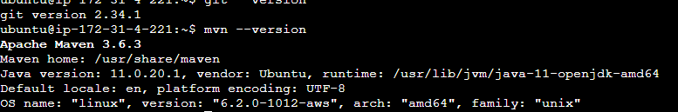

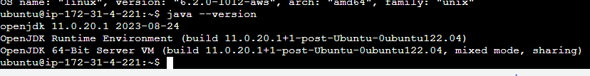

How to create a job in cicd

Step-1:

Click on new item

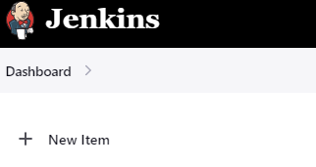

Step-2: Enter an item name

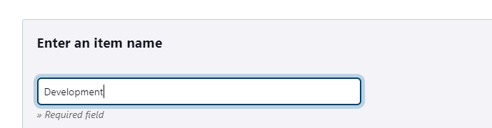

Step-3:Click on free style project and then click ok

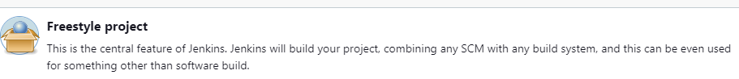

Based on the above steps job is getting created.

Then go to the github repository as the developers will dump the code

Go that project

Click on the project

Go to code

U will get the URL

Go to the source code mgmt(the server where the code is uploaded)

Then click on GIT

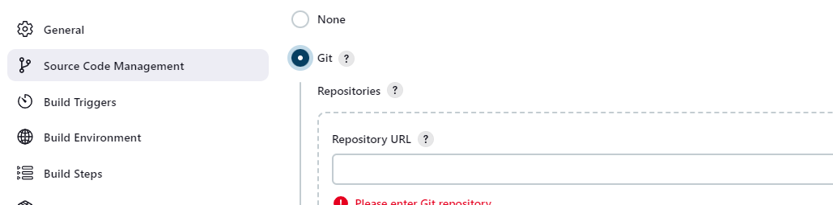

Paste the URL in the Repository URL and click on Apply and then Save

Then go to the dashboard

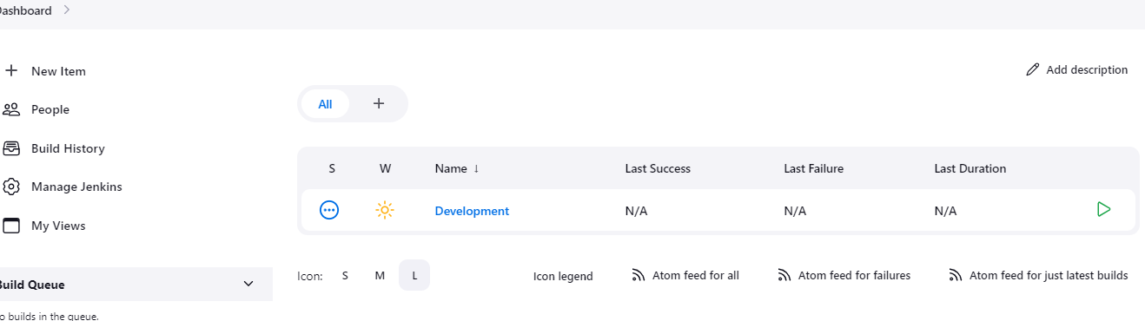

It will download a code which was present in the git repository to a jenkin server.

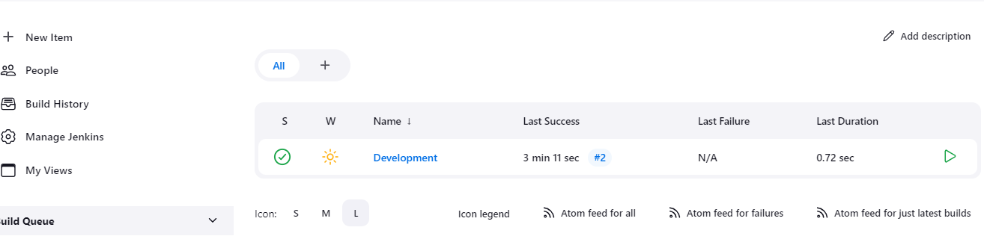

Click 

Click on the number in the last success u will get the console output

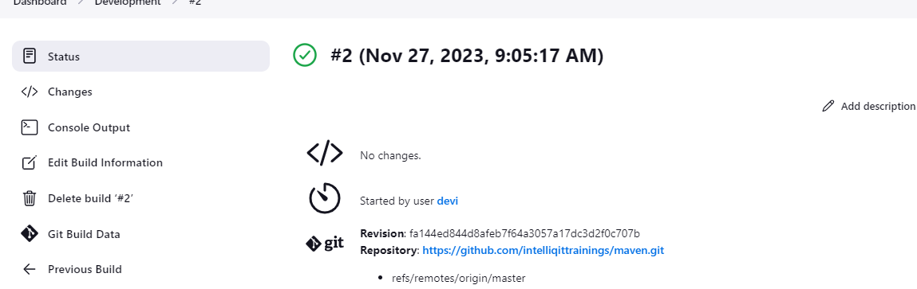

It is the location where the logs of Jenkins were present.

The next step is converting the code into set up file using maven

Under development->click on configure

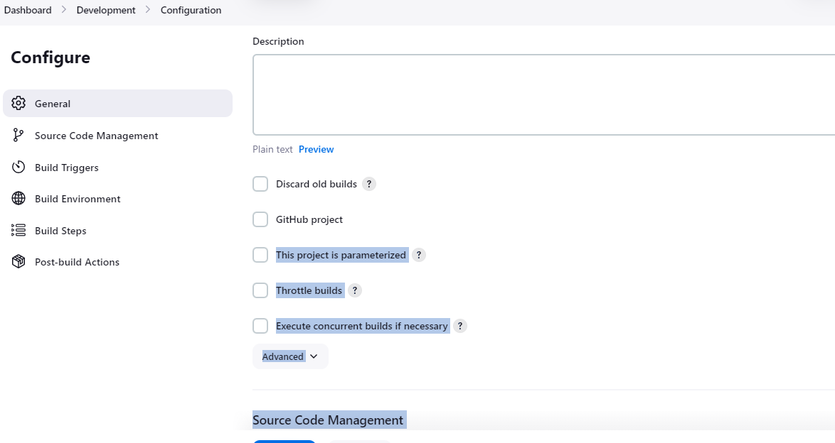

Click on Build steps->add build step->click on Invoke top-level Maven Targets

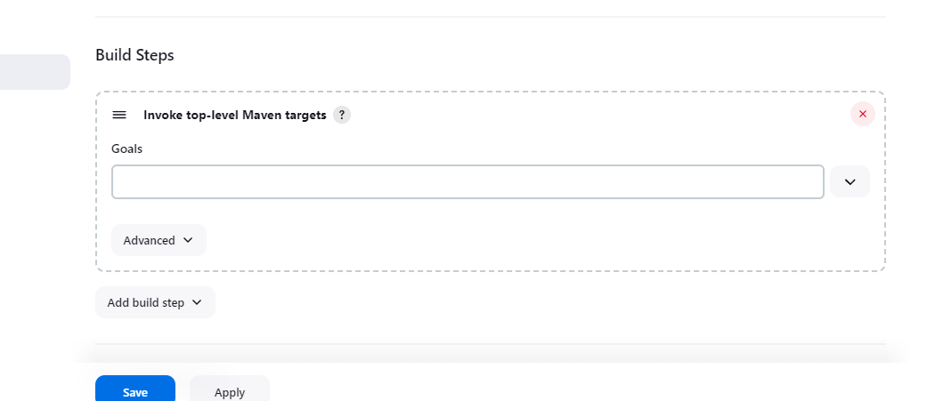

Under goals write the word package and save

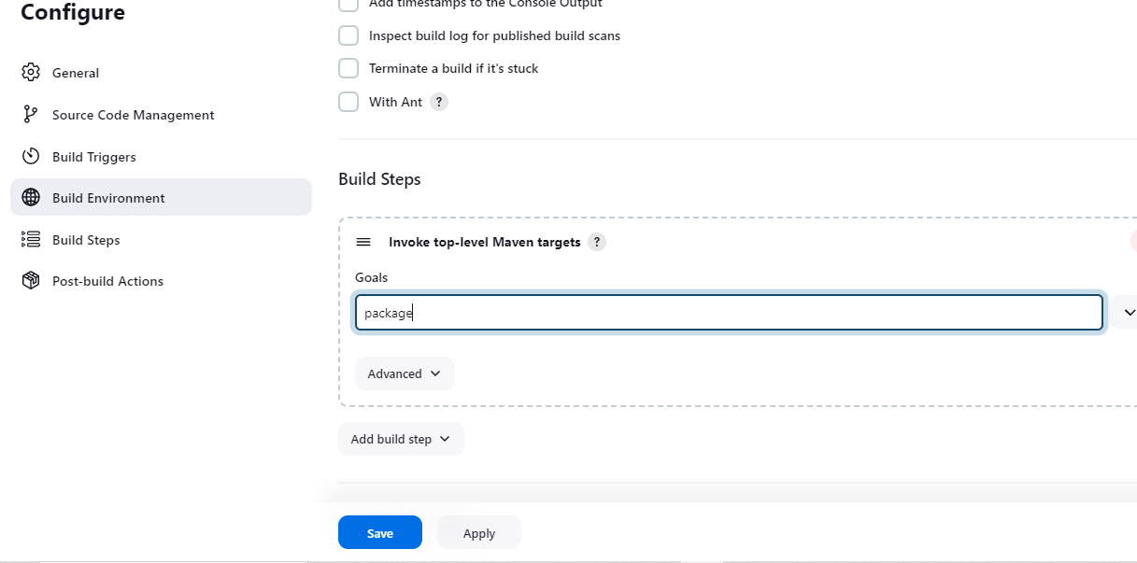

Go back to dashboard and execute the job

It is downloading the code and the same time it is converting the code into a setup file(artifact)

Go to console output and check the logs.

Deploy to container pulgin->need to deploy into the tomcat. It should be done manually.

Dashboard->manage Jenkins

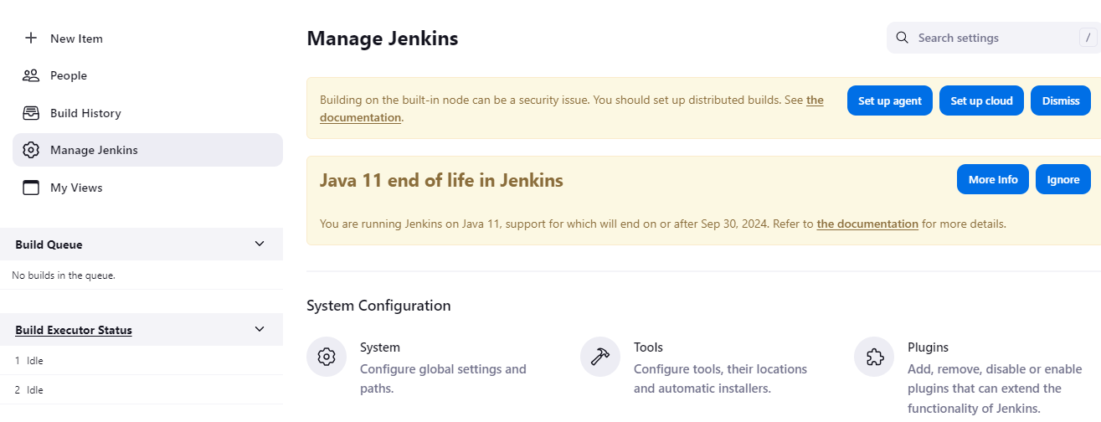

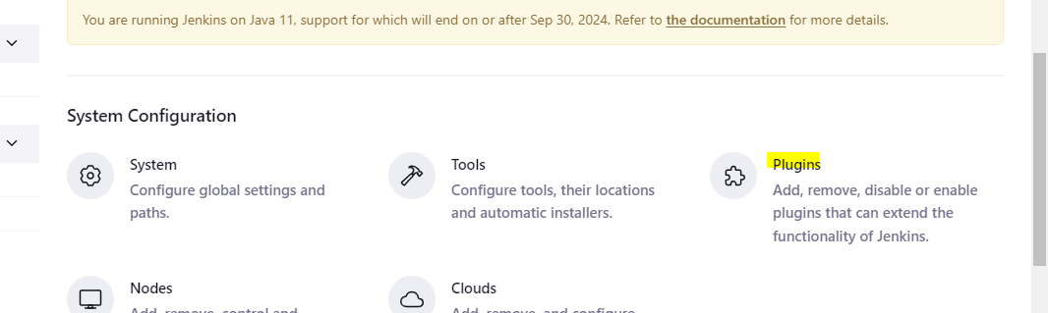

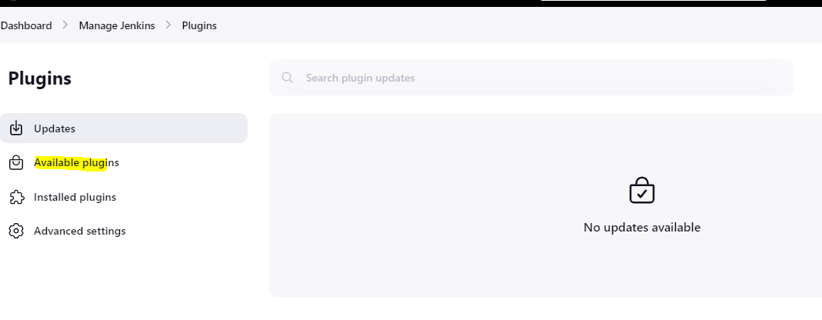

Search for deploy to container

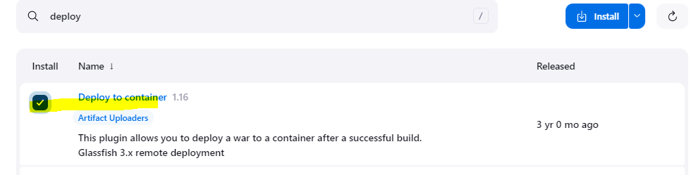

Click on install

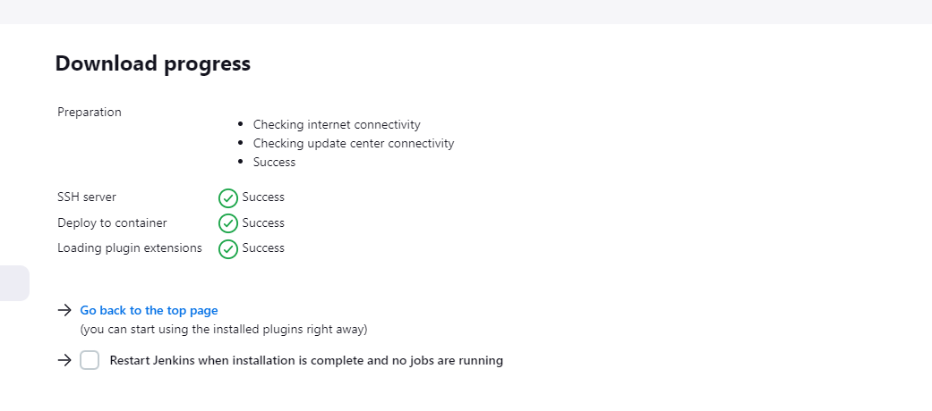

Jenkins will co-ordinate with tomcat

Go to dashboard-configure->post-build actions

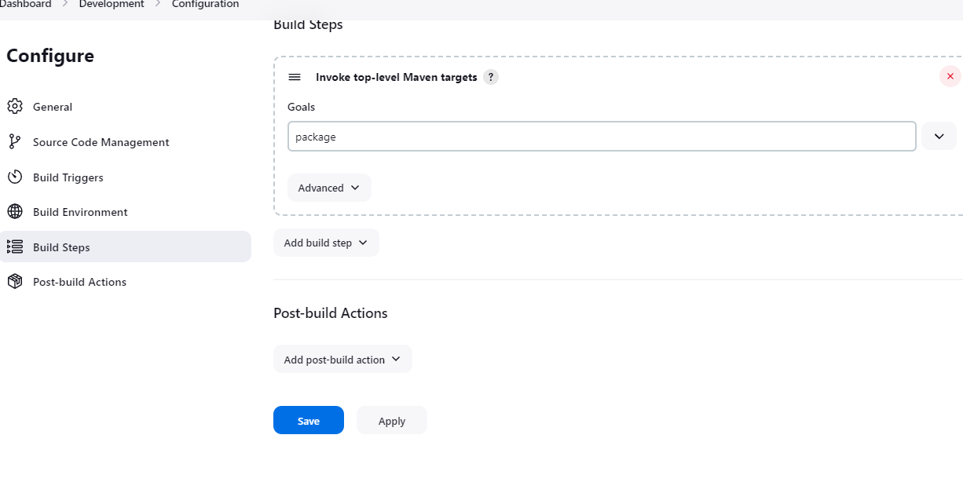

Under add post-build action click on deploy to container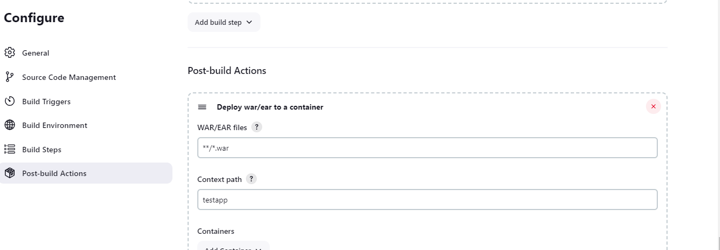

\*\* includes the to search the files in the development, \*-file name, .war-file extension

Context path: the tester should name the application inorder to access by the users.

Click on add container

Search for tomcat 9

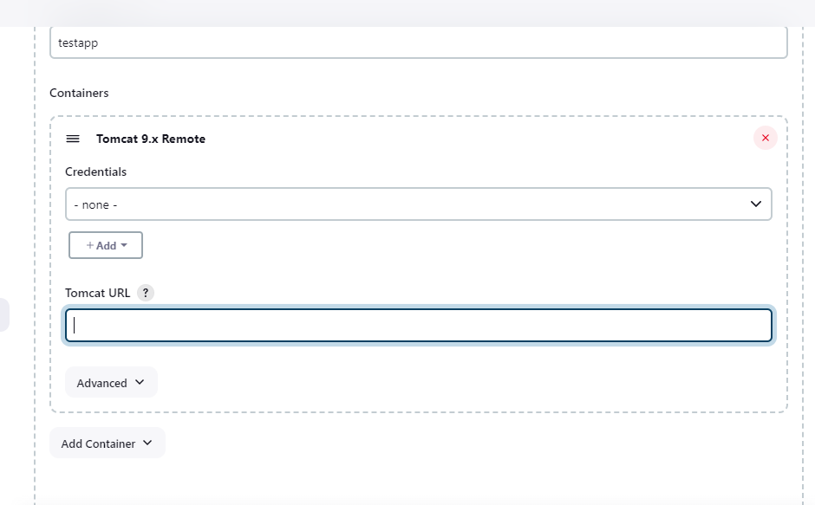

Enter admin and pwd after

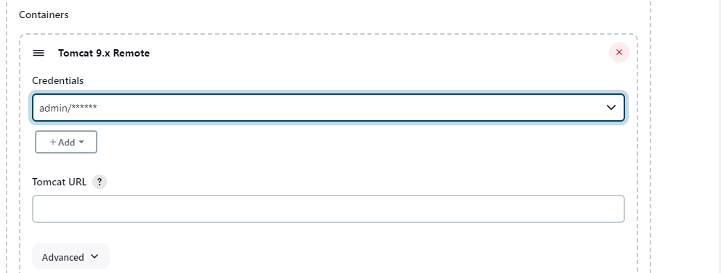

Jenkins is deploying into the QA server so need to take the private ip

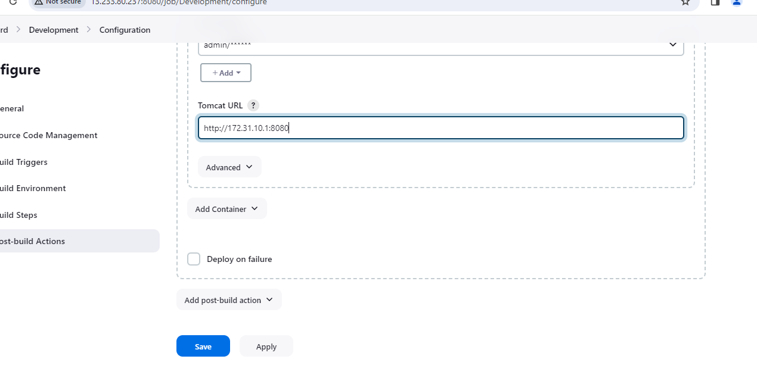

Need to perform the testing for an application

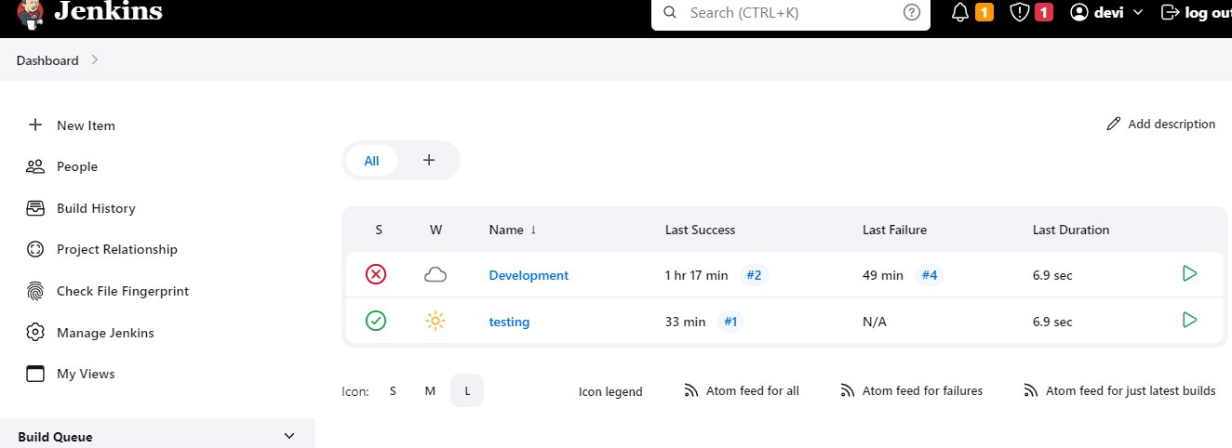

Go to configure ->build Steps->add build steps->select execute shell

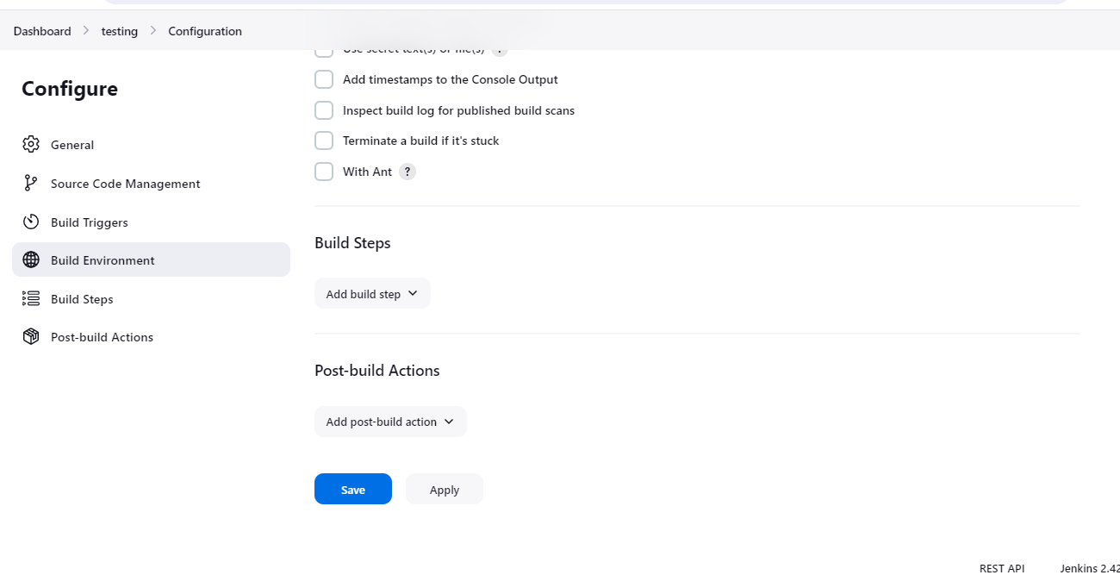

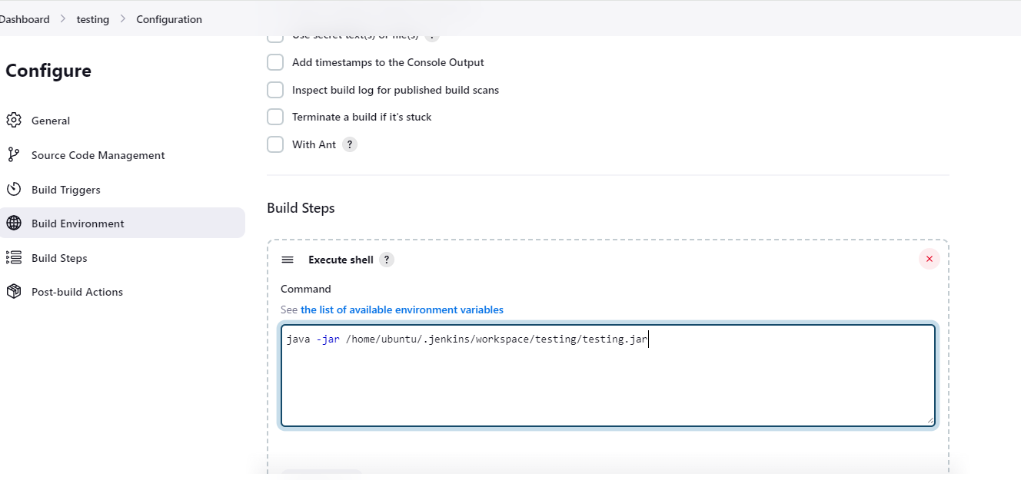

Development job will perform the first 3 stages of CICD and will move to testing job. Once the jobs were executed in the development it should automatically go to the testing phase. This was the next procedure to move automatically to the testing environment.

Step-1: Go to development job->configure->post Build Actions->Add postBuild Action->select build other projects

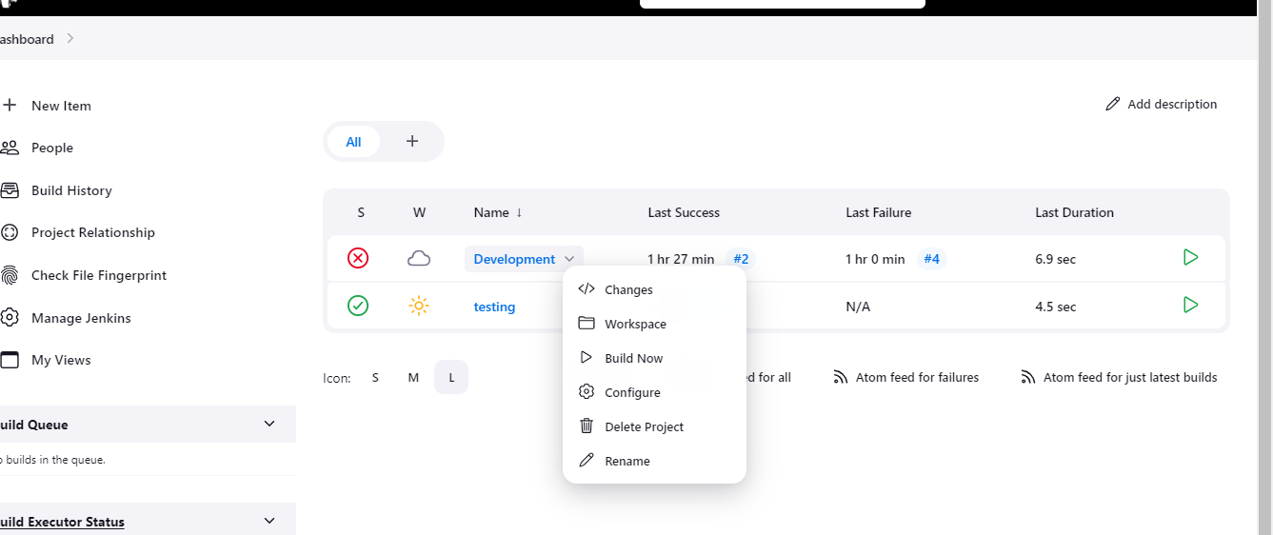

Install the tomcat in the production server

The war files which was present in the development folder should go to the testing folder->copy artifact plugin

Go to-.dashboard->development->configure->post build actions->add post build action-archive the artifacts.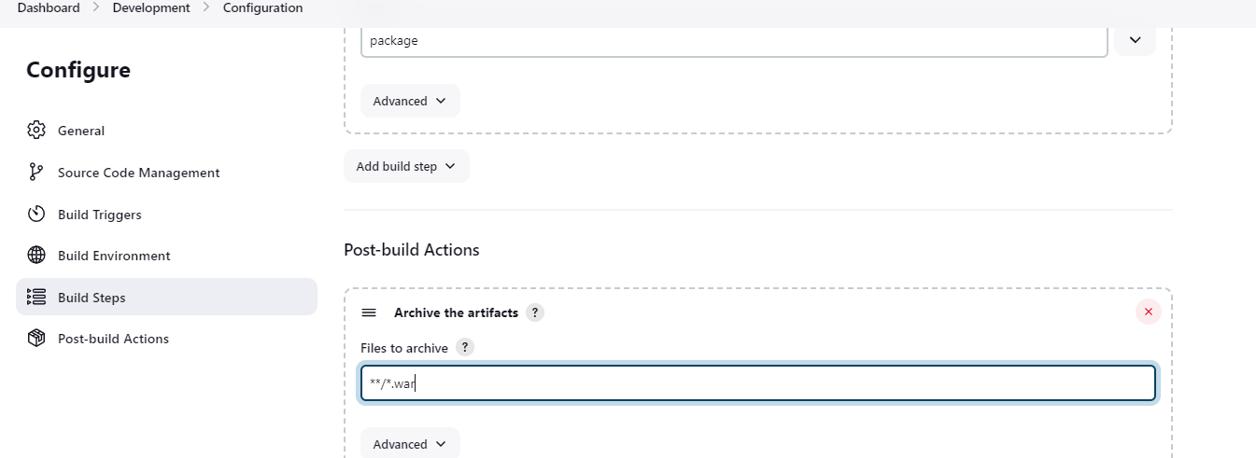

Go to testing->configure->build steps->add build step->copy artifact plugin

