Task 1 / Question 1

Deploy data collectors (simulated) in a cloud environment

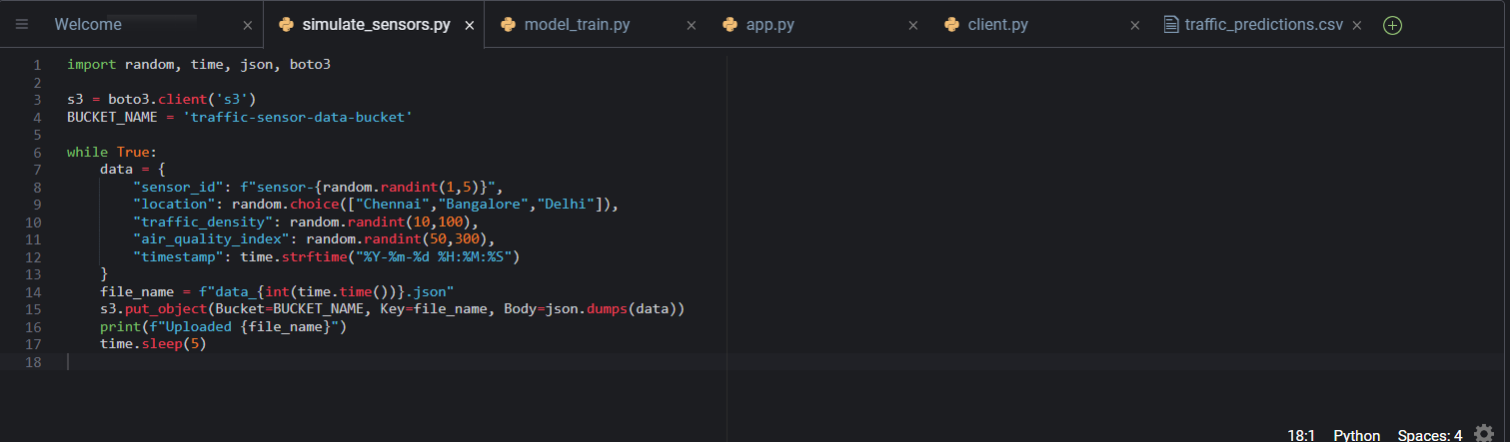
Screenshot 1 : Simulating data using python IDE in cloud9

Stream and Store traffic and pollution data

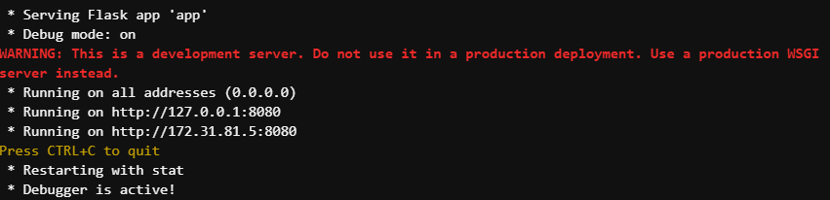
Screenshot 2: Streaming cloud data locally

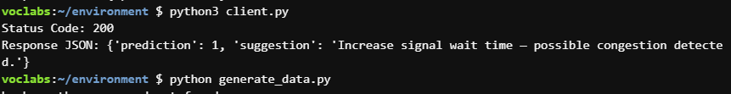
Screenshot 3: Live API response after streaming the data.

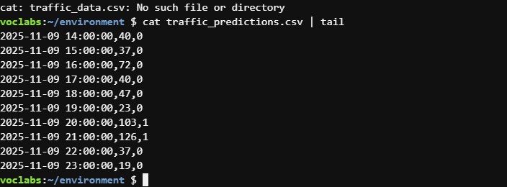
Screenshot 4: Data streaming using cloud9
Develop AI MODEL to predict congestion and air quality index

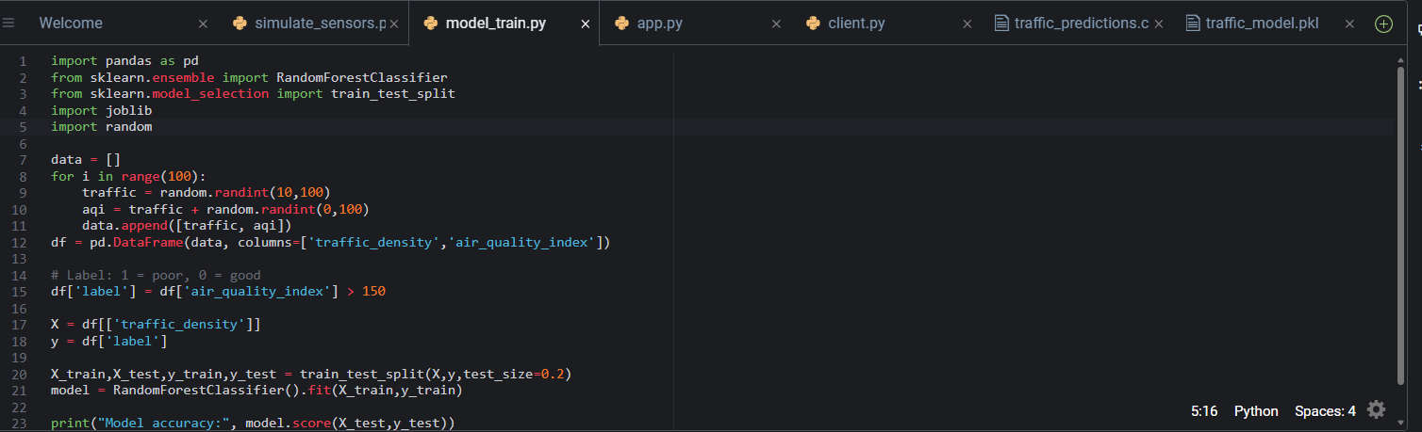
Screenshot 5: Training ML Model to score the air quality index

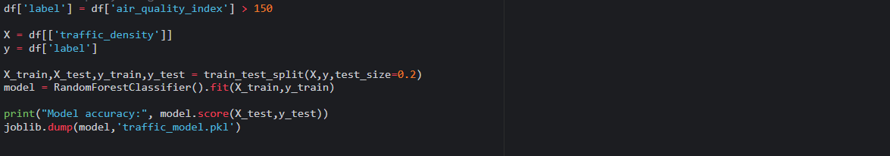
Screenshot 6: Classifying using Random forest algorithm.

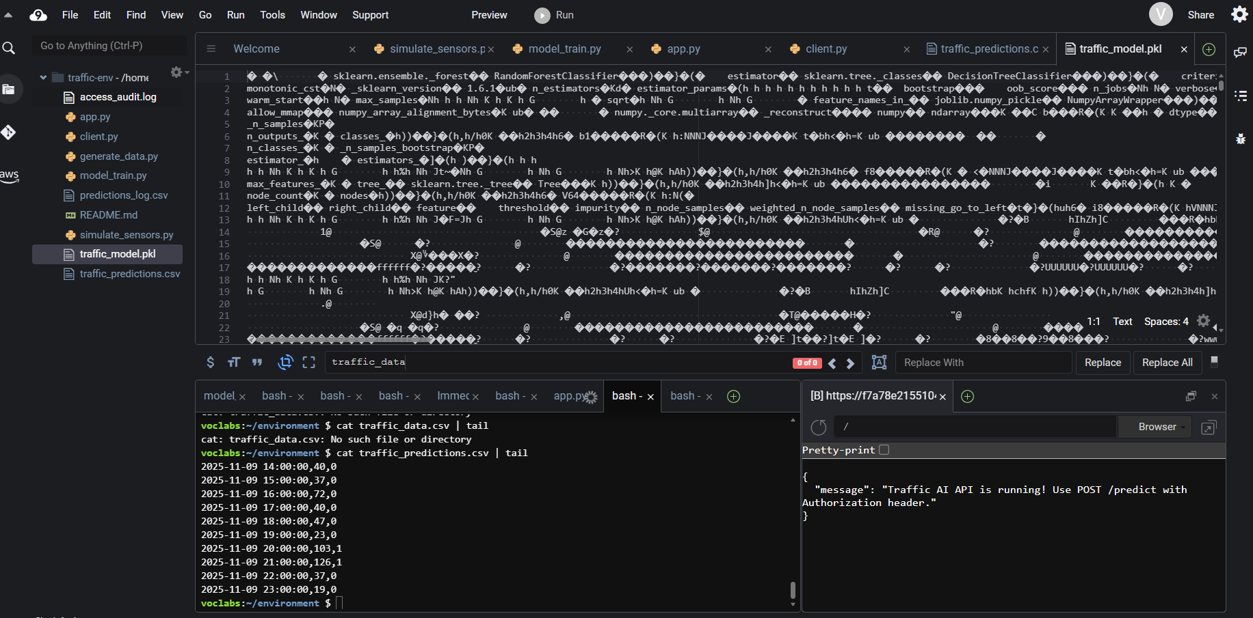
Screenshot 7: traffic_mode.pkl file gets created

Secure the end points using Token based authentication

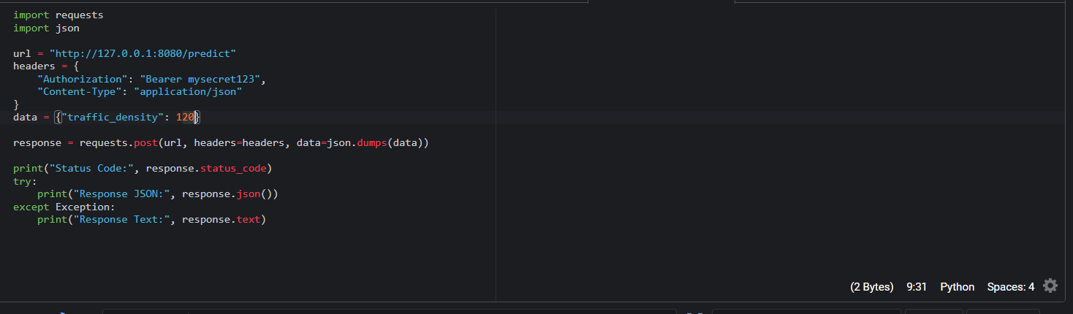
Screenshot 8: Creating a bearer key and token, and using user authentication.

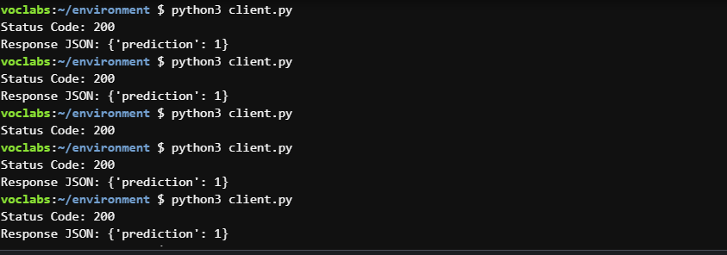
Screenshot 9: Receiving a response only after authetication.

Connect real time data dashboards with CLOUD API

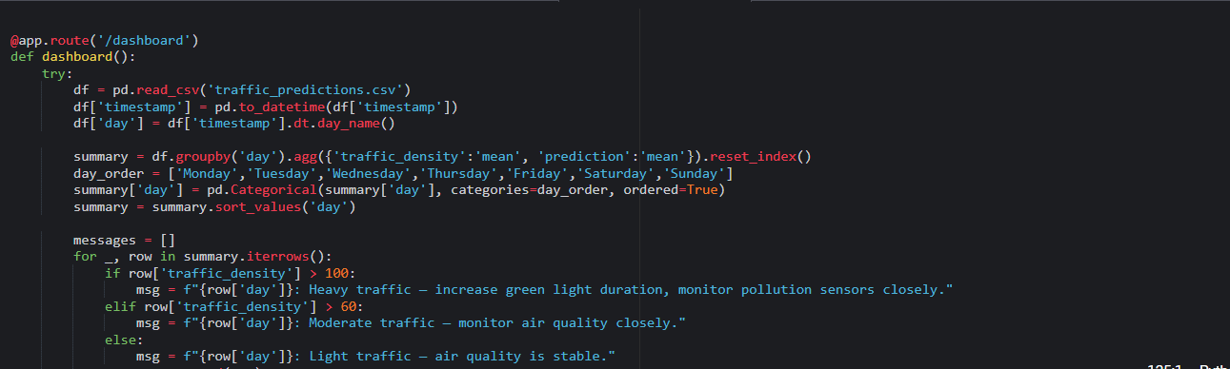
Screenshot 10: Creating a cloud data dashboard route.

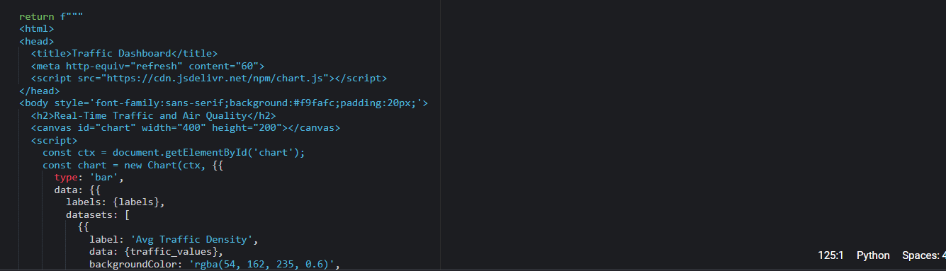
Screenshot 10: Using cloud APIs to create visualisation from the collected data.

Temporary cloud dashboard link: https://f7a78e215510421d991ad0fd6f5a89d5.vfs.cloud9.us-east-1.amazonaws.com/dashboard

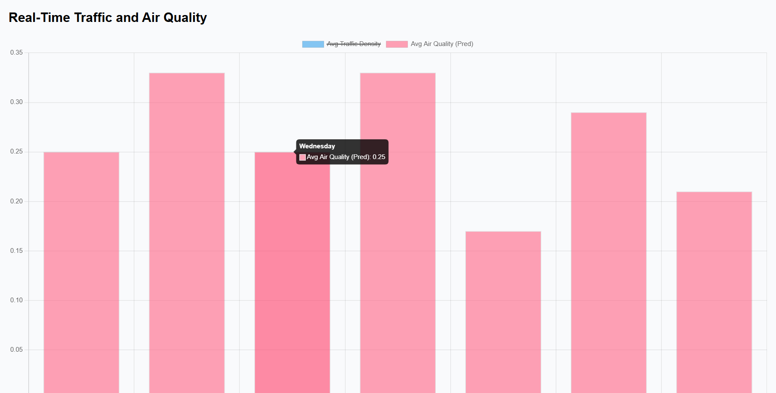
Screenshot 11: Air quality prediction in real time.

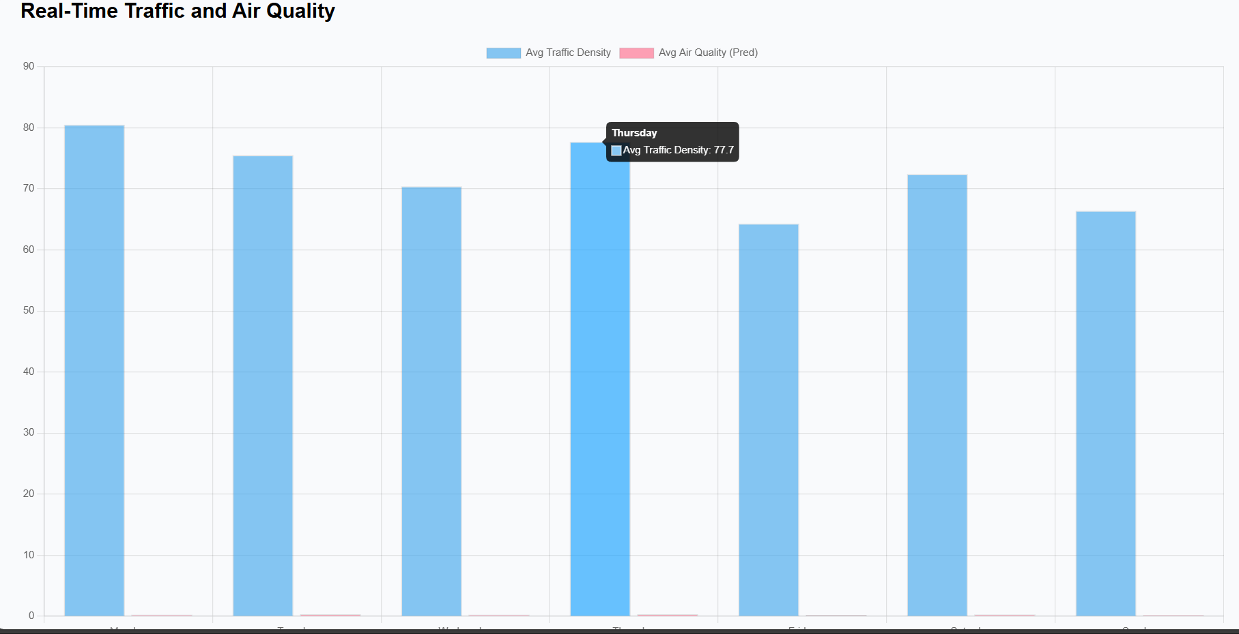

Screenshot 12: Air traffic density prediction in real time visualisation over cloud.

Perform aggregation daily and generate daily aggregation reports.

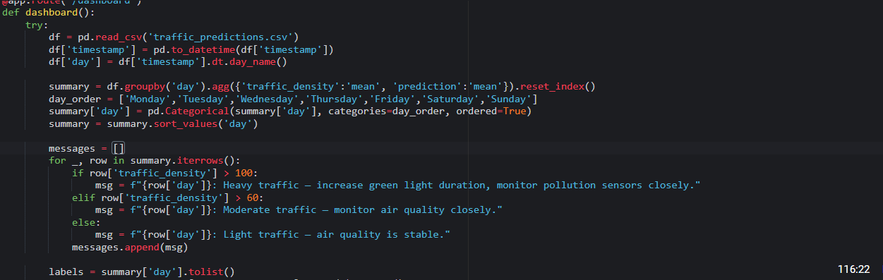
Screenshot 13: Daily aggregation of data and Daily prediction of data.

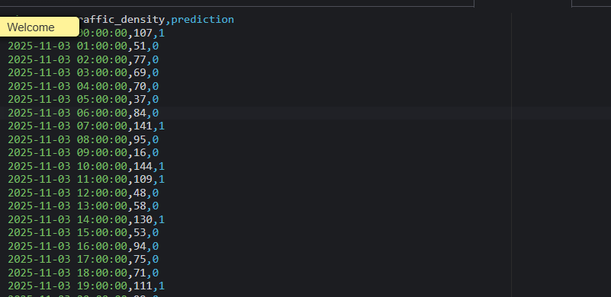
Screenshot 14: Traffic prediction based on time and date

Suggest Adaptive control based on model output:

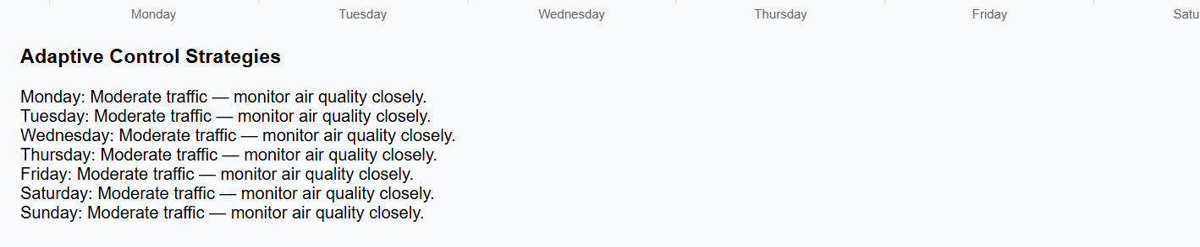
Screenshot 15: Suggesting adaptive control strategies.

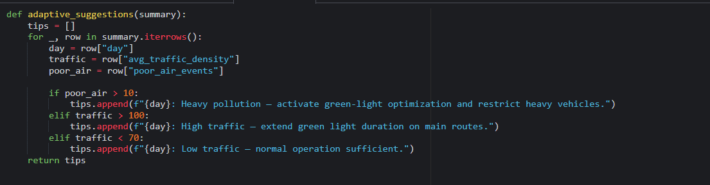
Screenshot 16: Code for adaptive control strategies.

Implement an audit system to log and manage audit data.

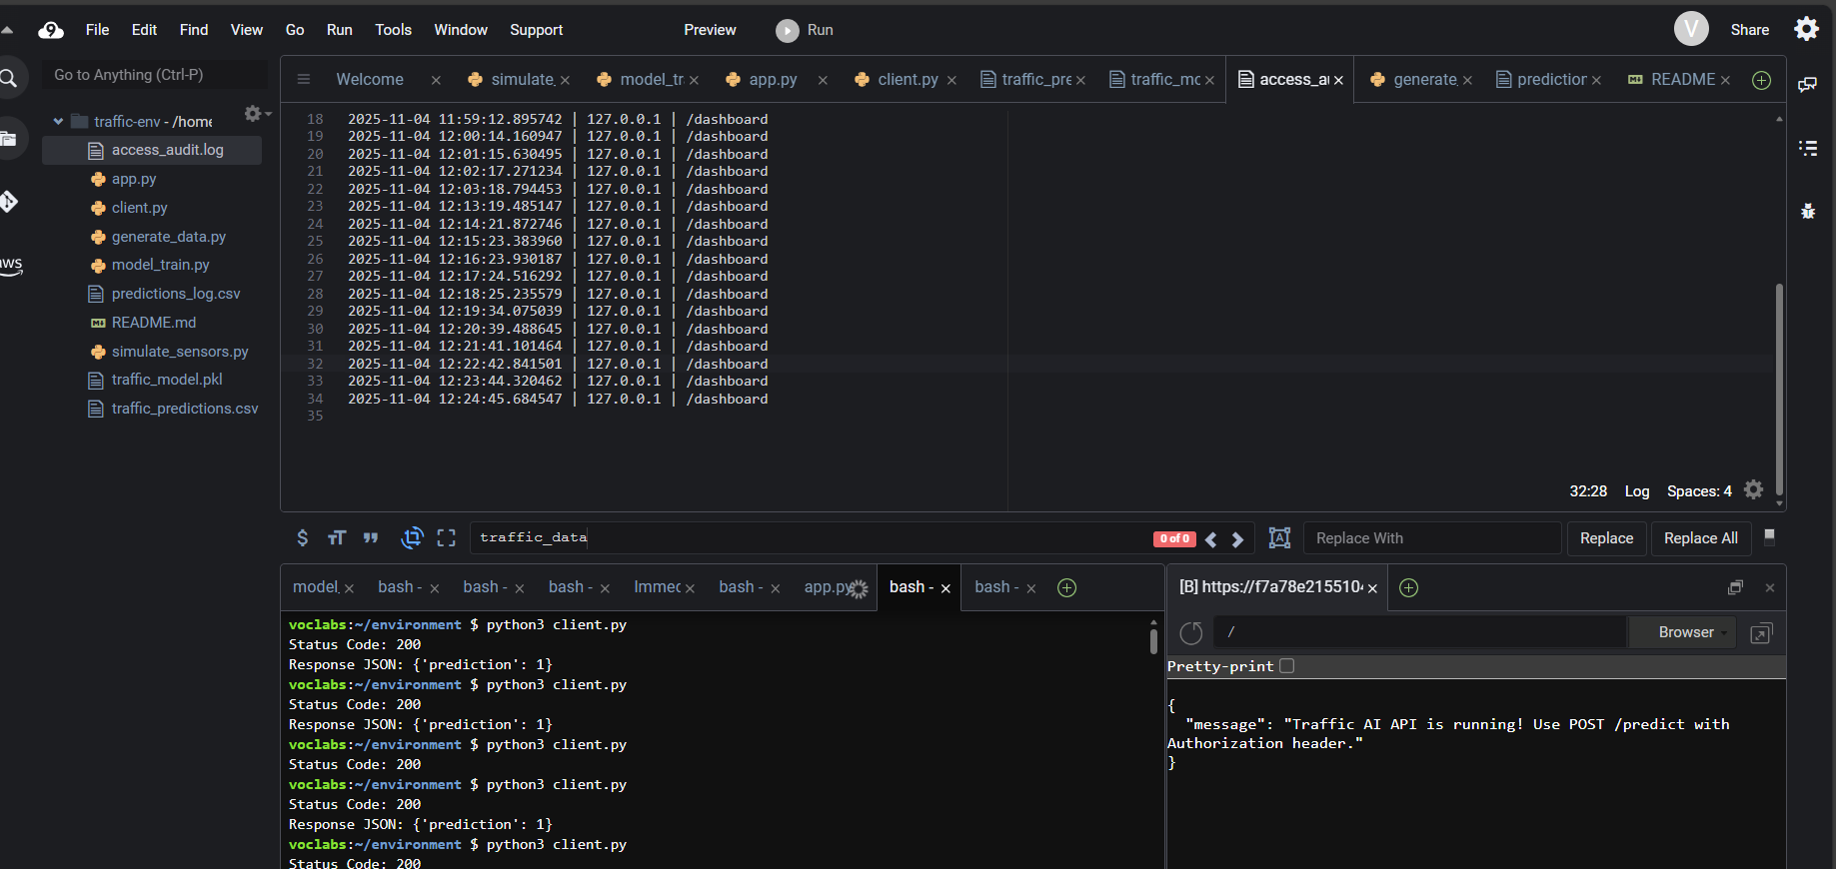
Screenshot 17: Implementing audit to manage data.

