两个算法可以直接合成一个，在最下面

# 一

//Random Forest model is utilized for training, prediction, and assessing feature importance.

Algorithm 1: Random Forest Classifier Training

Data:

Training dataset: X_train, y_train

Testing dataset: X_test, y_test

Results:

Trained model: model

Accuracy: actual_acc

中间流程：（这个title不显示）

1. 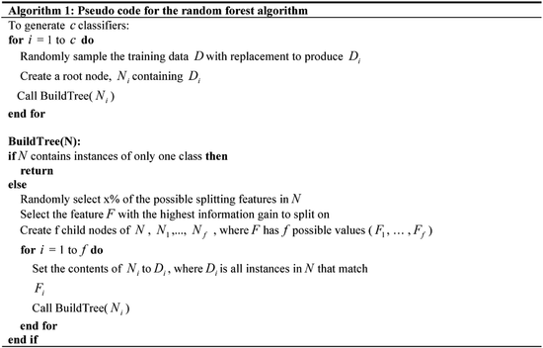

2  x，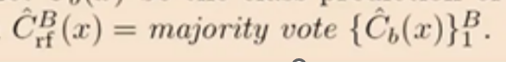

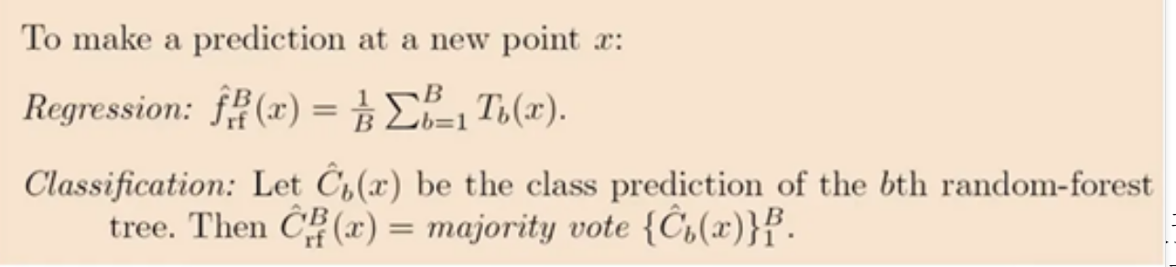（这一问的x换成*X_test*，得到那个叫*y_pred*）

3 *actual_acc* <- *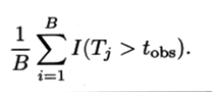I(y_pred == y_test)*/ len(y_test)（这个B可以不换，如果橙色图片里的B没换的话）

# 二

-----------------------------------------------------------------------------------------------------

//Permutation test is employed to assess the statistical significance of the model's accuracy under the null hypothesis.

Algorithm 2: Permutation Test

Data:

Real results of the test set *y_test*

Predicted results of the model on the test set *y_pred*

Results:

List of accuracy values generated during iterations *acc_list*

Probability *p*

1 *n* <- 1000

2 for *i* <- 1 to *n* do

3 *y_perm* <- random_permutation(*y_test*)

4 *acc_list[i]* <- accuracy_score(*y_perm*, *y_pred*)

6 *p* <- * I(acc_list >= actual_acc)*图片中的B换成n

**7 return** *p*

# 三

Algorithm: Random Forest Prediction and Permutation Test

Data:

Training dataset: X_train, y_train

Testing dataset: X_test, y_test

Results:

List of accuracy values generated during iterations *acc_list*

Probability *p*

中间流程：（这个title不显示）

1. 

2  x，

（这一问的x换成*X_test*，得到那个叫*y_pred*）

3 *actual_acc* <- *I(y_pred == y_test)*/ len(y_test)（这个B可以不换，如果橙色图片里的B没换的话）

4 *n* <- 1000

5 for *i* <- 1 to *n* do

6 *y_perm* <- random_permutation(*y_test*)

7 *acc_list[i]* <- accuracy_score(*y_perm*, *y_pred*)

8 *p* <- * I(acc_list >= actual_acc)*图片中的B换成n

**9 return** *p*