LightGBM, a variant of the gradient boosting decision tree (GBDT), builds upon decision tree algorithms with a leaf-wise splitting strategy. Unlike the traditional level-wise approach, the leaf-wise method in LightGBM efficiently minimizes loss during tree growth, leading to significantly enhanced classification accuracy compared to other established boosting algorithms. LightGBM introduces two innovative techniques: Exclusive Feature Bundling (EFB) and Gradient-based One-Side Sampling (GOSS).

The prediction of a Gradient Boosting Decision Tree (GBDT), denoted as T(x), is obtained by summing the outputs of a set of decision tree models, expressed as e(x), according to Equation (6).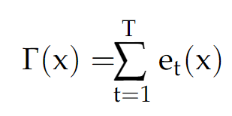

To construct a GBDT model that effectively fits the given loss function Ф(y, T(x)), the aim is to determine the approximate function Γ that minimizes the loss.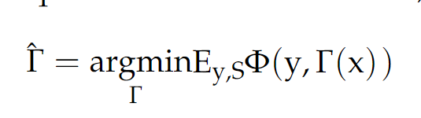

LightGBM diverges from the traditional GBDT approach by employing the Gradient-based One-Side Sampling (GOSS) method to split internal nodes instead of relying on information gain. The specific formula for this splitting strategy is provided as follows.

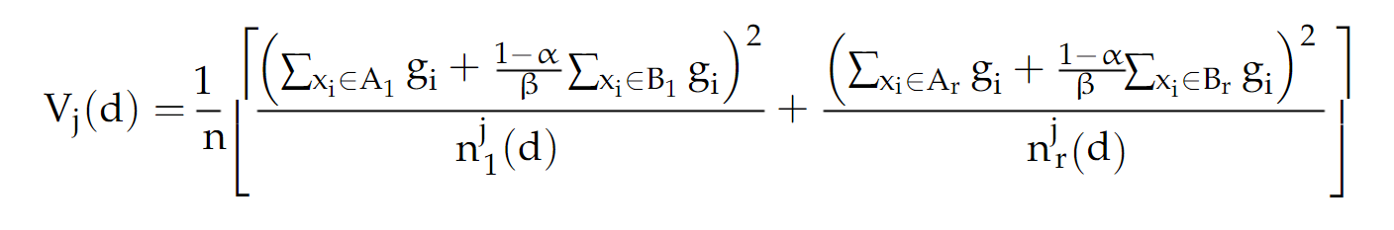

For a detailed explanation, please refer to the citation [1] in the paper."