ARTIFICIAL INTELLIGENCE

Assignment – 1
AI Smart Energy Management System
An Intelligent Agent-Based Approach to Energy Efficiency
Submitted By

Devi Parvathy K
Group 8
S7 CSE-A
Roll No: 25

1. Introduction
The AI Smart Energy Management System is an intelligent agent designed to minimize electricity consumption in buildings while maintaining occupant comfort. The system monitors factors such as room occupancy, indoor temperature, light level, and outdoor temperature to make intelligent decisions regarding HVAC systems and lighting.
The intelligent agent automatically controls energy-consuming devices based on predefined comfort requirements and current environmental conditions. It reduces unnecessary energy consumption by switching off HVAC and lighting in unoccupied rooms and adjusting artificial lighting according to available daylight.

2. PEAS Representation
Agent Type | Performance Measure | Environment | Actuators | Sensors
AI Smart Energy  Management System | Minimize electricity consumption  Maintain occupant comfort  Reduce unnecessary energy usage  Improve energy efficiency  Maximize energy savings | Smart building rooms  Occupants  HVAC systems  Lighting systems | HVAC controller  Smart lights / dimmer  Smart plugs | Occupancy sensor  Indoor temperature sensor  Light sensor  Outdoor temperature feed  Appliance power meter
Table 1: PEAS Representation of the AI Smart Energy Management System

3. Environment Properties
Property | Type | Justification
Observability | Partially Observable | Sensor readings contain noise, and the agent cannot know every environmental factor exactly.
Determinism | Stochastic | Occupancy, temperature changes, and environmental conditions involve random variations.
Dynamics | Dynamic | Room temperature, occupancy, outdoor temperature, and daylight change over time.
Discreteness | Continuous | Temperature, light level, and energy consumption can take continuous values.
Agents | Single Agent | A single intelligent agent controls the energy-management decisions for all rooms.
Knowledge | Partially Known | The agent knows comfort requirements and control rules, but environmental changes are not completely predictable.
Table 2: Environment Properties of the AI Smart Energy Management System

4. Rationality Measure
A rational agent selects actions that maximize its performance based on the information available.
In the proposed AI Smart Energy Management System, the agent aims to minimize electricity consumption while maintaining occupant comfort. It checks room occupancy and temperature before deciding whether HVAC should be activated. HVAC is switched off when a room is unoccupied, thereby preventing unnecessary energy consumption.
The agent also uses daylight harvesting for lighting. When sufficient natural light is available, artificial lighting is reduced or switched off. When the room is occupied and the light level is low, the system increases the artificial lighting level.
The agent also uses a comfort band around the preferred temperature. This prevents the system from continuously operating the HVAC when the room temperature is already within an acceptable range.
Therefore, the system behaves rationally by selecting actions that provide a suitable balance between energy savings and occupant comfort.

5. Innovation Points

1. Occupancy-Based Energy Control
The system detects whether a room is occupied and automatically switches off unnecessary HVAC and lighting when the room is empty.

2. Daylight Harvesting
The system measures the available natural light and automatically adjusts the brightness of artificial lights. This reduces electricity consumption while maintaining adequate lighting.

3. Predictive / Pre-emptive HVAC Control
The system considers the current temperature and comfort limits and activates HVAC before the room moves significantly outside the comfort range. This helps maintain comfort without continuously running the HVAC system.

6. System Architecture Diagram
ROOM SENSORS
│
┌───────────────────┼───────────────────┐
│ │ │
Occupancy Sensor Temperature Sensor Light Sensor
│ │ │
└───────────────────┼───────────────────┘
│
▼
┌────────────────────────────────┐
│ AI SMART ENERGY MANAGEMENT │
│ AGENT │
└────────────────────────────────┘
│
┌───────────────┼───────────────┐
│ │ │
▼ ▼ ▼
HVAC LIGHTS SMART PLUGS
│ │ │
└───────────────┼───────────────┘
▼
ENERGY OPTIMIZATION
│
▼
COMFORTABLE BUILDING
Figure 1: Architecture of the AI Smart Energy Management System

7. Conclusion
The AI Smart Energy Management System provides an intelligent solution for reducing electricity consumption in buildings while maintaining occupant comfort. By monitoring occupancy, temperature, and light levels, the intelligent agent makes appropriate decisions regarding HVAC and lighting operation.
The system reduces unnecessary energy usage through occupancy-based control, daylight harvesting, and intelligent HVAC management. The simulation also compares the energy consumed by the AI-controlled building with a baseline system, allowing the effectiveness of the proposed intelligent agent to be evaluated.

8. Simulation
The simulation demonstrates the operation of the intelligent agent in a multi-room building. The system consists of four rooms: Living Room, Bedroom, Office, and Kitchen.
At each simulation step, the environment generates sensor readings such as:
- Room temperature
- Occupancy status
- Light level
- Outdoor temperature
The intelligent agent analyzes these readings and determines:
- Whether HVAC should be OFF, COOL, or HEAT
- The required lighting intensity
- The energy consumed during the simulation period
The system then compares its energy consumption against a baseline building, where HVAC and lighting operate without intelligent optimization.

9. Screenshots of Full Code
The following screenshots document the complete implementation of the AI Smart Energy Management System.
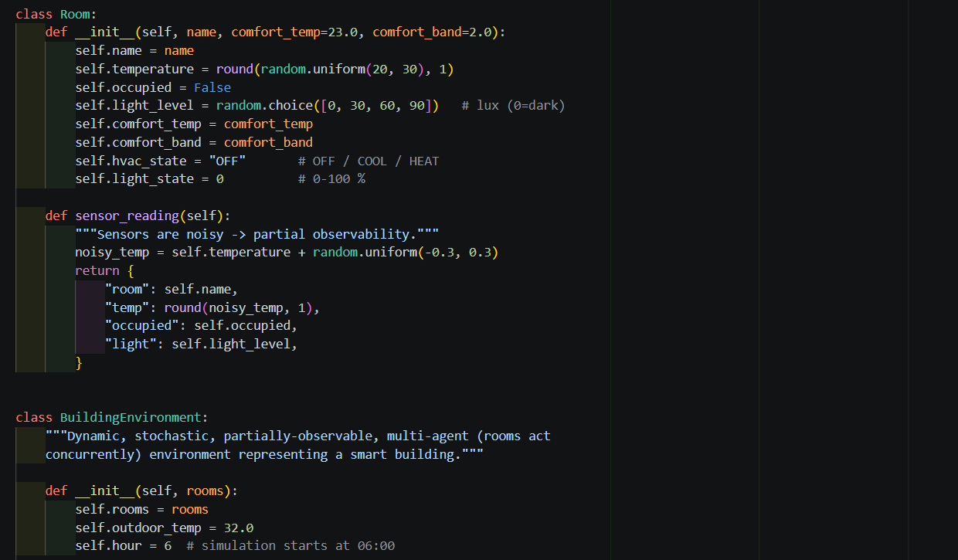
Figure 2: Environment and Room Class
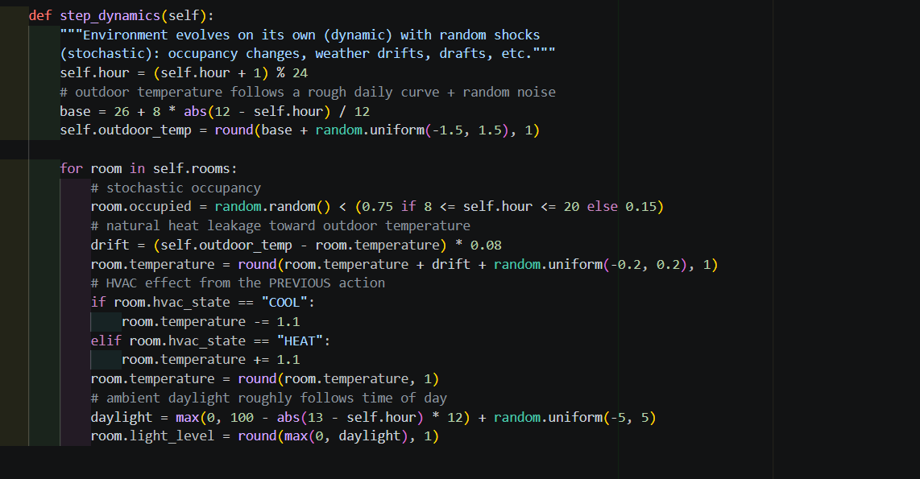
Figure 3: Environment Dynamics and Sensor Simulation
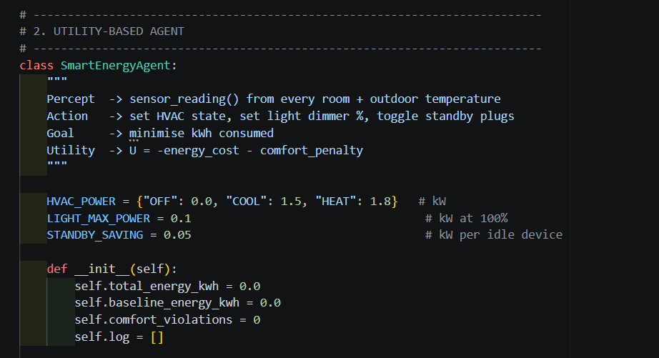
Figure 4: Smart Energy Management Agent
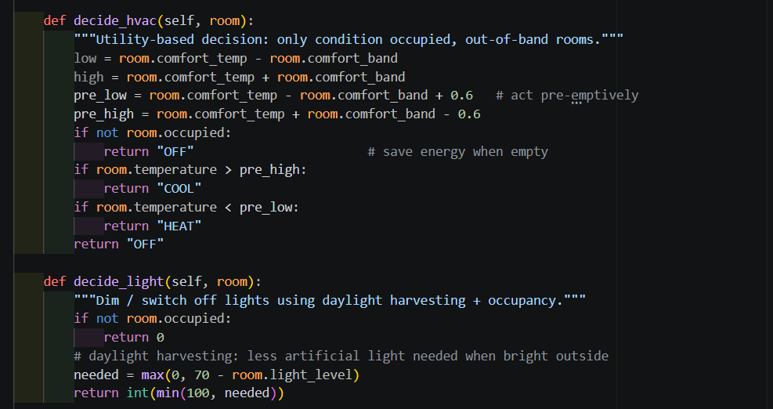
Figure 5: Intelligent HVAC and Lighting Decision Functions
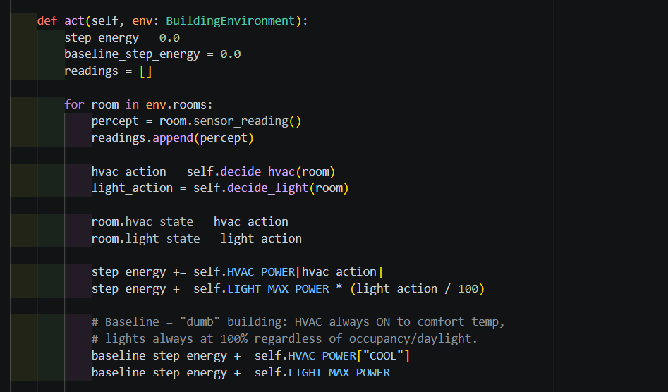
Figure 6: Agent Actions and Energy Consumption Calculation
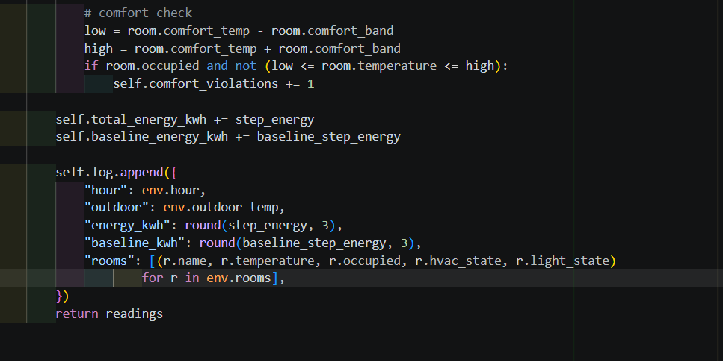
Figure 7: Comfort Evaluation and Performance Logging
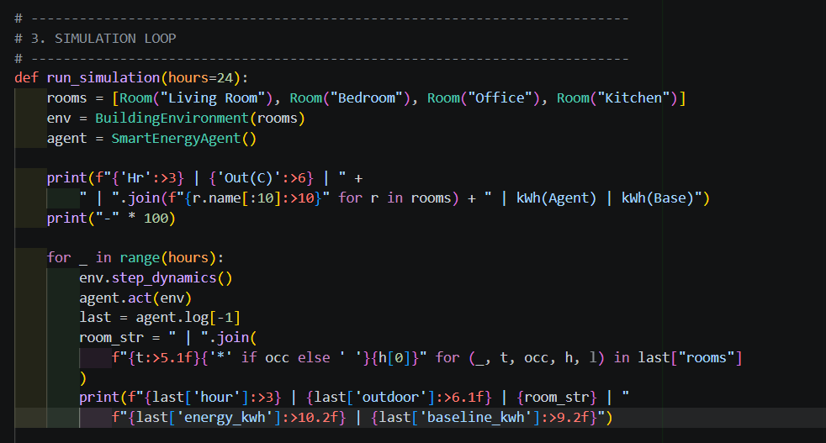
Figure 8: 24-Hour Simulation Loop
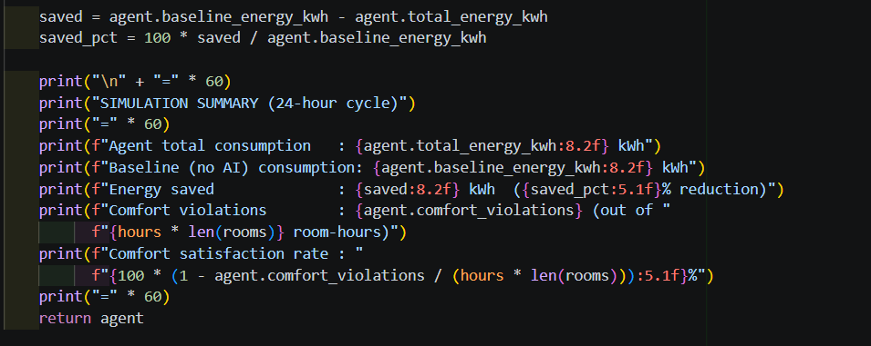
Figure 9: Performance Evaluation and Final Output

10. Output
The final output of the simulation includes the total energy consumed by the AI agent, baseline energy consumption, energy saved, comfort violations, and comfort satisfaction rate.
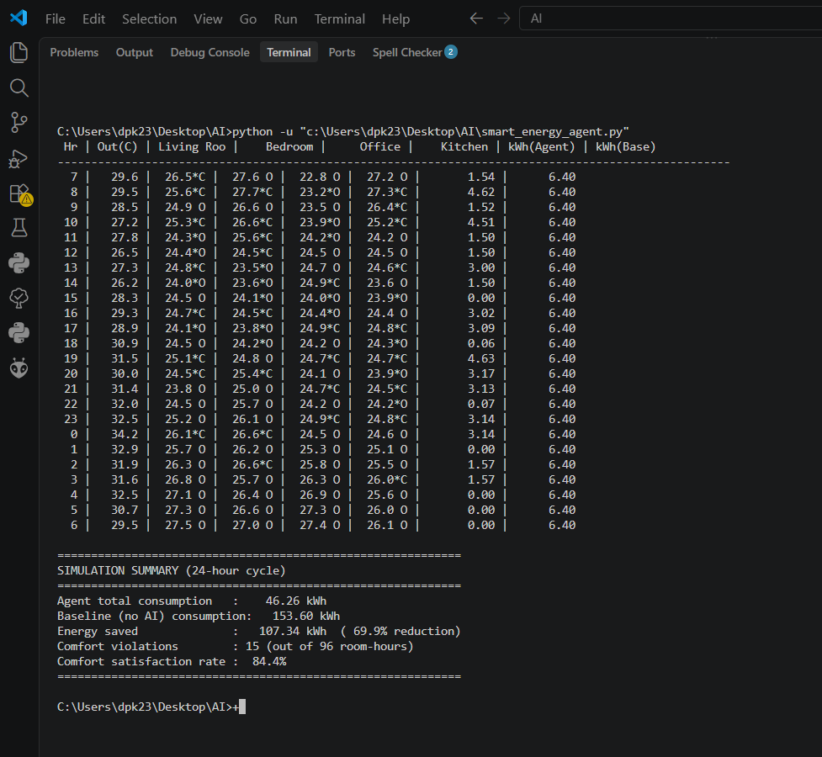
Figure 10: Program Execution

