INSTRUCTIONS

The expected output is:

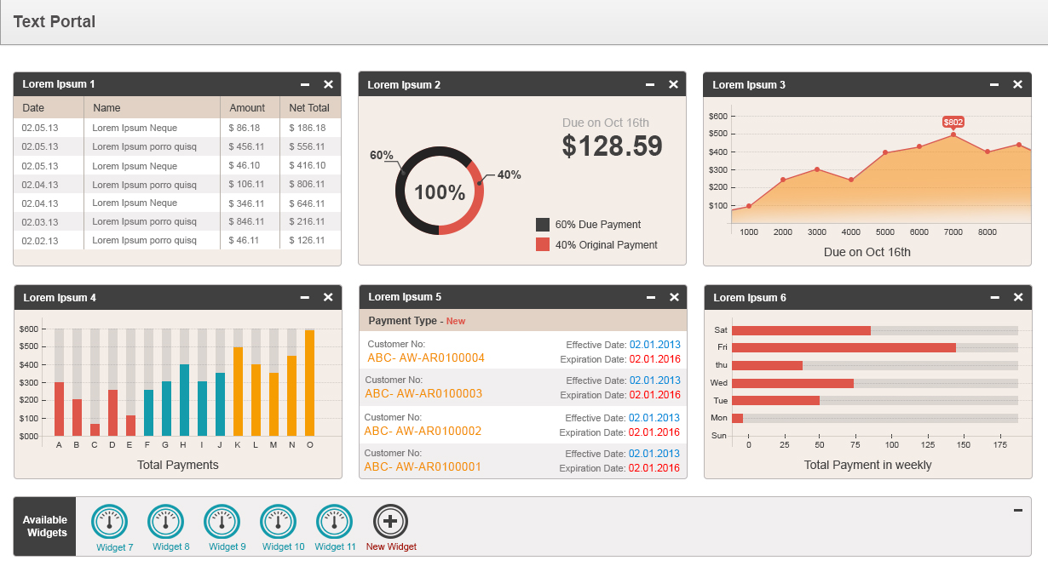

1. The widgets in the main area are different than the widgets in the sliding area.
2. For any widget available on the main screen:
   1. On click of the close button then it should be invisible in the main screen and be visible in the sliding area(footer)

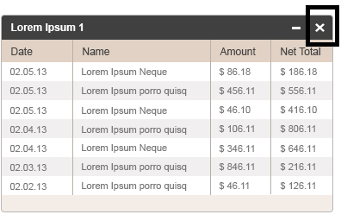

* 1. On click of the minimize button, only the widget name should be visible.

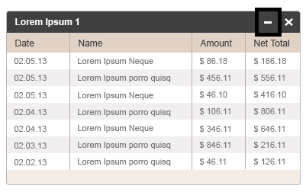

1. At the footer, there should be a sliding area which will hold available widgets which are not added on main area.
   1. If we click the “-“ button, the screen should minimize and just a dark grey area should appear with text Available Widgets. And clicking back on it, the view shown below should be seen.

SlidingArea.png

For any widget available in the sliding area:

* 1. We should be able to drag and place any widget from the sliding area into the main area. By this action, the widget should be invisible in the sliding area and be visible in the main area
  2. When user clicks on (+) New widget icon (from sliding area) it should add one panel to main area with "widget Name” and the code for any plug-in. For example, like the pie chart or data.

AddWidget.png

