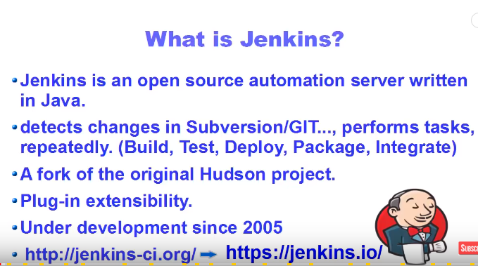

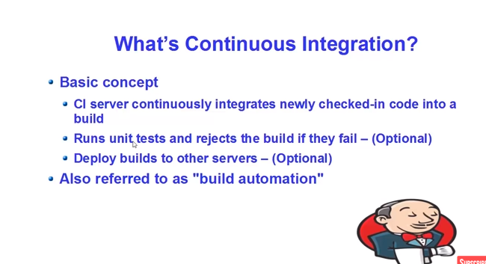

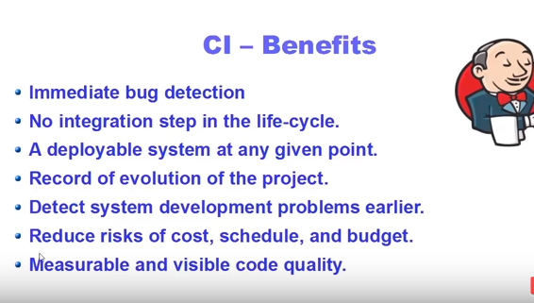

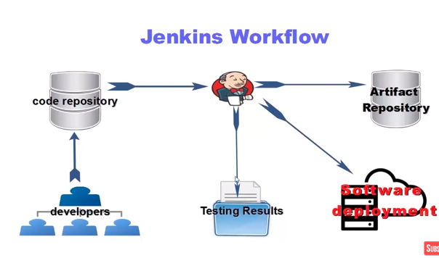

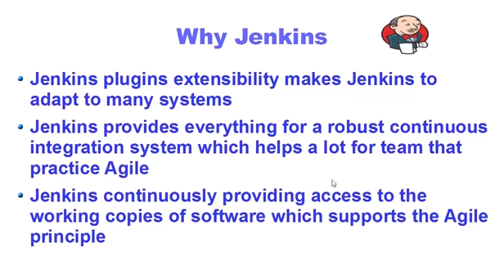

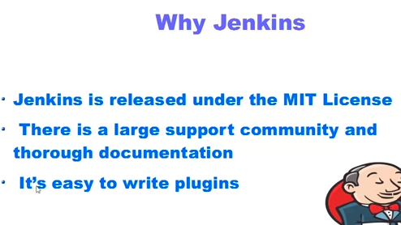

**Upstream and Downstream**

An upstream job is a configured project that triggers a project as of its execution.

A downstream job is a configured project that is triggered as part of a execution of pipeline.

Upstream and downstream jobs help you to configure the sequence of execution for different operations and hence you can orchestrate the flow of execution. We can configure one or more projects as downstream jobs in Jenkins.

In simple words, **Jenkins Pipeline** is a combination of plugins that support the integration and implementation of continuous delivery **pipelines** using **Jenkins**. A **pipeline** has an extensible automation server for creating simple or complex delivery **pipelines** "as code," via **pipeline** DSL (Domain-specific Language).

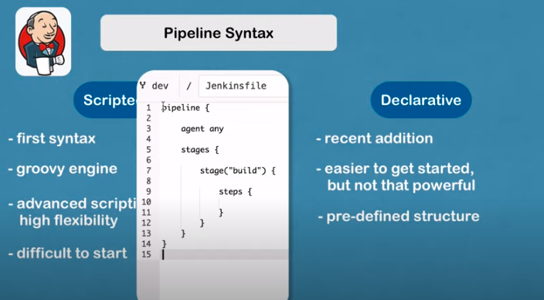

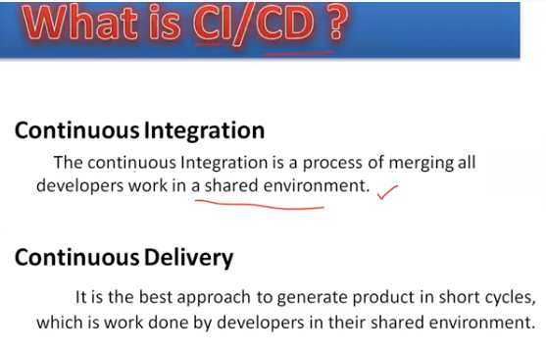

Build Configuration

Configure GitHub

Build Configuration ---> jenksfile

Credentials in Jenkins

Select jenkins --> Create Github credentials

System- Only available on jenkins server NOT for jenkins jobs

Global --> Everywhere accessible