CREATE A SOCIAL MEDIA POST

INTRODUCTION

1.1Overview:

* Perform competitive analysis
* Gather content
* Create a calendar
* Develop a content creation plan

1.2purpose

* Increase brand awareness and visibility
* Allows the sharing of ideas and information
* Sharing ,learning,interacting and marketing
* Internet with your audience in an easy

2.Problem definition&Design thinking

2.1 Empathy map

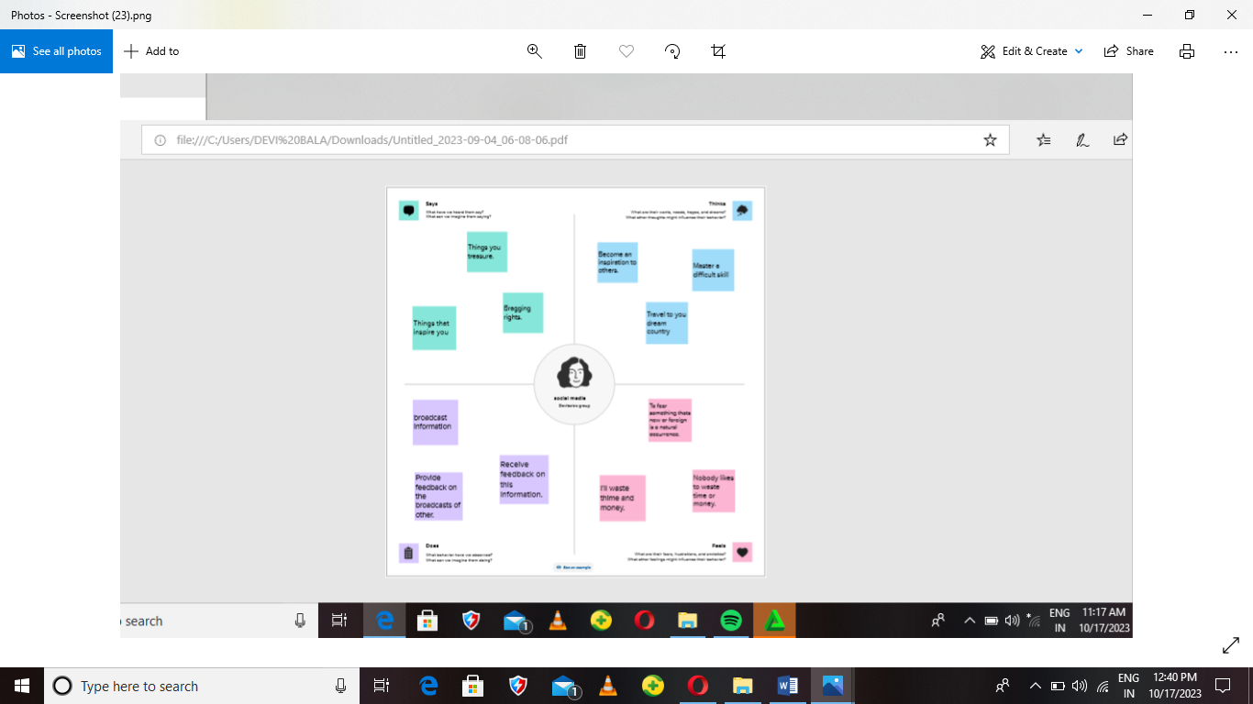

2.2 Brain storm

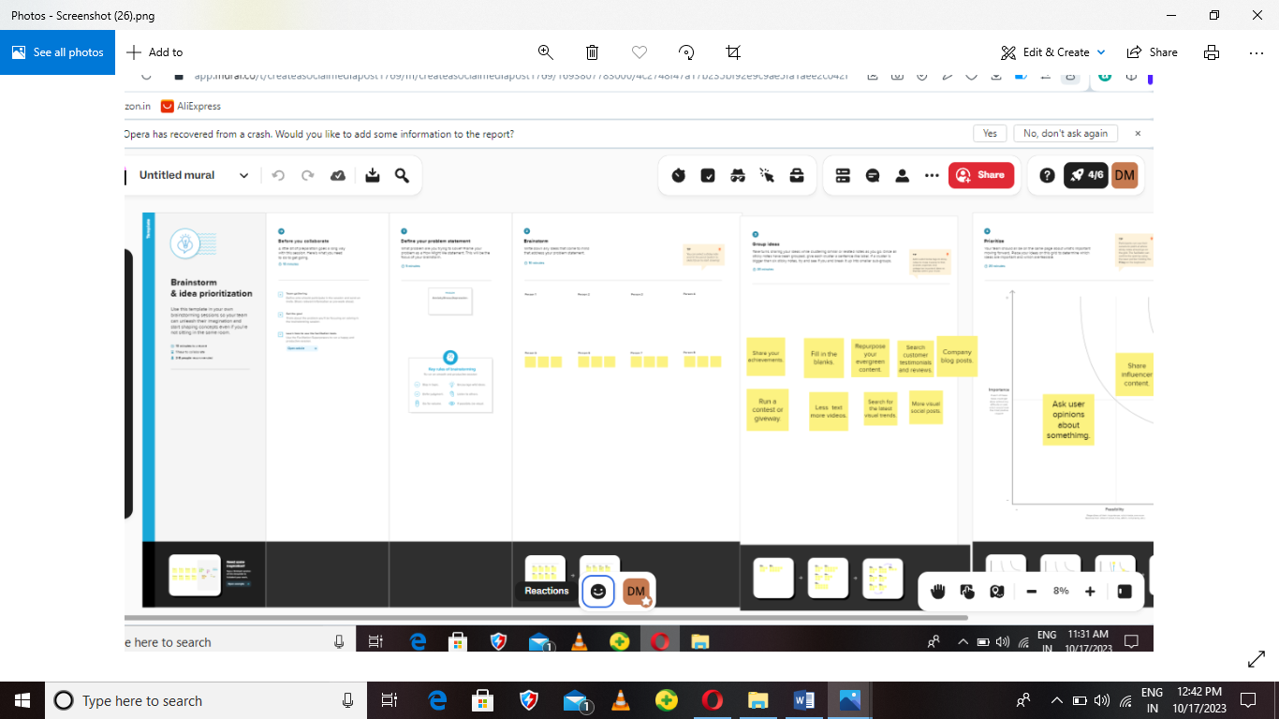

3.Result



4.Advantages&disadvantages;

Advantages

* Education
* You reach large audiences
* Information and updates
* Establishes company branding
* Direct connection with your audience

Disadvantages

* Lacking understanding and thoughtfulness
* Cheating and relationship issues
* Negative feedback for brands
* Facilities laziness
* Lacks emotional connection

**Application**

**Social application is a collective term for websites and application that focus on communication,community-based input interaction,content-sharing and collaporation.People use social media to stay in touch and interact with friends,family and various communities.**

**CONCLUSION**

**In conclusion,social media has plenty of good uses as it allows stories or events that begin locally to gain a global or worldwise attention. This allows to become an amazing platform to make the world connect and spread information faster than ever in the history of mankind.**