Ex.no:3 Identify use cases and develop the Use Case model.
Date:

UML DIAGRAMS – ONLINE EXAM REGISTRATION SYSTEM:
The following UML diagrams describe the process involved in
the online Exam Registration system.

USECASE DIAGRAM:
Use case diagrams illustrate the interactions between users and a system, showing the various actions users can perform and how the system responds. They provide a high-level view of system functionality and help inunderstanding user requirements.

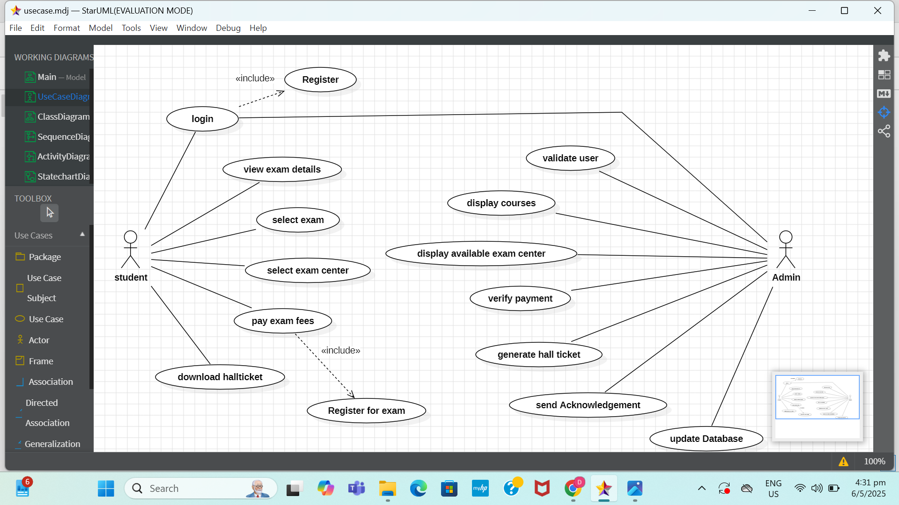

Documentation Of Use Case Diagram:

Actors:
- New Student: Registers Login Credentials.
- Registered Student: Logs In, Selects Exam, Registers for Exam, Makes Payment, Downloads Hall Ticket.
- Bank Server: Verifies Payment Details, Processes Transactions, Displays Status Message.
- Admin: Adds/Updates Exams, Manages Student Records, Views Registrations, Maintains Database.

Activities (Use Cases):
- Register Account: New students provide personal details and create login credentials.
- Login: Students enter username and password. Credentials are authenticated against the database.
- Select Exam: After login, students browse available exams and choose the desired one based on eligibility and schedule.
- Register for Exam: The system verifies eligibility and reserves a slot for the student in the selected exam.
- Make Payment: Payment can be completed via multiple options such as UPI, Credit/Debit Card, or Net Banking. The bank server validates the payment and sends confirmation.
- Download Hall Ticket: Once payment is successful and registration is confirmed, students can download their hall ticket with exam details.

Ex.no:4 Identify the conceptual classes and develop a Domain Model and also derive a Class Diagram from that.
Date:

CLASS DIAGRAM:

Class diagrams represent the static structure of a system, depicting
classes, attributes, operations, and their relationships. They serve as blueprints for system design and help in modeling the static aspects of object-oriented systems.

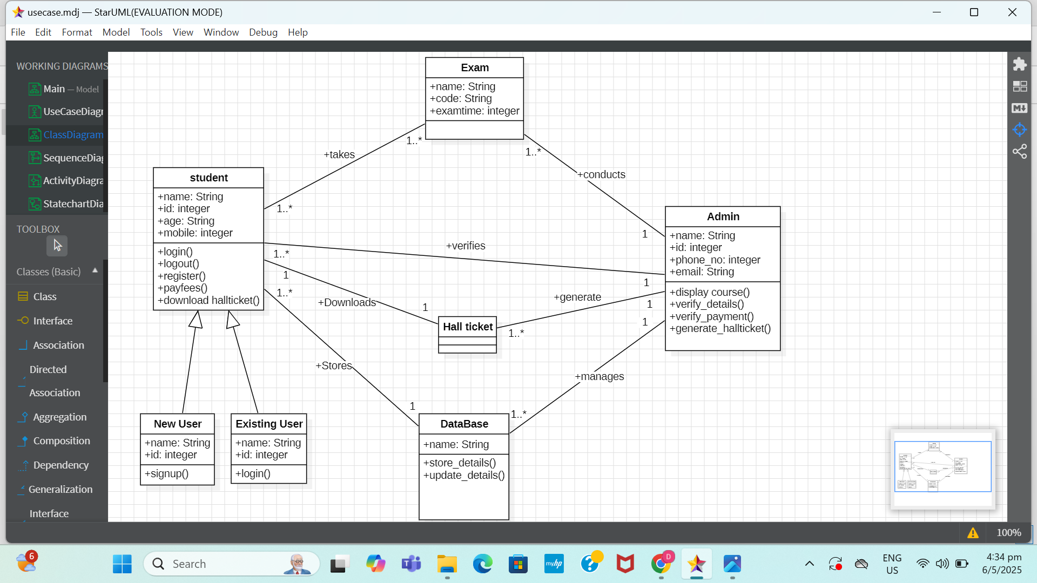

Documentation of Class Diagram:
This Class Diagram Has 7 Classes:
- Student is the class name. Its attributes are student_id, student_name, age, gender, mobile_no, email, address.
The operations performed are: login, logout, select_exam, register_for_exam, make_payment, download_hall_ticket.
- New User is the class name. Its attributes are user_id, username, password, email.
The operation performed is: register_account.
- Existing User is the class name. Its attributes are user_id, username, password.
The operations performed are: login, update_profile.
- Exam is the class name. Its attributes are exam_code, exam_name, subject, exam_date, duration, total_seats, eligibility_criteria.
No operations are performed.
- HallTicket is the class name.
No operations are performed.
- Admin is the class name. Its attributes are admin_id, admin_name, phone_no, email.
The operations performed are: login, add_exam, update_exam, view_registered_students, generate_hall_ticket, logout.
- Database is the class name. Its attribute is DB_name.
The operations performed are: store_details, update_details.

Ex.no:5 Using the identified scenarios, find the interaction between objects Date: and represent them using UML Sequence.

SEQUENCE DIAGRAM:
Sequence diagrams depict the interactions between objects or components in a system over time, illustrating the sequence of messages exchanged among them. They provide insights into the dynamic behaviour of a system and help in understanding the flow of control during runtime.
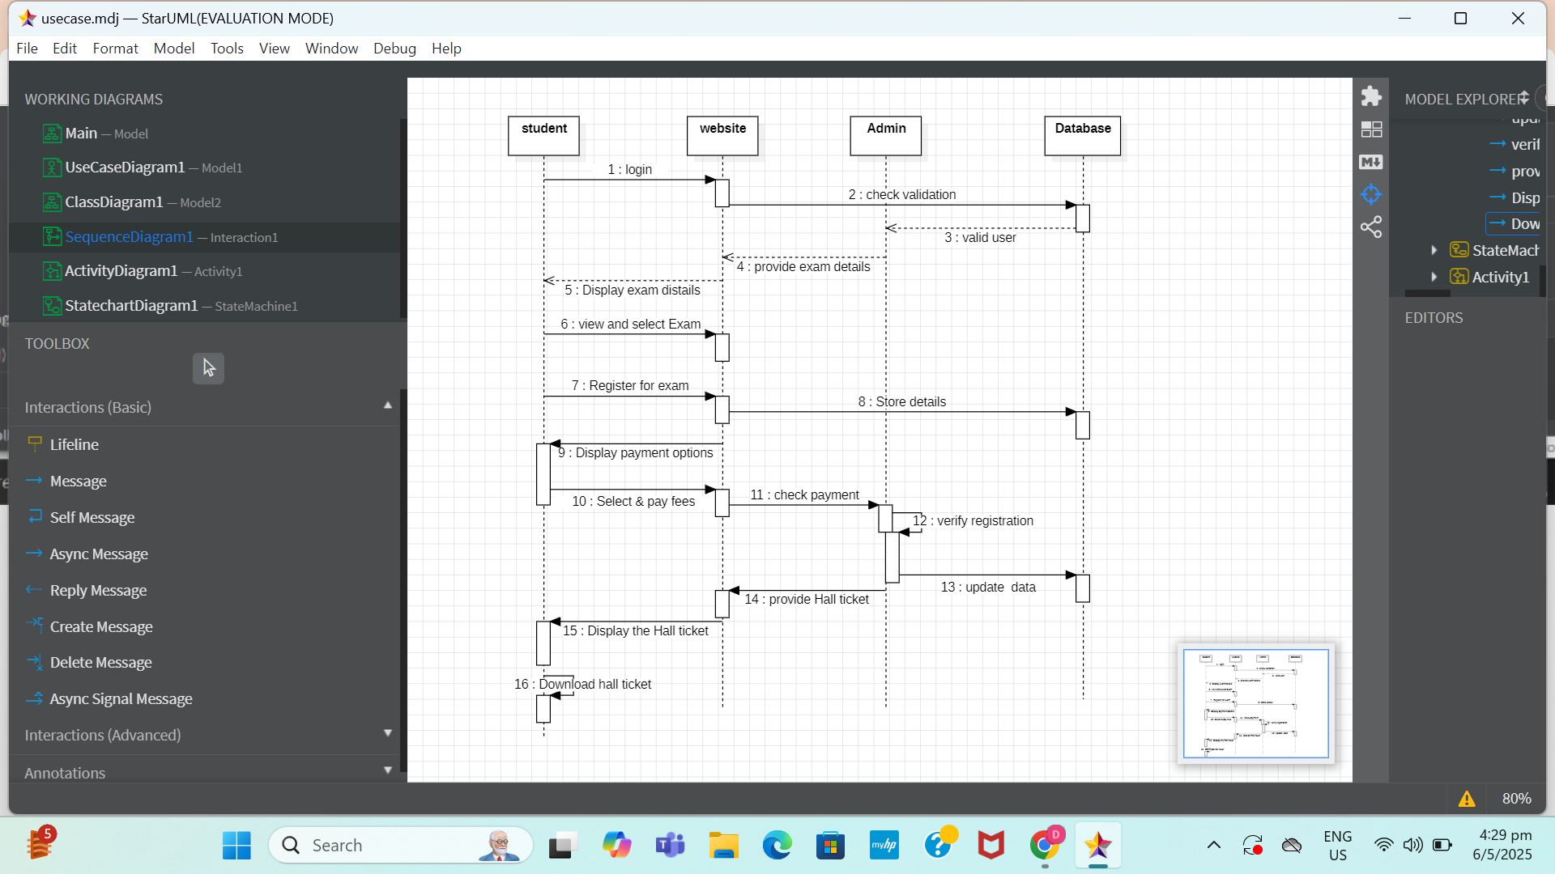

Documentation of Sequence Diagram:
The Sequence Diagram Describes the Sequence of Steps to Show:
- Students are requested to enter their username and password, which are verified by the Admin using the Database.
- If the credentials are correct, the student is successfully logged in, otherwise, the student is requested to re-enter the login details.
- After login, a list of available exams is shown to the student by querying the Database.
- The student selects the desired exam, and the system checks the eligibility and seat availability.
- If the student is eligible and seats are available, the exam registration is confirmed and recorded in the Database. Otherwise, the student is notified of ineligibility or full capacity.
- The student proceeds to make the payment. If the payment fails, the student is prompted to retry the payment process.
- If the payment is successful, the hall ticket is generated by the Admin and stored in the system.
- The student can then download the hall ticket from their dashboard.
- Finally, the student logs out of the system.

Ex.no:6 Using the identified scenarios, find the interaction between objects and represent them using Collaboration Diagrams.
Date:

COLLABORATION DIAGRAM:

A collaboration diagram illustrates how objects communicate to accomplish tasks. It shows messages exchanged between objects, highlighting their interactions and relationships within a system.

Documentation of Collaboration Diagram:
The Collaboration Diagram visually represents the interaction between different components of the system.

Main Components Are:
- Student
- Admin
- Database

Activities Performed Are:
- Registration/Login by Student
- Validation by Admin using Database
- Displaying Exam List by Admin
- Exam Selection and Registration by Student
- Payment by Student
- Payment Validation by Admin
- Data Update by Database
- Hall Ticket Generation by Admin
- Downloading Hall Ticket and Logging Out by Student

Ex.no: 7 Draw relevant Activity Diagrams for the same system.
Date:

ACTIVITY DIAGRAM:
Activity diagrams model the flow of activities or actions within a system, illustrating the sequence of steps to accomplish a particular task.They are useful for visualizing business processes, workflows, and system behaviours.

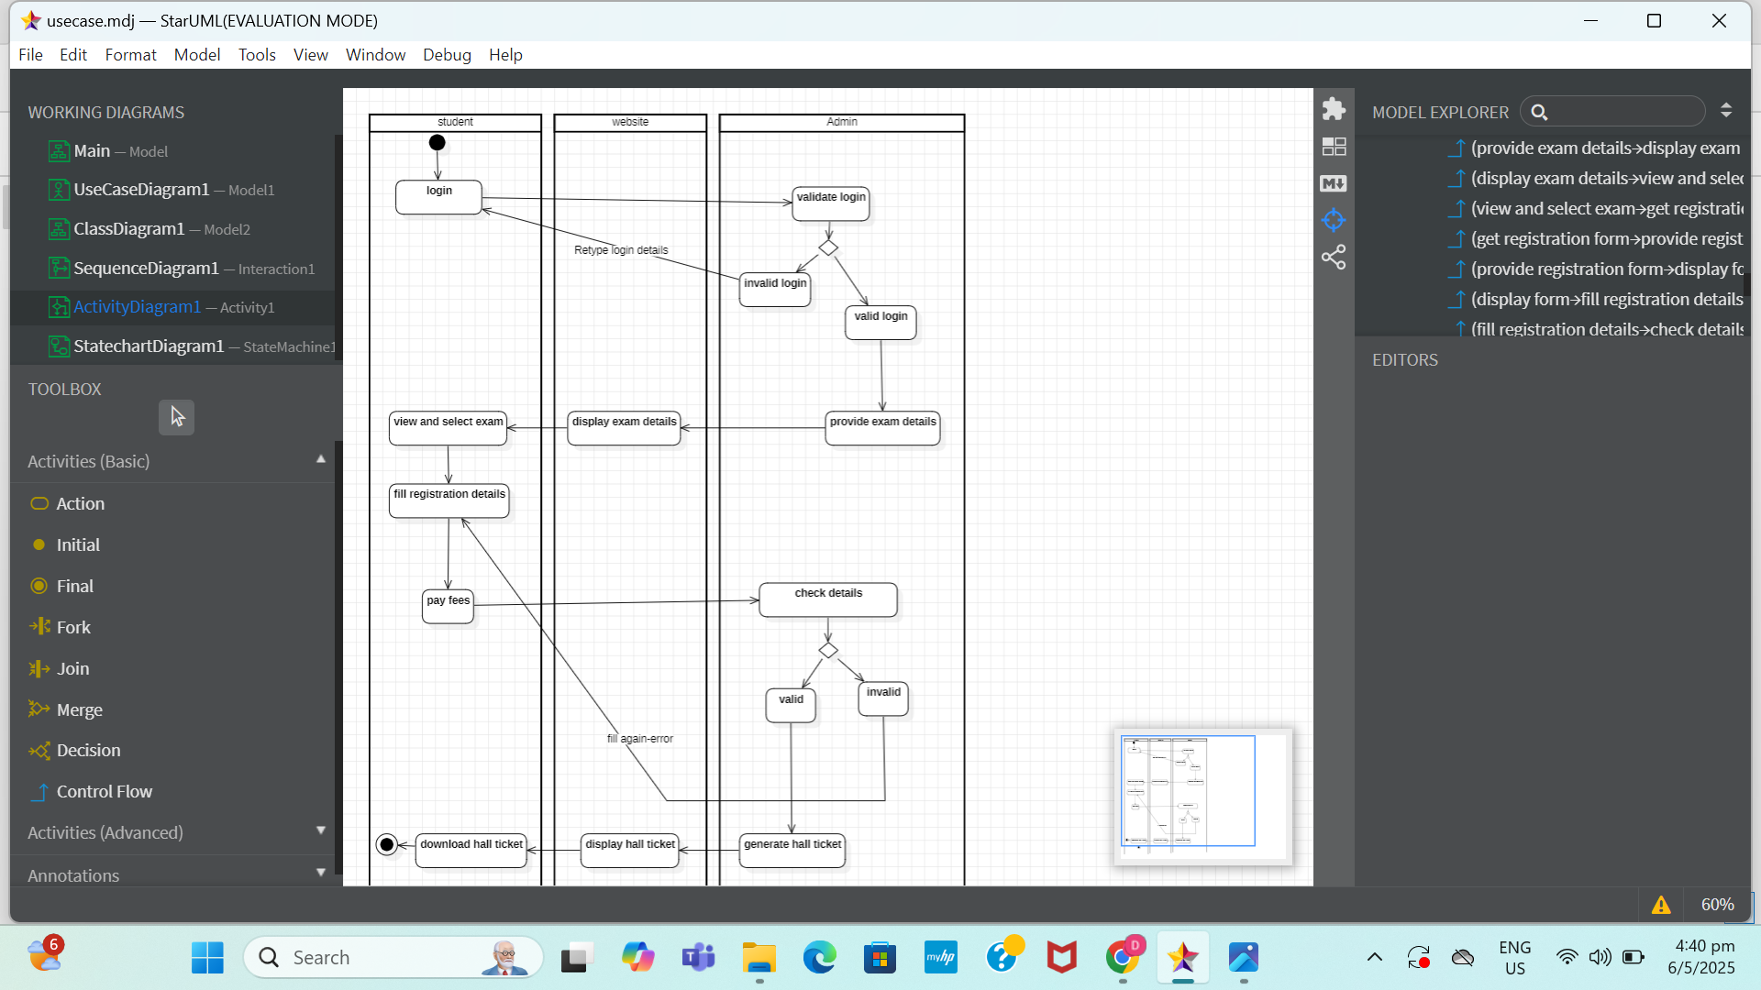

Documentation of Activity Diagram:
This Activity Diagram describes the behavior of the Online Exam Registration System.
- The Student enters their login credentials, which are validated by the Admin using the Database.
- If the credentials are valid, the student is logged in; else, the student is requested to re-enter their credentials.
- The student selects an exam, which is checked for eligibility and seat availability by the Admin using the Database.
- If the exam is not available or the student is not eligible, the student is asked to choose another exam; else, the exam registration proceeds.
- The student makes a payment for the exam.
- If the payment is valid, the hall ticket is generated; else, the student is prompted to make the payment again.
- The student downloads the hall ticket and logs out of the system.

Ex.no: 8 Draw relevant State Chart for the same system.
Date:

STATECHART DIAGRAM:

State Chart diagrams depict the states and transitions of an object or system, illustrating how it responds to various events over time. They are particularly valuable for modeling complex behaviour and state-dependent functionality.
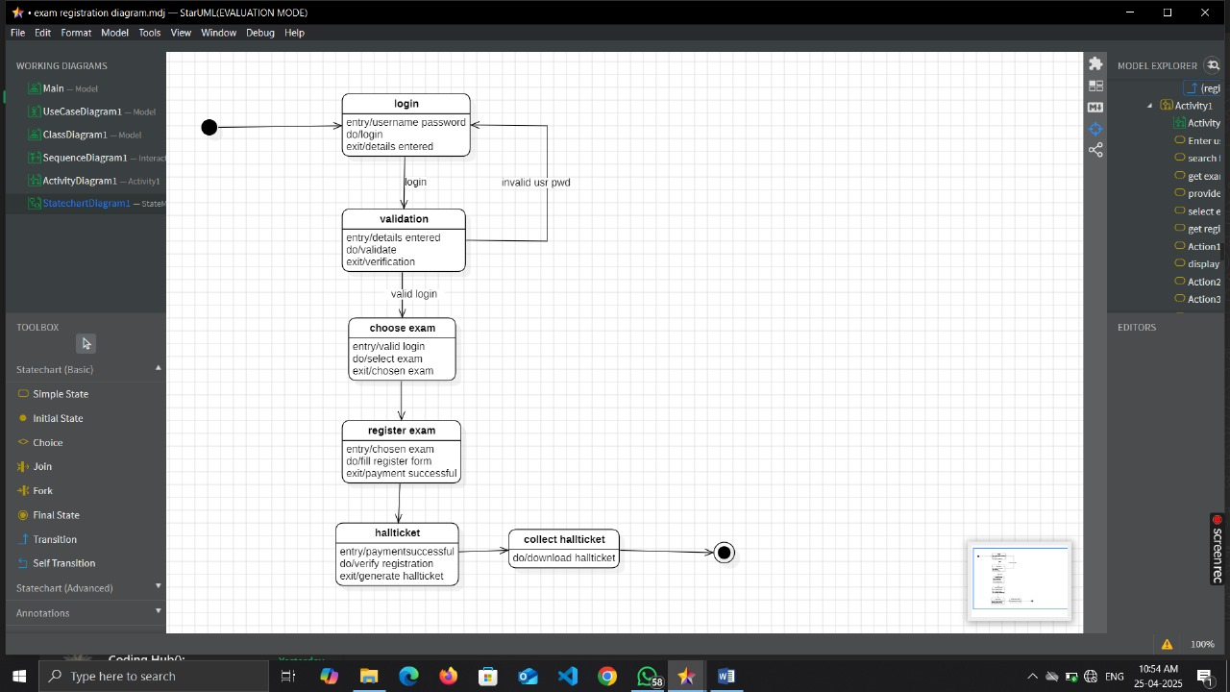

Documentation of Statechart Diagram:
- Initial states are Registration and Login, which are used for accessing the Online Exam Registration Platform.
- The next state is Validation, where the system checks the entered credentials against the database.
- The third state is Choose Exam, where the student views and selects from the available exams.
- The fourth state is Register Exam, where the student registers for the selected exam based on eligibility and availability.
- The fifth state is Hall Ticket Generation, which occurs after successful registration and payment.
- The sixth state is Collect Hall Ticket, where the student downloads or receives the hall ticket.
- The final state is used for logging out the student from the system.

Ex.no:9 Draw relevant Package diagram for the same system
Date:
PACKAGE DIAGRAM:
A package diagram in unified modeling language that depicts the dependencies between the packages that make up a model. A Package Diagram (PD) shows a grouping of elements in the OO model, and is a Cradle extension to UML. PDs can be used to show groups of classes in Class Diagrams (CDs), groups of components or processes in Component Diagrams (CPDs), or groups of processors in Deployment Diagrams (DPDs). There are three types of layers. They are
a. User interface layer.
b. Domain layer.
c. Technical services layer.
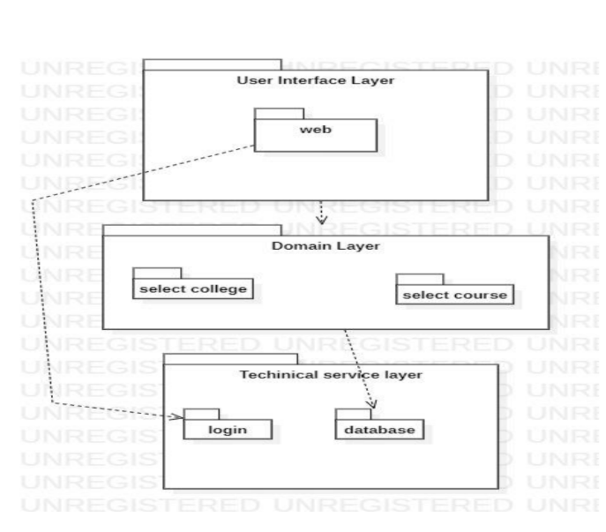

Documentation of Package Diagram:
The three layers in the online Exam Registration system are
a. The User interface layer - consists of the form and login. This layer describes how the applicant logins to the search and apply for the exam.
b. The Domain layer – shows the activities that are performed in the Exam Registration system. The activities are register and search the database.
c. The Technical service layer – get student details and the selected applicant details are stored in the database.

Ex.no:10 Draw relevant component and deployment diagram
Date: for the same system.

COMPONENT DIAGRAM:
Component diagrams depict the organization and dependencies of software components within a system, illustrating how components interact to fulfil system functionalities. They aid in understanding the modular structure of a system and its component-level relationships.
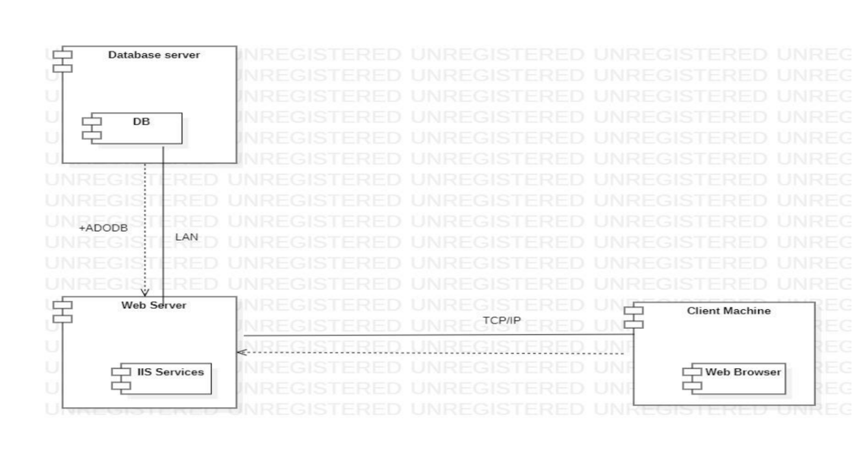

Documentation of Component Diagram:
The main components in this component diagram are
a. Database server which stores the student details as well as exam details.
b. Client machine is a student side component which contains the student details.
c. Web server is the overall details of all students and database.

DEPLOYMENT DIAGRAM:
Deployment diagrams visualize the physical deployment of software components in a system, showcasing how software artifacts are deployed on hardware nodes and interconnected through communication paths. They are crucial for understanding the system's infrastructure and deployment architecture.

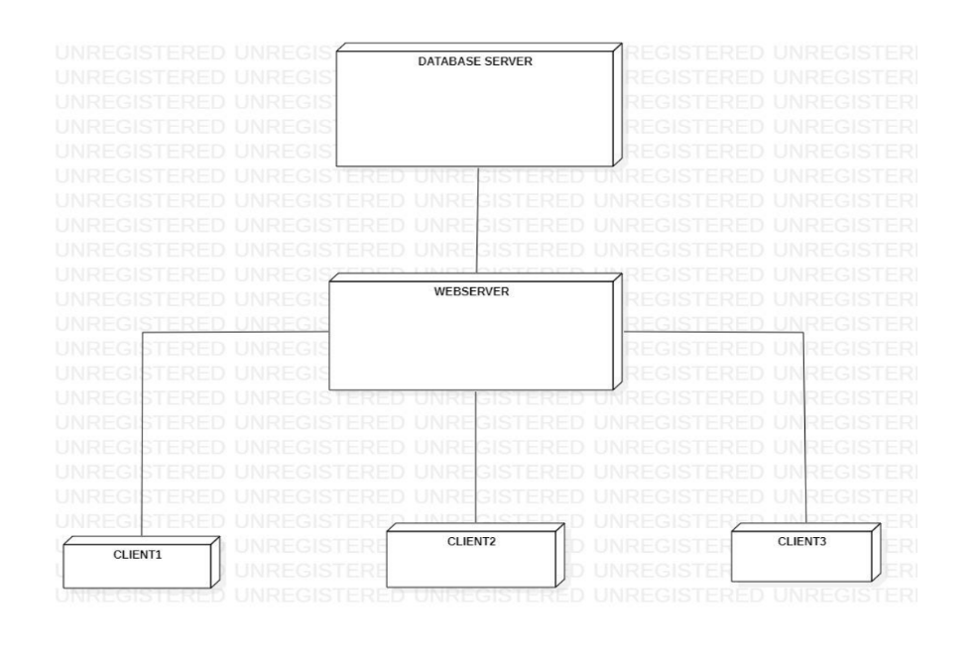

Documentation of Deployment Diagram:
The deployment diagrams mainly consist of three parts
– The database server which has the overall information. The webserver which has the webpage information and the client module which contains the student data.

